PFOA 1 compartment Plots (v8)

Weihsueh Chiu, Claire Lay, Parker Malek

2022-01-19

library(coda)  
library(bayesplot)

## This is bayesplot version 1.8.0

## - Online documentation and vignettes at mc-stan.org/bayesplot

## - bayesplot theme set to bayesplot::theme_default()

## * Does _not_ affect other ggplot2 plots

## * See ?bayesplot_theme_set for details on theme setting

library(ggplot2)  
library(ggsci)  
library(khroma) # for colors  
library(tidyverse)

## ── Attaching packages ─────────────────────────────────────── tidyverse 1.3.0 ──

## ✓ tibble 3.1.0 ✓ dplyr 1.0.5  
## ✓ tidyr 1.1.3 ✓ stringr 1.4.0  
## ✓ readr 1.4.0 ✓ forcats 0.5.1  
## ✓ purrr 0.3.4

## ── Conflicts ────────────────────────────────────────── tidyverse_conflicts() ──  
## x dplyr::filter() masks stats::filter()  
## x dplyr::lag() masks stats::lag()

library(reshape2)

##   
## Attaching package: 'reshape2'

## The following object is masked from 'package:tidyr':  
##   
## smiths

library(here)

## here() starts at /media/projects/projects/PFAS_PBPK/user/weihsueh_2021/PFAS_1cpt_v8-main/PFOA_1cpt_v8

knitr::opts_chunk$set(echo = TRUE, dpi = 300 )

Set up MCSim file

# this markdown file must be saved in top level directory for the following to work; the mcsim code depends on getwd results.  
mdir <- "MCSim"  
source(here::here(mdir,"setup_MCSim.R"))  
# Make mod.exe (used to create mcsim executable from model file)  
makemod()

## The mod.exe had been created.

## Set filenames and load data

## Set up dataset

id_lut <- multicheck$df_check %>% select(Level) %>% unique () %>%  
 mutate(dataset = c(   
 rep("Decatur M Train", 9),  
 rep("Decatur F Train", 9),  
 rep("Arnsberg M Train", 41),  
 rep("Arnsberg F Train", 69),  
 rep("Decatur M Test", 9),  
 rep("Decatur F Test", 10),  
 rep("Arnsberg M Test", 41),  
 rep("Arnsberg F Test", 69),   
 rep("Minnesota Train", 48),  
 rep("Minnesota Test", 47),   
 'Lubeck-Bartell-Train', 'Lubeck-Bartell-Test',  
 'Little Hocking-Bartell-Train', 'Little Hocking-Bartell-Test',  
 'Little Hocking-Emmett-Test',  
 'Paulsboro-Train','Horsham-Train',  
 'Warminster-Test','Warrington-Train'  
 ),   
 Sex = c(   
 rep("M", 9),  
 rep("F", 9),  
 rep("M", 41),  
 rep("F", 69),  
 rep("M", 9),  
 rep("F", 10),  
 rep("M", 41),  
 rep("F", 69),   
 rep("Mixed",95),  
 rep('Mixed',9)),  
 City = c(   
 rep("Decatur", 18),  
 rep("Arnsberg", 110),  
 rep("Decatur", 19),  
 rep("Arnsberg", 110),  
 rep("Minnesota", 95),  
 rep('Lubeck-Bartell',2),  
 rep('Little Hocking-Bartell',2),  
 'Little Hocking-Emmett',   
 'Paulsboro','Horsham','Warminster','Warrington'),   
 Train_Test = c(   
 rep("Train", 128),  
 rep("Test", 129),  
 rep("Train",48),  
 rep("Test",47),  
 'Train', 'Test',  
 'Train', 'Test',  
 'Test',  
 'Train','Train',  
 'Test','Test'),  
 datatype = c(  
 rep("Individual",9+9+41+69+9+10+41+69+95),  
 rep("Summary",9)),  
  
 Simulation = row_number(),  
 variable = paste0(dataset, " ",Simulation))  
  
id_lut$dataset <- factor(id_lut$dataset,levels=  
 c("Decatur M Train","Decatur F Train","Arnsberg M Train",  
 "Arnsberg F Train","Decatur M Test","Decatur F Test","Arnsberg M Test",  
 "Arnsberg F Test","Minnesota Train","Minnesota Test",  
 'Lubeck-Bartell-Train', 'Lubeck-Bartell-Test',  
 'Little Hocking-Bartell-Train', 'Little Hocking-Bartell-Test',  
 'Little Hocking-Emmett-Test','Paulsboro-Train','Horsham-Train',  
 'Warminster-Test','Warrington-Train'))  
id_lut$City <- factor(id_lut$City,levels =   
 c("Decatur","Arnsberg","Minnesota",'Lubeck-Bartell',  
 'Little Hocking-Bartell','Little Hocking-Emmett',  
 'Paulsboro','Horsham','Warminster','Warrington'))  
  
indiv_lut <- id_lut %>%   
 filter(City %in% c("Decatur", "Arnsberg","Minnesota")) %>%  
 mutate( dataset = as.factor(dataset))  
  
nv <- data.frame(dataset =unique(indiv_lut$dataset),   
 variable= rep("Pop GM", 10),  
 type= rep("Pop GM", 10), stringsAsFactors = FALSE)

## Individual parameters

set.seed(314159)  
  
indiv_parms <- indiv_lut  
lnkparmnames <- paste("ln_k.",gsub("_",".",indiv_parms$Level),".",sep="")  
lnVdparmnames <- paste("ln_Vd.",gsub("_",".",indiv_parms$Level),".",sep="")  
  
parmsamp <- apply(multicheck$parms.samp,2,sample,1)  
  
## Random z-score estimate of each parameter  
indiv_parms$ln_k.z.samp <- parmsamp[lnkparmnames]  
indiv_parms$ln_Vd.z.samp <- parmsamp[lnVdparmnames]  
  
normd <- data.frame(x=qnorm(ppoints(200)))  
normd$y <- dnorm(normd$x)  
  
iplotk<-  
 ggplot(subset(indiv_parms,Train_Test=="Train"))+  
 geom_histogram(aes(x=ln_k.z.samp,after_stat(density)),bins=20)+facet_wrap(~City,ncol=1)+  
 geom_line(aes(x=x,y=y),data=normd)+  
 xlab("Individual z-scores for k")  
  
iplotVd<-  
 ggplot(subset(indiv_parms,Train_Test=="Train"))+  
 geom_histogram(aes(x=ln_Vd.z.samp,after_stat(density)),bins=20)+facet_wrap(~City,ncol=1)+  
 geom_line(aes(x=x,y=y),data=normd)+  
 xlab("Individual z-scores for Vd")  
  
print(iplotk)

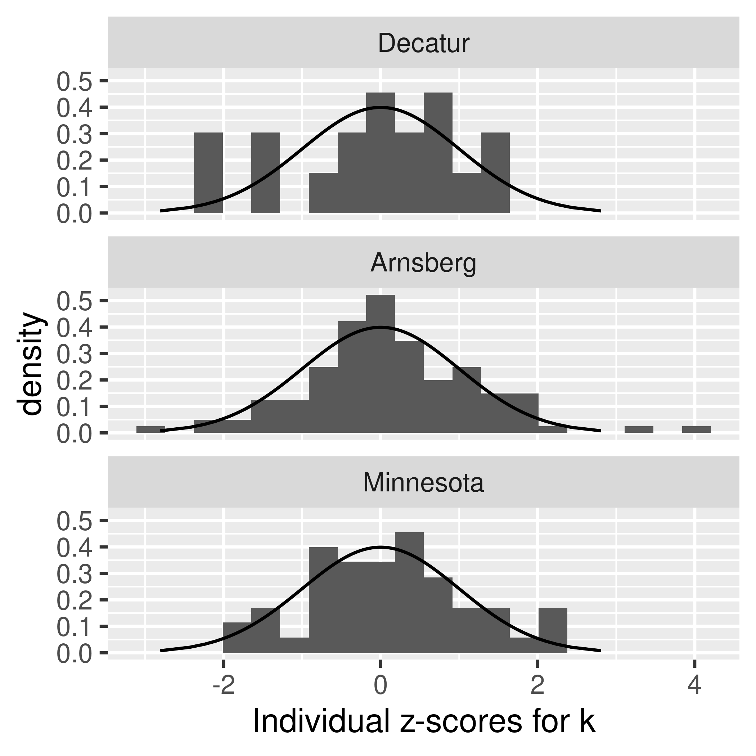

print(iplotVd)

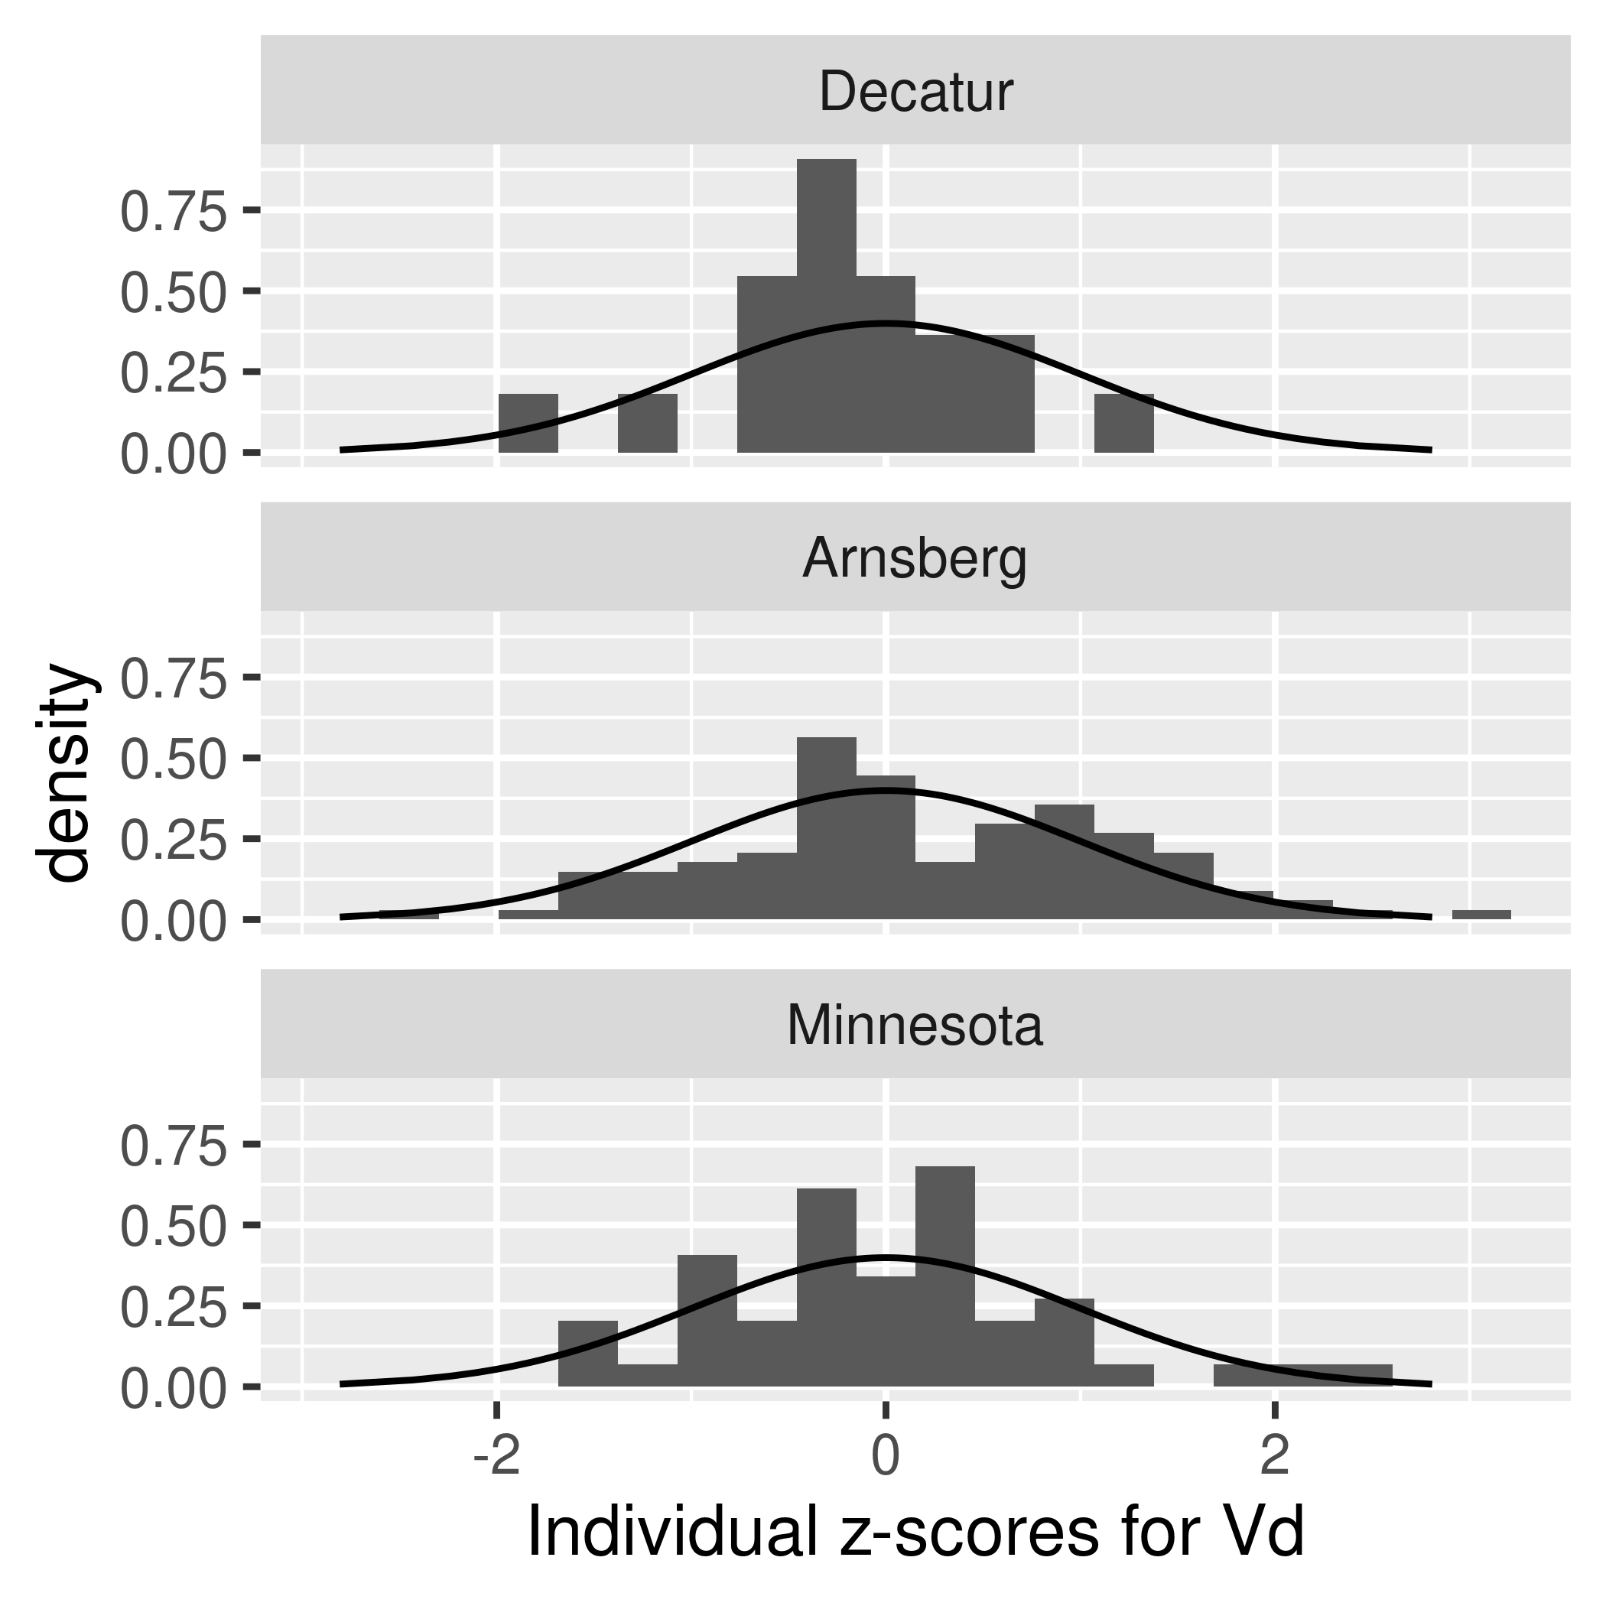

ggsave(file.path("output-plots",  
 paste0( sa,"Indiv_zscores_k_PFOA.pdf")),iplotk,dpi=600)

## Saving 3.5 x 3.5 in image

ggsave(file.path("output-plots",  
 paste0( sa,"Indiv_zscores_Vd_PFOA.pdf")),iplotVd,dpi=600)

## Saving 3.5 x 3.5 in image

ggsave(file.path("output-plots",  
 paste0( sa,"Indiv_zscores_k_PFOA.png")),iplotk,dpi=600)

## Saving 3.5 x 3.5 in image

ggsave(file.path("output-plots",  
 paste0( sa,"Indiv_zscores_Vd_PFOA.png")),iplotVd,dpi=600)

## Saving 3.5 x 3.5 in image

## Scatter plot of predictions (median of multicheck samples) versus data.

This is a Figure 2 panel. Needed to use “scale=1.1” in ggsave to make sure “City” appeared.

nrow(multicheck$df_check)

## [1] 312000

nrow(id_lut)

## [1] 361

multicheck$df_check %>% left_join(id_lut) %>% nrow()

## Joining, by = c("Level", "Simulation")

## [1] 312000

names(multicheck$df_check)

## [1] "Level" "Simulation" "Output_Var" "Time" "Data"   
## [6] "Prediction"

multicheck2 <- multicheck$df_check %>%   
 left_join(id_lut, by = c("Level", "Simulation"))%>%   
 group_by_at ( vars(-Prediction)) %>%   
 summarise(Prediction = median(Prediction)) %>%  
 ungroup() %>%  
 group_by(City) %>%   
 mutate(Train_Test = factor(Train_Test, levels = c("Train", "Test")),  
 `City (datatype)` = case_when(datatype == 'Individual' ~ paste0(City, "\n(", datatype, ")") ,  
 datatype == 'Summary' & grepl('-', as.character(City)) ~ paste0(gsub('-', '\n', City),"" ),  
 TRUE ~ as.character(City)),  
 `City (datatype)` = factor ( `City (datatype)`),  
 label = case_when(Train_Test=="Train" ~ "A: PFOA Train",  
 Train_Test=="Test" ~ "B: PFOA Test",  
 TRUE ~ ""))

## `summarise()` has grouped output by 'Level', 'Simulation', 'Output_Var', 'Time', 'Data', 'dataset', 'Sex', 'City', 'Train_Test', 'datatype'. You can override using the `.groups` argument.

#define color for testing boxplots  
bp_cols <- c (as.character (khroma::colour("muted")(9)) , "#191919")   
bp_cols <-bp_cols[c(1:7,10:8)]# plot_scheme_colourblind(bp_cols)   
  
### Create aesthetics lookup  
aes_lut <- multicheck2 %>% ungroup() %>%   
 group_by(City, datatype, `City (datatype)` ) %>% summarise () %>% ungroup() %>%  
 mutate( cols = bp_cols, city_fills = bp_cols ,   
 # for individual level on point plot (multicheck2), darken outlines for visibility, use standard colors otherwise  
 city_outlines = if_else(datatype == "Individual" , colorspace::darken(city_fills, 0.3), city_fills) ,   
 shapes = case_when(datatype == "Individual" & `City` %in% c('Decatur', 'Arnsberg', 'Minnesota') ~ 23,  
 datatype == "Summary" &`City` %in% c("Horsham", "Warminster", "Warrington") ~ 2,  
 datatype == "Summary" & `City` %in%  
 c("Lubeck-Bartell", "Little Hocking-Bartell", "Little Hocking-Emmett") ~ 0,  
 datatype == "Summary" & `City` == "Paulsboro" ~ 1,  
 TRUE ~ 18 ),   
 size = if_else(datatype =="Individual", 1.75, 2.5 ) )

## `summarise()` has grouped output by 'City', 'datatype'. You can override using the `.groups` argument.

source( paste0(gsub(basename(here()), 'shared_functions', here()), '/plot_scatter_mcheck.r'))  
  
p2 <- plot_scatter_mcheck(dframe = multicheck2, pfas_nom = pfas_name, aes_lut_fn = aes_lut ) +   
 theme(  
 legend.text = element_text(  
 margin = margin(t = 2, b = 2, unit = "pt")) )  
print(p2)

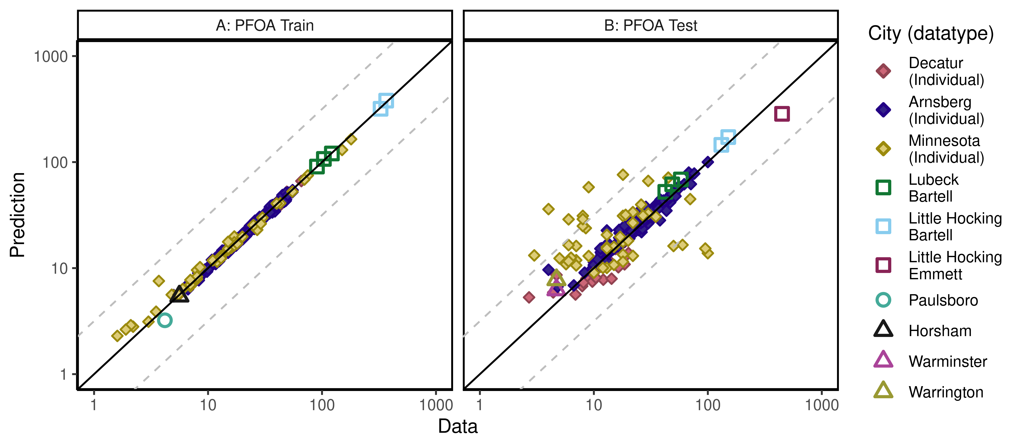

ggsave(here ("output-plots", paste0( sa,"multicheckplot_", pfas_name,  
 ".pdf")),p2,  
 dpi=600, scale=1.1)

## Saving 8.8 x 3.85 in image

ggsave(here ("output-plots", paste0( sa,"multicheckplot_", pfas_name,  
 ".png")),p2,  
 dpi=600, scale=1.1)

## Saving 8.8 x 3.85 in image

## Parse multicheck

df_check <- multicheck$df_check  
df_check <- subset(df_check,Data > 0)   
  
n1 <- nrow(df_check)  
id_chks <- df_check %>% select(Level) %>% unique() %>% bind_cols(id_lut) %>%  
 mutate(dataset = as.factor(dataset), Sex = as.factor(Sex), City = as.factor(City),   
 Train_Test = as.factor(Train_Test))

## New names:  
## * Level -> Level...1  
## * Level -> Level...2

df_check <- df_check %>% left_join(id_chks)%>%  
 mutate(Dataset = paste(as.character(dataset), Simulation),  
 Sex = ordered(Sex, levels = c("M", "F", "Mixed"),   
 labels = c("Male", "Female", "Mixed (all sexes)")))

## Joining, by = "Simulation"

df_check$Dataset = factor(df_check$Dataset, levels =  
 unique(paste(as.character(df_check$dataset), df_check$Simulation)))  
n2 <- nrow(df_check)  
if(n1 != n2)print("duplicates created in id-lut join")

df_check$Time.desc <- as.character(paste0("T=",df_check$Time))  
df_check$Time.desc[df_check$Time.desc == "T=1e-06"] <- "SteadyState"  
df_check$Dataset.Time <- interaction(df_check$Dataset,  
 df_check$Time.desc,lex.order=TRUE)  
df_check$Dataset.Time <- factor(df_check$Dataset.Time,  
 levels=levels(df_check$Dataset.Time))  
calibdata <- df_check[,names(df_check) != "Prediction"]  
calibdata <- calibdata[!duplicated(calibdata),]  
print(calibdata)

## Level Simulation Output_Var Time Data Level...1 Level...2  
## 1 1_1_1 1 Cserum_t 0.000000 41.000 1_1_1 1_1_1  
## 2 1_1_1 1 Cserum_t 5.802000 29.300 1_1_1 1_1_1  
## 3 1_1_2 2 Cserum_t 0.000000 13.100 1_1_2 1_1_2  
## 4 1_1_2 2 Cserum_t 5.802000 10.300 1_1_2 1_1_2  
## 5 1_1_3 3 Cserum_t 0.000000 25.700 1_1_3 1_1_3  
## 6 1_1_3 3 Cserum_t 5.802000 10.100 1_1_3 1_1_3  
## 7 1_1_4 4 Cserum_t 0.000000 47.700 1_1_4 1_1_4  
## 8 1_1_4 4 Cserum_t 5.802000 11.300 1_1_4 1_1_4  
## 9 1_1_5 5 Cserum_t 0.000000 51.200 1_1_5 1_1_5  
## 10 1_1_5 5 Cserum_t 5.802000 19.300 1_1_5 1_1_5  
## 11 1_1_6 6 Cserum_t 0.000000 12.600 1_1_6 1_1_6  
## 12 1_1_6 6 Cserum_t 5.802000 9.800 1_1_6 1_1_6  
## 13 1_1_7 7 Cserum_t 0.000000 44.300 1_1_7 1_1_7  
## 14 1_1_7 7 Cserum_t 5.802000 12.700 1_1_7 1_1_7  
## 15 1_1_8 8 Cserum_t 0.000000 47.400 1_1_8 1_1_8  
## 16 1_1_8 8 Cserum_t 5.802000 15.600 1_1_8 1_1_8  
## 17 1_1_9 9 Cserum_t 0.000000 19.600 1_1_9 1_1_9  
## 18 1_1_9 9 Cserum_t 5.802000 12.700 1_1_9 1_1_9  
## 19 1_1_10 10 Cserum_t 0.000000 7.600 1_1_10 1_1_10  
## 20 1_1_10 10 Cserum_t 5.802000 5.500 1_1_10 1_1_10  
## 21 1_1_11 11 Cserum_t 0.000000 46.100 1_1_11 1_1_11  
## 22 1_1_11 11 Cserum_t 5.802000 30.900 1_1_11 1_1_11  
## 23 1_1_12 12 Cserum_t 0.000000 10.900 1_1_12 1_1_12  
## 24 1_1_12 12 Cserum_t 5.802000 9.800 1_1_12 1_1_12  
## 25 1_1_13 13 Cserum_t 0.000000 6.700 1_1_13 1_1_13  
## 26 1_1_13 13 Cserum_t 5.802000 7.300 1_1_13 1_1_13  
## 27 1_1_14 14 Cserum_t 0.000000 65.900 1_1_14 1_1_14  
## 28 1_1_14 14 Cserum_t 5.802000 31.500 1_1_14 1_1_14  
## 29 1_1_15 15 Cserum_t 0.000000 49.100 1_1_15 1_1_15  
## 30 1_1_15 15 Cserum_t 5.802000 42.400 1_1_15 1_1_15  
## 31 1_1_16 16 Cserum_t 0.000000 13.000 1_1_16 1_1_16  
## 32 1_1_16 16 Cserum_t 5.802000 8.500 1_1_16 1_1_16  
## 33 1_1_17 17 Cserum_t 0.000000 45.500 1_1_17 1_1_17  
## 34 1_1_17 17 Cserum_t 5.802000 17.700 1_1_17 1_1_17  
## 35 1_1_18 18 Cserum_t 0.000000 34.300 1_1_18 1_1_18  
## 36 1_1_18 18 Cserum_t 5.802000 15.000 1_1_18 1_1_18  
## 37 1_2_1 19 Cserum_t 0.000000 15.700 1_2_1 1_2_1  
## 38 1_2_1 19 Cserum_t 0.982900 16.000 1_2_1 1_2_1  
## 39 1_2_2 20 Cserum_t 0.000000 14.300 1_2_2 1_2_2  
## 40 1_2_2 20 Cserum_t 0.982900 15.000 1_2_2 1_2_2  
## 41 1_2_3 21 Cserum_t 0.000000 40.500 1_2_3 1_2_3  
## 42 1_2_3 21 Cserum_t 0.982900 32.000 1_2_3 1_2_3  
## 43 1_2_4 22 Cserum_t 0.000000 45.000 1_2_4 1_2_4  
## 44 1_2_4 22 Cserum_t 0.982900 48.000 1_2_4 1_2_4  
## 45 1_2_5 23 Cserum_t 0.000000 38.330 1_2_5 1_2_5  
## 46 1_2_5 23 Cserum_t 0.982900 32.000 1_2_5 1_2_5  
## 47 1_2_6 24 Cserum_t 0.000000 16.500 1_2_6 1_2_6  
## 48 1_2_6 24 Cserum_t 0.982900 13.600 1_2_6 1_2_6  
## 49 1_2_7 25 Cserum_t 0.000000 40.200 1_2_7 1_2_7  
## 50 1_2_7 25 Cserum_t 0.982900 35.700 1_2_7 1_2_7  
## 51 1_2_8 26 Cserum_t 0.000000 21.400 1_2_8 1_2_8  
## 52 1_2_8 26 Cserum_t 0.982900 16.300 1_2_8 1_2_8  
## 53 1_2_9 27 Cserum_t 0.000000 45.000 1_2_9 1_2_9  
## 54 1_2_9 27 Cserum_t 0.982900 46.500 1_2_9 1_2_9  
## 55 1_2_10 28 Cserum_t 0.000000 11.670 1_2_10 1_2_10  
## 56 1_2_10 28 Cserum_t 0.982900 8.200 1_2_10 1_2_10  
## 57 1_2_11 29 Cserum_t 0.000000 21.300 1_2_11 1_2_11  
## 58 1_2_11 29 Cserum_t 0.982900 20.000 1_2_11 1_2_11  
## 59 1_2_12 30 Cserum_t 0.000000 21.500 1_2_12 1_2_12  
## 60 1_2_12 30 Cserum_t 0.982900 16.000 1_2_12 1_2_12  
## 61 1_2_13 31 Cserum_t 0.000000 26.900 1_2_13 1_2_13  
## 62 1_2_13 31 Cserum_t 0.982900 20.300 1_2_13 1_2_13  
## 63 1_2_14 32 Cserum_t 0.000000 13.300 1_2_14 1_2_14  
## 64 1_2_14 32 Cserum_t 0.982900 11.670 1_2_14 1_2_14  
## 65 1_2_15 33 Cserum_t 0.000000 23.330 1_2_15 1_2_15  
## 66 1_2_15 33 Cserum_t 0.982900 18.330 1_2_15 1_2_15  
## 67 1_2_16 34 Cserum_t 0.000000 50.000 1_2_16 1_2_16  
## 68 1_2_16 34 Cserum_t 0.982900 46.800 1_2_16 1_2_16  
## 69 1_2_17 35 Cserum_t 0.000000 31.500 1_2_17 1_2_17  
## 70 1_2_17 35 Cserum_t 0.982900 30.000 1_2_17 1_2_17  
## 71 1_2_18 36 Cserum_t 0.000000 7.500 1_2_18 1_2_18  
## 72 1_2_18 36 Cserum_t 0.982900 7.500 1_2_18 1_2_18  
## 73 1_2_19 37 Cserum_t 0.000000 9.500 1_2_19 1_2_19  
## 74 1_2_19 37 Cserum_t 0.982900 8.000 1_2_19 1_2_19  
## 75 1_2_20 38 Cserum_t 0.000000 26.670 1_2_20 1_2_20  
## 76 1_2_20 38 Cserum_t 0.982900 23.330 1_2_20 1_2_20  
## 77 1_2_21 39 Cserum_t 0.000000 11.670 1_2_21 1_2_21  
## 78 1_2_21 39 Cserum_t 0.982900 10.000 1_2_21 1_2_21  
## 79 1_2_22 40 Cserum_t 0.000000 15.000 1_2_22 1_2_22  
## 80 1_2_22 40 Cserum_t 0.982900 13.330 1_2_22 1_2_22  
## 81 1_2_23 41 Cserum_t 0.000000 9.400 1_2_23 1_2_23  
## 82 1_2_23 41 Cserum_t 0.982900 9.800 1_2_23 1_2_23  
## 83 1_2_24 42 Cserum_t 0.000000 41.670 1_2_24 1_2_24  
## 84 1_2_24 42 Cserum_t 0.982900 38.000 1_2_24 1_2_24  
## 85 1_2_25 43 Cserum_t 0.000000 45.000 1_2_25 1_2_25  
## 86 1_2_25 43 Cserum_t 0.982900 46.500 1_2_25 1_2_25  
## 87 1_2_26 44 Cserum_t 0.000000 13.500 1_2_26 1_2_26  
## 88 1_2_26 44 Cserum_t 0.982900 11.670 1_2_26 1_2_26  
## 89 1_2_27 45 Cserum_t 0.000000 30.000 1_2_27 1_2_27  
## 90 1_2_27 45 Cserum_t 0.982900 26.500 1_2_27 1_2_27  
## 91 1_2_28 46 Cserum_t 0.000000 31.300 1_2_28 1_2_28  
## 92 1_2_28 46 Cserum_t 0.982900 28.300 1_2_28 1_2_28  
## 93 1_2_29 47 Cserum_t 0.000000 21.300 1_2_29 1_2_29  
## 94 1_2_29 47 Cserum_t 0.982900 20.500 1_2_29 1_2_29  
## 95 1_2_30 48 Cserum_t 0.000000 45.000 1_2_30 1_2_30  
## 96 1_2_30 48 Cserum_t 0.982900 40.500 1_2_30 1_2_30  
## 97 1_2_31 49 Cserum_t 0.000000 38.330 1_2_31 1_2_31  
## 98 1_2_31 49 Cserum_t 0.982900 36.500 1_2_31 1_2_31  
## 99 1_2_32 50 Cserum_t 0.000000 18.000 1_2_32 1_2_32  
## 100 1_2_32 50 Cserum_t 0.982900 16.670 1_2_32 1_2_32  
## 101 1_2_33 51 Cserum_t 0.000000 36.700 1_2_33 1_2_33  
## 102 1_2_33 51 Cserum_t 0.982900 33.500 1_2_33 1_2_33  
## 103 1_2_34 52 Cserum_t 0.000000 34.800 1_2_34 1_2_34  
## 104 1_2_34 52 Cserum_t 0.982900 36.670 1_2_34 1_2_34  
## 105 1_2_35 53 Cserum_t 0.000000 38.600 1_2_35 1_2_35  
## 106 1_2_35 53 Cserum_t 0.982900 36.300 1_2_35 1_2_35  
## 107 1_2_36 54 Cserum_t 0.000000 6.670 1_2_36 1_2_36  
## 108 1_2_36 54 Cserum_t 0.982900 6.670 1_2_36 1_2_36  
## 109 1_2_37 55 Cserum_t 0.000000 45.200 1_2_37 1_2_37  
## 110 1_2_37 55 Cserum_t 0.982900 46.700 1_2_37 1_2_37  
## 111 1_2_38 56 Cserum_t 0.000000 15.000 1_2_38 1_2_38  
## 112 1_2_38 56 Cserum_t 0.982900 14.700 1_2_38 1_2_38  
## 113 1_2_39 57 Cserum_t 0.000000 22.000 1_2_39 1_2_39  
## 114 1_2_39 57 Cserum_t 0.982900 18.000 1_2_39 1_2_39  
## 115 1_2_40 58 Cserum_t 0.000000 41.000 1_2_40 1_2_40  
## 116 1_2_40 58 Cserum_t 0.982900 38.300 1_2_40 1_2_40  
## 117 1_2_41 59 Cserum_t 0.000000 20.500 1_2_41 1_2_41  
## 118 1_2_41 59 Cserum_t 0.982900 20.500 1_2_41 1_2_41  
## 119 1_2_42 60 Cserum_t 0.000000 13.000 1_2_42 1_2_42  
## 120 1_2_42 60 Cserum_t 0.982900 13.000 1_2_42 1_2_42  
## 121 1_2_43 61 Cserum_t 0.000000 16.800 1_2_43 1_2_43  
## 122 1_2_43 61 Cserum_t 0.982900 13.600 1_2_43 1_2_43  
## 123 1_2_44 62 Cserum_t 0.000000 18.000 1_2_44 1_2_44  
## 124 1_2_44 62 Cserum_t 0.982900 17.700 1_2_44 1_2_44  
## 125 1_2_45 63 Cserum_t 0.000000 10.300 1_2_45 1_2_45  
## 126 1_2_45 63 Cserum_t 0.982900 8.300 1_2_45 1_2_45  
## 127 1_2_46 64 Cserum_t 0.000000 23.330 1_2_46 1_2_46  
## 128 1_2_46 64 Cserum_t 0.982900 18.330 1_2_46 1_2_46  
## 129 1_2_47 65 Cserum_t 0.000000 10.300 1_2_47 1_2_47  
## 130 1_2_47 65 Cserum_t 0.982900 8.500 1_2_47 1_2_47  
## 131 1_2_48 66 Cserum_t 0.000000 55.200 1_2_48 1_2_48  
## 132 1_2_48 66 Cserum_t 0.982900 43.500 1_2_48 1_2_48  
## 133 1_2_49 67 Cserum_t 0.000000 48.330 1_2_49 1_2_49  
## 134 1_2_49 67 Cserum_t 0.982900 38.330 1_2_49 1_2_49  
## 135 1_2_50 68 Cserum_t 0.000000 36.700 1_2_50 1_2_50  
## 136 1_2_50 68 Cserum_t 0.982900 33.330 1_2_50 1_2_50  
## 137 1_2_51 69 Cserum_t 0.000000 26.000 1_2_51 1_2_51  
## 138 1_2_51 69 Cserum_t 0.982900 25.000 1_2_51 1_2_51  
## 139 1_2_52 70 Cserum_t 0.000000 28.330 1_2_52 1_2_52  
## 140 1_2_52 70 Cserum_t 0.982900 24.600 1_2_52 1_2_52  
## 141 1_2_53 71 Cserum_t 0.000000 18.330 1_2_53 1_2_53  
## 142 1_2_53 71 Cserum_t 0.982900 12.900 1_2_53 1_2_53  
## 143 1_2_54 72 Cserum_t 0.000000 20.000 1_2_54 1_2_54  
## 144 1_2_54 72 Cserum_t 0.982900 20.200 1_2_54 1_2_54  
## 145 1_2_55 73 Cserum_t 0.000000 18.330 1_2_55 1_2_55  
## 146 1_2_55 73 Cserum_t 0.982900 13.330 1_2_55 1_2_55  
## 147 1_2_56 74 Cserum_t 0.000000 21.700 1_2_56 1_2_56  
## 148 1_2_56 74 Cserum_t 0.982900 16.700 1_2_56 1_2_56  
## 149 1_2_57 75 Cserum_t 0.000000 12.500 1_2_57 1_2_57  
## 150 1_2_57 75 Cserum_t 0.982900 5.000 1_2_57 1_2_57  
## 151 1_2_58 76 Cserum_t 0.000000 15.200 1_2_58 1_2_58  
## 152 1_2_58 76 Cserum_t 0.982900 14.900 1_2_58 1_2_58  
## 153 1_2_59 77 Cserum_t 0.000000 26.500 1_2_59 1_2_59  
## 154 1_2_59 77 Cserum_t 0.982900 15.400 1_2_59 1_2_59  
## 155 1_2_60 78 Cserum_t 0.000000 11.670 1_2_60 1_2_60  
## 156 1_2_60 78 Cserum_t 0.982900 8.330 1_2_60 1_2_60  
## 157 1_2_61 79 Cserum_t 0.000000 35.000 1_2_61 1_2_61  
## 158 1_2_61 79 Cserum_t 0.982900 26.400 1_2_61 1_2_61  
## 159 1_2_62 80 Cserum_t 0.000000 29.700 1_2_62 1_2_62  
## 160 1_2_62 80 Cserum_t 0.982900 25.000 1_2_62 1_2_62  
## 161 1_2_63 81 Cserum_t 0.000000 26.700 1_2_63 1_2_63  
## 162 1_2_63 81 Cserum_t 0.982900 23.330 1_2_63 1_2_63  
## 163 1_2_64 82 Cserum_t 0.000000 10.300 1_2_64 1_2_64  
## 164 1_2_64 82 Cserum_t 0.982900 8.600 1_2_64 1_2_64  
## 165 1_2_65 83 Cserum_t 0.000000 25.000 1_2_65 1_2_65  
## 166 1_2_65 83 Cserum_t 0.982900 19.600 1_2_65 1_2_65  
## 167 1_2_66 84 Cserum_t 0.000000 35.400 1_2_66 1_2_66  
## 168 1_2_66 84 Cserum_t 0.982900 38.600 1_2_66 1_2_66  
## 169 1_2_67 85 Cserum_t 0.000000 16.670 1_2_67 1_2_67  
## 170 1_2_67 85 Cserum_t 0.982900 12.800 1_2_67 1_2_67  
## 171 1_2_68 86 Cserum_t 0.000000 25.000 1_2_68 1_2_68  
## 172 1_2_68 86 Cserum_t 0.982900 20.000 1_2_68 1_2_68  
## 173 1_2_69 87 Cserum_t 0.000000 22.700 1_2_69 1_2_69  
## 174 1_2_69 87 Cserum_t 0.982900 19.800 1_2_69 1_2_69  
## 175 1_2_70 88 Cserum_t 0.000000 12.500 1_2_70 1_2_70  
## 176 1_2_70 88 Cserum_t 0.982900 11.300 1_2_70 1_2_70  
## 177 1_2_71 89 Cserum_t 0.000000 8.400 1_2_71 1_2_71  
## 178 1_2_71 89 Cserum_t 0.982900 7.800 1_2_71 1_2_71  
## 179 1_2_72 90 Cserum_t 0.000000 26.000 1_2_72 1_2_72  
## 180 1_2_72 90 Cserum_t 0.982900 20.000 1_2_72 1_2_72  
## 181 1_2_73 91 Cserum_t 0.000000 6.670 1_2_73 1_2_73  
## 182 1_2_73 91 Cserum_t 0.982900 5.000 1_2_73 1_2_73  
## 183 1_2_74 92 Cserum_t 0.000000 8.300 1_2_74 1_2_74  
## 184 1_2_74 92 Cserum_t 0.982900 5.000 1_2_74 1_2_74  
## 185 1_2_75 93 Cserum_t 0.000000 13.000 1_2_75 1_2_75  
## 186 1_2_75 93 Cserum_t 0.982900 11.500 1_2_75 1_2_75  
## 187 1_2_76 94 Cserum_t 0.000000 48.330 1_2_76 1_2_76  
## 188 1_2_76 94 Cserum_t 0.982900 41.700 1_2_76 1_2_76  
## 189 1_2_77 95 Cserum_t 0.000000 16.670 1_2_77 1_2_77  
## 190 1_2_77 95 Cserum_t 0.982900 13.330 1_2_77 1_2_77  
## 191 1_2_78 96 Cserum_t 0.000000 23.700 1_2_78 1_2_78  
## 192 1_2_78 96 Cserum_t 0.982900 16.670 1_2_78 1_2_78  
## 193 1_2_79 97 Cserum_t 0.000000 16.800 1_2_79 1_2_79  
## 194 1_2_79 97 Cserum_t 0.982900 11.670 1_2_79 1_2_79  
## 195 1_2_80 98 Cserum_t 0.000000 12.500 1_2_80 1_2_80  
## 196 1_2_80 98 Cserum_t 0.982900 12.500 1_2_80 1_2_80  
## 197 1_2_81 99 Cserum_t 0.000000 20.000 1_2_81 1_2_81  
## 198 1_2_81 99 Cserum_t 0.982900 8.330 1_2_81 1_2_81  
## 199 1_2_82 100 Cserum_t 0.000000 22.700 1_2_82 1_2_82  
## 200 1_2_82 100 Cserum_t 0.982900 21.400 1_2_82 1_2_82  
## 201 1_2_83 101 Cserum_t 0.000000 17.600 1_2_83 1_2_83  
## 202 1_2_83 101 Cserum_t 0.982900 10.800 1_2_83 1_2_83  
## 203 1_2_84 102 Cserum_t 0.000000 27.700 1_2_84 1_2_84  
## 204 1_2_84 102 Cserum_t 0.982900 22.800 1_2_84 1_2_84  
## 205 1_2_85 103 Cserum_t 0.000000 32.500 1_2_85 1_2_85  
## 206 1_2_85 103 Cserum_t 0.982900 23.500 1_2_85 1_2_85  
## 207 1_2_86 104 Cserum_t 0.000000 10.000 1_2_86 1_2_86  
## 208 1_2_86 104 Cserum_t 0.982900 8.300 1_2_86 1_2_86  
## 209 1_2_87 105 Cserum_t 0.000000 23.330 1_2_87 1_2_87  
## 210 1_2_87 105 Cserum_t 0.982900 17.400 1_2_87 1_2_87  
## 211 1_2_88 106 Cserum_t 0.000000 42.300 1_2_88 1_2_88  
## 212 1_2_88 106 Cserum_t 0.982900 36.300 1_2_88 1_2_88  
## 213 1_2_89 107 Cserum_t 0.000000 45.000 1_2_89 1_2_89  
## 214 1_2_89 107 Cserum_t 0.982900 42.500 1_2_89 1_2_89  
## 215 1_2_90 108 Cserum_t 0.000000 12.400 1_2_90 1_2_90  
## 216 1_2_90 108 Cserum_t 0.982900 8.500 1_2_90 1_2_90  
## 217 1_2_91 109 Cserum_t 0.000000 48.100 1_2_91 1_2_91  
## 218 1_2_91 109 Cserum_t 0.982900 48.330 1_2_91 1_2_91  
## 219 1_2_92 110 Cserum_t 0.000000 8.330 1_2_92 1_2_92  
## 220 1_2_92 110 Cserum_t 0.982900 6.670 1_2_92 1_2_92  
## 221 1_2_93 111 Cserum_t 0.000000 39.700 1_2_93 1_2_93  
## 222 1_2_93 111 Cserum_t 0.982900 25.800 1_2_93 1_2_93  
## 223 1_2_94 112 Cserum_t 0.000000 38.000 1_2_94 1_2_94  
## 224 1_2_94 112 Cserum_t 0.982900 26.670 1_2_94 1_2_94  
## 225 1_2_95 113 Cserum_t 0.000000 38.100 1_2_95 1_2_95  
## 226 1_2_95 113 Cserum_t 0.982900 35.000 1_2_95 1_2_95  
## 227 1_2_96 114 Cserum_t 0.000000 17.800 1_2_96 1_2_96  
## 228 1_2_96 114 Cserum_t 0.982900 17.500 1_2_96 1_2_96  
## 229 1_2_97 115 Cserum_t 0.000000 41.700 1_2_97 1_2_97  
## 230 1_2_97 115 Cserum_t 0.982900 28.330 1_2_97 1_2_97  
## 231 1_2_98 116 Cserum_t 0.000000 25.850 1_2_98 1_2_98  
## 232 1_2_98 116 Cserum_t 0.982900 24.900 1_2_98 1_2_98  
## 233 1_2_99 117 Cserum_t 0.000000 50.000 1_2_99 1_2_99  
## 234 1_2_99 117 Cserum_t 0.982900 38.500 1_2_99 1_2_99  
## 235 1_2_100 118 Cserum_t 0.000000 25.000 1_2_100 1_2_100  
## 236 1_2_100 118 Cserum_t 0.982900 25.500 1_2_100 1_2_100  
## 237 1_2_101 119 Cserum_t 0.000000 25.000 1_2_101 1_2_101  
## 238 1_2_101 119 Cserum_t 0.982900 18.000 1_2_101 1_2_101  
## 239 1_2_102 120 Cserum_t 0.000000 29.800 1_2_102 1_2_102  
## 240 1_2_102 120 Cserum_t 0.982900 21.700 1_2_102 1_2_102  
## 241 1_2_103 121 Cserum_t 0.000000 8.330 1_2_103 1_2_103  
## 242 1_2_103 121 Cserum_t 0.982900 6.670 1_2_103 1_2_103  
## 243 1_2_104 122 Cserum_t 0.000000 18.330 1_2_104 1_2_104  
## 244 1_2_104 122 Cserum_t 0.982900 13.330 1_2_104 1_2_104  
## 245 1_2_105 123 Cserum_t 0.000000 21.500 1_2_105 1_2_105  
## 246 1_2_105 123 Cserum_t 0.982900 13.330 1_2_105 1_2_105  
## 247 1_2_106 124 Cserum_t 0.000000 55.000 1_2_106 1_2_106  
## 248 1_2_106 124 Cserum_t 0.982900 36.670 1_2_106 1_2_106  
## 249 1_2_107 125 Cserum_t 0.000000 10.200 1_2_107 1_2_107  
## 250 1_2_107 125 Cserum_t 0.982900 8.300 1_2_107 1_2_107  
## 251 1_2_108 126 Cserum_t 0.000000 34.500 1_2_108 1_2_108  
## 252 1_2_108 126 Cserum_t 0.982900 23.330 1_2_108 1_2_108  
## 253 1_2_109 127 Cserum_t 0.000000 24.000 1_2_109 1_2_109  
## 254 1_2_109 127 Cserum_t 0.982900 17.700 1_2_109 1_2_109  
## 255 1_2_110 128 Cserum_t 0.000000 23.330 1_2_110 1_2_110  
## 256 1_2_110 128 Cserum_t 0.982900 18.330 1_2_110 1_2_110  
## 257 1_3_1 129 Cserum_t 0.000000 8.800 1_3_1 1_3_1  
## 258 1_3_1 129 Cserum_t 5.802000 2.700 1_3_1 1_3_1  
## 259 1_3_2 130 Cserum_t 0.000000 29.600 1_3_2 1_3_2  
## 260 1_3_2 130 Cserum_t 5.802000 14.400 1_3_2 1_3_2  
## 261 1_3_3 131 Cserum_t 0.000000 51.000 1_3_3 1_3_3  
## 262 1_3_3 131 Cserum_t 5.802000 16.900 1_3_3 1_3_3  
## 263 1_3_4 132 Cserum_t 0.000000 18.800 1_3_4 1_3_4  
## 264 1_3_4 132 Cserum_t 5.802000 10.400 1_3_4 1_3_4  
## 265 1_3_5 133 Cserum_t 0.000000 28.600 1_3_5 1_3_5  
## 266 1_3_5 133 Cserum_t 5.802000 18.600 1_3_5 1_3_5  
## 267 1_3_6 134 Cserum_t 0.000000 28.400 1_3_6 1_3_6  
## 268 1_3_6 134 Cserum_t 5.802000 16.400 1_3_6 1_3_6  
## 269 1_3_7 135 Cserum_t 0.000000 18.600 1_3_7 1_3_7  
## 270 1_3_7 135 Cserum_t 5.802000 8.100 1_3_7 1_3_7  
## 271 1_3_8 136 Cserum_t 0.000000 21.800 1_3_8 1_3_8  
## 272 1_3_8 136 Cserum_t 5.802000 9.800 1_3_8 1_3_8  
## 273 1_3_9 137 Cserum_t 0.000000 27.300 1_3_9 1_3_9  
## 274 1_3_9 137 Cserum_t 5.802000 11.400 1_3_9 1_3_9  
## 275 1_3_10 138 Cserum_t 0.000000 12.600 1_3_10 1_3_10  
## 276 1_3_10 138 Cserum_t 5.802000 4.400 1_3_10 1_3_10  
## 277 1_3_11 139 Cserum_t 0.000000 43.200 1_3_11 1_3_11  
## 278 1_3_11 139 Cserum_t 5.802000 20.100 1_3_11 1_3_11  
## 279 1_3_12 140 Cserum_t 0.000000 15.500 1_3_12 1_3_12  
## 280 1_3_12 140 Cserum_t 5.802000 7.900 1_3_12 1_3_12  
## 281 1_3_13 141 Cserum_t 0.000000 18.700 1_3_13 1_3_13  
## 282 1_3_13 141 Cserum_t 5.802000 12.100 1_3_13 1_3_13  
## 283 1_3_14 142 Cserum_t 0.000000 18.700 1_3_14 1_3_14  
## 284 1_3_14 142 Cserum_t 5.802000 8.600 1_3_14 1_3_14  
## 285 1_3_15 143 Cserum_t 0.000000 23.400 1_3_15 1_3_15  
## 286 1_3_15 143 Cserum_t 5.802000 4.700 1_3_15 1_3_15  
## 287 1_3_16 144 Cserum_t 0.000000 19.400 1_3_16 1_3_16  
## 288 1_3_16 144 Cserum_t 5.802000 14.300 1_3_16 1_3_16  
## 289 1_3_17 145 Cserum_t 0.000000 41.300 1_3_17 1_3_17  
## 290 1_3_17 145 Cserum_t 5.802000 18.800 1_3_17 1_3_17  
## 291 1_3_18 146 Cserum_t 0.000000 11.900 1_3_18 1_3_18  
## 292 1_3_18 146 Cserum_t 5.802000 6.900 1_3_18 1_3_18  
## 293 1_3_19 147 Cserum_t 0.000000 17.800 1_3_19 1_3_19  
## 294 1_3_19 147 Cserum_t 5.802000 9.700 1_3_19 1_3_19  
## 295 1_4_1 148 Cserum_t 0.000000 11.000 1_4_1 1_4_1  
## 296 1_4_1 148 Cserum_t 0.982900 11.200 1_4_1 1_4_1  
## 297 1_4_2 149 Cserum_t 0.000000 11.670 1_4_2 1_4_2  
## 298 1_4_2 149 Cserum_t 0.982900 10.000 1_4_2 1_4_2  
## 299 1_4_3 150 Cserum_t 0.000000 14.800 1_4_3 1_4_3  
## 300 1_4_3 150 Cserum_t 0.982900 11.670 1_4_3 1_4_3  
## 301 1_4_4 151 Cserum_t 0.000000 15.000 1_4_4 1_4_4  
## 302 1_4_4 151 Cserum_t 0.982900 11.670 1_4_4 1_4_4  
## 303 1_4_5 152 Cserum_t 0.000000 18.000 1_4_5 1_4_5  
## 304 1_4_5 152 Cserum_t 0.982900 16.670 1_4_5 1_4_5  
## 305 1_4_6 153 Cserum_t 0.000000 18.330 1_4_6 1_4_6  
## 306 1_4_6 153 Cserum_t 0.982900 16.500 1_4_6 1_4_6  
## 307 1_4_7 154 Cserum_t 0.000000 20.000 1_4_7 1_4_7  
## 308 1_4_7 154 Cserum_t 0.982900 16.670 1_4_7 1_4_7  
## 309 1_4_8 155 Cserum_t 0.000000 20.000 1_4_8 1_4_8  
## 310 1_4_8 155 Cserum_t 0.982900 18.500 1_4_8 1_4_8  
## 311 1_4_9 156 Cserum_t 0.000000 21.300 1_4_9 1_4_9  
## 312 1_4_9 156 Cserum_t 0.982900 20.000 1_4_9 1_4_9  
## 313 1_4_10 157 Cserum_t 0.000000 21.300 1_4_10 1_4_10  
## 314 1_4_10 157 Cserum_t 0.982900 20.500 1_4_10 1_4_10  
## 315 1_4_11 158 Cserum_t 0.000000 21.670 1_4_11 1_4_11  
## 316 1_4_11 158 Cserum_t 0.982900 18.330 1_4_11 1_4_11  
## 317 1_4_12 159 Cserum_t 0.000000 25.000 1_4_12 1_4_12  
## 318 1_4_12 159 Cserum_t 0.982900 26.200 1_4_12 1_4_12  
## 319 1_4_13 160 Cserum_t 0.000000 25.000 1_4_13 1_4_13  
## 320 1_4_13 160 Cserum_t 0.982900 20.000 1_4_13 1_4_13  
## 321 1_4_14 161 Cserum_t 0.000000 25.300 1_4_14 1_4_14  
## 322 1_4_14 161 Cserum_t 0.982900 22.000 1_4_14 1_4_14  
## 323 1_4_15 162 Cserum_t 0.000000 26.670 1_4_15 1_4_15  
## 324 1_4_15 162 Cserum_t 0.982900 21.670 1_4_15 1_4_15  
## 325 1_4_16 163 Cserum_t 0.000000 26.800 1_4_16 1_4_16  
## 326 1_4_16 163 Cserum_t 0.982900 25.000 1_4_16 1_4_16  
## 327 1_4_17 164 Cserum_t 0.000000 26.800 1_4_17 1_4_17  
## 328 1_4_17 164 Cserum_t 0.982900 23.300 1_4_17 1_4_17  
## 329 1_4_18 165 Cserum_t 0.000000 27.000 1_4_18 1_4_18  
## 330 1_4_18 165 Cserum_t 0.982900 25.300 1_4_18 1_4_18  
## 331 1_4_19 166 Cserum_t 0.000000 27.200 1_4_19 1_4_19  
## 332 1_4_19 166 Cserum_t 0.982900 25.300 1_4_19 1_4_19  
## 333 1_4_20 167 Cserum_t 0.000000 28.330 1_4_20 1_4_20  
## 334 1_4_20 167 Cserum_t 0.982900 28.330 1_4_20 1_4_20  
## 335 1_4_21 168 Cserum_t 0.000000 30.000 1_4_21 1_4_21  
## 336 1_4_21 168 Cserum_t 0.982900 26.400 1_4_21 1_4_21  
## 337 1_4_22 169 Cserum_t 0.000000 30.000 1_4_22 1_4_22  
## 338 1_4_22 169 Cserum_t 0.982900 30.000 1_4_22 1_4_22  
## 339 1_4_23 170 Cserum_t 0.000000 31.000 1_4_23 1_4_23  
## 340 1_4_23 170 Cserum_t 0.982900 25.000 1_4_23 1_4_23  
## 341 1_4_24 171 Cserum_t 0.000000 33.330 1_4_24 1_4_24  
## 342 1_4_24 171 Cserum_t 0.982900 28.300 1_4_24 1_4_24  
## 343 1_4_25 172 Cserum_t 0.000000 32.600 1_4_25 1_4_25  
## 344 1_4_25 172 Cserum_t 0.982900 26.670 1_4_25 1_4_25  
## 345 1_4_26 173 Cserum_t 0.000000 32.500 1_4_26 1_4_26  
## 346 1_4_26 173 Cserum_t 0.982900 38.000 1_4_26 1_4_26  
## 347 1_4_27 174 Cserum_t 0.000000 35.200 1_4_27 1_4_27  
## 348 1_4_27 174 Cserum_t 0.982900 32.000 1_4_27 1_4_27  
## 349 1_4_28 175 Cserum_t 0.000000 35.000 1_4_28 1_4_28  
## 350 1_4_28 175 Cserum_t 0.982900 26.670 1_4_28 1_4_28  
## 351 1_4_29 176 Cserum_t 0.000000 35.000 1_4_29 1_4_29  
## 352 1_4_29 176 Cserum_t 0.982900 30.000 1_4_29 1_4_29  
## 353 1_4_30 177 Cserum_t 0.000000 36.200 1_4_30 1_4_30  
## 354 1_4_30 177 Cserum_t 0.982900 33.330 1_4_30 1_4_30  
## 355 1_4_31 178 Cserum_t 0.000000 36.800 1_4_31 1_4_31  
## 356 1_4_31 178 Cserum_t 0.982900 31.700 1_4_31 1_4_31  
## 357 1_4_32 179 Cserum_t 0.000000 38.600 1_4_32 1_4_32  
## 358 1_4_32 179 Cserum_t 0.982900 32.500 1_4_32 1_4_32  
## 359 1_4_33 180 Cserum_t 0.000000 41.670 1_4_33 1_4_33  
## 360 1_4_33 180 Cserum_t 0.982900 43.330 1_4_33 1_4_33  
## 361 1_4_34 181 Cserum_t 0.000000 42.000 1_4_34 1_4_34  
## 362 1_4_34 181 Cserum_t 0.982900 33.330 1_4_34 1_4_34  
## 363 1_4_35 182 Cserum_t 0.000000 41.400 1_4_35 1_4_35  
## 364 1_4_35 182 Cserum_t 0.982900 35.500 1_4_35 1_4_35  
## 365 1_4_36 183 Cserum_t 0.000000 43.330 1_4_36 1_4_36  
## 366 1_4_36 183 Cserum_t 0.982900 33.330 1_4_36 1_4_36  
## 367 1_4_37 184 Cserum_t 0.000000 45.000 1_4_37 1_4_37  
## 368 1_4_37 184 Cserum_t 0.982900 36.500 1_4_37 1_4_37  
## 369 1_4_38 185 Cserum_t 0.000000 48.000 1_4_38 1_4_38  
## 370 1_4_38 185 Cserum_t 0.982900 40.000 1_4_38 1_4_38  
## 371 1_4_39 186 Cserum_t 0.000000 48.300 1_4_39 1_4_39  
## 372 1_4_39 186 Cserum_t 0.982900 39.700 1_4_39 1_4_39  
## 373 1_4_40 187 Cserum_t 0.000000 55.500 1_4_40 1_4_40  
## 374 1_4_40 187 Cserum_t 0.982900 52.000 1_4_40 1_4_40  
## 375 1_4_41 188 Cserum_t 0.000000 76.000 1_4_41 1_4_41  
## 376 1_4_41 188 Cserum_t 0.982900 71.000 1_4_41 1_4_41  
## 377 1_4_42 189 Cserum_t 0.000000 6.670 1_4_42 1_4_42  
## 378 1_4_42 189 Cserum_t 0.982900 4.800 1_4_42 1_4_42  
## 379 1_4_43 190 Cserum_t 0.000000 9.800 1_4_43 1_4_43  
## 380 1_4_43 190 Cserum_t 0.982900 8.300 1_4_43 1_4_43  
## 381 1_4_44 191 Cserum_t 0.000000 10.000 1_4_44 1_4_44  
## 382 1_4_44 191 Cserum_t 0.982900 4.000 1_4_44 1_4_44  
## 383 1_4_45 192 Cserum_t 0.000000 11.670 1_4_45 1_4_45  
## 384 1_4_45 192 Cserum_t 0.982900 10.000 1_4_45 1_4_45  
## 385 1_4_46 193 Cserum_t 0.000000 12.800 1_4_46 1_4_46  
## 386 1_4_46 193 Cserum_t 0.982900 13.100 1_4_46 1_4_46  
## 387 1_4_47 194 Cserum_t 0.000000 13.330 1_4_47 1_4_47  
## 388 1_4_47 194 Cserum_t 0.982900 10.800 1_4_47 1_4_47  
## 389 1_4_48 195 Cserum_t 0.000000 15.100 1_4_48 1_4_48  
## 390 1_4_48 195 Cserum_t 0.982900 13.300 1_4_48 1_4_48  
## 391 1_4_49 196 Cserum_t 0.000000 15.100 1_4_49 1_4_49  
## 392 1_4_49 196 Cserum_t 0.982900 11.670 1_4_49 1_4_49  
## 393 1_4_50 197 Cserum_t 0.000000 16.000 1_4_50 1_4_50  
## 394 1_4_50 197 Cserum_t 0.982900 11.500 1_4_50 1_4_50  
## 395 1_4_51 198 Cserum_t 0.000000 15.700 1_4_51 1_4_51  
## 396 1_4_51 198 Cserum_t 0.982900 13.330 1_4_51 1_4_51  
## 397 1_4_52 199 Cserum_t 0.000000 16.800 1_4_52 1_4_52  
## 398 1_4_52 199 Cserum_t 0.982900 11.700 1_4_52 1_4_52  
## 399 1_4_53 200 Cserum_t 0.000000 17.500 1_4_53 1_4_53  
## 400 1_4_53 200 Cserum_t 0.982900 11.400 1_4_53 1_4_53  
## 401 1_4_54 201 Cserum_t 0.000000 17.500 1_4_54 1_4_54  
## 402 1_4_54 201 Cserum_t 0.982900 14.800 1_4_54 1_4_54  
## 403 1_4_55 202 Cserum_t 0.000000 17.600 1_4_55 1_4_55  
## 404 1_4_55 202 Cserum_t 0.982900 13.200 1_4_55 1_4_55  
## 405 1_4_56 203 Cserum_t 0.000000 18.000 1_4_56 1_4_56  
## 406 1_4_56 203 Cserum_t 0.982900 15.000 1_4_56 1_4_56  
## 407 1_4_57 204 Cserum_t 0.000000 18.330 1_4_57 1_4_57  
## 408 1_4_57 204 Cserum_t 0.982900 16.200 1_4_57 1_4_57  
## 409 1_4_58 205 Cserum_t 0.000000 19.800 1_4_58 1_4_58  
## 410 1_4_58 205 Cserum_t 0.982900 13.300 1_4_58 1_4_58  
## 411 1_4_59 206 Cserum_t 0.000000 20.000 1_4_59 1_4_59  
## 412 1_4_59 206 Cserum_t 0.982900 16.100 1_4_59 1_4_59  
## 413 1_4_60 207 Cserum_t 0.000000 21.700 1_4_60 1_4_60  
## 414 1_4_60 207 Cserum_t 0.982900 18.330 1_4_60 1_4_60  
## 415 1_4_61 208 Cserum_t 0.000000 21.700 1_4_61 1_4_61  
## 416 1_4_61 208 Cserum_t 0.982900 16.800 1_4_61 1_4_61  
## 417 1_4_62 209 Cserum_t 0.000000 21.900 1_4_62 1_4_62  
## 418 1_4_62 209 Cserum_t 0.982900 17.000 1_4_62 1_4_62  
## 419 1_4_63 210 Cserum_t 0.000000 22.600 1_4_63 1_4_63  
## 420 1_4_63 210 Cserum_t 0.982900 16.670 1_4_63 1_4_63  
## 421 1_4_64 211 Cserum_t 0.000000 23.500 1_4_64 1_4_64  
## 422 1_4_64 211 Cserum_t 0.982900 19.800 1_4_64 1_4_64  
## 423 1_4_65 212 Cserum_t 0.000000 23.700 1_4_65 1_4_65  
## 424 1_4_65 212 Cserum_t 0.982900 19.700 1_4_65 1_4_65  
## 425 1_4_66 213 Cserum_t 0.000000 25.000 1_4_66 1_4_66  
## 426 1_4_66 213 Cserum_t 0.982900 16.800 1_4_66 1_4_66  
## 427 1_4_67 214 Cserum_t 0.000000 25.000 1_4_67 1_4_67  
## 428 1_4_67 214 Cserum_t 0.982900 21.800 1_4_67 1_4_67  
## 429 1_4_68 215 Cserum_t 0.000000 24.800 1_4_68 1_4_68  
## 430 1_4_68 215 Cserum_t 0.982900 21.500 1_4_68 1_4_68  
## 431 1_4_69 216 Cserum_t 0.000000 25.000 1_4_69 1_4_69  
## 432 1_4_69 216 Cserum_t 0.982900 21.400 1_4_69 1_4_69  
## 433 1_4_70 217 Cserum_t 0.000000 25.200 1_4_70 1_4_70  
## 434 1_4_70 217 Cserum_t 0.982900 18.500 1_4_70 1_4_70  
## 435 1_4_71 218 Cserum_t 0.000000 25.850 1_4_71 1_4_71  
## 436 1_4_71 218 Cserum_t 0.982900 21.670 1_4_71 1_4_71  
## 437 1_4_72 219 Cserum_t 0.000000 26.000 1_4_72 1_4_72  
## 438 1_4_72 219 Cserum_t 0.982900 23.000 1_4_72 1_4_72  
## 439 1_4_73 220 Cserum_t 0.000000 26.000 1_4_73 1_4_73  
## 440 1_4_73 220 Cserum_t 0.982900 13.000 1_4_73 1_4_73  
## 441 1_4_74 221 Cserum_t 0.000000 26.200 1_4_74 1_4_74  
## 442 1_4_74 221 Cserum_t 0.982900 23.500 1_4_74 1_4_74  
## 443 1_4_75 222 Cserum_t 0.000000 26.700 1_4_75 1_4_75  
## 444 1_4_75 222 Cserum_t 0.982900 16.670 1_4_75 1_4_75  
## 445 1_4_76 223 Cserum_t 0.000000 26.800 1_4_76 1_4_76  
## 446 1_4_76 223 Cserum_t 0.982900 24.800 1_4_76 1_4_76  
## 447 1_4_77 224 Cserum_t 0.000000 26.670 1_4_77 1_4_77  
## 448 1_4_77 224 Cserum_t 0.982900 16.800 1_4_77 1_4_77  
## 449 1_4_78 225 Cserum_t 0.000000 26.700 1_4_78 1_4_78  
## 450 1_4_78 225 Cserum_t 0.982900 21.670 1_4_78 1_4_78  
## 451 1_4_79 226 Cserum_t 0.000000 27.700 1_4_79 1_4_79  
## 452 1_4_79 226 Cserum_t 0.982900 23.330 1_4_79 1_4_79  
## 453 1_4_80 227 Cserum_t 0.000000 28.000 1_4_80 1_4_80  
## 454 1_4_80 227 Cserum_t 0.982900 24.800 1_4_80 1_4_80  
## 455 1_4_81 228 Cserum_t 0.000000 28.000 1_4_81 1_4_81  
## 456 1_4_81 228 Cserum_t 0.982900 26.700 1_4_81 1_4_81  
## 457 1_4_82 229 Cserum_t 0.000000 28.330 1_4_82 1_4_82  
## 458 1_4_82 229 Cserum_t 0.982900 19.700 1_4_82 1_4_82  
## 459 1_4_83 230 Cserum_t 0.000000 29.000 1_4_83 1_4_83  
## 460 1_4_83 230 Cserum_t 0.982900 23.330 1_4_83 1_4_83  
## 461 1_4_84 231 Cserum_t 0.000000 30.000 1_4_84 1_4_84  
## 462 1_4_84 231 Cserum_t 0.982900 20.000 1_4_84 1_4_84  
## 463 1_4_85 232 Cserum_t 0.000000 30.000 1_4_85 1_4_85  
## 464 1_4_85 232 Cserum_t 0.982900 23.500 1_4_85 1_4_85  
## 465 1_4_86 233 Cserum_t 0.000000 30.000 1_4_86 1_4_86  
## 466 1_4_86 233 Cserum_t 0.982900 18.600 1_4_86 1_4_86  
## 467 1_4_87 234 Cserum_t 0.000000 30.400 1_4_87 1_4_87  
## 468 1_4_87 234 Cserum_t 0.982900 23.330 1_4_87 1_4_87  
## 469 1_4_88 235 Cserum_t 0.000000 30.500 1_4_88 1_4_88  
## 470 1_4_88 235 Cserum_t 0.982900 21.670 1_4_88 1_4_88  
## 471 1_4_89 236 Cserum_t 0.000000 30.800 1_4_89 1_4_89  
## 472 1_4_89 236 Cserum_t 0.982900 25.800 1_4_89 1_4_89  
## 473 1_4_90 237 Cserum_t 0.000000 31.700 1_4_90 1_4_90  
## 474 1_4_90 237 Cserum_t 0.982900 21.200 1_4_90 1_4_90  
## 475 1_4_91 238 Cserum_t 0.000000 31.700 1_4_91 1_4_91  
## 476 1_4_91 238 Cserum_t 0.982900 25.800 1_4_91 1_4_91  
## 477 1_4_92 239 Cserum_t 0.000000 31.700 1_4_92 1_4_92  
## 478 1_4_92 239 Cserum_t 0.982900 26.670 1_4_92 1_4_92  
## 479 1_4_93 240 Cserum_t 0.000000 32.500 1_4_93 1_4_93  
## 480 1_4_93 240 Cserum_t 0.982900 24.700 1_4_93 1_4_93  
## 481 1_4_94 241 Cserum_t 0.000000 32.500 1_4_94 1_4_94  
## 482 1_4_94 241 Cserum_t 0.982900 23.500 1_4_94 1_4_94  
## 483 1_4_95 242 Cserum_t 0.000000 33.330 1_4_95 1_4_95  
## 484 1_4_95 242 Cserum_t 0.982900 28.330 1_4_95 1_4_95  
## 485 1_4_96 243 Cserum_t 0.000000 33.330 1_4_96 1_4_96  
## 486 1_4_96 243 Cserum_t 0.982900 27.800 1_4_96 1_4_96  
## 487 1_4_97 244 Cserum_t 0.000000 35.800 1_4_97 1_4_97  
## 488 1_4_97 244 Cserum_t 0.982900 26.700 1_4_97 1_4_97  
## 489 1_4_98 245 Cserum_t 0.000000 36.700 1_4_98 1_4_98  
## 490 1_4_98 245 Cserum_t 0.982900 31.300 1_4_98 1_4_98  
## 491 1_4_99 246 Cserum_t 0.000000 36.700 1_4_99 1_4_99  
## 492 1_4_99 246 Cserum_t 0.982900 33.330 1_4_99 1_4_99  
## 493 1_4_100 247 Cserum_t 0.000000 38.500 1_4_100 1_4_100  
## 494 1_4_100 247 Cserum_t 0.982900 30.000 1_4_100 1_4_100  
## 495 1_4_101 248 Cserum_t 0.000000 40.800 1_4_101 1_4_101  
## 496 1_4_101 248 Cserum_t 0.982900 26.000 1_4_101 1_4_101  
## 497 1_4_102 249 Cserum_t 0.000000 44.900 1_4_102 1_4_102  
## 498 1_4_102 249 Cserum_t 0.982900 28.600 1_4_102 1_4_102  
## 499 1_4_103 250 Cserum_t 0.000000 47.500 1_4_103 1_4_103  
## 500 1_4_103 250 Cserum_t 0.982900 35.200 1_4_103 1_4_103  
## 501 1_4_104 251 Cserum_t 0.000000 50.000 1_4_104 1_4_104  
## 502 1_4_104 251 Cserum_t 0.982900 46.700 1_4_104 1_4_104  
## 503 1_4_105 252 Cserum_t 0.000000 52.500 1_4_105 1_4_105  
## 504 1_4_105 252 Cserum_t 0.982900 38.400 1_4_105 1_4_105  
## 505 1_4_106 253 Cserum_t 0.000000 53.500 1_4_106 1_4_106  
## 506 1_4_106 253 Cserum_t 0.982900 43.000 1_4_106 1_4_106  
## 507 1_4_107 254 Cserum_t 0.000000 55.000 1_4_107 1_4_107  
## 508 1_4_107 254 Cserum_t 0.982900 45.000 1_4_107 1_4_107  
## 509 1_4_108 255 Cserum_t 0.000000 55.800 1_4_108 1_4_108  
## 510 1_4_108 255 Cserum_t 0.982900 46.670 1_4_108 1_4_108  
## 511 1_4_109 256 Cserum_t 0.000000 72.500 1_4_109 1_4_109  
## 512 1_4_109 256 Cserum_t 0.982900 62.000 1_4_109 1_4_109  
## 513 1_4_110 257 Cserum_t 0.000000 100.000 1_4_110 1_4_110  
## 514 1_4_110 257 Cserum_t 0.982900 68.000 1_4_110 1_4_110  
## 515 1_5_1 258 Cbgd_Css 0.000001 7.000 1_5_1 1_5_1  
## 516 1_5_2 259 Cbgd_Css 0.000001 18.000 1_5_2 1_5_2  
## 517 1_5_3 260 Cbgd_Css 0.000001 12.000 1_5_3 1_5_3  
## 518 1_5_4 261 Cbgd_Css 0.000001 17.000 1_5_4 1_5_4  
## 519 1_5_5 262 Cbgd_Css 0.000001 15.000 1_5_5 1_5_5  
## 520 1_5_6 263 Cbgd_Css 0.000001 7.000 1_5_6 1_5_6  
## 521 1_5_7 264 Cbgd_Css 0.000001 1.900 1_5_7 1_5_7  
## 522 1_5_8 265 Cbgd_Css 0.000001 55.000 1_5_8 1_5_8  
## 523 1_5_9 266 Cbgd_Css 0.000001 7.000 1_5_9 1_5_9  
## 524 1_5_10 267 Cbgd_Css 0.000001 18.000 1_5_10 1_5_10  
## 525 1_5_11 268 Cbgd_Css 0.000001 15.000 1_5_11 1_5_11  
## 526 1_5_12 269 Cbgd_Css 0.000001 180.000 1_5_12 1_5_12  
## 527 1_5_13 270 Cbgd_Css 0.000001 12.000 1_5_13 1_5_13  
## 528 1_5_14 271 Cbgd_Css 0.000001 43.000 1_5_14 1_5_14  
## 529 1_5_15 272 Cbgd_Css 0.000001 16.000 1_5_15 1_5_15  
## 530 1_5_16 273 Cbgd_Css 0.000001 75.000 1_5_16 1_5_16  
## 531 1_5_17 274 Cbgd_Css 0.000001 8.000 1_5_17 1_5_17  
## 532 1_5_18 275 Cbgd_Css 0.000001 2.200 1_5_18 1_5_18  
## 533 1_5_19 276 Cbgd_Css 0.000001 30.000 1_5_19 1_5_19  
## 534 1_5_20 277 Cbgd_Css 0.000001 5.000 1_5_20 1_5_20  
## 535 1_5_21 278 Cbgd_Css 0.000001 7.900 1_5_21 1_5_21  
## 536 1_5_22 279 Cbgd_Css 0.000001 2.100 1_5_22 1_5_22  
## 537 1_5_23 280 Cbgd_Css 0.000001 17.000 1_5_23 1_5_23  
## 538 1_5_24 281 Cbgd_Css 0.000001 40.000 1_5_24 1_5_24  
## 539 1_5_25 282 Cbgd_Css 0.000001 27.000 1_5_25 1_5_25  
## 540 1_5_26 283 Cbgd_Css 0.000001 13.000 1_5_26 1_5_26  
## 541 1_5_27 284 Cbgd_Css 0.000001 4.800 1_5_27 1_5_27  
## 542 1_5_28 285 Cbgd_Css 0.000001 30.000 1_5_28 1_5_28  
## 543 1_5_29 286 Cbgd_Css 0.000001 8.000 1_5_29 1_5_29  
## 544 1_5_30 287 Cbgd_Css 0.000001 150.000 1_5_30 1_5_30  
## 545 1_5_31 288 Cbgd_Css 0.000001 5.500 1_5_31 1_5_31  
## 546 1_5_32 289 Cbgd_Css 0.000001 11.000 1_5_32 1_5_32  
## 547 1_5_33 290 Cbgd_Css 0.000001 17.000 1_5_33 1_5_33  
## 548 1_5_34 291 Cbgd_Css 0.000001 25.000 1_5_34 1_5_34  
## 549 1_5_35 292 Cbgd_Css 0.000001 70.000 1_5_35 1_5_35  
## 550 1_5_36 293 Cbgd_Css 0.000001 15.000 1_5_36 1_5_36  
## 551 1_5_37 294 Cbgd_Css 0.000001 8.500 1_5_37 1_5_37  
## 552 1_5_38 295 Cbgd_Css 0.000001 1.600 1_5_38 1_5_38  
## 553 1_5_39 296 Cbgd_Css 0.000001 3.500 1_5_39 1_5_39  
## 554 1_5_40 297 Cbgd_Css 0.000001 6.000 1_5_40 1_5_40  
## 555 1_5_41 298 Cbgd_Css 0.000001 13.000 1_5_41 1_5_41  
## 556 1_5_42 299 Cbgd_Css 0.000001 8.000 1_5_42 1_5_42  
## 557 1_5_43 300 Cbgd_Css 0.000001 20.000 1_5_43 1_5_43  
## 558 1_5_44 301 Cbgd_Css 0.000001 29.000 1_5_44 1_5_44  
## 559 1_5_45 302 Cbgd_Css 0.000001 18.000 1_5_45 1_5_45  
## 560 1_5_46 303 Cbgd_Css 0.000001 5.500 1_5_46 1_5_46  
## 561 1_5_47 304 Cbgd_Css 0.000001 3.000 1_5_47 1_5_47  
## 562 1_6_1 305 Cbgd_Css 0.000001 3.700 1_6_1 1_6_1  
## 563 1_6_2 306 Cbgd_Css 0.000001 10.000 1_6_2 1_6_2  
## 564 1_6_3 307 Cbgd_Css 0.000001 5.700 1_6_3 1_6_3  
## 565 1_6_4 308 Cbgd_Css 0.000001 13.000 1_6_4 1_6_4  
## 566 1_6_5 309 Cbgd_Css 0.000001 12.000 1_6_5 1_6_5  
## 567 1_6_6 310 Cbgd_Css 0.000001 7.000 1_6_6 1_6_6  
## 568 1_6_7 311 Cbgd_Css 0.000001 15.000 1_6_7 1_6_7  
## 569 1_6_8 312 Cbgd_Css 0.000001 18.000 1_6_8 1_6_8  
## 570 1_6_9 313 Cbgd_Css 0.000001 6.000 1_6_9 1_6_9  
## 571 1_6_10 314 Cbgd_Css 0.000001 22.000 1_6_10 1_6_10  
## 572 1_6_11 315 Cbgd_Css 0.000001 18.000 1_6_11 1_6_11  
## 573 1_6_12 316 Cbgd_Css 0.000001 9.000 1_6_12 1_6_12  
## 574 1_6_13 317 Cbgd_Css 0.000001 7.000 1_6_13 1_6_13  
## 575 1_6_14 318 Cbgd_Css 0.000001 6.300 1_6_14 1_6_14  
## 576 1_6_15 319 Cbgd_Css 0.000001 5.000 1_6_15 1_6_15  
## 577 1_6_16 320 Cbgd_Css 0.000001 100.000 1_6_16 1_6_16  
## 578 1_6_17 321 Cbgd_Css 0.000001 3.000 1_6_17 1_6_17  
## 579 1_6_18 322 Cbgd_Css 0.000001 13.000 1_6_18 1_6_18  
## 580 1_6_19 323 Cbgd_Css 0.000001 95.000 1_6_19 1_6_19  
## 581 1_6_20 324 Cbgd_Css 0.000001 60.000 1_6_20 1_6_20  
## 582 1_6_21 325 Cbgd_Css 0.000001 50.000 1_6_21 1_6_21  
## 583 1_6_22 326 Cbgd_Css 0.000001 15.000 1_6_22 1_6_22  
## 584 1_6_23 327 Cbgd_Css 0.000001 13.000 1_6_23 1_6_23  
## 585 1_6_24 328 Cbgd_Css 0.000001 7.000 1_6_24 1_6_24  
## 586 1_6_25 329 Cbgd_Css 0.000001 6.000 1_6_25 1_6_25  
## 587 1_6_26 330 Cbgd_Css 0.000001 18.000 1_6_26 1_6_26  
## 588 1_6_27 331 Cbgd_Css 0.000001 17.000 1_6_27 1_6_27  
## 589 1_6_28 332 Cbgd_Css 0.000001 20.000 1_6_28 1_6_28  
## 590 1_6_29 333 Cbgd_Css 0.000001 13.000 1_6_29 1_6_29  
## 591 1_6_30 334 Cbgd_Css 0.000001 8.500 1_6_30 1_6_30  
## 592 1_6_31 335 Cbgd_Css 0.000001 8.000 1_6_31 1_6_31  
## 593 1_6_32 336 Cbgd_Css 0.000001 22.000 1_6_32 1_6_32  
## 594 1_6_33 337 Cbgd_Css 0.000001 35.000 1_6_33 1_6_33  
## 595 1_6_34 338 Cbgd_Css 0.000001 8.000 1_6_34 1_6_34  
## 596 1_6_35 339 Cbgd_Css 0.000001 6.000 1_6_35 1_6_35  
## 597 1_6_36 340 Cbgd_Css 0.000001 8.000 1_6_36 1_6_36  
## 598 1_6_37 341 Cbgd_Css 0.000001 30.000 1_6_37 1_6_37  
## 599 1_6_38 342 Cbgd_Css 0.000001 18.000 1_6_38 1_6_38  
## 600 1_6_39 343 Cbgd_Css 0.000001 27.000 1_6_39 1_6_39  
## 601 1_6_40 344 Cbgd_Css 0.000001 22.000 1_6_40 1_6_40  
## 602 1_6_41 345 Cbgd_Css 0.000001 19.000 1_6_41 1_6_41  
## 603 1_6_42 346 Cbgd_Css 0.000001 4.000 1_6_42 1_6_42  
## 604 1_6_43 347 Cbgd_Css 0.000001 26.000 1_6_43 1_6_43  
## 605 1_6_44 348 Cbgd_Css 0.000001 70.000 1_6_44 1_6_44  
## 606 1_6_45 349 Cbgd_Css 0.000001 9.000 1_6_45 1_6_45  
## 607 1_6_46 350 Cbgd_Css 0.000001 30.000 1_6_46 1_6_46  
## 608 1_6_47 351 Cbgd_Css 0.000001 45.000 1_6_47 1_6_47  
## 609 1_6_48 352 Cbgd_Css 0.000001 18.000 1_6_48 1_6_48  
## 610 1_7_1 353 M_Cserum 0.000000 122.000 1_7_1 1_7_1  
## 611 1_7_1 353 M_Cserum 0.500000 103.820 1_7_1 1_7_1  
## 612 1_7_1 353 M_Cserum 1.250000 90.280 1_7_1 1_7_1  
## 613 1_8_1 354 M_Cserum 0.000000 58.000 1_8_1 1_8_1  
## 614 1_8_1 354 M_Cserum 0.500000 48.690 1_8_1 1_8_1  
## 615 1_8_1 354 M_Cserum 1.250000 42.340 1_8_1 1_8_1  
## 616 1_9_1 355 M_Cserum 0.000000 365.660 1_9_1 1_9_1  
## 617 1_9_1 355 M_Cserum 0.750000 326.480 1_9_1 1_9_1  
## 618 1_10_1 356 M_Cserum 0.000000 151.110 1_10_1 1_10_1  
## 619 1_10_1 356 M_Cserum 0.750000 131.400 1_10_1 1_10_1  
## 620 1_11_1 357 M_Cbgd_Css 0.000001 448.000 1_11_1 1_11_1  
## 621 1_12_1 358 M_Cbgd_Css 2.200000 4.180 1_12_1 1_12_1  
## 622 1_13_1 359 M_Cbgd_Css 2.000000 5.604 1_13_1 1_13_1  
## 623 1_14_1 360 M_Cbgd_Css 2.000000 4.696 1_14_1 1_14_1  
## 624 1_15_1 361 M_Cbgd_Css 2.000000 4.696 1_15_1 1_15_1  
## dataset Sex City  
## 1 Decatur M Train Male Decatur  
## 2 Decatur M Train Male Decatur  
## 3 Decatur M Train Male Decatur  
## 4 Decatur M Train Male Decatur  
## 5 Decatur M Train Male Decatur  
## 6 Decatur M Train Male Decatur  
## 7 Decatur M Train Male Decatur  
## 8 Decatur M Train Male Decatur  
## 9 Decatur M Train Male Decatur  
## 10 Decatur M Train Male Decatur  
## 11 Decatur M Train Male Decatur  
## 12 Decatur M Train Male Decatur  
## 13 Decatur M Train Male Decatur  
## 14 Decatur M Train Male Decatur  
## 15 Decatur M Train Male Decatur  
## 16 Decatur M Train Male Decatur  
## 17 Decatur M Train Male Decatur  
## 18 Decatur M Train Male Decatur  
## 19 Decatur F Train Female Decatur  
## 20 Decatur F Train Female Decatur  
## 21 Decatur F Train Female Decatur  
## 22 Decatur F Train Female Decatur  
## 23 Decatur F Train Female Decatur  
## 24 Decatur F Train Female Decatur  
## 25 Decatur F Train Female Decatur  
## 26 Decatur F Train Female Decatur  
## 27 Decatur F Train Female Decatur  
## 28 Decatur F Train Female Decatur  
## 29 Decatur F Train Female Decatur  
## 30 Decatur F Train Female Decatur  
## 31 Decatur F Train Female Decatur  
## 32 Decatur F Train Female Decatur  
## 33 Decatur F Train Female Decatur  
## 34 Decatur F Train Female Decatur  
## 35 Decatur F Train Female Decatur  
## 36 Decatur F Train Female Decatur  
## 37 Arnsberg M Train Male Arnsberg  
## 38 Arnsberg M Train Male Arnsberg  
## 39 Arnsberg M Train Male Arnsberg  
## 40 Arnsberg M Train Male Arnsberg  
## 41 Arnsberg M Train Male Arnsberg  
## 42 Arnsberg M Train Male Arnsberg  
## 43 Arnsberg M Train Male Arnsberg  
## 44 Arnsberg M Train Male Arnsberg  
## 45 Arnsberg M Train Male Arnsberg  
## 46 Arnsberg M Train Male Arnsberg  
## 47 Arnsberg M Train Male Arnsberg  
## 48 Arnsberg M Train Male Arnsberg  
## 49 Arnsberg M Train Male Arnsberg  
## 50 Arnsberg M Train Male Arnsberg  
## 51 Arnsberg M Train Male Arnsberg  
## 52 Arnsberg M Train Male Arnsberg  
## 53 Arnsberg M Train Male Arnsberg  
## 54 Arnsberg M Train Male Arnsberg  
## 55 Arnsberg M Train Male Arnsberg  
## 56 Arnsberg M Train Male Arnsberg  
## 57 Arnsberg M Train Male Arnsberg  
## 58 Arnsberg M Train Male Arnsberg  
## 59 Arnsberg M Train Male Arnsberg  
## 60 Arnsberg M Train Male Arnsberg  
## 61 Arnsberg M Train Male Arnsberg  
## 62 Arnsberg M Train Male Arnsberg  
## 63 Arnsberg M Train Male Arnsberg  
## 64 Arnsberg M Train Male Arnsberg  
## 65 Arnsberg M Train Male Arnsberg  
## 66 Arnsberg M Train Male Arnsberg  
## 67 Arnsberg M Train Male Arnsberg  
## 68 Arnsberg M Train Male Arnsberg  
## 69 Arnsberg M Train Male Arnsberg  
## 70 Arnsberg M Train Male Arnsberg  
## 71 Arnsberg M Train Male Arnsberg  
## 72 Arnsberg M Train Male Arnsberg  
## 73 Arnsberg M Train Male Arnsberg  
## 74 Arnsberg M Train Male Arnsberg  
## 75 Arnsberg M Train Male Arnsberg  
## 76 Arnsberg M Train Male Arnsberg  
## 77 Arnsberg M Train Male Arnsberg  
## 78 Arnsberg M Train Male Arnsberg  
## 79 Arnsberg M Train Male Arnsberg  
## 80 Arnsberg M Train Male Arnsberg  
## 81 Arnsberg M Train Male Arnsberg  
## 82 Arnsberg M Train Male Arnsberg  
## 83 Arnsberg M Train Male Arnsberg  
## 84 Arnsberg M Train Male Arnsberg  
## 85 Arnsberg M Train Male Arnsberg  
## 86 Arnsberg M Train Male Arnsberg  
## 87 Arnsberg M Train Male Arnsberg  
## 88 Arnsberg M Train Male Arnsberg  
## 89 Arnsberg M Train Male Arnsberg  
## 90 Arnsberg M Train Male Arnsberg  
## 91 Arnsberg M Train Male Arnsberg  
## 92 Arnsberg M Train Male Arnsberg  
## 93 Arnsberg M Train Male Arnsberg  
## 94 Arnsberg M Train Male Arnsberg  
## 95 Arnsberg M Train Male Arnsberg  
## 96 Arnsberg M Train Male Arnsberg  
## 97 Arnsberg M Train Male Arnsberg  
## 98 Arnsberg M Train Male Arnsberg  
## 99 Arnsberg M Train Male Arnsberg  
## 100 Arnsberg M Train Male Arnsberg  
## 101 Arnsberg M Train Male Arnsberg  
## 102 Arnsberg M Train Male Arnsberg  
## 103 Arnsberg M Train Male Arnsberg  
## 104 Arnsberg M Train Male Arnsberg  
## 105 Arnsberg M Train Male Arnsberg  
## 106 Arnsberg M Train Male Arnsberg  
## 107 Arnsberg M Train Male Arnsberg  
## 108 Arnsberg M Train Male Arnsberg  
## 109 Arnsberg M Train Male Arnsberg  
## 110 Arnsberg M Train Male Arnsberg  
## 111 Arnsberg M Train Male Arnsberg  
## 112 Arnsberg M Train Male Arnsberg  
## 113 Arnsberg M Train Male Arnsberg  
## 114 Arnsberg M Train Male Arnsberg  
## 115 Arnsberg M Train Male Arnsberg  
## 116 Arnsberg M Train Male Arnsberg  
## 117 Arnsberg M Train Male Arnsberg  
## 118 Arnsberg M Train Male Arnsberg  
## 119 Arnsberg F Train Female Arnsberg  
## 120 Arnsberg F Train Female Arnsberg  
## 121 Arnsberg F Train Female Arnsberg  
## 122 Arnsberg F Train Female Arnsberg  
## 123 Arnsberg F Train Female Arnsberg  
## 124 Arnsberg F Train Female Arnsberg  
## 125 Arnsberg F Train Female Arnsberg  
## 126 Arnsberg F Train Female Arnsberg  
## 127 Arnsberg F Train Female Arnsberg  
## 128 Arnsberg F Train Female Arnsberg  
## 129 Arnsberg F Train Female Arnsberg  
## 130 Arnsberg F Train Female Arnsberg  
## 131 Arnsberg F Train Female Arnsberg  
## 132 Arnsberg F Train Female Arnsberg  
## 133 Arnsberg F Train Female Arnsberg  
## 134 Arnsberg F Train Female Arnsberg  
## 135 Arnsberg F Train Female Arnsberg  
## 136 Arnsberg F Train Female Arnsberg  
## 137 Arnsberg F Train Female Arnsberg  
## 138 Arnsberg F Train Female Arnsberg  
## 139 Arnsberg F Train Female Arnsberg  
## 140 Arnsberg F Train Female Arnsberg  
## 141 Arnsberg F Train Female Arnsberg  
## 142 Arnsberg F Train Female Arnsberg  
## 143 Arnsberg F Train Female Arnsberg  
## 144 Arnsberg F Train Female Arnsberg  
## 145 Arnsberg F Train Female Arnsberg  
## 146 Arnsberg F Train Female Arnsberg  
## 147 Arnsberg F Train Female Arnsberg  
## 148 Arnsberg F Train Female Arnsberg  
## 149 Arnsberg F Train Female Arnsberg  
## 150 Arnsberg F Train Female Arnsberg  
## 151 Arnsberg F Train Female Arnsberg  
## 152 Arnsberg F Train Female Arnsberg  
## 153 Arnsberg F Train Female Arnsberg  
## 154 Arnsberg F Train Female Arnsberg  
## 155 Arnsberg F Train Female Arnsberg  
## 156 Arnsberg F Train Female Arnsberg  
## 157 Arnsberg F Train Female Arnsberg  
## 158 Arnsberg F Train Female Arnsberg  
## 159 Arnsberg F Train Female Arnsberg  
## 160 Arnsberg F Train Female Arnsberg  
## 161 Arnsberg F Train Female Arnsberg  
## 162 Arnsberg F Train Female Arnsberg  
## 163 Arnsberg F Train Female Arnsberg  
## 164 Arnsberg F Train Female Arnsberg  
## 165 Arnsberg F Train Female Arnsberg  
## 166 Arnsberg F Train Female Arnsberg  
## 167 Arnsberg F Train Female Arnsberg  
## 168 Arnsberg F Train Female Arnsberg  
## 169 Arnsberg F Train Female Arnsberg  
## 170 Arnsberg F Train Female Arnsberg  
## 171 Arnsberg F Train Female Arnsberg  
## 172 Arnsberg F Train Female Arnsberg  
## 173 Arnsberg F Train Female Arnsberg  
## 174 Arnsberg F Train Female Arnsberg  
## 175 Arnsberg F Train Female Arnsberg  
## 176 Arnsberg F Train Female Arnsberg  
## 177 Arnsberg F Train Female Arnsberg  
## 178 Arnsberg F Train Female Arnsberg  
## 179 Arnsberg F Train Female Arnsberg  
## 180 Arnsberg F Train Female Arnsberg  
## 181 Arnsberg F Train Female Arnsberg  
## 182 Arnsberg F Train Female Arnsberg  
## 183 Arnsberg F Train Female Arnsberg  
## 184 Arnsberg F Train Female Arnsberg  
## 185 Arnsberg F Train Female Arnsberg  
## 186 Arnsberg F Train Female Arnsberg  
## 187 Arnsberg F Train Female Arnsberg  
## 188 Arnsberg F Train Female Arnsberg  
## 189 Arnsberg F Train Female Arnsberg  
## 190 Arnsberg F Train Female Arnsberg  
## 191 Arnsberg F Train Female Arnsberg  
## 192 Arnsberg F Train Female Arnsberg  
## 193 Arnsberg F Train Female Arnsberg  
## 194 Arnsberg F Train Female Arnsberg  
## 195 Arnsberg F Train Female Arnsberg  
## 196 Arnsberg F Train Female Arnsberg  
## 197 Arnsberg F Train Female Arnsberg  
## 198 Arnsberg F Train Female Arnsberg  
## 199 Arnsberg F Train Female Arnsberg  
## 200 Arnsberg F Train Female Arnsberg  
## 201 Arnsberg F Train Female Arnsberg  
## 202 Arnsberg F Train Female Arnsberg  
## 203 Arnsberg F Train Female Arnsberg  
## 204 Arnsberg F Train Female Arnsberg  
## 205 Arnsberg F Train Female Arnsberg  
## 206 Arnsberg F Train Female Arnsberg  
## 207 Arnsberg F Train Female Arnsberg  
## 208 Arnsberg F Train Female Arnsberg  
## 209 Arnsberg F Train Female Arnsberg  
## 210 Arnsberg F Train Female Arnsberg  
## 211 Arnsberg F Train Female Arnsberg  
## 212 Arnsberg F Train Female Arnsberg  
## 213 Arnsberg F Train Female Arnsberg  
## 214 Arnsberg F Train Female Arnsberg  
## 215 Arnsberg F Train Female Arnsberg  
## 216 Arnsberg F Train Female Arnsberg  
## 217 Arnsberg F Train Female Arnsberg  
## 218 Arnsberg F Train Female Arnsberg  
## 219 Arnsberg F Train Female Arnsberg  
## 220 Arnsberg F Train Female Arnsberg  
## 221 Arnsberg F Train Female Arnsberg  
## 222 Arnsberg F Train Female Arnsberg  
## 223 Arnsberg F Train Female Arnsberg  
## 224 Arnsberg F Train Female Arnsberg  
## 225 Arnsberg F Train Female Arnsberg  
## 226 Arnsberg F Train Female Arnsberg  
## 227 Arnsberg F Train Female Arnsberg  
## 228 Arnsberg F Train Female Arnsberg  
## 229 Arnsberg F Train Female Arnsberg  
## 230 Arnsberg F Train Female Arnsberg  
## 231 Arnsberg F Train Female Arnsberg  
## 232 Arnsberg F Train Female Arnsberg  
## 233 Arnsberg F Train Female Arnsberg  
## 234 Arnsberg F Train Female Arnsberg  
## 235 Arnsberg F Train Female Arnsberg  
## 236 Arnsberg F Train Female Arnsberg  
## 237 Arnsberg F Train Female Arnsberg  
## 238 Arnsberg F Train Female Arnsberg  
## 239 Arnsberg F Train Female Arnsberg  
## 240 Arnsberg F Train Female Arnsberg  
## 241 Arnsberg F Train Female Arnsberg  
## 242 Arnsberg F Train Female Arnsberg  
## 243 Arnsberg F Train Female Arnsberg  
## 244 Arnsberg F Train Female Arnsberg  
## 245 Arnsberg F Train Female Arnsberg  
## 246 Arnsberg F Train Female Arnsberg  
## 247 Arnsberg F Train Female Arnsberg  
## 248 Arnsberg F Train Female Arnsberg  
## 249 Arnsberg F Train Female Arnsberg  
## 250 Arnsberg F Train Female Arnsberg  
## 251 Arnsberg F Train Female Arnsberg  
## 252 Arnsberg F Train Female Arnsberg  
## 253 Arnsberg F Train Female Arnsberg  
## 254 Arnsberg F Train Female Arnsberg  
## 255 Arnsberg F Train Female Arnsberg  
## 256 Arnsberg F Train Female Arnsberg  
## 257 Decatur M Test Male Decatur  
## 258 Decatur M Test Male Decatur  
## 259 Decatur M Test Male Decatur  
## 260 Decatur M Test Male Decatur  
## 261 Decatur M Test Male Decatur  
## 262 Decatur M Test Male Decatur  
## 263 Decatur M Test Male Decatur  
## 264 Decatur M Test Male Decatur  
## 265 Decatur M Test Male Decatur  
## 266 Decatur M Test Male Decatur  
## 267 Decatur M Test Male Decatur  
## 268 Decatur M Test Male Decatur  
## 269 Decatur M Test Male Decatur  
## 270 Decatur M Test Male Decatur  
## 271 Decatur M Test Male Decatur  
## 272 Decatur M Test Male Decatur  
## 273 Decatur M Test Male Decatur  
## 274 Decatur M Test Male Decatur  
## 275 Decatur F Test Female Decatur  
## 276 Decatur F Test Female Decatur  
## 277 Decatur F Test Female Decatur  
## 278 Decatur F Test Female Decatur  
## 279 Decatur F Test Female Decatur  
## 280 Decatur F Test Female Decatur  
## 281 Decatur F Test Female Decatur  
## 282 Decatur F Test Female Decatur  
## 283 Decatur F Test Female Decatur  
## 284 Decatur F Test Female Decatur  
## 285 Decatur F Test Female Decatur  
## 286 Decatur F Test Female Decatur  
## 287 Decatur F Test Female Decatur  
## 288 Decatur F Test Female Decatur  
## 289 Decatur F Test Female Decatur  
## 290 Decatur F Test Female Decatur  
## 291 Decatur F Test Female Decatur  
## 292 Decatur F Test Female Decatur  
## 293 Decatur F Test Female Decatur  
## 294 Decatur F Test Female Decatur  
## 295 Arnsberg M Test Male Arnsberg  
## 296 Arnsberg M Test Male Arnsberg  
## 297 Arnsberg M Test Male Arnsberg  
## 298 Arnsberg M Test Male Arnsberg  
## 299 Arnsberg M Test Male Arnsberg  
## 300 Arnsberg M Test Male Arnsberg  
## 301 Arnsberg M Test Male Arnsberg  
## 302 Arnsberg M Test Male Arnsberg  
## 303 Arnsberg M Test Male Arnsberg  
## 304 Arnsberg M Test Male Arnsberg  
## 305 Arnsberg M Test Male Arnsberg  
## 306 Arnsberg M Test Male Arnsberg  
## 307 Arnsberg M Test Male Arnsberg  
## 308 Arnsberg M Test Male Arnsberg  
## 309 Arnsberg M Test Male Arnsberg  
## 310 Arnsberg M Test Male Arnsberg  
## 311 Arnsberg M Test Male Arnsberg  
## 312 Arnsberg M Test Male Arnsberg  
## 313 Arnsberg M Test Male Arnsberg  
## 314 Arnsberg M Test Male Arnsberg  
## 315 Arnsberg M Test Male Arnsberg  
## 316 Arnsberg M Test Male Arnsberg  
## 317 Arnsberg M Test Male Arnsberg  
## 318 Arnsberg M Test Male Arnsberg  
## 319 Arnsberg M Test Male Arnsberg  
## 320 Arnsberg M Test Male Arnsberg  
## 321 Arnsberg M Test Male Arnsberg  
## 322 Arnsberg M Test Male Arnsberg  
## 323 Arnsberg M Test Male Arnsberg  
## 324 Arnsberg M Test Male Arnsberg  
## 325 Arnsberg M Test Male Arnsberg  
## 326 Arnsberg M Test Male Arnsberg  
## 327 Arnsberg M Test Male Arnsberg  
## 328 Arnsberg M Test Male Arnsberg  
## 329 Arnsberg M Test Male Arnsberg  
## 330 Arnsberg M Test Male Arnsberg  
## 331 Arnsberg M Test Male Arnsberg  
## 332 Arnsberg M Test Male Arnsberg  
## 333 Arnsberg M Test Male Arnsberg  
## 334 Arnsberg M Test Male Arnsberg  
## 335 Arnsberg M Test Male Arnsberg  
## 336 Arnsberg M Test Male Arnsberg  
## 337 Arnsberg M Test Male Arnsberg  
## 338 Arnsberg M Test Male Arnsberg  
## 339 Arnsberg M Test Male Arnsberg  
## 340 Arnsberg M Test Male Arnsberg  
## 341 Arnsberg M Test Male Arnsberg  
## 342 Arnsberg M Test Male Arnsberg  
## 343 Arnsberg M Test Male Arnsberg  
## 344 Arnsberg M Test Male Arnsberg  
## 345 Arnsberg M Test Male Arnsberg  
## 346 Arnsberg M Test Male Arnsberg  
## 347 Arnsberg M Test Male Arnsberg  
## 348 Arnsberg M Test Male Arnsberg  
## 349 Arnsberg M Test Male Arnsberg  
## 350 Arnsberg M Test Male Arnsberg  
## 351 Arnsberg M Test Male Arnsberg  
## 352 Arnsberg M Test Male Arnsberg  
## 353 Arnsberg M Test Male Arnsberg  
## 354 Arnsberg M Test Male Arnsberg  
## 355 Arnsberg M Test Male Arnsberg  
## 356 Arnsberg M Test Male Arnsberg  
## 357 Arnsberg M Test Male Arnsberg  
## 358 Arnsberg M Test Male Arnsberg  
## 359 Arnsberg M Test Male Arnsberg  
## 360 Arnsberg M Test Male Arnsberg  
## 361 Arnsberg M Test Male Arnsberg  
## 362 Arnsberg M Test Male Arnsberg  
## 363 Arnsberg M Test Male Arnsberg  
## 364 Arnsberg M Test Male Arnsberg  
## 365 Arnsberg M Test Male Arnsberg  
## 366 Arnsberg M Test Male Arnsberg  
## 367 Arnsberg M Test Male Arnsberg  
## 368 Arnsberg M Test Male Arnsberg  
## 369 Arnsberg M Test Male Arnsberg  
## 370 Arnsberg M Test Male Arnsberg  
## 371 Arnsberg M Test Male Arnsberg  
## 372 Arnsberg M Test Male Arnsberg  
## 373 Arnsberg M Test Male Arnsberg  
## 374 Arnsberg M Test Male Arnsberg  
## 375 Arnsberg M Test Male Arnsberg  
## 376 Arnsberg M Test Male Arnsberg  
## 377 Arnsberg F Test Female Arnsberg  
## 378 Arnsberg F Test Female Arnsberg  
## 379 Arnsberg F Test Female Arnsberg  
## 380 Arnsberg F Test Female Arnsberg  
## 381 Arnsberg F Test Female Arnsberg  
## 382 Arnsberg F Test Female Arnsberg  
## 383 Arnsberg F Test Female Arnsberg  
## 384 Arnsberg F Test Female Arnsberg  
## 385 Arnsberg F Test Female Arnsberg  
## 386 Arnsberg F Test Female Arnsberg  
## 387 Arnsberg F Test Female Arnsberg  
## 388 Arnsberg F Test Female Arnsberg  
## 389 Arnsberg F Test Female Arnsberg  
## 390 Arnsberg F Test Female Arnsberg  
## 391 Arnsberg F Test Female Arnsberg  
## 392 Arnsberg F Test Female Arnsberg  
## 393 Arnsberg F Test Female Arnsberg  
## 394 Arnsberg F Test Female Arnsberg  
## 395 Arnsberg F Test Female Arnsberg  
## 396 Arnsberg F Test Female Arnsberg  
## 397 Arnsberg F Test Female Arnsberg  
## 398 Arnsberg F Test Female Arnsberg  
## 399 Arnsberg F Test Female Arnsberg  
## 400 Arnsberg F Test Female Arnsberg  
## 401 Arnsberg F Test Female Arnsberg  
## 402 Arnsberg F Test Female Arnsberg  
## 403 Arnsberg F Test Female Arnsberg  
## 404 Arnsberg F Test Female Arnsberg  
## 405 Arnsberg F Test Female Arnsberg  
## 406 Arnsberg F Test Female Arnsberg  
## 407 Arnsberg F Test Female Arnsberg  
## 408 Arnsberg F Test Female Arnsberg  
## 409 Arnsberg F Test Female Arnsberg  
## 410 Arnsberg F Test Female Arnsberg  
## 411 Arnsberg F Test Female Arnsberg  
## 412 Arnsberg F Test Female Arnsberg  
## 413 Arnsberg F Test Female Arnsberg  
## 414 Arnsberg F Test Female Arnsberg  
## 415 Arnsberg F Test Female Arnsberg  
## 416 Arnsberg F Test Female Arnsberg  
## 417 Arnsberg F Test Female Arnsberg  
## 418 Arnsberg F Test Female Arnsberg  
## 419 Arnsberg F Test Female Arnsberg  
## 420 Arnsberg F Test Female Arnsberg  
## 421 Arnsberg F Test Female Arnsberg  
## 422 Arnsberg F Test Female Arnsberg  
## 423 Arnsberg F Test Female Arnsberg  
## 424 Arnsberg F Test Female Arnsberg  
## 425 Arnsberg F Test Female Arnsberg  
## 426 Arnsberg F Test Female Arnsberg  
## 427 Arnsberg F Test Female Arnsberg  
## 428 Arnsberg F Test Female Arnsberg  
## 429 Arnsberg F Test Female Arnsberg  
## 430 Arnsberg F Test Female Arnsberg  
## 431 Arnsberg F Test Female Arnsberg  
## 432 Arnsberg F Test Female Arnsberg  
## 433 Arnsberg F Test Female Arnsberg  
## 434 Arnsberg F Test Female Arnsberg  
## 435 Arnsberg F Test Female Arnsberg  
## 436 Arnsberg F Test Female Arnsberg  
## 437 Arnsberg F Test Female Arnsberg  
## 438 Arnsberg F Test Female Arnsberg  
## 439 Arnsberg F Test Female Arnsberg  
## 440 Arnsberg F Test Female Arnsberg  
## 441 Arnsberg F Test Female Arnsberg  
## 442 Arnsberg F Test Female Arnsberg  
## 443 Arnsberg F Test Female Arnsberg  
## 444 Arnsberg F Test Female Arnsberg  
## 445 Arnsberg F Test Female Arnsberg  
## 446 Arnsberg F Test Female Arnsberg  
## 447 Arnsberg F Test Female Arnsberg  
## 448 Arnsberg F Test Female Arnsberg  
## 449 Arnsberg F Test Female Arnsberg  
## 450 Arnsberg F Test Female Arnsberg  
## 451 Arnsberg F Test Female Arnsberg  
## 452 Arnsberg F Test Female Arnsberg  
## 453 Arnsberg F Test Female Arnsberg  
## 454 Arnsberg F Test Female Arnsberg  
## 455 Arnsberg F Test Female Arnsberg  
## 456 Arnsberg F Test Female Arnsberg  
## 457 Arnsberg F Test Female Arnsberg  
## 458 Arnsberg F Test Female Arnsberg  
## 459 Arnsberg F Test Female Arnsberg  
## 460 Arnsberg F Test Female Arnsberg  
## 461 Arnsberg F Test Female Arnsberg  
## 462 Arnsberg F Test Female Arnsberg  
## 463 Arnsberg F Test Female Arnsberg  
## 464 Arnsberg F Test Female Arnsberg  
## 465 Arnsberg F Test Female Arnsberg  
## 466 Arnsberg F Test Female Arnsberg  
## 467 Arnsberg F Test Female Arnsberg  
## 468 Arnsberg F Test Female Arnsberg  
## 469 Arnsberg F Test Female Arnsberg  
## 470 Arnsberg F Test Female Arnsberg  
## 471 Arnsberg F Test Female Arnsberg  
## 472 Arnsberg F Test Female Arnsberg  
## 473 Arnsberg F Test Female Arnsberg  
## 474 Arnsberg F Test Female Arnsberg  
## 475 Arnsberg F Test Female Arnsberg  
## 476 Arnsberg F Test Female Arnsberg  
## 477 Arnsberg F Test Female Arnsberg  
## 478 Arnsberg F Test Female Arnsberg  
## 479 Arnsberg F Test Female Arnsberg  
## 480 Arnsberg F Test Female Arnsberg  
## 481 Arnsberg F Test Female Arnsberg  
## 482 Arnsberg F Test Female Arnsberg  
## 483 Arnsberg F Test Female Arnsberg  
## 484 Arnsberg F Test Female Arnsberg  
## 485 Arnsberg F Test Female Arnsberg  
## 486 Arnsberg F Test Female Arnsberg  
## 487 Arnsberg F Test Female Arnsberg  
## 488 Arnsberg F Test Female Arnsberg  
## 489 Arnsberg F Test Female Arnsberg  
## 490 Arnsberg F Test Female Arnsberg  
## 491 Arnsberg F Test Female Arnsberg  
## 492 Arnsberg F Test Female Arnsberg  
## 493 Arnsberg F Test Female Arnsberg  
## 494 Arnsberg F Test Female Arnsberg  
## 495 Arnsberg F Test Female Arnsberg  
## 496 Arnsberg F Test Female Arnsberg  
## 497 Arnsberg F Test Female Arnsberg  
## 498 Arnsberg F Test Female Arnsberg  
## 499 Arnsberg F Test Female Arnsberg  
## 500 Arnsberg F Test Female Arnsberg  
## 501 Arnsberg F Test Female Arnsberg  
## 502 Arnsberg F Test Female Arnsberg  
## 503 Arnsberg F Test Female Arnsberg  
## 504 Arnsberg F Test Female Arnsberg  
## 505 Arnsberg F Test Female Arnsberg  
## 506 Arnsberg F Test Female Arnsberg  
## 507 Arnsberg F Test Female Arnsberg  
## 508 Arnsberg F Test Female Arnsberg  
## 509 Arnsberg F Test Female Arnsberg  
## 510 Arnsberg F Test Female Arnsberg  
## 511 Arnsberg F Test Female Arnsberg  
## 512 Arnsberg F Test Female Arnsberg  
## 513 Arnsberg F Test Female Arnsberg  
## 514 Arnsberg F Test Female Arnsberg  
## 515 Minnesota Train Mixed (all sexes) Minnesota  
## 516 Minnesota Train Mixed (all sexes) Minnesota  
## 517 Minnesota Train Mixed (all sexes) Minnesota  
## 518 Minnesota Train Mixed (all sexes) Minnesota  
## 519 Minnesota Train Mixed (all sexes) Minnesota  
## 520 Minnesota Train Mixed (all sexes) Minnesota  
## 521 Minnesota Train Mixed (all sexes) Minnesota  
## 522 Minnesota Train Mixed (all sexes) Minnesota  
## 523 Minnesota Train Mixed (all sexes) Minnesota  
## 524 Minnesota Train Mixed (all sexes) Minnesota  
## 525 Minnesota Train Mixed (all sexes) Minnesota  
## 526 Minnesota Train Mixed (all sexes) Minnesota  
## 527 Minnesota Train Mixed (all sexes) Minnesota  
## 528 Minnesota Train Mixed (all sexes) Minnesota  
## 529 Minnesota Train Mixed (all sexes) Minnesota  
## 530 Minnesota Train Mixed (all sexes) Minnesota  
## 531 Minnesota Train Mixed (all sexes) Minnesota  
## 532 Minnesota Train Mixed (all sexes) Minnesota  
## 533 Minnesota Train Mixed (all sexes) Minnesota  
## 534 Minnesota Train Mixed (all sexes) Minnesota  
## 535 Minnesota Train Mixed (all sexes) Minnesota  
## 536 Minnesota Train Mixed (all sexes) Minnesota  
## 537 Minnesota Train Mixed (all sexes) Minnesota  
## 538 Minnesota Train Mixed (all sexes) Minnesota  
## 539 Minnesota Train Mixed (all sexes) Minnesota  
## 540 Minnesota Train Mixed (all sexes) Minnesota  
## 541 Minnesota Train Mixed (all sexes) Minnesota  
## 542 Minnesota Train Mixed (all sexes) Minnesota  
## 543 Minnesota Train Mixed (all sexes) Minnesota  
## 544 Minnesota Train Mixed (all sexes) Minnesota  
## 545 Minnesota Train Mixed (all sexes) Minnesota  
## 546 Minnesota Train Mixed (all sexes) Minnesota  
## 547 Minnesota Train Mixed (all sexes) Minnesota  
## 548 Minnesota Train Mixed (all sexes) Minnesota  
## 549 Minnesota Train Mixed (all sexes) Minnesota  
## 550 Minnesota Train Mixed (all sexes) Minnesota  
## 551 Minnesota Train Mixed (all sexes) Minnesota  
## 552 Minnesota Train Mixed (all sexes) Minnesota  
## 553 Minnesota Train Mixed (all sexes) Minnesota  
## 554 Minnesota Train Mixed (all sexes) Minnesota  
## 555 Minnesota Train Mixed (all sexes) Minnesota  
## 556 Minnesota Train Mixed (all sexes) Minnesota  
## 557 Minnesota Train Mixed (all sexes) Minnesota  
## 558 Minnesota Train Mixed (all sexes) Minnesota  
## 559 Minnesota Train Mixed (all sexes) Minnesota  
## 560 Minnesota Train Mixed (all sexes) Minnesota  
## 561 Minnesota Train Mixed (all sexes) Minnesota  
## 562 Minnesota Train Mixed (all sexes) Minnesota  
## 563 Minnesota Test Mixed (all sexes) Minnesota  
## 564 Minnesota Test Mixed (all sexes) Minnesota  
## 565 Minnesota Test Mixed (all sexes) Minnesota  
## 566 Minnesota Test Mixed (all sexes) Minnesota  
## 567 Minnesota Test Mixed (all sexes) Minnesota  
## 568 Minnesota Test Mixed (all sexes) Minnesota  
## 569 Minnesota Test Mixed (all sexes) Minnesota  
## 570 Minnesota Test Mixed (all sexes) Minnesota  
## 571 Minnesota Test Mixed (all sexes) Minnesota  
## 572 Minnesota Test Mixed (all sexes) Minnesota  
## 573 Minnesota Test Mixed (all sexes) Minnesota  
## 574 Minnesota Test Mixed (all sexes) Minnesota  
## 575 Minnesota Test Mixed (all sexes) Minnesota  
## 576 Minnesota Test Mixed (all sexes) Minnesota  
## 577 Minnesota Test Mixed (all sexes) Minnesota  
## 578 Minnesota Test Mixed (all sexes) Minnesota  
## 579 Minnesota Test Mixed (all sexes) Minnesota  
## 580 Minnesota Test Mixed (all sexes) Minnesota  
## 581 Minnesota Test Mixed (all sexes) Minnesota  
## 582 Minnesota Test Mixed (all sexes) Minnesota  
## 583 Minnesota Test Mixed (all sexes) Minnesota  
## 584 Minnesota Test Mixed (all sexes) Minnesota  
## 585 Minnesota Test Mixed (all sexes) Minnesota  
## 586 Minnesota Test Mixed (all sexes) Minnesota  
## 587 Minnesota Test Mixed (all sexes) Minnesota  
## 588 Minnesota Test Mixed (all sexes) Minnesota  
## 589 Minnesota Test Mixed (all sexes) Minnesota  
## 590 Minnesota Test Mixed (all sexes) Minnesota  
## 591 Minnesota Test Mixed (all sexes) Minnesota  
## 592 Minnesota Test Mixed (all sexes) Minnesota  
## 593 Minnesota Test Mixed (all sexes) Minnesota  
## 594 Minnesota Test Mixed (all sexes) Minnesota  
## 595 Minnesota Test Mixed (all sexes) Minnesota  
## 596 Minnesota Test Mixed (all sexes) Minnesota  
## 597 Minnesota Test Mixed (all sexes) Minnesota  
## 598 Minnesota Test Mixed (all sexes) Minnesota  
## 599 Minnesota Test Mixed (all sexes) Minnesota  
## 600 Minnesota Test Mixed (all sexes) Minnesota  
## 601 Minnesota Test Mixed (all sexes) Minnesota  
## 602 Minnesota Test Mixed (all sexes) Minnesota  
## 603 Minnesota Test Mixed (all sexes) Minnesota  
## 604 Minnesota Test Mixed (all sexes) Minnesota  
## 605 Minnesota Test Mixed (all sexes) Minnesota  
## 606 Minnesota Test Mixed (all sexes) Minnesota  
## 607 Minnesota Test Mixed (all sexes) Minnesota  
## 608 Minnesota Test Mixed (all sexes) Minnesota  
## 609 Minnesota Test Mixed (all sexes) Minnesota  
## 610 Lubeck-Bartell-Train Mixed (all sexes) Lubeck-Bartell  
## 611 Lubeck-Bartell-Train Mixed (all sexes) Lubeck-Bartell  
## 612 Lubeck-Bartell-Train Mixed (all sexes) Lubeck-Bartell  
## 613 Lubeck-Bartell-Test Mixed (all sexes) Lubeck-Bartell  
## 614 Lubeck-Bartell-Test Mixed (all sexes) Lubeck-Bartell  
## 615 Lubeck-Bartell-Test Mixed (all sexes) Lubeck-Bartell  
## 616 Little Hocking-Bartell-Train Mixed (all sexes) Little Hocking-Bartell  
## 617 Little Hocking-Bartell-Train Mixed (all sexes) Little Hocking-Bartell  
## 618 Little Hocking-Bartell-Test Mixed (all sexes) Little Hocking-Bartell  
## 619 Little Hocking-Bartell-Test Mixed (all sexes) Little Hocking-Bartell  
## 620 Little Hocking-Emmett-Test Mixed (all sexes) Little Hocking-Emmett  
## 621 Paulsboro-Train Mixed (all sexes) Paulsboro  
## 622 Horsham-Train Mixed (all sexes) Horsham  
## 623 Warminster-Test Mixed (all sexes) Warminster  
## 624 Warrington-Train Mixed (all sexes) Warrington  
## Train_Test datatype variable  
## 1 Train Individual Decatur M Train 1  
## 2 Train Individual Decatur M Train 1  
## 3 Train Individual Decatur M Train 2  
## 4 Train Individual Decatur M Train 2  
## 5 Train Individual Decatur M Train 3  
## 6 Train Individual Decatur M Train 3  
## 7 Train Individual Decatur M Train 4  
## 8 Train Individual Decatur M Train 4  
## 9 Train Individual Decatur M Train 5  
## 10 Train Individual Decatur M Train 5  
## 11 Train Individual Decatur M Train 6  
## 12 Train Individual Decatur M Train 6  
## 13 Train Individual Decatur M Train 7  
## 14 Train Individual Decatur M Train 7  
## 15 Train Individual Decatur M Train 8  
## 16 Train Individual Decatur M Train 8  
## 17 Train Individual Decatur M Train 9  
## 18 Train Individual Decatur M Train 9  
## 19 Train Individual Decatur F Train 10  
## 20 Train Individual Decatur F Train 10  
## 21 Train Individual Decatur F Train 11  
## 22 Train Individual Decatur F Train 11  
## 23 Train Individual Decatur F Train 12  
## 24 Train Individual Decatur F Train 12  
## 25 Train Individual Decatur F Train 13  
## 26 Train Individual Decatur F Train 13  
## 27 Train Individual Decatur F Train 14  
## 28 Train Individual Decatur F Train 14  
## 29 Train Individual Decatur F Train 15  
## 30 Train Individual Decatur F Train 15  
## 31 Train Individual Decatur F Train 16  
## 32 Train Individual Decatur F Train 16  
## 33 Train Individual Decatur F Train 17  
## 34 Train Individual Decatur F Train 17  
## 35 Train Individual Decatur F Train 18  
## 36 Train Individual Decatur F Train 18  
## 37 Train Individual Arnsberg M Train 19  
## 38 Train Individual Arnsberg M Train 19  
## 39 Train Individual Arnsberg M Train 20  
## 40 Train Individual Arnsberg M Train 20  
## 41 Train Individual Arnsberg M Train 21  
## 42 Train Individual Arnsberg M Train 21  
## 43 Train Individual Arnsberg M Train 22  
## 44 Train Individual Arnsberg M Train 22  
## 45 Train Individual Arnsberg M Train 23  
## 46 Train Individual Arnsberg M Train 23  
## 47 Train Individual Arnsberg M Train 24  
## 48 Train Individual Arnsberg M Train 24  
## 49 Train Individual Arnsberg M Train 25  
## 50 Train Individual Arnsberg M Train 25  
## 51 Train Individual Arnsberg M Train 26  
## 52 Train Individual Arnsberg M Train 26  
## 53 Train Individual Arnsberg M Train 27  
## 54 Train Individual Arnsberg M Train 27  
## 55 Train Individual Arnsberg M Train 28  
## 56 Train Individual Arnsberg M Train 28  
## 57 Train Individual Arnsberg M Train 29  
## 58 Train Individual Arnsberg M Train 29  
## 59 Train Individual Arnsberg M Train 30  
## 60 Train Individual Arnsberg M Train 30  
## 61 Train Individual Arnsberg M Train 31  
## 62 Train Individual Arnsberg M Train 31  
## 63 Train Individual Arnsberg M Train 32  
## 64 Train Individual Arnsberg M Train 32  
## 65 Train Individual Arnsberg M Train 33  
## 66 Train Individual Arnsberg M Train 33  
## 67 Train Individual Arnsberg M Train 34  
## 68 Train Individual Arnsberg M Train 34  
## 69 Train Individual Arnsberg M Train 35  
## 70 Train Individual Arnsberg M Train 35  
## 71 Train Individual Arnsberg M Train 36  
## 72 Train Individual Arnsberg M Train 36  
## 73 Train Individual Arnsberg M Train 37  
## 74 Train Individual Arnsberg M Train 37  
## 75 Train Individual Arnsberg M Train 38  
## 76 Train Individual Arnsberg M Train 38  
## 77 Train Individual Arnsberg M Train 39  
## 78 Train Individual Arnsberg M Train 39  
## 79 Train Individual Arnsberg M Train 40  
## 80 Train Individual Arnsberg M Train 40  
## 81 Train Individual Arnsberg M Train 41  
## 82 Train Individual Arnsberg M Train 41  
## 83 Train Individual Arnsberg M Train 42  
## 84 Train Individual Arnsberg M Train 42  
## 85 Train Individual Arnsberg M Train 43  
## 86 Train Individual Arnsberg M Train 43  
## 87 Train Individual Arnsberg M Train 44  
## 88 Train Individual Arnsberg M Train 44  
## 89 Train Individual Arnsberg M Train 45  
## 90 Train Individual Arnsberg M Train 45  
## 91 Train Individual Arnsberg M Train 46  
## 92 Train Individual Arnsberg M Train 46  
## 93 Train Individual Arnsberg M Train 47  
## 94 Train Individual Arnsberg M Train 47  
## 95 Train Individual Arnsberg M Train 48  
## 96 Train Individual Arnsberg M Train 48  
## 97 Train Individual Arnsberg M Train 49  
## 98 Train Individual Arnsberg M Train 49  
## 99 Train Individual Arnsberg M Train 50  
## 100 Train Individual Arnsberg M Train 50  
## 101 Train Individual Arnsberg M Train 51  
## 102 Train Individual Arnsberg M Train 51  
## 103 Train Individual Arnsberg M Train 52  
## 104 Train Individual Arnsberg M Train 52  
## 105 Train Individual Arnsberg M Train 53  
## 106 Train Individual Arnsberg M Train 53  
## 107 Train Individual Arnsberg M Train 54  
## 108 Train Individual Arnsberg M Train 54  
## 109 Train Individual Arnsberg M Train 55  
## 110 Train Individual Arnsberg M Train 55  
## 111 Train Individual Arnsberg M Train 56  
## 112 Train Individual Arnsberg M Train 56  
## 113 Train Individual Arnsberg M Train 57  
## 114 Train Individual Arnsberg M Train 57  
## 115 Train Individual Arnsberg M Train 58  
## 116 Train Individual Arnsberg M Train 58  
## 117 Train Individual Arnsberg M Train 59  
## 118 Train Individual Arnsberg M Train 59  
## 119 Train Individual Arnsberg F Train 60  
## 120 Train Individual Arnsberg F Train 60  
## 121 Train Individual Arnsberg F Train 61  
## 122 Train Individual Arnsberg F Train 61  
## 123 Train Individual Arnsberg F Train 62  
## 124 Train Individual Arnsberg F Train 62  
## 125 Train Individual Arnsberg F Train 63  
## 126 Train Individual Arnsberg F Train 63  
## 127 Train Individual Arnsberg F Train 64  
## 128 Train Individual Arnsberg F Train 64  
## 129 Train Individual Arnsberg F Train 65  
## 130 Train Individual Arnsberg F Train 65  
## 131 Train Individual Arnsberg F Train 66  
## 132 Train Individual Arnsberg F Train 66  
## 133 Train Individual Arnsberg F Train 67  
## 134 Train Individual Arnsberg F Train 67  
## 135 Train Individual Arnsberg F Train 68  
## 136 Train Individual Arnsberg F Train 68  
## 137 Train Individual Arnsberg F Train 69  
## 138 Train Individual Arnsberg F Train 69  
## 139 Train Individual Arnsberg F Train 70  
## 140 Train Individual Arnsberg F Train 70  
## 141 Train Individual Arnsberg F Train 71  
## 142 Train Individual Arnsberg F Train 71  
## 143 Train Individual Arnsberg F Train 72  
## 144 Train Individual Arnsberg F Train 72  
## 145 Train Individual Arnsberg F Train 73  
## 146 Train Individual Arnsberg F Train 73  
## 147 Train Individual Arnsberg F Train 74  
## 148 Train Individual Arnsberg F Train 74  
## 149 Train Individual Arnsberg F Train 75  
## 150 Train Individual Arnsberg F Train 75  
## 151 Train Individual Arnsberg F Train 76  
## 152 Train Individual Arnsberg F Train 76  
## 153 Train Individual Arnsberg F Train 77  
## 154 Train Individual Arnsberg F Train 77  
## 155 Train Individual Arnsberg F Train 78  
## 156 Train Individual Arnsberg F Train 78  
## 157 Train Individual Arnsberg F Train 79  
## 158 Train Individual Arnsberg F Train 79  
## 159 Train Individual Arnsberg F Train 80  
## 160 Train Individual Arnsberg F Train 80  
## 161 Train Individual Arnsberg F Train 81  
## 162 Train Individual Arnsberg F Train 81  
## 163 Train Individual Arnsberg F Train 82  
## 164 Train Individual Arnsberg F Train 82  
## 165 Train Individual Arnsberg F Train 83  
## 166 Train Individual Arnsberg F Train 83  
## 167 Train Individual Arnsberg F Train 84  
## 168 Train Individual Arnsberg F Train 84  
## 169 Train Individual Arnsberg F Train 85  
## 170 Train Individual Arnsberg F Train 85  
## 171 Train Individual Arnsberg F Train 86  
## 172 Train Individual Arnsberg F Train 86  
## 173 Train Individual Arnsberg F Train 87  
## 174 Train Individual Arnsberg F Train 87  
## 175 Train Individual Arnsberg F Train 88  
## 176 Train Individual Arnsberg F Train 88  
## 177 Train Individual Arnsberg F Train 89  
## 178 Train Individual Arnsberg F Train 89  
## 179 Train Individual Arnsberg F Train 90  
## 180 Train Individual Arnsberg F Train 90  
## 181 Train Individual Arnsberg F Train 91  
## 182 Train Individual Arnsberg F Train 91  
## 183 Train Individual Arnsberg F Train 92  
## 184 Train Individual Arnsberg F Train 92  
## 185 Train Individual Arnsberg F Train 93  
## 186 Train Individual Arnsberg F Train 93  
## 187 Train Individual Arnsberg F Train 94  
## 188 Train Individual Arnsberg F Train 94  
## 189 Train Individual Arnsberg F Train 95  
## 190 Train Individual Arnsberg F Train 95  
## 191 Train Individual Arnsberg F Train 96  
## 192 Train Individual Arnsberg F Train 96  
## 193 Train Individual Arnsberg F Train 97  
## 194 Train Individual Arnsberg F Train 97  
## 195 Train Individual Arnsberg F Train 98  
## 196 Train Individual Arnsberg F Train 98  
## 197 Train Individual Arnsberg F Train 99  
## 198 Train Individual Arnsberg F Train 99  
## 199 Train Individual Arnsberg F Train 100  
## 200 Train Individual Arnsberg F Train 100  
## 201 Train Individual Arnsberg F Train 101  
## 202 Train Individual Arnsberg F Train 101  
## 203 Train Individual Arnsberg F Train 102  
## 204 Train Individual Arnsberg F Train 102  
## 205 Train Individual Arnsberg F Train 103  
## 206 Train Individual Arnsberg F Train 103  
## 207 Train Individual Arnsberg F Train 104  
## 208 Train Individual Arnsberg F Train 104  
## 209 Train Individual Arnsberg F Train 105  
## 210 Train Individual Arnsberg F Train 105  
## 211 Train Individual Arnsberg F Train 106  
## 212 Train Individual Arnsberg F Train 106  
## 213 Train Individual Arnsberg F Train 107  
## 214 Train Individual Arnsberg F Train 107  
## 215 Train Individual Arnsberg F Train 108  
## 216 Train Individual Arnsberg F Train 108  
## 217 Train Individual Arnsberg F Train 109  
## 218 Train Individual Arnsberg F Train 109  
## 219 Train Individual Arnsberg F Train 110  
## 220 Train Individual Arnsberg F Train 110  
## 221 Train Individual Arnsberg F Train 111  
## 222 Train Individual Arnsberg F Train 111  
## 223 Train Individual Arnsberg F Train 112  
## 224 Train Individual Arnsberg F Train 112  
## 225 Train Individual Arnsberg F Train 113  
## 226 Train Individual Arnsberg F Train 113  
## 227 Train Individual Arnsberg F Train 114  
## 228 Train Individual Arnsberg F Train 114  
## 229 Train Individual Arnsberg F Train 115  
## 230 Train Individual Arnsberg F Train 115  
## 231 Train Individual Arnsberg F Train 116  
## 232 Train Individual Arnsberg F Train 116  
## 233 Train Individual Arnsberg F Train 117  
## 234 Train Individual Arnsberg F Train 117  
## 235 Train Individual Arnsberg F Train 118  
## 236 Train Individual Arnsberg F Train 118  
## 237 Train Individual Arnsberg F Train 119  
## 238 Train Individual Arnsberg F Train 119  
## 239 Train Individual Arnsberg F Train 120  
## 240 Train Individual Arnsberg F Train 120  
## 241 Train Individual Arnsberg F Train 121  
## 242 Train Individual Arnsberg F Train 121  
## 243 Train Individual Arnsberg F Train 122  
## 244 Train Individual Arnsberg F Train 122  
## 245 Train Individual Arnsberg F Train 123  
## 246 Train Individual Arnsberg F Train 123  
## 247 Train Individual Arnsberg F Train 124  
## 248 Train Individual Arnsberg F Train 124  
## 249 Train Individual Arnsberg F Train 125  
## 250 Train Individual Arnsberg F Train 125  
## 251 Train Individual Arnsberg F Train 126  
## 252 Train Individual Arnsberg F Train 126  
## 253 Train Individual Arnsberg F Train 127  
## 254 Train Individual Arnsberg F Train 127  
## 255 Train Individual Arnsberg F Train 128  
## 256 Train Individual Arnsberg F Train 128  
## 257 Test Individual Decatur M Test 129  
## 258 Test Individual Decatur M Test 129  
## 259 Test Individual Decatur M Test 130  
## 260 Test Individual Decatur M Test 130  
## 261 Test Individual Decatur M Test 131  
## 262 Test Individual Decatur M Test 131  
## 263 Test Individual Decatur M Test 132  
## 264 Test Individual Decatur M Test 132  
## 265 Test Individual Decatur M Test 133  
## 266 Test Individual Decatur M Test 133  
## 267 Test Individual Decatur M Test 134  
## 268 Test Individual Decatur M Test 134  
## 269 Test Individual Decatur M Test 135  
## 270 Test Individual Decatur M Test 135  
## 271 Test Individual Decatur M Test 136  
## 272 Test Individual Decatur M Test 136  
## 273 Test Individual Decatur M Test 137  
## 274 Test Individual Decatur M Test 137  
## 275 Test Individual Decatur F Test 138  
## 276 Test Individual Decatur F Test 138  
## 277 Test Individual Decatur F Test 139  
## 278 Test Individual Decatur F Test 139  
## 279 Test Individual Decatur F Test 140  
## 280 Test Individual Decatur F Test 140  
## 281 Test Individual Decatur F Test 141  
## 282 Test Individual Decatur F Test 141  
## 283 Test Individual Decatur F Test 142  
## 284 Test Individual Decatur F Test 142  
## 285 Test Individual Decatur F Test 143  
## 286 Test Individual Decatur F Test 143  
## 287 Test Individual Decatur F Test 144  
## 288 Test Individual Decatur F Test 144  
## 289 Test Individual Decatur F Test 145  
## 290 Test Individual Decatur F Test 145  
## 291 Test Individual Decatur F Test 146  
## 292 Test Individual Decatur F Test 146  
## 293 Test Individual Decatur F Test 147  
## 294 Test Individual Decatur F Test 147  
## 295 Test Individual Arnsberg M Test 148  
## 296 Test Individual Arnsberg M Test 148  
## 297 Test Individual Arnsberg M Test 149  
## 298 Test Individual Arnsberg M Test 149  
## 299 Test Individual Arnsberg M Test 150  
## 300 Test Individual Arnsberg M Test 150  
## 301 Test Individual Arnsberg M Test 151  
## 302 Test Individual Arnsberg M Test 151  
## 303 Test Individual Arnsberg M Test 152  
## 304 Test Individual Arnsberg M Test 152  
## 305 Test Individual Arnsberg M Test 153  
## 306 Test Individual Arnsberg M Test 153  
## 307 Test Individual Arnsberg M Test 154  
## 308 Test Individual Arnsberg M Test 154  
## 309 Test Individual Arnsberg M Test 155  
## 310 Test Individual Arnsberg M Test 155  
## 311 Test Individual Arnsberg M Test 156  
## 312 Test Individual Arnsberg M Test 156  
## 313 Test Individual Arnsberg M Test 157  
## 314 Test Individual Arnsberg M Test 157  
## 315 Test Individual Arnsberg M Test 158  
## 316 Test Individual Arnsberg M Test 158  
## 317 Test Individual Arnsberg M Test 159  
## 318 Test Individual Arnsberg M Test 159  
## 319 Test Individual Arnsberg M Test 160  
## 320 Test Individual Arnsberg M Test 160  
## 321 Test Individual Arnsberg M Test 161  
## 322 Test Individual Arnsberg M Test 161  
## 323 Test Individual Arnsberg M Test 162  
## 324 Test Individual Arnsberg M Test 162  
## 325 Test Individual Arnsberg M Test 163  
## 326 Test Individual Arnsberg M Test 163  
## 327 Test Individual Arnsberg M Test 164  
## 328 Test Individual Arnsberg M Test 164  
## 329 Test Individual Arnsberg M Test 165  
## 330 Test Individual Arnsberg M Test 165  
## 331 Test Individual Arnsberg M Test 166  
## 332 Test Individual Arnsberg M Test 166  
## 333 Test Individual Arnsberg M Test 167  
## 334 Test Individual Arnsberg M Test 167  
## 335 Test Individual Arnsberg M Test 168  
## 336 Test Individual Arnsberg M Test 168  
## 337 Test Individual Arnsberg M Test 169  
## 338 Test Individual Arnsberg M Test 169  
## 339 Test Individual Arnsberg M Test 170  
## 340 Test Individual Arnsberg M Test 170  
## 341 Test Individual Arnsberg M Test 171  
## 342 Test Individual Arnsberg M Test 171  
## 343 Test Individual Arnsberg M Test 172  
## 344 Test Individual Arnsberg M Test 172  
## 345 Test Individual Arnsberg M Test 173  
## 346 Test Individual Arnsberg M Test 173  
## 347 Test Individual Arnsberg M Test 174  
## 348 Test Individual Arnsberg M Test 174  
## 349 Test Individual Arnsberg M Test 175  
## 350 Test Individual Arnsberg M Test 175  
## 351 Test Individual Arnsberg M Test 176  
## 352 Test Individual Arnsberg M Test 176  
## 353 Test Individual Arnsberg M Test 177  
## 354 Test Individual Arnsberg M Test 177  
## 355 Test Individual Arnsberg M Test 178  
## 356 Test Individual Arnsberg M Test 178  
## 357 Test Individual Arnsberg M Test 179  
## 358 Test Individual Arnsberg M Test 179  
## 359 Test Individual Arnsberg M Test 180  
## 360 Test Individual Arnsberg M Test 180  
## 361 Test Individual Arnsberg M Test 181  
## 362 Test Individual Arnsberg M Test 181  
## 363 Test Individual Arnsberg M Test 182  
## 364 Test Individual Arnsberg M Test 182  
## 365 Test Individual Arnsberg M Test 183  
## 366 Test Individual Arnsberg M Test 183  
## 367 Test Individual Arnsberg M Test 184  
## 368 Test Individual Arnsberg M Test 184  
## 369 Test Individual Arnsberg M Test 185  
## 370 Test Individual Arnsberg M Test 185  
## 371 Test Individual Arnsberg M Test 186  
## 372 Test Individual Arnsberg M Test 186  
## 373 Test Individual Arnsberg M Test 187  
## 374 Test Individual Arnsberg M Test 187  
## 375 Test Individual Arnsberg M Test 188  
## 376 Test Individual Arnsberg M Test 188  
## 377 Test Individual Arnsberg F Test 189  
## 378 Test Individual Arnsberg F Test 189  
## 379 Test Individual Arnsberg F Test 190  
## 380 Test Individual Arnsberg F Test 190  
## 381 Test Individual Arnsberg F Test 191  
## 382 Test Individual Arnsberg F Test 191  
## 383 Test Individual Arnsberg F Test 192  
## 384 Test Individual Arnsberg F Test 192  
## 385 Test Individual Arnsberg F Test 193  
## 386 Test Individual Arnsberg F Test 193  
## 387 Test Individual Arnsberg F Test 194  
## 388 Test Individual Arnsberg F Test 194  
## 389 Test Individual Arnsberg F Test 195  
## 390 Test Individual Arnsberg F Test 195  
## 391 Test Individual Arnsberg F Test 196  
## 392 Test Individual Arnsberg F Test 196  
## 393 Test Individual Arnsberg F Test 197  
## 394 Test Individual Arnsberg F Test 197  
## 395 Test Individual Arnsberg F Test 198  
## 396 Test Individual Arnsberg F Test 198  
## 397 Test Individual Arnsberg F Test 199  
## 398 Test Individual Arnsberg F Test 199  
## 399 Test Individual Arnsberg F Test 200  
## 400 Test Individual Arnsberg F Test 200  
## 401 Test Individual Arnsberg F Test 201  
## 402 Test Individual Arnsberg F Test 201  
## 403 Test Individual Arnsberg F Test 202  
## 404 Test Individual Arnsberg F Test 202  
## 405 Test Individual Arnsberg F Test 203  
## 406 Test Individual Arnsberg F Test 203  
## 407 Test Individual Arnsberg F Test 204  
## 408 Test Individual Arnsberg F Test 204  
## 409 Test Individual Arnsberg F Test 205  
## 410 Test Individual Arnsberg F Test 205  
## 411 Test Individual Arnsberg F Test 206  
## 412 Test Individual Arnsberg F Test 206  
## 413 Test Individual Arnsberg F Test 207  
## 414 Test Individual Arnsberg F Test 207  
## 415 Test Individual Arnsberg F Test 208  
## 416 Test Individual Arnsberg F Test 208  
## 417 Test Individual Arnsberg F Test 209  
## 418 Test Individual Arnsberg F Test 209  
## 419 Test Individual Arnsberg F Test 210  
## 420 Test Individual Arnsberg F Test 210  
## 421 Test Individual Arnsberg F Test 211  
## 422 Test Individual Arnsberg F Test 211  
## 423 Test Individual Arnsberg F Test 212  
## 424 Test Individual Arnsberg F Test 212  
## 425 Test Individual Arnsberg F Test 213  
## 426 Test Individual Arnsberg F Test 213  
## 427 Test Individual Arnsberg F Test 214  
## 428 Test Individual Arnsberg F Test 214  
## 429 Test Individual Arnsberg F Test 215  
## 430 Test Individual Arnsberg F Test 215  
## 431 Test Individual Arnsberg F Test 216  
## 432 Test Individual Arnsberg F Test 216  
## 433 Test Individual Arnsberg F Test 217  
## 434 Test Individual Arnsberg F Test 217  
## 435 Test Individual Arnsberg F Test 218  
## 436 Test Individual Arnsberg F Test 218  
## 437 Test Individual Arnsberg F Test 219  
## 438 Test Individual Arnsberg F Test 219  
## 439 Test Individual Arnsberg F Test 220  
## 440 Test Individual Arnsberg F Test 220  
## 441 Test Individual Arnsberg F Test 221  
## 442 Test Individual Arnsberg F Test 221  
## 443 Test Individual Arnsberg F Test 222  
## 444 Test Individual Arnsberg F Test 222  
## 445 Test Individual Arnsberg F Test 223  
## 446 Test Individual Arnsberg F Test 223  
## 447 Test Individual Arnsberg F Test 224  
## 448 Test Individual Arnsberg F Test 224  
## 449 Test Individual Arnsberg F Test 225  
## 450 Test Individual Arnsberg F Test 225  
## 451 Test Individual Arnsberg F Test 226  
## 452 Test Individual Arnsberg F Test 226  
## 453 Test Individual Arnsberg F Test 227  
## 454 Test Individual Arnsberg F Test 227  
## 455 Test Individual Arnsberg F Test 228  
## 456 Test Individual Arnsberg F Test 228  
## 457 Test Individual Arnsberg F Test 229  
## 458 Test Individual Arnsberg F Test 229  
## 459 Test Individual Arnsberg F Test 230  
## 460 Test Individual Arnsberg F Test 230  
## 461 Test Individual Arnsberg F Test 231  
## 462 Test Individual Arnsberg F Test 231  
## 463 Test Individual Arnsberg F Test 232  
## 464 Test Individual Arnsberg F Test 232  
## 465 Test Individual Arnsberg F Test 233  
## 466 Test Individual Arnsberg F Test 233  
## 467 Test Individual Arnsberg F Test 234  
## 468 Test Individual Arnsberg F Test 234  
## 469 Test Individual Arnsberg F Test 235  
## 470 Test Individual Arnsberg F Test 235  
## 471 Test Individual Arnsberg F Test 236  
## 472 Test Individual Arnsberg F Test 236  
## 473 Test Individual Arnsberg F Test 237  
## 474 Test Individual Arnsberg F Test 237  
## 475 Test Individual Arnsberg F Test 238  
## 476 Test Individual Arnsberg F Test 238  
## 477 Test Individual Arnsberg F Test 239  
## 478 Test Individual Arnsberg F Test 239  
## 479 Test Individual Arnsberg F Test 240  
## 480 Test Individual Arnsberg F Test 240  
## 481 Test Individual Arnsberg F Test 241  
## 482 Test Individual Arnsberg F Test 241  
## 483 Test Individual Arnsberg F Test 242  
## 484 Test Individual Arnsberg F Test 242  
## 485 Test Individual Arnsberg F Test 243  
## 486 Test Individual Arnsberg F Test 243  
## 487 Test Individual Arnsberg F Test 244  
## 488 Test Individual Arnsberg F Test 244  
## 489 Test Individual Arnsberg F Test 245  
## 490 Test Individual Arnsberg F Test 245  
## 491 Test Individual Arnsberg F Test 246  
## 492 Test Individual Arnsberg F Test 246  
## 493 Test Individual Arnsberg F Test 247  
## 494 Test Individual Arnsberg F Test 247  
## 495 Test Individual Arnsberg F Test 248  
## 496 Test Individual Arnsberg F Test 248  
## 497 Test Individual Arnsberg F Test 249  
## 498 Test Individual Arnsberg F Test 249  
## 499 Test Individual Arnsberg F Test 250  
## 500 Test Individual Arnsberg F Test 250  
## 501 Test Individual Arnsberg F Test 251  
## 502 Test Individual Arnsberg F Test 251  
## 503 Test Individual Arnsberg F Test 252  
## 504 Test Individual Arnsberg F Test 252  
## 505 Test Individual Arnsberg F Test 253  
## 506 Test Individual Arnsberg F Test 253  
## 507 Test Individual Arnsberg F Test 254  
## 508 Test Individual Arnsberg F Test 254  
## 509 Test Individual Arnsberg F Test 255  
## 510 Test Individual Arnsberg F Test 255  
## 511 Test Individual Arnsberg F Test 256  
## 512 Test Individual Arnsberg F Test 256  
## 513 Test Individual Arnsberg F Test 257  
## 514 Test Individual Arnsberg F Test 257  
## 515 Train Individual Minnesota Train 258  
## 516 Train Individual Minnesota Train 259  
## 517 Train Individual Minnesota Train 260  
## 518 Train Individual Minnesota Train 261  
## 519 Train Individual Minnesota Train 262  
## 520 Train Individual Minnesota Train 263  
## 521 Train Individual Minnesota Train 264  
## 522 Train Individual Minnesota Train 265  
## 523 Train Individual Minnesota Train 266  
## 524 Train Individual Minnesota Train 267  
## 525 Train Individual Minnesota Train 268  
## 526 Train Individual Minnesota Train 269  
## 527 Train Individual Minnesota Train 270  
## 528 Train Individual Minnesota Train 271  
## 529 Train Individual Minnesota Train 272  
## 530 Train Individual Minnesota Train 273  
## 531 Train Individual Minnesota Train 274  
## 532 Train Individual Minnesota Train 275  
## 533 Train Individual Minnesota Train 276  
## 534 Train Individual Minnesota Train 277  
## 535 Train Individual Minnesota Train 278  
## 536 Train Individual Minnesota Train 279  
## 537 Train Individual Minnesota Train 280  
## 538 Train Individual Minnesota Train 281  
## 539 Train Individual Minnesota Train 282  
## 540 Train Individual Minnesota Train 283  
## 541 Train Individual Minnesota Train 284  
## 542 Train Individual Minnesota Train 285  
## 543 Train Individual Minnesota Train 286  
## 544 Train Individual Minnesota Train 287  
## 545 Train Individual Minnesota Train 288  
## 546 Train Individual Minnesota Train 289  
## 547 Train Individual Minnesota Train 290  
## 548 Train Individual Minnesota Train 291  
## 549 Train Individual Minnesota Train 292  
## 550 Train Individual Minnesota Train 293  
## 551 Train Individual Minnesota Train 294  
## 552 Train Individual Minnesota Train 295  
## 553 Train Individual Minnesota Train 296  
## 554 Train Individual Minnesota Train 297  
## 555 Train Individual Minnesota Train 298  
## 556 Train Individual Minnesota Train 299  
## 557 Train Individual Minnesota Train 300  
## 558 Train Individual Minnesota Train 301  
## 559 Train Individual Minnesota Train 302  
## 560 Train Individual Minnesota Train 303  
## 561 Train Individual Minnesota Train 304  
## 562 Train Individual Minnesota Train 305  
## 563 Test Individual Minnesota Test 306  
## 564 Test Individual Minnesota Test 307  
## 565 Test Individual Minnesota Test 308  
## 566 Test Individual Minnesota Test 309  
## 567 Test Individual Minnesota Test 310  
## 568 Test Individual Minnesota Test 311  
## 569 Test Individual Minnesota Test 312  
## 570 Test Individual Minnesota Test 313  
## 571 Test Individual Minnesota Test 314  
## 572 Test Individual Minnesota Test 315  
## 573 Test Individual Minnesota Test 316  
## 574 Test Individual Minnesota Test 317  
## 575 Test Individual Minnesota Test 318  
## 576 Test Individual Minnesota Test 319  
## 577 Test Individual Minnesota Test 320  
## 578 Test Individual Minnesota Test 321  
## 579 Test Individual Minnesota Test 322  
## 580 Test Individual Minnesota Test 323  
## 581 Test Individual Minnesota Test 324  
## 582 Test Individual Minnesota Test 325  
## 583 Test Individual Minnesota Test 326  
## 584 Test Individual Minnesota Test 327  
## 585 Test Individual Minnesota Test 328  
## 586 Test Individual Minnesota Test 329  
## 587 Test Individual Minnesota Test 330  
## 588 Test Individual Minnesota Test 331  
## 589 Test Individual Minnesota Test 332  
## 590 Test Individual Minnesota Test 333  
## 591 Test Individual Minnesota Test 334  
## 592 Test Individual Minnesota Test 335  
## 593 Test Individual Minnesota Test 336  
## 594 Test Individual Minnesota Test 337  
## 595 Test Individual Minnesota Test 338  
## 596 Test Individual Minnesota Test 339  
## 597 Test Individual Minnesota Test 340  
## 598 Test Individual Minnesota Test 341  
## 599 Test Individual Minnesota Test 342  
## 600 Test Individual Minnesota Test 343  
## 601 Test Individual Minnesota Test 344  
## 602 Test Individual Minnesota Test 345  
## 603 Test Individual Minnesota Test 346  
## 604 Test Individual Minnesota Test 347  
## 605 Test Individual Minnesota Test 348  
## 606 Test Individual Minnesota Test 349  
## 607 Test Individual Minnesota Test 350  
## 608 Test Individual Minnesota Test 351  
## 609 Test Individual Minnesota Test 352  
## 610 Train Summary Lubeck-Bartell-Train 353  
## 611 Train Summary Lubeck-Bartell-Train 353  
## 612 Train Summary Lubeck-Bartell-Train 353  
## 613 Test Summary Lubeck-Bartell-Test 354  
## 614 Test Summary Lubeck-Bartell-Test 354  
## 615 Test Summary Lubeck-Bartell-Test 354  
## 616 Train Summary Little Hocking-Bartell-Train 355  
## 617 Train Summary Little Hocking-Bartell-Train 355  
## 618 Test Summary Little Hocking-Bartell-Test 356  
## 619 Test Summary Little Hocking-Bartell-Test 356  
## 620 Test Summary Little Hocking-Emmett-Test 357  
## 621 Train Summary Paulsboro-Train 358  
## 622 Train Summary Horsham-Train 359  
## 623 Test Summary Warminster-Test 360  
## 624 Test Summary Warrington-Train 361  
## Dataset Time.desc  
## 1 Decatur M Train 1 T=0  
## 2 Decatur M Train 1 T=5.802  
## 3 Decatur M Train 2 T=0  
## 4 Decatur M Train 2 T=5.802  
## 5 Decatur M Train 3 T=0  
## 6 Decatur M Train 3 T=5.802  
## 7 Decatur M Train 4 T=0  
## 8 Decatur M Train 4 T=5.802  
## 9 Decatur M Train 5 T=0  
## 10 Decatur M Train 5 T=5.802  
## 11 Decatur M Train 6 T=0  
## 12 Decatur M Train 6 T=5.802  
## 13 Decatur M Train 7 T=0  
## 14 Decatur M Train 7 T=5.802  
## 15 Decatur M Train 8 T=0  
## 16 Decatur M Train 8 T=5.802  
## 17 Decatur M Train 9 T=0  
## 18 Decatur M Train 9 T=5.802  
## 19 Decatur F Train 10 T=0  
## 20 Decatur F Train 10 T=5.802  
## 21 Decatur F Train 11 T=0  
## 22 Decatur F Train 11 T=5.802  
## 23 Decatur F Train 12 T=0  
## 24 Decatur F Train 12 T=5.802  
## 25 Decatur F Train 13 T=0  
## 26 Decatur F Train 13 T=5.802  
## 27 Decatur F Train 14 T=0  
## 28 Decatur F Train 14 T=5.802  
## 29 Decatur F Train 15 T=0  
## 30 Decatur F Train 15 T=5.802  
## 31 Decatur F Train 16 T=0  
## 32 Decatur F Train 16 T=5.802  
## 33 Decatur F Train 17 T=0  
## 34 Decatur F Train 17 T=5.802  
## 35 Decatur F Train 18 T=0  
## 36 Decatur F Train 18 T=5.802  
## 37 Arnsberg M Train 19 T=0  
## 38 Arnsberg M Train 19 T=0.9829  
## 39 Arnsberg M Train 20 T=0  
## 40 Arnsberg M Train 20 T=0.9829  
## 41 Arnsberg M Train 21 T=0  
## 42 Arnsberg M Train 21 T=0.9829  
## 43 Arnsberg M Train 22 T=0  
## 44 Arnsberg M Train 22 T=0.9829  
## 45 Arnsberg M Train 23 T=0  
## 46 Arnsberg M Train 23 T=0.9829  
## 47 Arnsberg M Train 24 T=0  
## 48 Arnsberg M Train 24 T=0.9829  
## 49 Arnsberg M Train 25 T=0  
## 50 Arnsberg M Train 25 T=0.9829  
## 51 Arnsberg M Train 26 T=0  
## 52 Arnsberg M Train 26 T=0.9829  
## 53 Arnsberg M Train 27 T=0  
## 54 Arnsberg M Train 27 T=0.9829  
## 55 Arnsberg M Train 28 T=0  
## 56 Arnsberg M Train 28 T=0.9829  
## 57 Arnsberg M Train 29 T=0  
## 58 Arnsberg M Train 29 T=0.9829  
## 59 Arnsberg M Train 30 T=0  
## 60 Arnsberg M Train 30 T=0.9829  
## 61 Arnsberg M Train 31 T=0  
## 62 Arnsberg M Train 31 T=0.9829  
## 63 Arnsberg M Train 32 T=0  
## 64 Arnsberg M Train 32 T=0.9829  
## 65 Arnsberg M Train 33 T=0  
## 66 Arnsberg M Train 33 T=0.9829  
## 67 Arnsberg M Train 34 T=0  
## 68 Arnsberg M Train 34 T=0.9829  
## 69 Arnsberg M Train 35 T=0  
## 70 Arnsberg M Train 35 T=0.9829  
## 71 Arnsberg M Train 36 T=0  
## 72 Arnsberg M Train 36 T=0.9829  
## 73 Arnsberg M Train 37 T=0  
## 74 Arnsberg M Train 37 T=0.9829  
## 75 Arnsberg M Train 38 T=0  
## 76 Arnsberg M Train 38 T=0.9829  
## 77 Arnsberg M Train 39 T=0  
## 78 Arnsberg M Train 39 T=0.9829  
## 79 Arnsberg M Train 40 T=0  
## 80 Arnsberg M Train 40 T=0.9829  
## 81 Arnsberg M Train 41 T=0  
## 82 Arnsberg M Train 41 T=0.9829  
## 83 Arnsberg M Train 42 T=0  
## 84 Arnsberg M Train 42 T=0.9829  
## 85 Arnsberg M Train 43 T=0  
## 86 Arnsberg M Train 43 T=0.9829  
## 87 Arnsberg M Train 44 T=0  
## 88 Arnsberg M Train 44 T=0.9829  
## 89 Arnsberg M Train 45 T=0  
## 90 Arnsberg M Train 45 T=0.9829  
## 91 Arnsberg M Train 46 T=0  
## 92 Arnsberg M Train 46 T=0.9829  
## 93 Arnsberg M Train 47 T=0  
## 94 Arnsberg M Train 47 T=0.9829  
## 95 Arnsberg M Train 48 T=0  
## 96 Arnsberg M Train 48 T=0.9829  
## 97 Arnsberg M Train 49 T=0  
## 98 Arnsberg M Train 49 T=0.9829  
## 99 Arnsberg M Train 50 T=0  
## 100 Arnsberg M Train 50 T=0.9829  
## 101 Arnsberg M Train 51 T=0  
## 102 Arnsberg M Train 51 T=0.9829  
## 103 Arnsberg M Train 52 T=0  
## 104 Arnsberg M Train 52 T=0.9829  
## 105 Arnsberg M Train 53 T=0  
## 106 Arnsberg M Train 53 T=0.9829  
## 107 Arnsberg M Train 54 T=0  
## 108 Arnsberg M Train 54 T=0.9829  
## 109 Arnsberg M Train 55 T=0  
## 110 Arnsberg M Train 55 T=0.9829  
## 111 Arnsberg M Train 56 T=0  
## 112 Arnsberg M Train 56 T=0.9829  
## 113 Arnsberg M Train 57 T=0  
## 114 Arnsberg M Train 57 T=0.9829  
## 115 Arnsberg M Train 58 T=0  
## 116 Arnsberg M Train 58 T=0.9829  
## 117 Arnsberg M Train 59 T=0  
## 118 Arnsberg M Train 59 T=0.9829  
## 119 Arnsberg F Train 60 T=0  
## 120 Arnsberg F Train 60 T=0.9829  
## 121 Arnsberg F Train 61 T=0  
## 122 Arnsberg F Train 61 T=0.9829  
## 123 Arnsberg F Train 62 T=0  
## 124 Arnsberg F Train 62 T=0.9829  
## 125 Arnsberg F Train 63 T=0  
## 126 Arnsberg F Train 63 T=0.9829  
## 127 Arnsberg F Train 64 T=0  
## 128 Arnsberg F Train 64 T=0.9829  
## 129 Arnsberg F Train 65 T=0  
## 130 Arnsberg F Train 65 T=0.9829  
## 131 Arnsberg F Train 66 T=0  
## 132 Arnsberg F Train 66 T=0.9829  
## 133 Arnsberg F Train 67 T=0  
## 134 Arnsberg F Train 67 T=0.9829  
## 135 Arnsberg F Train 68 T=0  
## 136 Arnsberg F Train 68 T=0.9829  
## 137 Arnsberg F Train 69 T=0  
## 138 Arnsberg F Train 69 T=0.9829  
## 139 Arnsberg F Train 70 T=0  
## 140 Arnsberg F Train 70 T=0.9829  
## 141 Arnsberg F Train 71 T=0  
## 142 Arnsberg F Train 71 T=0.9829  
## 143 Arnsberg F Train 72 T=0  
## 144 Arnsberg F Train 72 T=0.9829  
## 145 Arnsberg F Train 73 T=0  
## 146 Arnsberg F Train 73 T=0.9829  
## 147 Arnsberg F Train 74 T=0  
## 148 Arnsberg F Train 74 T=0.9829  
## 149 Arnsberg F Train 75 T=0  
## 150 Arnsberg F Train 75 T=0.9829  
## 151 Arnsberg F Train 76 T=0  
## 152 Arnsberg F Train 76 T=0.9829  
## 153 Arnsberg F Train 77 T=0  
## 154 Arnsberg F Train 77 T=0.9829  
## 155 Arnsberg F Train 78 T=0  
## 156 Arnsberg F Train 78 T=0.9829  
## 157 Arnsberg F Train 79 T=0  
## 158 Arnsberg F Train 79 T=0.9829  
## 159 Arnsberg F Train 80 T=0  
## 160 Arnsberg F Train 80 T=0.9829  
## 161 Arnsberg F Train 81 T=0  
## 162 Arnsberg F Train 81 T=0.9829  
## 163 Arnsberg F Train 82 T=0  
## 164 Arnsberg F Train 82 T=0.9829  
## 165 Arnsberg F Train 83 T=0  
## 166 Arnsberg F Train 83 T=0.9829  
## 167 Arnsberg F Train 84 T=0  
## 168 Arnsberg F Train 84 T=0.9829  
## 169 Arnsberg F Train 85 T=0  
## 170 Arnsberg F Train 85 T=0.9829  
## 171 Arnsberg F Train 86 T=0  
## 172 Arnsberg F Train 86 T=0.9829  
## 173 Arnsberg F Train 87 T=0  
## 174 Arnsberg F Train 87 T=0.9829  
## 175 Arnsberg F Train 88 T=0  
## 176 Arnsberg F Train 88 T=0.9829  
## 177 Arnsberg F Train 89 T=0  
## 178 Arnsberg F Train 89 T=0.9829  
## 179 Arnsberg F Train 90 T=0  
## 180 Arnsberg F Train 90 T=0.9829  
## 181 Arnsberg F Train 91 T=0  
## 182 Arnsberg F Train 91 T=0.9829  
## 183 Arnsberg F Train 92 T=0  
## 184 Arnsberg F Train 92 T=0.9829  
## 185 Arnsberg F Train 93 T=0  
## 186 Arnsberg F Train 93 T=0.9829  
## 187 Arnsberg F Train 94 T=0  
## 188 Arnsberg F Train 94 T=0.9829  
## 189 Arnsberg F Train 95 T=0  
## 190 Arnsberg F Train 95 T=0.9829  
## 191 Arnsberg F Train 96 T=0  
## 192 Arnsberg F Train 96 T=0.9829  
## 193 Arnsberg F Train 97 T=0  
## 194 Arnsberg F Train 97 T=0.9829  
## 195 Arnsberg F Train 98 T=0  
## 196 Arnsberg F Train 98 T=0.9829  
## 197 Arnsberg F Train 99 T=0  
## 198 Arnsberg F Train 99 T=0.9829  
## 199 Arnsberg F Train 100 T=0  
## 200 Arnsberg F Train 100 T=0.9829  
## 201 Arnsberg F Train 101 T=0  
## 202 Arnsberg F Train 101 T=0.9829  
## 203 Arnsberg F Train 102 T=0  
## 204 Arnsberg F Train 102 T=0.9829  
## 205 Arnsberg F Train 103 T=0  
## 206 Arnsberg F Train 103 T=0.9829  
## 207 Arnsberg F Train 104 T=0  
## 208 Arnsberg F Train 104 T=0.9829  
## 209 Arnsberg F Train 105 T=0  
## 210 Arnsberg F Train 105 T=0.9829  
## 211 Arnsberg F Train 106 T=0  
## 212 Arnsberg F Train 106 T=0.9829  
## 213 Arnsberg F Train 107 T=0  
## 214 Arnsberg F Train 107 T=0.9829  
## 215 Arnsberg F Train 108 T=0  
## 216 Arnsberg F Train 108 T=0.9829  
## 217 Arnsberg F Train 109 T=0  
## 218 Arnsberg F Train 109 T=0.9829  
## 219 Arnsberg F Train 110 T=0  
## 220 Arnsberg F Train 110 T=0.9829  
## 221 Arnsberg F Train 111 T=0  
## 222 Arnsberg F Train 111 T=0.9829  
## 223 Arnsberg F Train 112 T=0  
## 224 Arnsberg F Train 112 T=0.9829  
## 225 Arnsberg F Train 113 T=0  
## 226 Arnsberg F Train 113 T=0.9829  
## 227 Arnsberg F Train 114 T=0  
## 228 Arnsberg F Train 114 T=0.9829  
## 229 Arnsberg F Train 115 T=0  
## 230 Arnsberg F Train 115 T=0.9829  
## 231 Arnsberg F Train 116 T=0  
## 232 Arnsberg F Train 116 T=0.9829  
## 233 Arnsberg F Train 117 T=0  
## 234 Arnsberg F Train 117 T=0.9829  
## 235 Arnsberg F Train 118 T=0  
## 236 Arnsberg F Train 118 T=0.9829  
## 237 Arnsberg F Train 119 T=0  
## 238 Arnsberg F Train 119 T=0.9829  
## 239 Arnsberg F Train 120 T=0  
## 240 Arnsberg F Train 120 T=0.9829  
## 241 Arnsberg F Train 121 T=0  
## 242 Arnsberg F Train 121 T=0.9829  
## 243 Arnsberg F Train 122 T=0  
## 244 Arnsberg F Train 122 T=0.9829  
## 245 Arnsberg F Train 123 T=0  
## 246 Arnsberg F Train 123 T=0.9829  
## 247 Arnsberg F Train 124 T=0  
## 248 Arnsberg F Train 124 T=0.9829  
## 249 Arnsberg F Train 125 T=0  
## 250 Arnsberg F Train 125 T=0.9829  
## 251 Arnsberg F Train 126 T=0  
## 252 Arnsberg F Train 126 T=0.9829  
## 253 Arnsberg F Train 127 T=0  
## 254 Arnsberg F Train 127 T=0.9829  
## 255 Arnsberg F Train 128 T=0  
## 256 Arnsberg F Train 128 T=0.9829  
## 257 Decatur M Test 129 T=0  
## 258 Decatur M Test 129 T=5.802  
## 259 Decatur M Test 130 T=0  
## 260 Decatur M Test 130 T=5.802  
## 261 Decatur M Test 131 T=0  
## 262 Decatur M Test 131 T=5.802  
## 263 Decatur M Test 132 T=0  
## 264 Decatur M Test 132 T=5.802  
## 265 Decatur M Test 133 T=0  
## 266 Decatur M Test 133 T=5.802  
## 267 Decatur M Test 134 T=0  
## 268 Decatur M Test 134 T=5.802  
## 269 Decatur M Test 135 T=0  
## 270 Decatur M Test 135 T=5.802  
## 271 Decatur M Test 136 T=0  
## 272 Decatur M Test 136 T=5.802  
## 273 Decatur M Test 137 T=0  
## 274 Decatur M Test 137 T=5.802  
## 275 Decatur F Test 138 T=0  
## 276 Decatur F Test 138 T=5.802  
## 277 Decatur F Test 139 T=0  
## 278 Decatur F Test 139 T=5.802  
## 279 Decatur F Test 140 T=0  
## 280 Decatur F Test 140 T=5.802  
## 281 Decatur F Test 141 T=0  
## 282 Decatur F Test 141 T=5.802  
## 283 Decatur F Test 142 T=0  
## 284 Decatur F Test 142 T=5.802  
## 285 Decatur F Test 143 T=0  
## 286 Decatur F Test 143 T=5.802  
## 287 Decatur F Test 144 T=0  
## 288 Decatur F Test 144 T=5.802  
## 289 Decatur F Test 145 T=0  
## 290 Decatur F Test 145 T=5.802  
## 291 Decatur F Test 146 T=0  
## 292 Decatur F Test 146 T=5.802  
## 293 Decatur F Test 147 T=0  
## 294 Decatur F Test 147 T=5.802  
## 295 Arnsberg M Test 148 T=0  
## 296 Arnsberg M Test 148 T=0.9829  
## 297 Arnsberg M Test 149 T=0  
## 298 Arnsberg M Test 149 T=0.9829  
## 299 Arnsberg M Test 150 T=0  
## 300 Arnsberg M Test 150 T=0.9829  
## 301 Arnsberg M Test 151 T=0  
## 302 Arnsberg M Test 151 T=0.9829  
## 303 Arnsberg M Test 152 T=0  
## 304 Arnsberg M Test 152 T=0.9829  
## 305 Arnsberg M Test 153 T=0  
## 306 Arnsberg M Test 153 T=0.9829  
## 307 Arnsberg M Test 154 T=0  
## 308 Arnsberg M Test 154 T=0.9829  
## 309 Arnsberg M Test 155 T=0  
## 310 Arnsberg M Test 155 T=0.9829  
## 311 Arnsberg M Test 156 T=0  
## 312 Arnsberg M Test 156 T=0.9829  
## 313 Arnsberg M Test 157 T=0  
## 314 Arnsberg M Test 157 T=0.9829  
## 315 Arnsberg M Test 158 T=0  
## 316 Arnsberg M Test 158 T=0.9829  
## 317 Arnsberg M Test 159 T=0  
## 318 Arnsberg M Test 159 T=0.9829  
## 319 Arnsberg M Test 160 T=0  
## 320 Arnsberg M Test 160 T=0.9829  
## 321 Arnsberg M Test 161 T=0  
## 322 Arnsberg M Test 161 T=0.9829  
## 323 Arnsberg M Test 162 T=0  
## 324 Arnsberg M Test 162 T=0.9829  
## 325 Arnsberg M Test 163 T=0  
## 326 Arnsberg M Test 163 T=0.9829  
## 327 Arnsberg M Test 164 T=0  
## 328 Arnsberg M Test 164 T=0.9829  
## 329 Arnsberg M Test 165 T=0  
## 330 Arnsberg M Test 165 T=0.9829  
## 331 Arnsberg M Test 166 T=0  
## 332 Arnsberg M Test 166 T=0.9829  
## 333 Arnsberg M Test 167 T=0  
## 334 Arnsberg M Test 167 T=0.9829  
## 335 Arnsberg M Test 168 T=0  
## 336 Arnsberg M Test 168 T=0.9829  
## 337 Arnsberg M Test 169 T=0  
## 338 Arnsberg M Test 169 T=0.9829  
## 339 Arnsberg M Test 170 T=0  
## 340 Arnsberg M Test 170 T=0.9829  
## 341 Arnsberg M Test 171 T=0  
## 342 Arnsberg M Test 171 T=0.9829  
## 343 Arnsberg M Test 172 T=0  
## 344 Arnsberg M Test 172 T=0.9829  
## 345 Arnsberg M Test 173 T=0  
## 346 Arnsberg M Test 173 T=0.9829  
## 347 Arnsberg M Test 174 T=0  
## 348 Arnsberg M Test 174 T=0.9829  
## 349 Arnsberg M Test 175 T=0  
## 350 Arnsberg M Test 175 T=0.9829  
## 351 Arnsberg M Test 176 T=0  
## 352 Arnsberg M Test 176 T=0.9829  
## 353 Arnsberg M Test 177 T=0  
## 354 Arnsberg M Test 177 T=0.9829  
## 355 Arnsberg M Test 178 T=0  
## 356 Arnsberg M Test 178 T=0.9829  
## 357 Arnsberg M Test 179 T=0  
## 358 Arnsberg M Test 179 T=0.9829  
## 359 Arnsberg M Test 180 T=0  
## 360 Arnsberg M Test 180 T=0.9829  
## 361 Arnsberg M Test 181 T=0  
## 362 Arnsberg M Test 181 T=0.9829  
## 363 Arnsberg M Test 182 T=0  
## 364 Arnsberg M Test 182 T=0.9829  
## 365 Arnsberg M Test 183 T=0  
## 366 Arnsberg M Test 183 T=0.9829  
## 367 Arnsberg M Test 184 T=0  
## 368 Arnsberg M Test 184 T=0.9829  
## 369 Arnsberg M Test 185 T=0  
## 370 Arnsberg M Test 185 T=0.9829  
## 371 Arnsberg M Test 186 T=0  
## 372 Arnsberg M Test 186 T=0.9829  
## 373 Arnsberg M Test 187 T=0  
## 374 Arnsberg M Test 187 T=0.9829  
## 375 Arnsberg M Test 188 T=0  
## 376 Arnsberg M Test 188 T=0.9829  
## 377 Arnsberg F Test 189 T=0  
## 378 Arnsberg F Test 189 T=0.9829  
## 379 Arnsberg F Test 190 T=0  
## 380 Arnsberg F Test 190 T=0.9829  
## 381 Arnsberg F Test 191 T=0  
## 382 Arnsberg F Test 191 T=0.9829  
## 383 Arnsberg F Test 192 T=0  
## 384 Arnsberg F Test 192 T=0.9829  
## 385 Arnsberg F Test 193 T=0  
## 386 Arnsberg F Test 193 T=0.9829  
## 387 Arnsberg F Test 194 T=0  
## 388 Arnsberg F Test 194 T=0.9829  
## 389 Arnsberg F Test 195 T=0  
## 390 Arnsberg F Test 195 T=0.9829  
## 391 Arnsberg F Test 196 T=0  
## 392 Arnsberg F Test 196 T=0.9829  
## 393 Arnsberg F Test 197 T=0  
## 394 Arnsberg F Test 197 T=0.9829  
## 395 Arnsberg F Test 198 T=0  
## 396 Arnsberg F Test 198 T=0.9829  
## 397 Arnsberg F Test 199 T=0  
## 398 Arnsberg F Test 199 T=0.9829  
## 399 Arnsberg F Test 200 T=0  
## 400 Arnsberg F Test 200 T=0.9829  
## 401 Arnsberg F Test 201 T=0  
## 402 Arnsberg F Test 201 T=0.9829  
## 403 Arnsberg F Test 202 T=0  
## 404 Arnsberg F Test 202 T=0.9829  
## 405 Arnsberg F Test 203 T=0  
## 406 Arnsberg F Test 203 T=0.9829  
## 407 Arnsberg F Test 204 T=0  
## 408 Arnsberg F Test 204 T=0.9829  
## 409 Arnsberg F Test 205 T=0  
## 410 Arnsberg F Test 205 T=0.9829  
## 411 Arnsberg F Test 206 T=0  
## 412 Arnsberg F Test 206 T=0.9829  
## 413 Arnsberg F Test 207 T=0  
## 414 Arnsberg F Test 207 T=0.9829  
## 415 Arnsberg F Test 208 T=0  
## 416 Arnsberg F Test 208 T=0.9829  
## 417 Arnsberg F Test 209 T=0  
## 418 Arnsberg F Test 209 T=0.9829  
## 419 Arnsberg F Test 210 T=0  
## 420 Arnsberg F Test 210 T=0.9829  
## 421 Arnsberg F Test 211 T=0  
## 422 Arnsberg F Test 211 T=0.9829  
## 423 Arnsberg F Test 212 T=0  
## 424 Arnsberg F Test 212 T=0.9829  
## 425 Arnsberg F Test 213 T=0  
## 426 Arnsberg F Test 213 T=0.9829  
## 427 Arnsberg F Test 214 T=0  
## 428 Arnsberg F Test 214 T=0.9829  
## 429 Arnsberg F Test 215 T=0  
## 430 Arnsberg F Test 215 T=0.9829  
## 431 Arnsberg F Test 216 T=0  
## 432 Arnsberg F Test 216 T=0.9829  
## 433 Arnsberg F Test 217 T=0  
## 434 Arnsberg F Test 217 T=0.9829  
## 435 Arnsberg F Test 218 T=0  
## 436 Arnsberg F Test 218 T=0.9829  
## 437 Arnsberg F Test 219 T=0  
## 438 Arnsberg F Test 219 T=0.9829  
## 439 Arnsberg F Test 220 T=0  
## 440 Arnsberg F Test 220 T=0.9829  
## 441 Arnsberg F Test 221 T=0  
## 442 Arnsberg F Test 221 T=0.9829  
## 443 Arnsberg F Test 222 T=0  
## 444 Arnsberg F Test 222 T=0.9829  
## 445 Arnsberg F Test 223 T=0  
## 446 Arnsberg F Test 223 T=0.9829  
## 447 Arnsberg F Test 224 T=0  
## 448 Arnsberg F Test 224 T=0.9829  
## 449 Arnsberg F Test 225 T=0  
## 450 Arnsberg F Test 225 T=0.9829  
## 451 Arnsberg F Test 226 T=0  
## 452 Arnsberg F Test 226 T=0.9829  
## 453 Arnsberg F Test 227 T=0  
## 454 Arnsberg F Test 227 T=0.9829  
## 455 Arnsberg F Test 228 T=0  
## 456 Arnsberg F Test 228 T=0.9829  
## 457 Arnsberg F Test 229 T=0  
## 458 Arnsberg F Test 229 T=0.9829  
## 459 Arnsberg F Test 230 T=0  
## 460 Arnsberg F Test 230 T=0.9829  
## 461 Arnsberg F Test 231 T=0  
## 462 Arnsberg F Test 231 T=0.9829  
## 463 Arnsberg F Test 232 T=0  
## 464 Arnsberg F Test 232 T=0.9829  
## 465 Arnsberg F Test 233 T=0  
## 466 Arnsberg F Test 233 T=0.9829  
## 467 Arnsberg F Test 234 T=0  
## 468 Arnsberg F Test 234 T=0.9829  
## 469 Arnsberg F Test 235 T=0  
## 470 Arnsberg F Test 235 T=0.9829  
## 471 Arnsberg F Test 236 T=0  
## 472 Arnsberg F Test 236 T=0.9829  
## 473 Arnsberg F Test 237 T=0  
## 474 Arnsberg F Test 237 T=0.9829  
## 475 Arnsberg F Test 238 T=0  
## 476 Arnsberg F Test 238 T=0.9829  
## 477 Arnsberg F Test 239 T=0  
## 478 Arnsberg F Test 239 T=0.9829  
## 479 Arnsberg F Test 240 T=0  
## 480 Arnsberg F Test 240 T=0.9829  
## 481 Arnsberg F Test 241 T=0  
## 482 Arnsberg F Test 241 T=0.9829  
## 483 Arnsberg F Test 242 T=0  
## 484 Arnsberg F Test 242 T=0.9829  
## 485 Arnsberg F Test 243 T=0  
## 486 Arnsberg F Test 243 T=0.9829  
## 487 Arnsberg F Test 244 T=0  
## 488 Arnsberg F Test 244 T=0.9829  
## 489 Arnsberg F Test 245 T=0  
## 490 Arnsberg F Test 245 T=0.9829  
## 491 Arnsberg F Test 246 T=0  
## 492 Arnsberg F Test 246 T=0.9829  
## 493 Arnsberg F Test 247 T=0  
## 494 Arnsberg F Test 247 T=0.9829  
## 495 Arnsberg F Test 248 T=0  
## 496 Arnsberg F Test 248 T=0.9829  
## 497 Arnsberg F Test 249 T=0  
## 498 Arnsberg F Test 249 T=0.9829  
## 499 Arnsberg F Test 250 T=0  
## 500 Arnsberg F Test 250 T=0.9829  
## 501 Arnsberg F Test 251 T=0  
## 502 Arnsberg F Test 251 T=0.9829  
## 503 Arnsberg F Test 252 T=0  
## 504 Arnsberg F Test 252 T=0.9829  
## 505 Arnsberg F Test 253 T=0  
## 506 Arnsberg F Test 253 T=0.9829  
## 507 Arnsberg F Test 254 T=0  
## 508 Arnsberg F Test 254 T=0.9829  
## 509 Arnsberg F Test 255 T=0  
## 510 Arnsberg F Test 255 T=0.9829  
## 511 Arnsberg F Test 256 T=0  
## 512 Arnsberg F Test 256 T=0.9829  
## 513 Arnsberg F Test 257 T=0  
## 514 Arnsberg F Test 257 T=0.9829  
## 515 Minnesota Train 258 SteadyState  
## 516 Minnesota Train 259 SteadyState  
## 517 Minnesota Train 260 SteadyState  
## 518 Minnesota Train 261 SteadyState  
## 519 Minnesota Train 262 SteadyState  
## 520 Minnesota Train 263 SteadyState  
## 521 Minnesota Train 264 SteadyState  
## 522 Minnesota Train 265 SteadyState  
## 523 Minnesota Train 266 SteadyState  
## 524 Minnesota Train 267 SteadyState  
## 525 Minnesota Train 268 SteadyState  
## 526 Minnesota Train 269 SteadyState  
## 527 Minnesota Train 270 SteadyState  
## 528 Minnesota Train 271 SteadyState  
## 529 Minnesota Train 272 SteadyState  
## 530 Minnesota Train 273 SteadyState  
## 531 Minnesota Train 274 SteadyState  
## 532 Minnesota Train 275 SteadyState  
## 533 Minnesota Train 276 SteadyState  
## 534 Minnesota Train 277 SteadyState  
## 535 Minnesota Train 278 SteadyState  
## 536 Minnesota Train 279 SteadyState  
## 537 Minnesota Train 280 SteadyState  
## 538 Minnesota Train 281 SteadyState  
## 539 Minnesota Train 282 SteadyState  
## 540 Minnesota Train 283 SteadyState  
## 541 Minnesota Train 284 SteadyState  
## 542 Minnesota Train 285 SteadyState  
## 543 Minnesota Train 286 SteadyState  
## 544 Minnesota Train 287 SteadyState  
## 545 Minnesota Train 288 SteadyState  
## 546 Minnesota Train 289 SteadyState  
## 547 Minnesota Train 290 SteadyState  
## 548 Minnesota Train 291 SteadyState  
## 549 Minnesota Train 292 SteadyState  
## 550 Minnesota Train 293 SteadyState  
## 551 Minnesota Train 294 SteadyState  
## 552 Minnesota Train 295 SteadyState  
## 553 Minnesota Train 296 SteadyState  
## 554 Minnesota Train 297 SteadyState  
## 555 Minnesota Train 298 SteadyState  
## 556 Minnesota Train 299 SteadyState  
## 557 Minnesota Train 300 SteadyState  
## 558 Minnesota Train 301 SteadyState  
## 559 Minnesota Train 302 SteadyState  
## 560 Minnesota Train 303 SteadyState  
## 561 Minnesota Train 304 SteadyState  
## 562 Minnesota Train 305 SteadyState  
## 563 Minnesota Test 306 SteadyState  
## 564 Minnesota Test 307 SteadyState  
## 565 Minnesota Test 308 SteadyState  
## 566 Minnesota Test 309 SteadyState  
## 567 Minnesota Test 310 SteadyState  
## 568 Minnesota Test 311 SteadyState  
## 569 Minnesota Test 312 SteadyState  
## 570 Minnesota Test 313 SteadyState  
## 571 Minnesota Test 314 SteadyState  
## 572 Minnesota Test 315 SteadyState  
## 573 Minnesota Test 316 SteadyState  
## 574 Minnesota Test 317 SteadyState  
## 575 Minnesota Test 318 SteadyState  
## 576 Minnesota Test 319 SteadyState  
## 577 Minnesota Test 320 SteadyState  
## 578 Minnesota Test 321 SteadyState  
## 579 Minnesota Test 322 SteadyState  
## 580 Minnesota Test 323 SteadyState  
## 581 Minnesota Test 324 SteadyState  
## 582 Minnesota Test 325 SteadyState  
## 583 Minnesota Test 326 SteadyState  
## 584 Minnesota Test 327 SteadyState  
## 585 Minnesota Test 328 SteadyState  
## 586 Minnesota Test 329 SteadyState  
## 587 Minnesota Test 330 SteadyState  
## 588 Minnesota Test 331 SteadyState  
## 589 Minnesota Test 332 SteadyState  
## 590 Minnesota Test 333 SteadyState  
## 591 Minnesota Test 334 SteadyState  
## 592 Minnesota Test 335 SteadyState  
## 593 Minnesota Test 336 SteadyState  
## 594 Minnesota Test 337 SteadyState  
## 595 Minnesota Test 338 SteadyState  
## 596 Minnesota Test 339 SteadyState  
## 597 Minnesota Test 340 SteadyState  
## 598 Minnesota Test 341 SteadyState  
## 599 Minnesota Test 342 SteadyState  
## 600 Minnesota Test 343 SteadyState  
## 601 Minnesota Test 344 SteadyState  
## 602 Minnesota Test 345 SteadyState  
## 603 Minnesota Test 346 SteadyState  
## 604 Minnesota Test 347 SteadyState  
## 605 Minnesota Test 348 SteadyState  
## 606 Minnesota Test 349 SteadyState  
## 607 Minnesota Test 350 SteadyState  
## 608 Minnesota Test 351 SteadyState  
## 609 Minnesota Test 352 SteadyState  
## 610 Lubeck-Bartell-Train 353 T=0  
## 611 Lubeck-Bartell-Train 353 T=0.5  
## 612 Lubeck-Bartell-Train 353 T=1.25  
## 613 Lubeck-Bartell-Test 354 T=0  
## 614 Lubeck-Bartell-Test 354 T=0.5  
## 615 Lubeck-Bartell-Test 354 T=1.25  
## 616 Little Hocking-Bartell-Train 355 T=0  
## 617 Little Hocking-Bartell-Train 355 T=0.75  
## 618 Little Hocking-Bartell-Test 356 T=0  
## 619 Little Hocking-Bartell-Test 356 T=0.75  
## 620 Little Hocking-Emmett-Test 357 SteadyState  
## 621 Paulsboro-Train 358 T=2.2  
## 622 Horsham-Train 359 T=2  
## 623 Warminster-Test 360 T=2  
## 624 Warrington-Train 361 T=2  
## Dataset.Time  
## 1 Decatur M Train 1.T=0  
## 2 Decatur M Train 1.T=5.802  
## 3 Decatur M Train 2.T=0  
## 4 Decatur M Train 2.T=5.802  
## 5 Decatur M Train 3.T=0  
## 6 Decatur M Train 3.T=5.802  
## 7 Decatur M Train 4.T=0  
## 8 Decatur M Train 4.T=5.802  
## 9 Decatur M Train 5.T=0  
## 10 Decatur M Train 5.T=5.802  
## 11 Decatur M Train 6.T=0  
## 12 Decatur M Train 6.T=5.802  
## 13 Decatur M Train 7.T=0  
## 14 Decatur M Train 7.T=5.802  
## 15 Decatur M Train 8.T=0  
## 16 Decatur M Train 8.T=5.802  
## 17 Decatur M Train 9.T=0  
## 18 Decatur M Train 9.T=5.802  
## 19 Decatur F Train 10.T=0  
## 20 Decatur F Train 10.T=5.802  
## 21 Decatur F Train 11.T=0  
## 22 Decatur F Train 11.T=5.802  
## 23 Decatur F Train 12.T=0  
## 24 Decatur F Train 12.T=5.802  
## 25 Decatur F Train 13.T=0  
## 26 Decatur F Train 13.T=5.802  
## 27 Decatur F Train 14.T=0  
## 28 Decatur F Train 14.T=5.802  
## 29 Decatur F Train 15.T=0  
## 30 Decatur F Train 15.T=5.802  
## 31 Decatur F Train 16.T=0  
## 32 Decatur F Train 16.T=5.802  
## 33 Decatur F Train 17.T=0  
## 34 Decatur F Train 17.T=5.802  
## 35 Decatur F Train 18.T=0  
## 36 Decatur F Train 18.T=5.802  
## 37 Arnsberg M Train 19.T=0  
## 38 Arnsberg M Train 19.T=0.9829  
## 39 Arnsberg M Train 20.T=0  
## 40 Arnsberg M Train 20.T=0.9829  
## 41 Arnsberg M Train 21.T=0  
## 42 Arnsberg M Train 21.T=0.9829  
## 43 Arnsberg M Train 22.T=0  
## 44 Arnsberg M Train 22.T=0.9829  
## 45 Arnsberg M Train 23.T=0  
## 46 Arnsberg M Train 23.T=0.9829  
## 47 Arnsberg M Train 24.T=0  
## 48 Arnsberg M Train 24.T=0.9829  
## 49 Arnsberg M Train 25.T=0  
## 50 Arnsberg M Train 25.T=0.9829  
## 51 Arnsberg M Train 26.T=0  
## 52 Arnsberg M Train 26.T=0.9829  
## 53 Arnsberg M Train 27.T=0  
## 54 Arnsberg M Train 27.T=0.9829  
## 55 Arnsberg M Train 28.T=0  
## 56 Arnsberg M Train 28.T=0.9829  
## 57 Arnsberg M Train 29.T=0  
## 58 Arnsberg M Train 29.T=0.9829  
## 59 Arnsberg M Train 30.T=0  
## 60 Arnsberg M Train 30.T=0.9829  
## 61 Arnsberg M Train 31.T=0  
## 62 Arnsberg M Train 31.T=0.9829  
## 63 Arnsberg M Train 32.T=0  
## 64 Arnsberg M Train 32.T=0.9829  
## 65 Arnsberg M Train 33.T=0  
## 66 Arnsberg M Train 33.T=0.9829  
## 67 Arnsberg M Train 34.T=0  
## 68 Arnsberg M Train 34.T=0.9829  
## 69 Arnsberg M Train 35.T=0  
## 70 Arnsberg M Train 35.T=0.9829  
## 71 Arnsberg M Train 36.T=0  
## 72 Arnsberg M Train 36.T=0.9829  
## 73 Arnsberg M Train 37.T=0  
## 74 Arnsberg M Train 37.T=0.9829  
## 75 Arnsberg M Train 38.T=0  
## 76 Arnsberg M Train 38.T=0.9829  
## 77 Arnsberg M Train 39.T=0  
## 78 Arnsberg M Train 39.T=0.9829  
## 79 Arnsberg M Train 40.T=0  
## 80 Arnsberg M Train 40.T=0.9829  
## 81 Arnsberg M Train 41.T=0  
## 82 Arnsberg M Train 41.T=0.9829  
## 83 Arnsberg M Train 42.T=0  
## 84 Arnsberg M Train 42.T=0.9829  
## 85 Arnsberg M Train 43.T=0  
## 86 Arnsberg M Train 43.T=0.9829  
## 87 Arnsberg M Train 44.T=0  
## 88 Arnsberg M Train 44.T=0.9829  
## 89 Arnsberg M Train 45.T=0  
## 90 Arnsberg M Train 45.T=0.9829  
## 91 Arnsberg M Train 46.T=0  
## 92 Arnsberg M Train 46.T=0.9829  
## 93 Arnsberg M Train 47.T=0  
## 94 Arnsberg M Train 47.T=0.9829  
## 95 Arnsberg M Train 48.T=0  
## 96 Arnsberg M Train 48.T=0.9829  
## 97 Arnsberg M Train 49.T=0  
## 98 Arnsberg M Train 49.T=0.9829  
## 99 Arnsberg M Train 50.T=0  
## 100 Arnsberg M Train 50.T=0.9829  
## 101 Arnsberg M Train 51.T=0  
## 102 Arnsberg M Train 51.T=0.9829  
## 103 Arnsberg M Train 52.T=0  
## 104 Arnsberg M Train 52.T=0.9829  
## 105 Arnsberg M Train 53.T=0  
## 106 Arnsberg M Train 53.T=0.9829  
## 107 Arnsberg M Train 54.T=0  
## 108 Arnsberg M Train 54.T=0.9829  
## 109 Arnsberg M Train 55.T=0  
## 110 Arnsberg M Train 55.T=0.9829  
## 111 Arnsberg M Train 56.T=0  
## 112 Arnsberg M Train 56.T=0.9829  
## 113 Arnsberg M Train 57.T=0  
## 114 Arnsberg M Train 57.T=0.9829  
## 115 Arnsberg M Train 58.T=0  
## 116 Arnsberg M Train 58.T=0.9829  
## 117 Arnsberg M Train 59.T=0  
## 118 Arnsberg M Train 59.T=0.9829  
## 119 Arnsberg F Train 60.T=0  
## 120 Arnsberg F Train 60.T=0.9829  
## 121 Arnsberg F Train 61.T=0  
## 122 Arnsberg F Train 61.T=0.9829  
## 123 Arnsberg F Train 62.T=0  
## 124 Arnsberg F Train 62.T=0.9829  
## 125 Arnsberg F Train 63.T=0  
## 126 Arnsberg F Train 63.T=0.9829  
## 127 Arnsberg F Train 64.T=0  
## 128 Arnsberg F Train 64.T=0.9829  
## 129 Arnsberg F Train 65.T=0  
## 130 Arnsberg F Train 65.T=0.9829  
## 131 Arnsberg F Train 66.T=0  
## 132 Arnsberg F Train 66.T=0.9829  
## 133 Arnsberg F Train 67.T=0  
## 134 Arnsberg F Train 67.T=0.9829  
## 135 Arnsberg F Train 68.T=0  
## 136 Arnsberg F Train 68.T=0.9829  
## 137 Arnsberg F Train 69.T=0  
## 138 Arnsberg F Train 69.T=0.9829  
## 139 Arnsberg F Train 70.T=0  
## 140 Arnsberg F Train 70.T=0.9829  
## 141 Arnsberg F Train 71.T=0  
## 142 Arnsberg F Train 71.T=0.9829  
## 143 Arnsberg F Train 72.T=0  
## 144 Arnsberg F Train 72.T=0.9829  
## 145 Arnsberg F Train 73.T=0  
## 146 Arnsberg F Train 73.T=0.9829  
## 147 Arnsberg F Train 74.T=0  
## 148 Arnsberg F Train 74.T=0.9829  
## 149 Arnsberg F Train 75.T=0  
## 150 Arnsberg F Train 75.T=0.9829  
## 151 Arnsberg F Train 76.T=0  
## 152 Arnsberg F Train 76.T=0.9829  
## 153 Arnsberg F Train 77.T=0  
## 154 Arnsberg F Train 77.T=0.9829  
## 155 Arnsberg F Train 78.T=0  
## 156 Arnsberg F Train 78.T=0.9829  
## 157 Arnsberg F Train 79.T=0  
## 158 Arnsberg F Train 79.T=0.9829  
## 159 Arnsberg F Train 80.T=0  
## 160 Arnsberg F Train 80.T=0.9829  
## 161 Arnsberg F Train 81.T=0  
## 162 Arnsberg F Train 81.T=0.9829  
## 163 Arnsberg F Train 82.T=0  
## 164 Arnsberg F Train 82.T=0.9829  
## 165 Arnsberg F Train 83.T=0  
## 166 Arnsberg F Train 83.T=0.9829  
## 167 Arnsberg F Train 84.T=0  
## 168 Arnsberg F Train 84.T=0.9829  
## 169 Arnsberg F Train 85.T=0  
## 170 Arnsberg F Train 85.T=0.9829  
## 171 Arnsberg F Train 86.T=0  
## 172 Arnsberg F Train 86.T=0.9829  
## 173 Arnsberg F Train 87.T=0  
## 174 Arnsberg F Train 87.T=0.9829  
## 175 Arnsberg F Train 88.T=0  
## 176 Arnsberg F Train 88.T=0.9829  
## 177 Arnsberg F Train 89.T=0  
## 178 Arnsberg F Train 89.T=0.9829  
## 179 Arnsberg F Train 90.T=0  
## 180 Arnsberg F Train 90.T=0.9829  
## 181 Arnsberg F Train 91.T=0  
## 182 Arnsberg F Train 91.T=0.9829  
## 183 Arnsberg F Train 92.T=0  
## 184 Arnsberg F Train 92.T=0.9829  
## 185 Arnsberg F Train 93.T=0  
## 186 Arnsberg F Train 93.T=0.9829  
## 187 Arnsberg F Train 94.T=0  
## 188 Arnsberg F Train 94.T=0.9829  
## 189 Arnsberg F Train 95.T=0  
## 190 Arnsberg F Train 95.T=0.9829  
## 191 Arnsberg F Train 96.T=0  
## 192 Arnsberg F Train 96.T=0.9829  
## 193 Arnsberg F Train 97.T=0  
## 194 Arnsberg F Train 97.T=0.9829  
## 195 Arnsberg F Train 98.T=0  
## 196 Arnsberg F Train 98.T=0.9829  
## 197 Arnsberg F Train 99.T=0  
## 198 Arnsberg F Train 99.T=0.9829  
## 199 Arnsberg F Train 100.T=0  
## 200 Arnsberg F Train 100.T=0.9829  
## 201 Arnsberg F Train 101.T=0  
## 202 Arnsberg F Train 101.T=0.9829  
## 203 Arnsberg F Train 102.T=0  
## 204 Arnsberg F Train 102.T=0.9829  
## 205 Arnsberg F Train 103.T=0  
## 206 Arnsberg F Train 103.T=0.9829  
## 207 Arnsberg F Train 104.T=0  
## 208 Arnsberg F Train 104.T=0.9829  
## 209 Arnsberg F Train 105.T=0  
## 210 Arnsberg F Train 105.T=0.9829  
## 211 Arnsberg F Train 106.T=0  
## 212 Arnsberg F Train 106.T=0.9829  
## 213 Arnsberg F Train 107.T=0  
## 214 Arnsberg F Train 107.T=0.9829  
## 215 Arnsberg F Train 108.T=0  
## 216 Arnsberg F Train 108.T=0.9829  
## 217 Arnsberg F Train 109.T=0  
## 218 Arnsberg F Train 109.T=0.9829  
## 219 Arnsberg F Train 110.T=0  
## 220 Arnsberg F Train 110.T=0.9829  
## 221 Arnsberg F Train 111.T=0  
## 222 Arnsberg F Train 111.T=0.9829  
## 223 Arnsberg F Train 112.T=0  
## 224 Arnsberg F Train 112.T=0.9829  
## 225 Arnsberg F Train 113.T=0  
## 226 Arnsberg F Train 113.T=0.9829  
## 227 Arnsberg F Train 114.T=0  
## 228 Arnsberg F Train 114.T=0.9829  
## 229 Arnsberg F Train 115.T=0  
## 230 Arnsberg F Train 115.T=0.9829  
## 231 Arnsberg F Train 116.T=0  
## 232 Arnsberg F Train 116.T=0.9829  
## 233 Arnsberg F Train 117.T=0  
## 234 Arnsberg F Train 117.T=0.9829  
## 235 Arnsberg F Train 118.T=0  
## 236 Arnsberg F Train 118.T=0.9829  
## 237 Arnsberg F Train 119.T=0  
## 238 Arnsberg F Train 119.T=0.9829  
## 239 Arnsberg F Train 120.T=0  
## 240 Arnsberg F Train 120.T=0.9829  
## 241 Arnsberg F Train 121.T=0  
## 242 Arnsberg F Train 121.T=0.9829  
## 243 Arnsberg F Train 122.T=0  
## 244 Arnsberg F Train 122.T=0.9829  
## 245 Arnsberg F Train 123.T=0  
## 246 Arnsberg F Train 123.T=0.9829  
## 247 Arnsberg F Train 124.T=0  
## 248 Arnsberg F Train 124.T=0.9829  
## 249 Arnsberg F Train 125.T=0  
## 250 Arnsberg F Train 125.T=0.9829  
## 251 Arnsberg F Train 126.T=0  
## 252 Arnsberg F Train 126.T=0.9829  
## 253 Arnsberg F Train 127.T=0  
## 254 Arnsberg F Train 127.T=0.9829  
## 255 Arnsberg F Train 128.T=0  
## 256 Arnsberg F Train 128.T=0.9829  
## 257 Decatur M Test 129.T=0  
## 258 Decatur M Test 129.T=5.802  
## 259 Decatur M Test 130.T=0  
## 260 Decatur M Test 130.T=5.802  
## 261 Decatur M Test 131.T=0  
## 262 Decatur M Test 131.T=5.802  
## 263 Decatur M Test 132.T=0  
## 264 Decatur M Test 132.T=5.802  
## 265 Decatur M Test 133.T=0  
## 266 Decatur M Test 133.T=5.802  
## 267 Decatur M Test 134.T=0  
## 268 Decatur M Test 134.T=5.802  
## 269 Decatur M Test 135.T=0  
## 270 Decatur M Test 135.T=5.802  
## 271 Decatur M Test 136.T=0  
## 272 Decatur M Test 136.T=5.802  
## 273 Decatur M Test 137.T=0  
## 274 Decatur M Test 137.T=5.802  
## 275 Decatur F Test 138.T=0  
## 276 Decatur F Test 138.T=5.802  
## 277 Decatur F Test 139.T=0  
## 278 Decatur F Test 139.T=5.802  
## 279 Decatur F Test 140.T=0  
## 280 Decatur F Test 140.T=5.802  
## 281 Decatur F Test 141.T=0  
## 282 Decatur F Test 141.T=5.802  
## 283 Decatur F Test 142.T=0  
## 284 Decatur F Test 142.T=5.802  
## 285 Decatur F Test 143.T=0  
## 286 Decatur F Test 143.T=5.802  
## 287 Decatur F Test 144.T=0  
## 288 Decatur F Test 144.T=5.802  
## 289 Decatur F Test 145.T=0  
## 290 Decatur F Test 145.T=5.802  
## 291 Decatur F Test 146.T=0  
## 292 Decatur F Test 146.T=5.802  
## 293 Decatur F Test 147.T=0  
## 294 Decatur F Test 147.T=5.802  
## 295 Arnsberg M Test 148.T=0  
## 296 Arnsberg M Test 148.T=0.9829  
## 297 Arnsberg M Test 149.T=0  
## 298 Arnsberg M Test 149.T=0.9829  
## 299 Arnsberg M Test 150.T=0  
## 300 Arnsberg M Test 150.T=0.9829  
## 301 Arnsberg M Test 151.T=0  
## 302 Arnsberg M Test 151.T=0.9829  
## 303 Arnsberg M Test 152.T=0  
## 304 Arnsberg M Test 152.T=0.9829  
## 305 Arnsberg M Test 153.T=0  
## 306 Arnsberg M Test 153.T=0.9829  
## 307 Arnsberg M Test 154.T=0  
## 308 Arnsberg M Test 154.T=0.9829  
## 309 Arnsberg M Test 155.T=0  
## 310 Arnsberg M Test 155.T=0.9829  
## 311 Arnsberg M Test 156.T=0  
## 312 Arnsberg M Test 156.T=0.9829  
## 313 Arnsberg M Test 157.T=0  
## 314 Arnsberg M Test 157.T=0.9829  
## 315 Arnsberg M Test 158.T=0  
## 316 Arnsberg M Test 158.T=0.9829  
## 317 Arnsberg M Test 159.T=0  
## 318 Arnsberg M Test 159.T=0.9829  
## 319 Arnsberg M Test 160.T=0  
## 320 Arnsberg M Test 160.T=0.9829  
## 321 Arnsberg M Test 161.T=0  
## 322 Arnsberg M Test 161.T=0.9829  
## 323 Arnsberg M Test 162.T=0  
## 324 Arnsberg M Test 162.T=0.9829  
## 325 Arnsberg M Test 163.T=0  
## 326 Arnsberg M Test 163.T=0.9829  
## 327 Arnsberg M Test 164.T=0  
## 328 Arnsberg M Test 164.T=0.9829  
## 329 Arnsberg M Test 165.T=0  
## 330 Arnsberg M Test 165.T=0.9829  
## 331 Arnsberg M Test 166.T=0  
## 332 Arnsberg M Test 166.T=0.9829  
## 333 Arnsberg M Test 167.T=0  
## 334 Arnsberg M Test 167.T=0.9829  
## 335 Arnsberg M Test 168.T=0  
## 336 Arnsberg M Test 168.T=0.9829  
## 337 Arnsberg M Test 169.T=0  
## 338 Arnsberg M Test 169.T=0.9829  
## 339 Arnsberg M Test 170.T=0  
## 340 Arnsberg M Test 170.T=0.9829  
## 341 Arnsberg M Test 171.T=0  
## 342 Arnsberg M Test 171.T=0.9829  
## 343 Arnsberg M Test 172.T=0  
## 344 Arnsberg M Test 172.T=0.9829  
## 345 Arnsberg M Test 173.T=0  
## 346 Arnsberg M Test 173.T=0.9829  
## 347 Arnsberg M Test 174.T=0  
## 348 Arnsberg M Test 174.T=0.9829  
## 349 Arnsberg M Test 175.T=0  
## 350 Arnsberg M Test 175.T=0.9829  
## 351 Arnsberg M Test 176.T=0  
## 352 Arnsberg M Test 176.T=0.9829  
## 353 Arnsberg M Test 177.T=0  
## 354 Arnsberg M Test 177.T=0.9829  
## 355 Arnsberg M Test 178.T=0  
## 356 Arnsberg M Test 178.T=0.9829  
## 357 Arnsberg M Test 179.T=0  
## 358 Arnsberg M Test 179.T=0.9829  
## 359 Arnsberg M Test 180.T=0  
## 360 Arnsberg M Test 180.T=0.9829  
## 361 Arnsberg M Test 181.T=0  
## 362 Arnsberg M Test 181.T=0.9829  
## 363 Arnsberg M Test 182.T=0  
## 364 Arnsberg M Test 182.T=0.9829  
## 365 Arnsberg M Test 183.T=0  
## 366 Arnsberg M Test 183.T=0.9829  
## 367 Arnsberg M Test 184.T=0  
## 368 Arnsberg M Test 184.T=0.9829  
## 369 Arnsberg M Test 185.T=0  
## 370 Arnsberg M Test 185.T=0.9829  
## 371 Arnsberg M Test 186.T=0  
## 372 Arnsberg M Test 186.T=0.9829  
## 373 Arnsberg M Test 187.T=0  
## 374 Arnsberg M Test 187.T=0.9829  
## 375 Arnsberg M Test 188.T=0  
## 376 Arnsberg M Test 188.T=0.9829  
## 377 Arnsberg F Test 189.T=0  
## 378 Arnsberg F Test 189.T=0.9829  
## 379 Arnsberg F Test 190.T=0  
## 380 Arnsberg F Test 190.T=0.9829  
## 381 Arnsberg F Test 191.T=0  
## 382 Arnsberg F Test 191.T=0.9829  
## 383 Arnsberg F Test 192.T=0  
## 384 Arnsberg F Test 192.T=0.9829  
## 385 Arnsberg F Test 193.T=0  
## 386 Arnsberg F Test 193.T=0.9829  
## 387 Arnsberg F Test 194.T=0  
## 388 Arnsberg F Test 194.T=0.9829  
## 389 Arnsberg F Test 195.T=0  
## 390 Arnsberg F Test 195.T=0.9829  
## 391 Arnsberg F Test 196.T=0  
## 392 Arnsberg F Test 196.T=0.9829  
## 393 Arnsberg F Test 197.T=0  
## 394 Arnsberg F Test 197.T=0.9829  
## 395 Arnsberg F Test 198.T=0  
## 396 Arnsberg F Test 198.T=0.9829  
## 397 Arnsberg F Test 199.T=0  
## 398 Arnsberg F Test 199.T=0.9829  
## 399 Arnsberg F Test 200.T=0  
## 400 Arnsberg F Test 200.T=0.9829  
## 401 Arnsberg F Test 201.T=0  
## 402 Arnsberg F Test 201.T=0.9829  
## 403 Arnsberg F Test 202.T=0  
## 404 Arnsberg F Test 202.T=0.9829  
## 405 Arnsberg F Test 203.T=0  
## 406 Arnsberg F Test 203.T=0.9829  
## 407 Arnsberg F Test 204.T=0  
## 408 Arnsberg F Test 204.T=0.9829  
## 409 Arnsberg F Test 205.T=0  
## 410 Arnsberg F Test 205.T=0.9829  
## 411 Arnsberg F Test 206.T=0  
## 412 Arnsberg F Test 206.T=0.9829  
## 413 Arnsberg F Test 207.T=0  
## 414 Arnsberg F Test 207.T=0.9829  
## 415 Arnsberg F Test 208.T=0  
## 416 Arnsberg F Test 208.T=0.9829  
## 417 Arnsberg F Test 209.T=0  
## 418 Arnsberg F Test 209.T=0.9829  
## 419 Arnsberg F Test 210.T=0  
## 420 Arnsberg F Test 210.T=0.9829  
## 421 Arnsberg F Test 211.T=0  
## 422 Arnsberg F Test 211.T=0.9829  
## 423 Arnsberg F Test 212.T=0  
## 424 Arnsberg F Test 212.T=0.9829  
## 425 Arnsberg F Test 213.T=0  
## 426 Arnsberg F Test 213.T=0.9829  
## 427 Arnsberg F Test 214.T=0  
## 428 Arnsberg F Test 214.T=0.9829  
## 429 Arnsberg F Test 215.T=0  
## 430 Arnsberg F Test 215.T=0.9829  
## 431 Arnsberg F Test 216.T=0  
## 432 Arnsberg F Test 216.T=0.9829  
## 433 Arnsberg F Test 217.T=0  
## 434 Arnsberg F Test 217.T=0.9829  
## 435 Arnsberg F Test 218.T=0  
## 436 Arnsberg F Test 218.T=0.9829  
## 437 Arnsberg F Test 219.T=0  
## 438 Arnsberg F Test 219.T=0.9829  
## 439 Arnsberg F Test 220.T=0  
## 440 Arnsberg F Test 220.T=0.9829  
## 441 Arnsberg F Test 221.T=0  
## 442 Arnsberg F Test 221.T=0.9829  
## 443 Arnsberg F Test 222.T=0  
## 444 Arnsberg F Test 222.T=0.9829  
## 445 Arnsberg F Test 223.T=0  
## 446 Arnsberg F Test 223.T=0.9829  
## 447 Arnsberg F Test 224.T=0  
## 448 Arnsberg F Test 224.T=0.9829  
## 449 Arnsberg F Test 225.T=0  
## 450 Arnsberg F Test 225.T=0.9829  
## 451 Arnsberg F Test 226.T=0  
## 452 Arnsberg F Test 226.T=0.9829  
## 453 Arnsberg F Test 227.T=0  
## 454 Arnsberg F Test 227.T=0.9829  
## 455 Arnsberg F Test 228.T=0  
## 456 Arnsberg F Test 228.T=0.9829  
## 457 Arnsberg F Test 229.T=0  
## 458 Arnsberg F Test 229.T=0.9829  
## 459 Arnsberg F Test 230.T=0  
## 460 Arnsberg F Test 230.T=0.9829  
## 461 Arnsberg F Test 231.T=0  
## 462 Arnsberg F Test 231.T=0.9829  
## 463 Arnsberg F Test 232.T=0  
## 464 Arnsberg F Test 232.T=0.9829  
## 465 Arnsberg F Test 233.T=0  
## 466 Arnsberg F Test 233.T=0.9829  
## 467 Arnsberg F Test 234.T=0  
## 468 Arnsberg F Test 234.T=0.9829  
## 469 Arnsberg F Test 235.T=0  
## 470 Arnsberg F Test 235.T=0.9829  
## 471 Arnsberg F Test 236.T=0  
## 472 Arnsberg F Test 236.T=0.9829  
## 473 Arnsberg F Test 237.T=0  
## 474 Arnsberg F Test 237.T=0.9829  
## 475 Arnsberg F Test 238.T=0  
## 476 Arnsberg F Test 238.T=0.9829  
## 477 Arnsberg F Test 239.T=0  
## 478 Arnsberg F Test 239.T=0.9829  
## 479 Arnsberg F Test 240.T=0  
## 480 Arnsberg F Test 240.T=0.9829  
## 481 Arnsberg F Test 241.T=0  
## 482 Arnsberg F Test 241.T=0.9829  
## 483 Arnsberg F Test 242.T=0  
## 484 Arnsberg F Test 242.T=0.9829  
## 485 Arnsberg F Test 243.T=0  
## 486 Arnsberg F Test 243.T=0.9829  
## 487 Arnsberg F Test 244.T=0  
## 488 Arnsberg F Test 244.T=0.9829  
## 489 Arnsberg F Test 245.T=0  
## 490 Arnsberg F Test 245.T=0.9829  
## 491 Arnsberg F Test 246.T=0  
## 492 Arnsberg F Test 246.T=0.9829  
## 493 Arnsberg F Test 247.T=0  
## 494 Arnsberg F Test 247.T=0.9829  
## 495 Arnsberg F Test 248.T=0  
## 496 Arnsberg F Test 248.T=0.9829  
## 497 Arnsberg F Test 249.T=0  
## 498 Arnsberg F Test 249.T=0.9829  
## 499 Arnsberg F Test 250.T=0  
## 500 Arnsberg F Test 250.T=0.9829  
## 501 Arnsberg F Test 251.T=0  
## 502 Arnsberg F Test 251.T=0.9829  
## 503 Arnsberg F Test 252.T=0  
## 504 Arnsberg F Test 252.T=0.9829  
## 505 Arnsberg F Test 253.T=0  
## 506 Arnsberg F Test 253.T=0.9829  
## 507 Arnsberg F Test 254.T=0  
## 508 Arnsberg F Test 254.T=0.9829  
## 509 Arnsberg F Test 255.T=0  
## 510 Arnsberg F Test 255.T=0.9829  
## 511 Arnsberg F Test 256.T=0  
## 512 Arnsberg F Test 256.T=0.9829  
## 513 Arnsberg F Test 257.T=0  
## 514 Arnsberg F Test 257.T=0.9829  
## 515 Minnesota Train 258.SteadyState  
## 516 Minnesota Train 259.SteadyState  
## 517 Minnesota Train 260.SteadyState  
## 518 Minnesota Train 261.SteadyState  
## 519 Minnesota Train 262.SteadyState  
## 520 Minnesota Train 263.SteadyState  
## 521 Minnesota Train 264.SteadyState  
## 522 Minnesota Train 265.SteadyState  
## 523 Minnesota Train 266.SteadyState  
## 524 Minnesota Train 267.SteadyState  
## 525 Minnesota Train 268.SteadyState  
## 526 Minnesota Train 269.SteadyState  
## 527 Minnesota Train 270.SteadyState  
## 528 Minnesota Train 271.SteadyState  
## 529 Minnesota Train 272.SteadyState  
## 530 Minnesota Train 273.SteadyState  
## 531 Minnesota Train 274.SteadyState  
## 532 Minnesota Train 275.SteadyState  
## 533 Minnesota Train 276.SteadyState  
## 534 Minnesota Train 277.SteadyState  
## 535 Minnesota Train 278.SteadyState  
## 536 Minnesota Train 279.SteadyState  
## 537 Minnesota Train 280.SteadyState  
## 538 Minnesota Train 281.SteadyState  
## 539 Minnesota Train 282.SteadyState  
## 540 Minnesota Train 283.SteadyState  
## 541 Minnesota Train 284.SteadyState  
## 542 Minnesota Train 285.SteadyState  
## 543 Minnesota Train 286.SteadyState  
## 544 Minnesota Train 287.SteadyState  
## 545 Minnesota Train 288.SteadyState  
## 546 Minnesota Train 289.SteadyState  
## 547 Minnesota Train 290.SteadyState  
## 548 Minnesota Train 291.SteadyState  
## 549 Minnesota Train 292.SteadyState  
## 550 Minnesota Train 293.SteadyState  
## 551 Minnesota Train 294.SteadyState  
## 552 Minnesota Train 295.SteadyState  
## 553 Minnesota Train 296.SteadyState  
## 554 Minnesota Train 297.SteadyState  
## 555 Minnesota Train 298.SteadyState  
## 556 Minnesota Train 299.SteadyState  
## 557 Minnesota Train 300.SteadyState  
## 558 Minnesota Train 301.SteadyState  
## 559 Minnesota Train 302.SteadyState  
## 560 Minnesota Train 303.SteadyState  
## 561 Minnesota Train 304.SteadyState  
## 562 Minnesota Train 305.SteadyState  
## 563 Minnesota Test 306.SteadyState  
## 564 Minnesota Test 307.SteadyState  
## 565 Minnesota Test 308.SteadyState  
## 566 Minnesota Test 309.SteadyState  
## 567 Minnesota Test 310.SteadyState  
## 568 Minnesota Test 311.SteadyState  
## 569 Minnesota Test 312.SteadyState  
## 570 Minnesota Test 313.SteadyState  
## 571 Minnesota Test 314.SteadyState  
## 572 Minnesota Test 315.SteadyState  
## 573 Minnesota Test 316.SteadyState  
## 574 Minnesota Test 317.SteadyState  
## 575 Minnesota Test 318.SteadyState  
## 576 Minnesota Test 319.SteadyState  
## 577 Minnesota Test 320.SteadyState  
## 578 Minnesota Test 321.SteadyState  
## 579 Minnesota Test 322.SteadyState  
## 580 Minnesota Test 323.SteadyState  
## 581 Minnesota Test 324.SteadyState  
## 582 Minnesota Test 325.SteadyState  
## 583 Minnesota Test 326.SteadyState  
## 584 Minnesota Test 327.SteadyState  
## 585 Minnesota Test 328.SteadyState  
## 586 Minnesota Test 329.SteadyState  
## 587 Minnesota Test 330.SteadyState  
## 588 Minnesota Test 331.SteadyState  
## 589 Minnesota Test 332.SteadyState  
## 590 Minnesota Test 333.SteadyState  
## 591 Minnesota Test 334.SteadyState  
## 592 Minnesota Test 335.SteadyState  
## 593 Minnesota Test 336.SteadyState  
## 594 Minnesota Test 337.SteadyState  
## 595 Minnesota Test 338.SteadyState  
## 596 Minnesota Test 339.SteadyState  
## 597 Minnesota Test 340.SteadyState  
## 598 Minnesota Test 341.SteadyState  
## 599 Minnesota Test 342.SteadyState  
## 600 Minnesota Test 343.SteadyState  
## 601 Minnesota Test 344.SteadyState  
## 602 Minnesota Test 345.SteadyState  
## 603 Minnesota Test 346.SteadyState  
## 604 Minnesota Test 347.SteadyState  
## 605 Minnesota Test 348.SteadyState  
## 606 Minnesota Test 349.SteadyState  
## 607 Minnesota Test 350.SteadyState  
## 608 Minnesota Test 351.SteadyState  
## 609 Minnesota Test 352.SteadyState  
## 610 Lubeck-Bartell-Train 353.T=0  
## 611 Lubeck-Bartell-Train 353.T=0.5  
## 612 Lubeck-Bartell-Train 353.T=1.25  
## 613 Lubeck-Bartell-Test 354.T=0  
## 614 Lubeck-Bartell-Test 354.T=0.5  
## 615 Lubeck-Bartell-Test 354.T=1.25  
## 616 Little Hocking-Bartell-Train 355.T=0  
## 617 Little Hocking-Bartell-Train 355.T=0.75  
## 618 Little Hocking-Bartell-Test 356.T=0  
## 619 Little Hocking-Bartell-Test 356.T=0.75  
## 620 Little Hocking-Emmett-Test 357.SteadyState  
## 621 Paulsboro-Train 358.T=2.2  
## 622 Horsham-Train 359.T=2  
## 623 Warminster-Test 360.T=2  
## 624 Warrington-Train 361.T=2

#Multicheck plot  
  
# Split Steady State Group into different populations for boxplot grouping  
#df_check[df_check$Time.desc == "SteadyState" & grepl("Lubeck",df_check$Dataset),]$Time.desc <- "Lubeck"  
#df_check[df_check$Time.desc == "SteadyState" & grepl("Little Hocking",df_check$Dataset),]$Time.desc <- "Little Hocking"

Modify aesthetics lookup table for boxplots

## additional source aesthetic lookup table for grey-scale time (years); merged legends save space on plotting output  
times <- df_check%>% select(Time.desc, Time) %>% unique () %>%   
 mutate(rank = rank(Time) , grey = grey.colors(start=1,end=0.4, n = n()),  
 alpha = (rank)/8) %>%   
 select(-Time)  
   
df_check <- df_check %>% mutate (legend_label = (paste0(City, "\n", Time.desc ) )) # add legend-labels  
aes_lut <- df_check %>%   
 select(City, Train_Test, datatype,Time, Time.desc, legend_label) %>% unique () %>%  
 left_join(aes_lut[, c("City", "cols")], by = "City") %>% ungroup () %>% unique ()%>%  
 left_join (times, by = "Time.desc") %>%   
 arrange(datatype, City, Train_Test, Time) %>%   
 mutate(alpha = if_else(City == "Horsham", alpha/2, alpha)) %>% # otherwise too dark with this color  
 mutate_if(is.factor, as.character)

## Decatur boxplots

Changed grey start to 1 instead of 0.8, end at 0.6 instead of 0.4. Changed shape of symbols so they are filled.

# Decatur   
  
df_decat <- df_check %>%   
 filter(City == "Decatur" & Train_Test %in% c ("Train", "Test")) %>%   
 mutate(panel = ordered (Train_Test, levels = c ("Train", "Test"),   
 labels = c("A: PFOA Decatur Train", "B: PFOA Decatur Test") ) )  
  
aes_lut_df_df_decat <- aes_lut %>%   
 filter(City == "Decatur" & Train_Test %in% c ("Train", "Test")) %>%   
 mutate_if(is.factor, as.character)   
  
source( paste0(gsub(basename(here()), 'shared_functions', here()), '/plot_sum_boxplot.r'))  
  
  
plt_train <- plot_sum_boxplot (dframe = df_decat, aes_lut= aes_lut_df_df_decat, facets = TRUE , pfas_nom = pfas_name )   
print(plt_train)

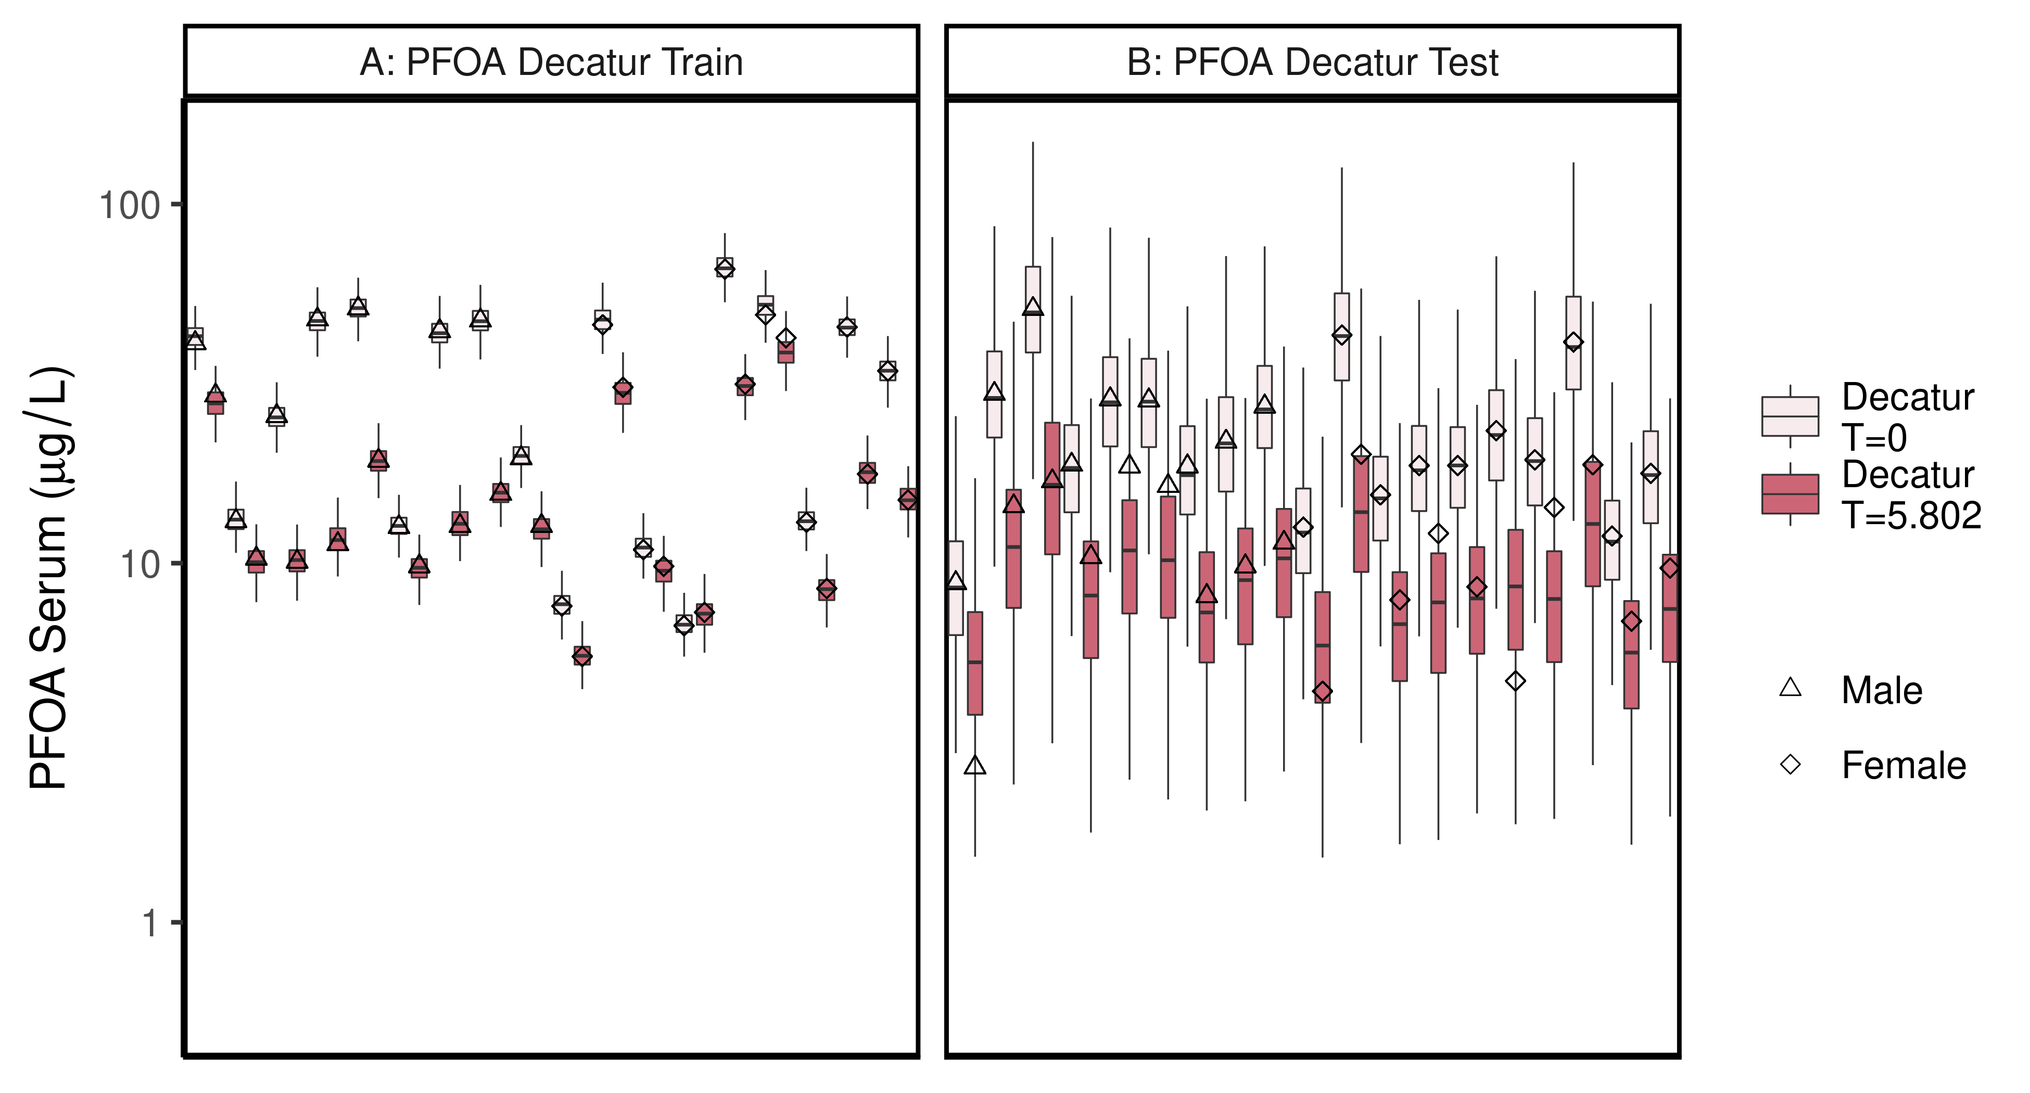

ggsave(here ("output-plots",paste0( sa,"DecaturTrainTestboxplot",pfas_name,".pdf")),plt_train,dpi=600)

## Saving 6.5 x 3.5 in image

ggsave(here ("output-plots",paste0( sa,"DecaturTrainTestboxplot",pfas_name,".png")),plt_train,dpi=600)

## Saving 6.5 x 3.5 in image

## All boxplots

Changed grey start to 1 instead of 0.8, end at 0.6 instead of 0.4. Added shapes and fills to data points.

print(pfas_name)

## [1] "PFOA"

lets <- LETTERS;  
names(lets)[1:(length(unique(df_check$dataset))-4)]<-as.character(unique(df_check$dataset))[c(3,4,7:length(unique(df_check$dataset)))]  
  
for (d in unique(df_check$dataset)) { # d = unique(df_check$dataset)[11]  
  
 ddset <- df_check %>%   
 filter(dataset == d)   
   
 aes_lut_ddset <- ddset %>% select(legend_label, City,Train_Test,datatype, Time.desc ) %>% unique () %>% inner_join(aes_lut)  
   
 gt <- ifelse(is.na(lets[d]),d,paste0(lets[d],": ", d))  
 plt <- plot_sum_boxplot(dframe = ddset, aes_lut= aes_lut_ddset, gtitle= gt, facets = FALSE, pfas_nom = pfas_name)  
   
 print(plt)  
 ggsave(here ("output-plots",  
 paste0( sa, d,"-boxplot-",   
 pfas_name,".pdf")) ,  
 plt,dpi=600)  
   
 ggsave(here ("output-plots",  
 paste0( sa, d,"-boxplot-",   
 pfas_name,".png")) ,  
 plt,dpi=600)  
  
  
}

## Joining, by = c("legend_label", "City", "Train_Test", "datatype", "Time.desc")

## Saving 6.5 x 3.5 in image  
## Saving 6.5 x 3.5 in image

## Joining, by = c("legend_label", "City", "Train_Test", "datatype", "Time.desc")

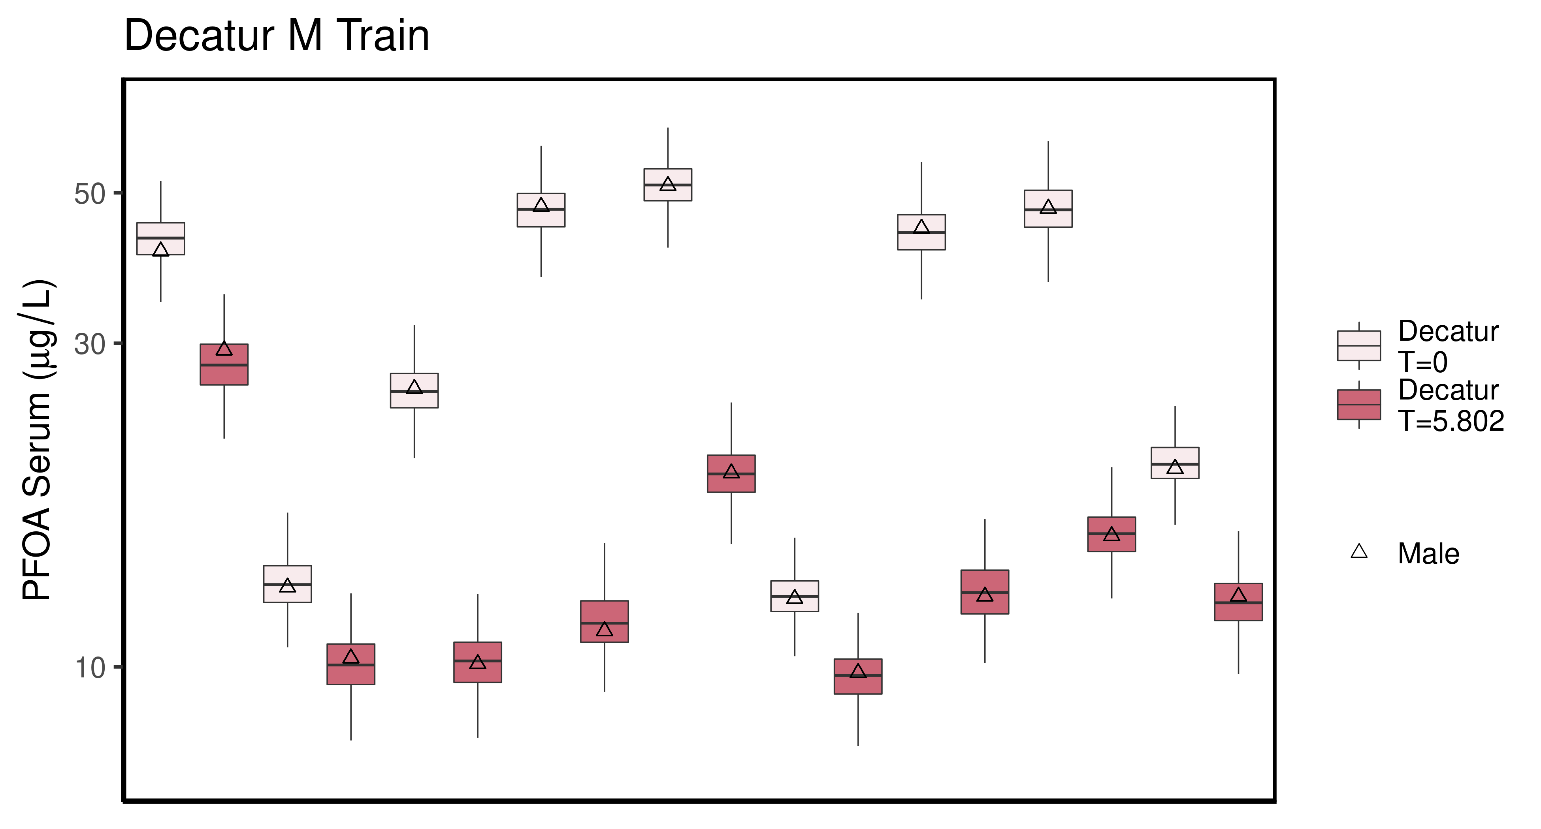

## Saving 6.5 x 3.5 in image

## Saving 6.5 x 3.5 in image

## Joining, by = c("legend_label", "City", "Train_Test", "datatype", "Time.desc")

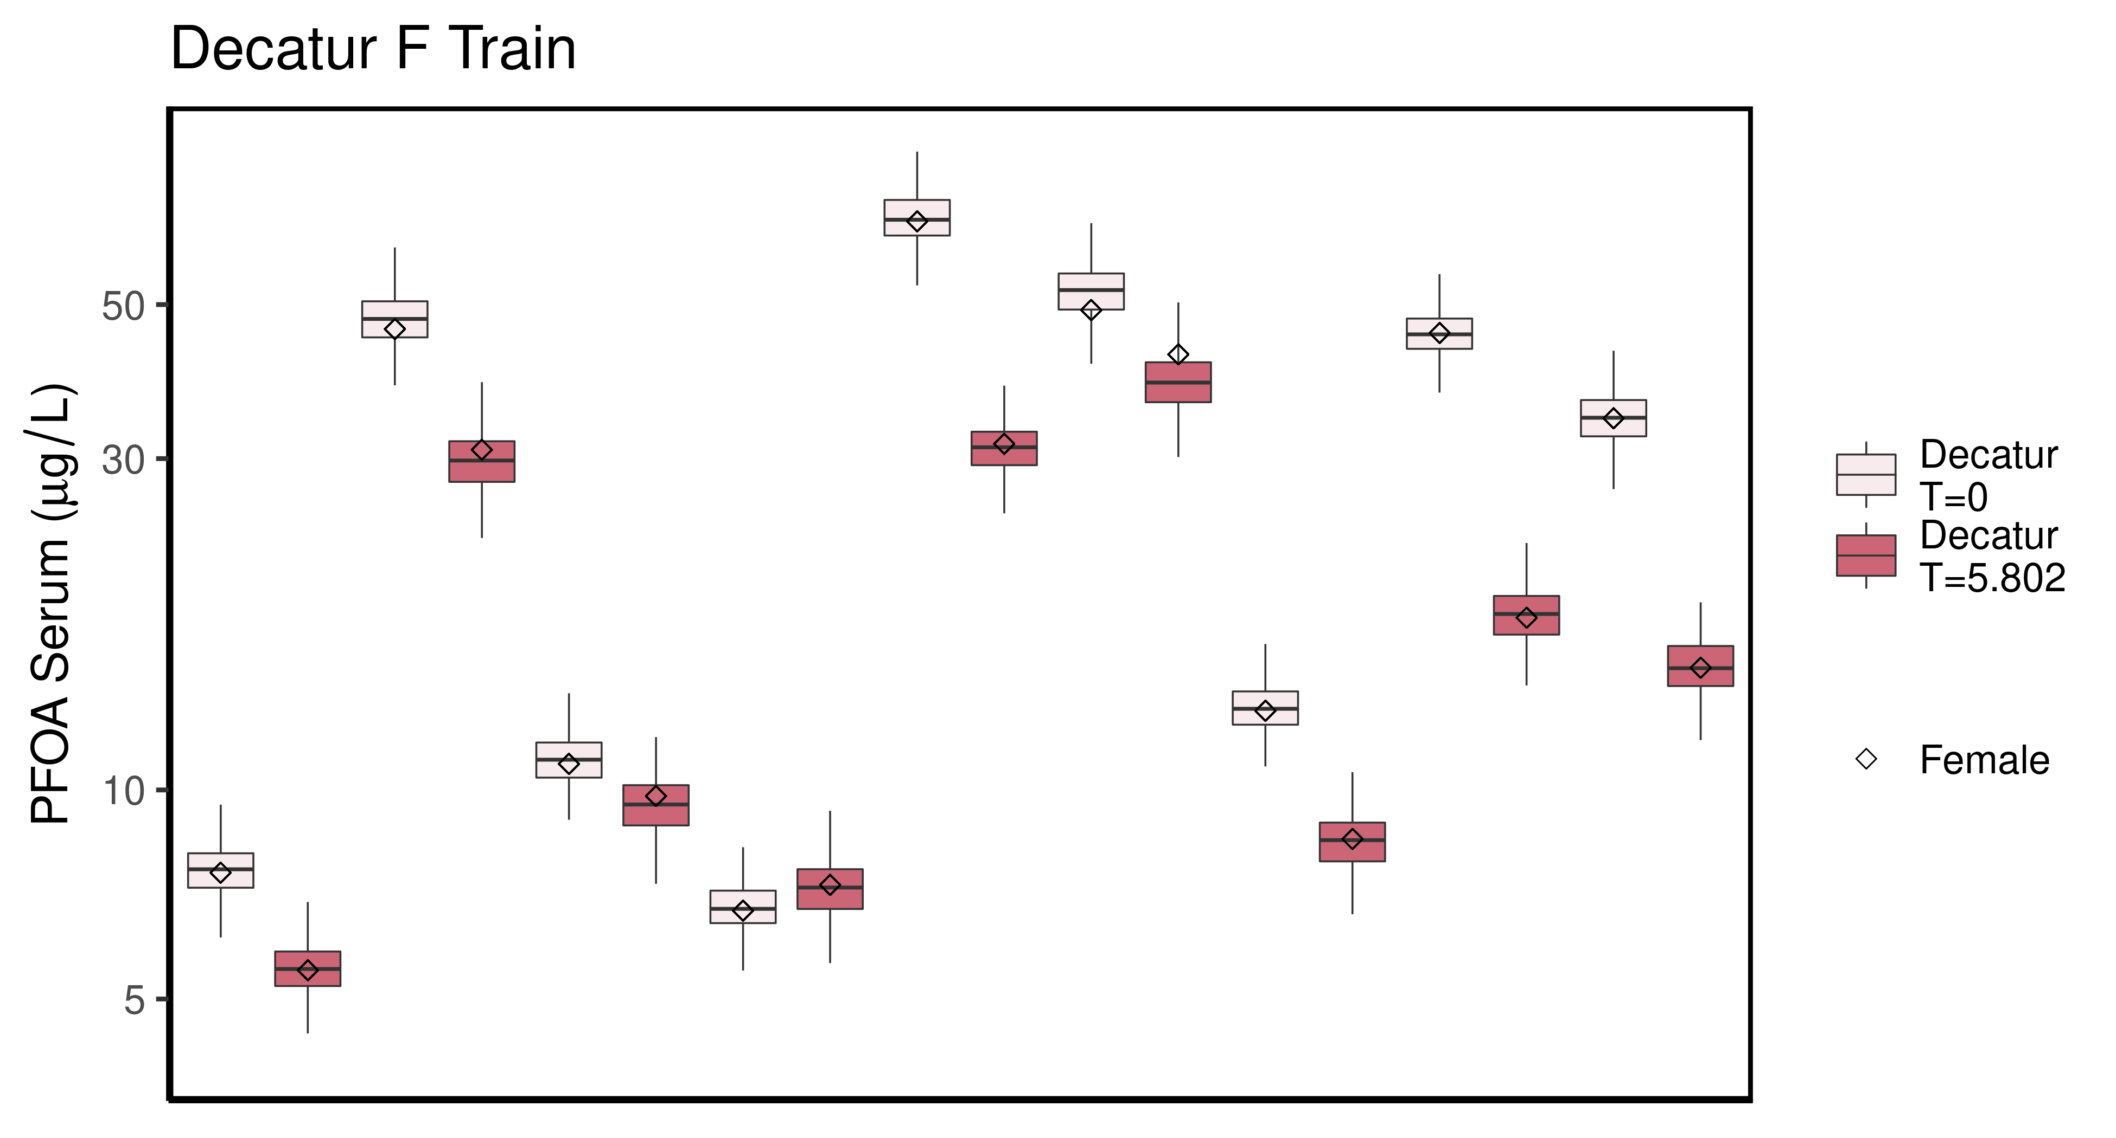

## Saving 6.5 x 3.5 in image

## Saving 6.5 x 3.5 in image

## Joining, by = c("legend_label", "City", "Train_Test", "datatype", "Time.desc")

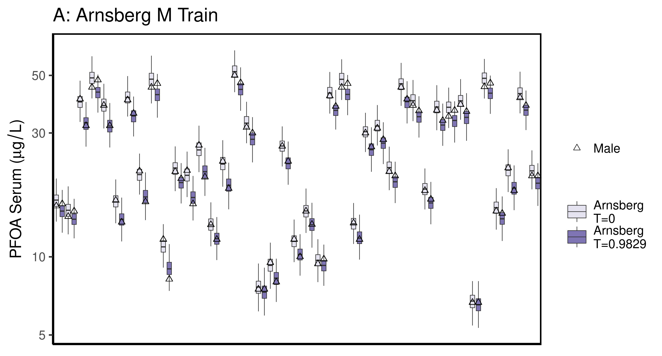

## Saving 6.5 x 3.5 in image

## Saving 6.5 x 3.5 in image

## Joining, by = c("legend_label", "City", "Train_Test", "datatype", "Time.desc")

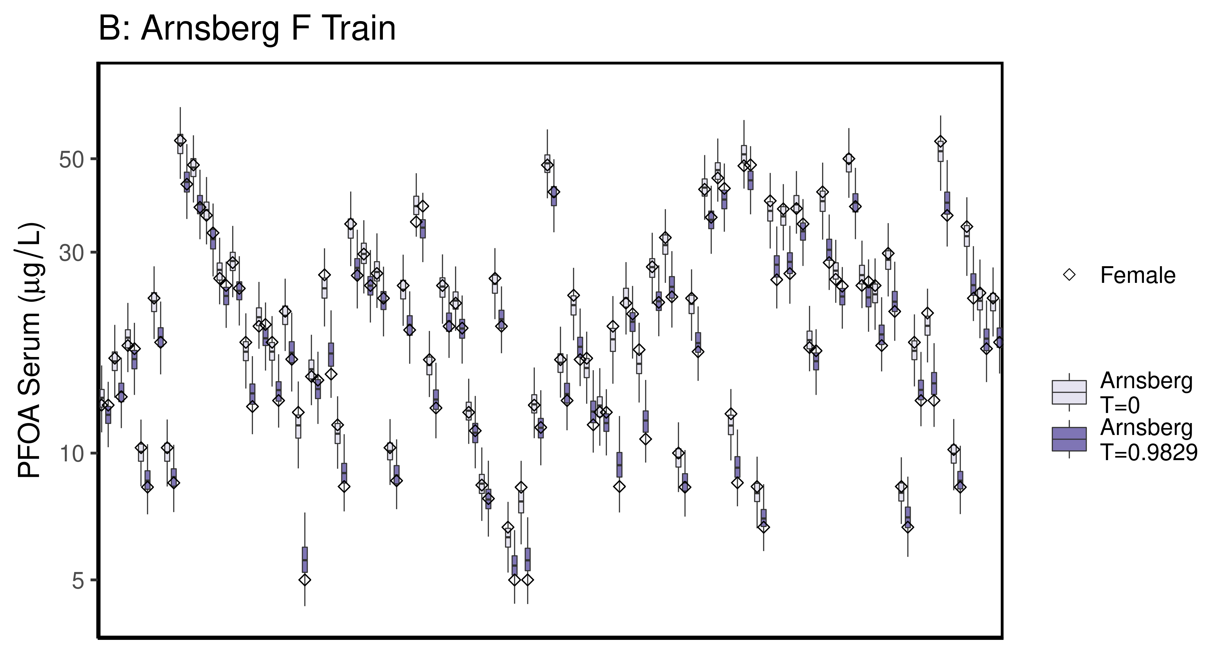

## Saving 6.5 x 3.5 in image

## Saving 6.5 x 3.5 in image

## Joining, by = c("legend_label", "City", "Train_Test", "datatype", "Time.desc")

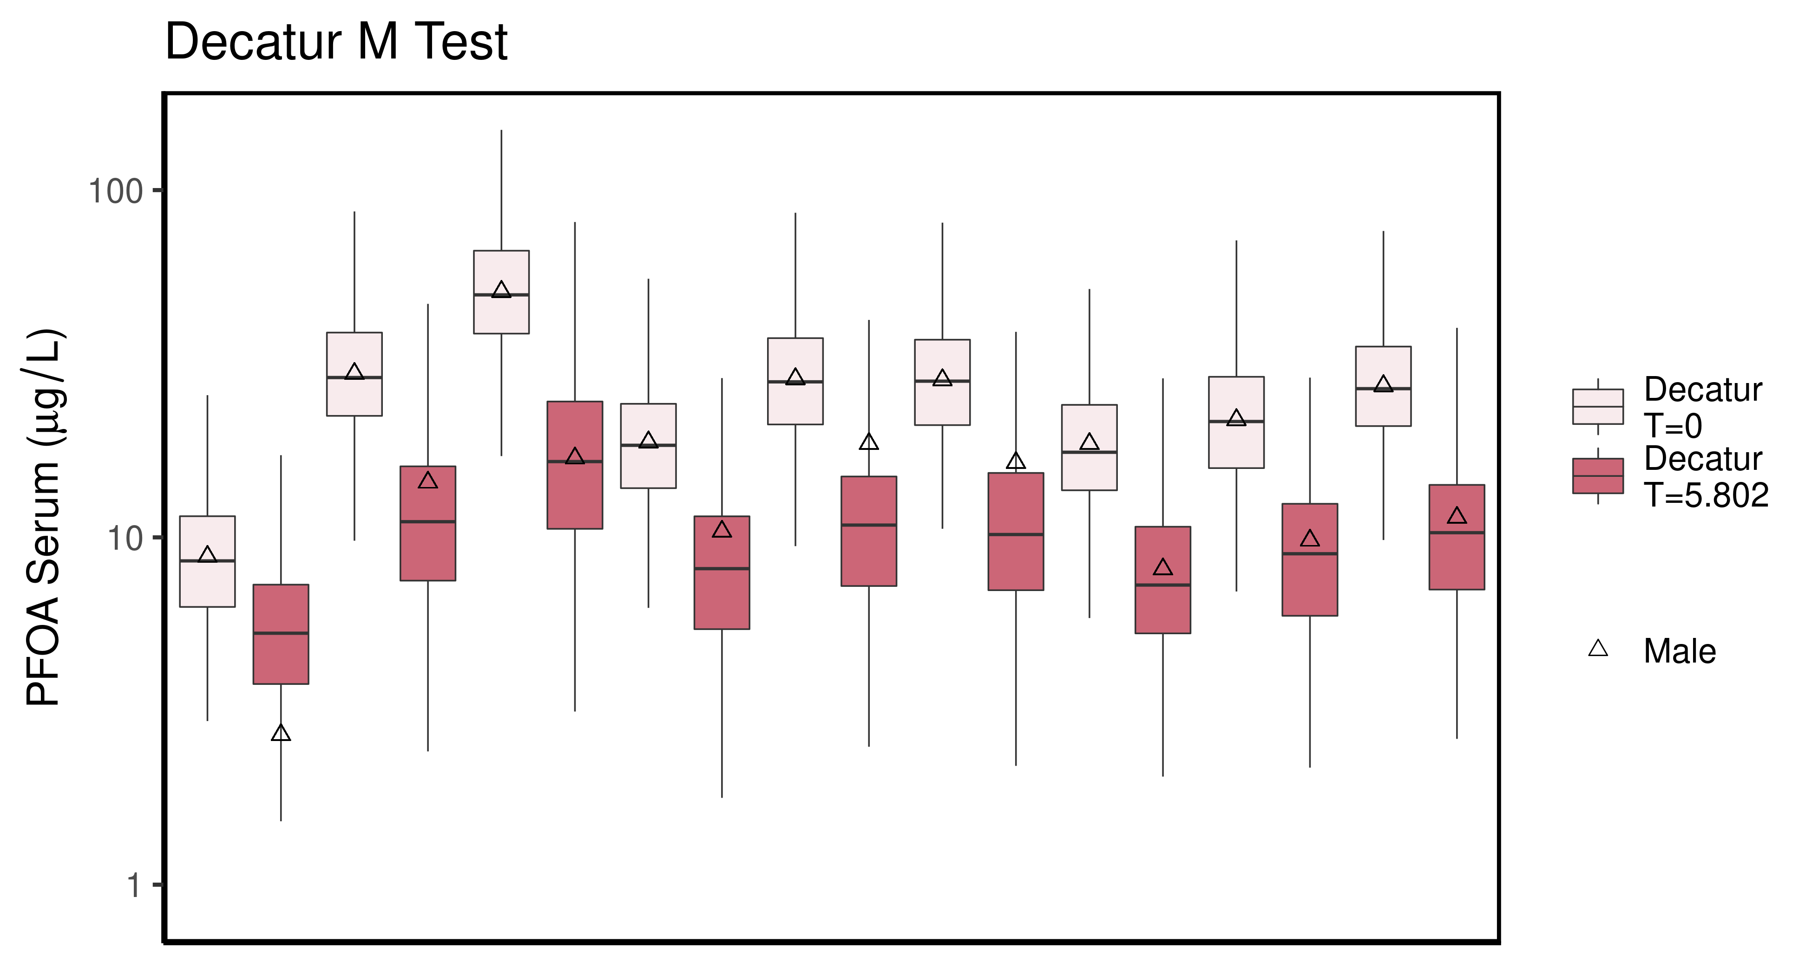

## Saving 6.5 x 3.5 in image

## Saving 6.5 x 3.5 in image

## Joining, by = c("legend_label", "City", "Train_Test", "datatype", "Time.desc")

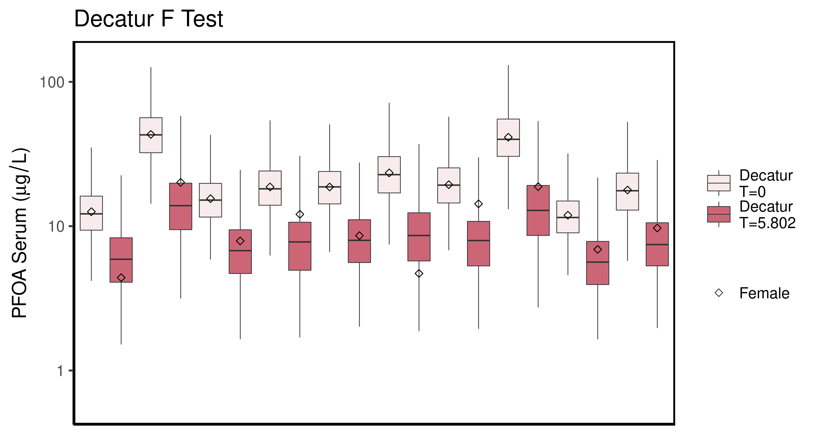

## Saving 6.5 x 3.5 in image

## Saving 6.5 x 3.5 in image

## Joining, by = c("legend_label", "City", "Train_Test", "datatype", "Time.desc")

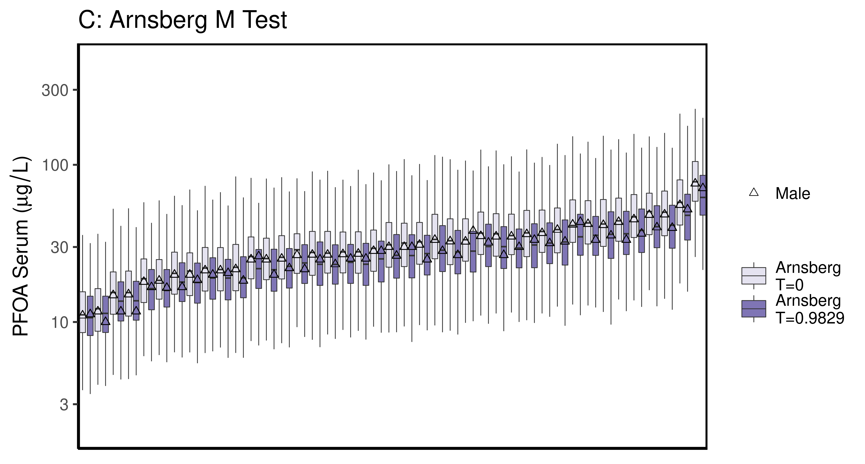

## Saving 6.5 x 3.5 in image

## Saving 6.5 x 3.5 in image

## Joining, by = c("legend_label", "City", "Train_Test", "datatype", "Time.desc")

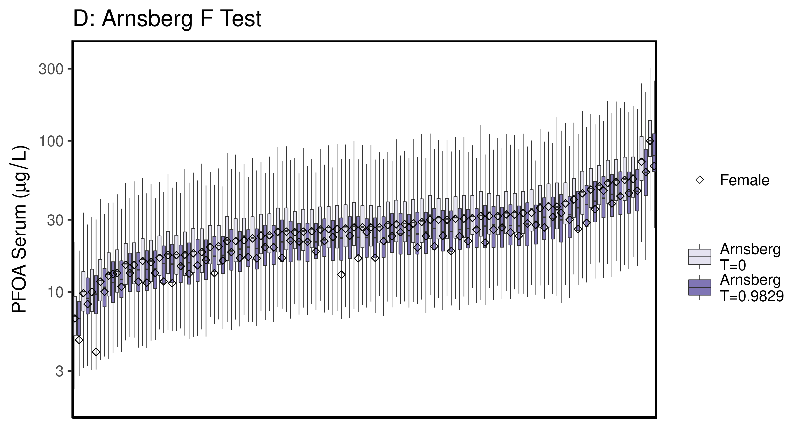

## Saving 6.5 x 3.5 in image

## Saving 6.5 x 3.5 in image

## Joining, by = c("legend_label", "City", "Train_Test", "datatype", "Time.desc")

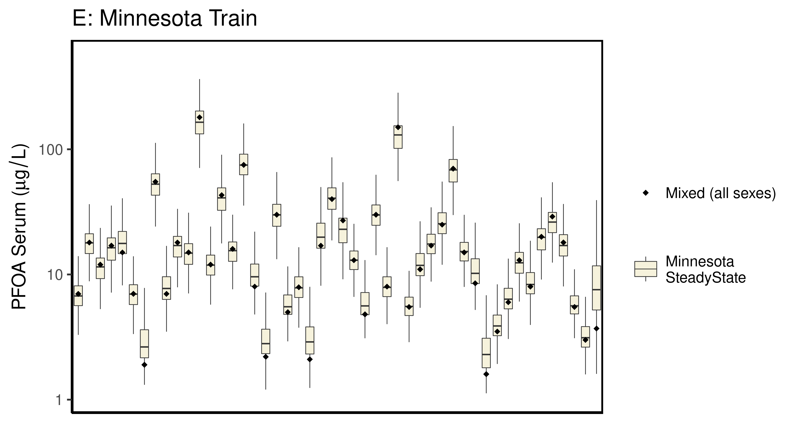

## Saving 6.5 x 3.5 in image

## Saving 6.5 x 3.5 in image

## Joining, by = c("legend_label", "City", "Train_Test", "datatype", "Time.desc")

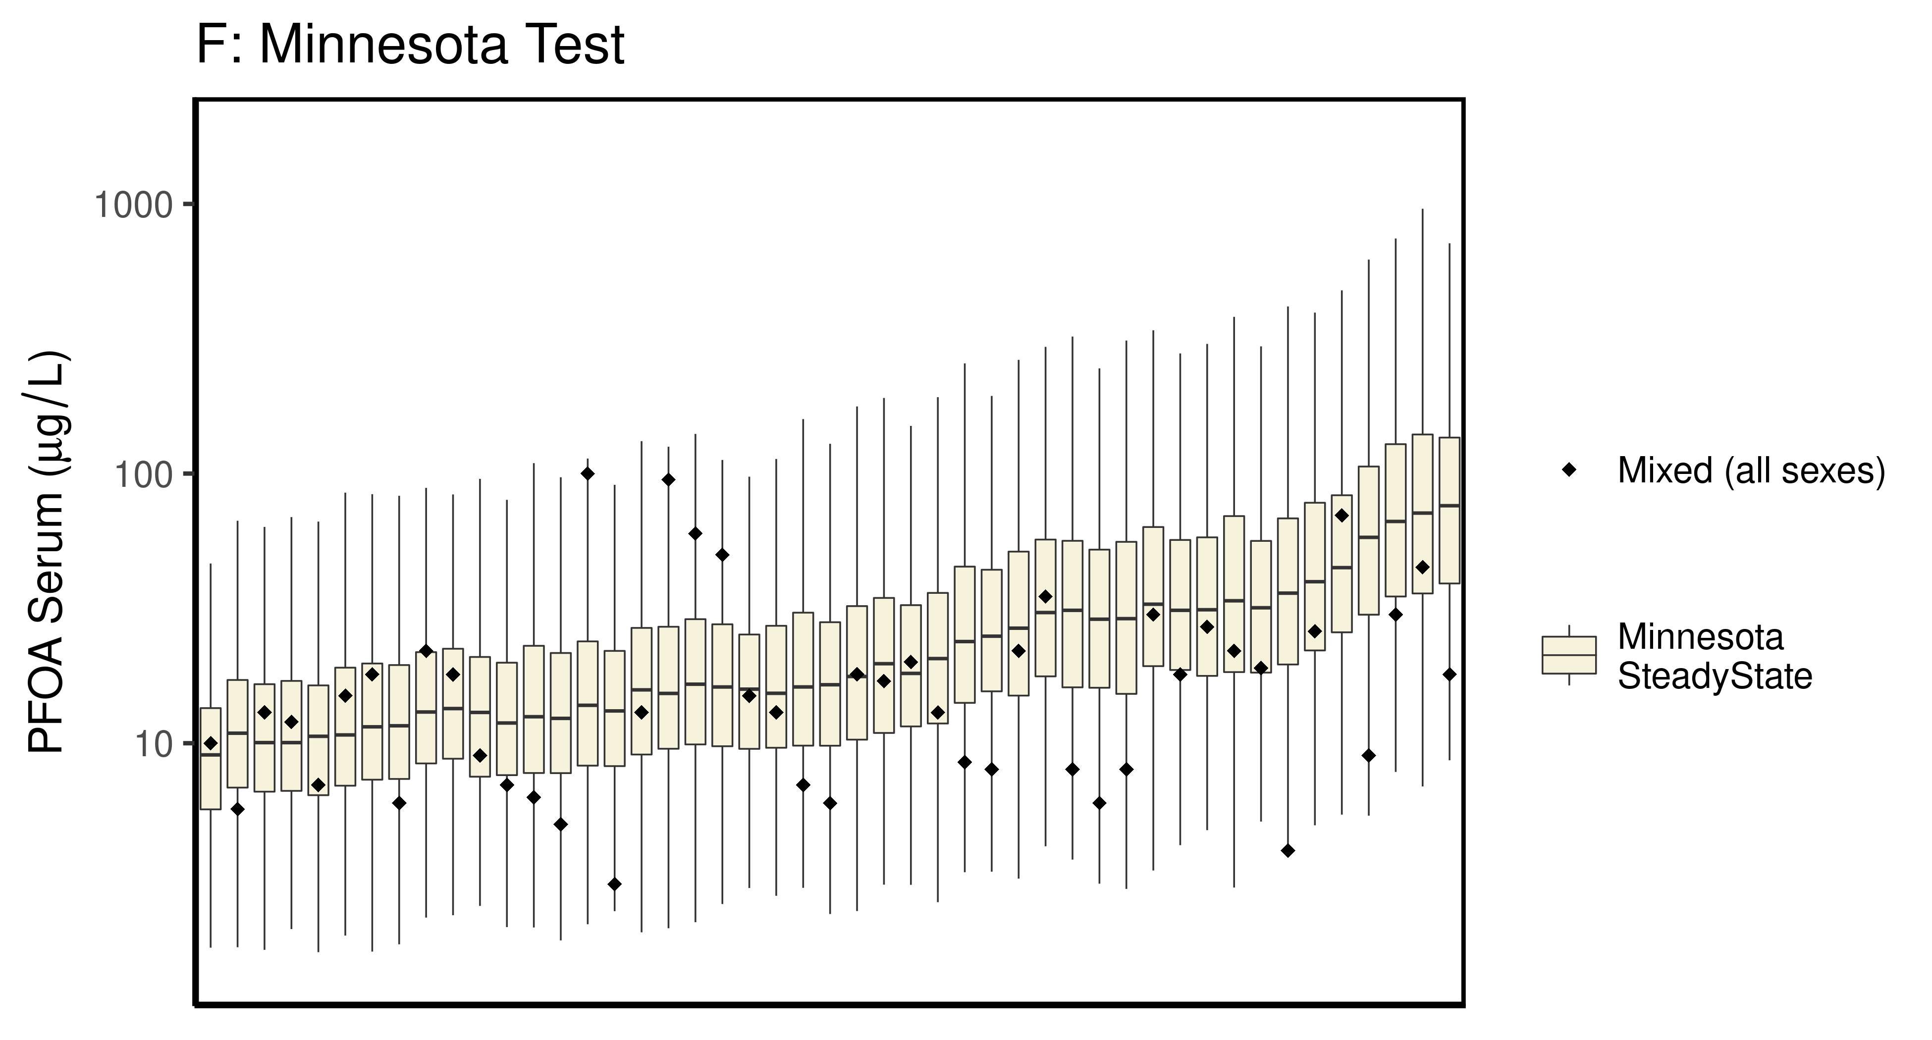

## Saving 6.5 x 3.5 in image

## Saving 6.5 x 3.5 in image

## Joining, by = c("legend_label", "City", "Train_Test", "datatype", "Time.desc")

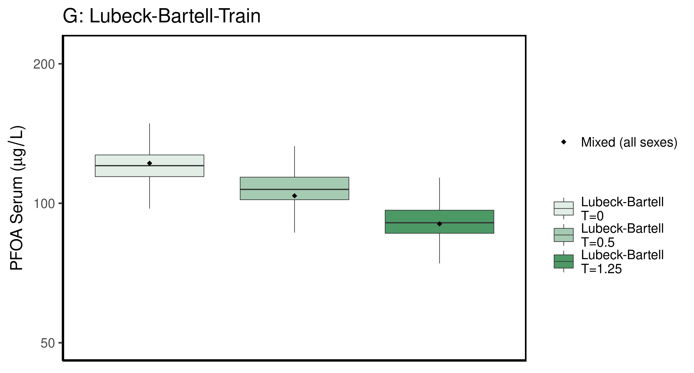

## Saving 6.5 x 3.5 in image

## Saving 6.5 x 3.5 in image

## Joining, by = c("legend_label", "City", "Train_Test", "datatype", "Time.desc")

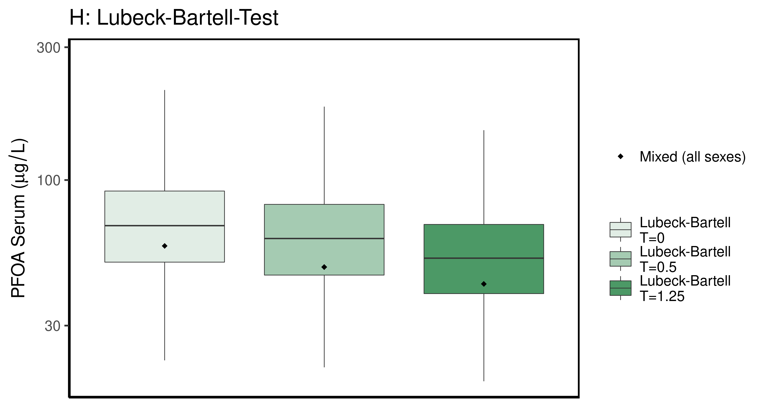

## Saving 6.5 x 3.5 in image

## Saving 6.5 x 3.5 in image

## Joining, by = c("legend_label", "City", "Train_Test", "datatype", "Time.desc")

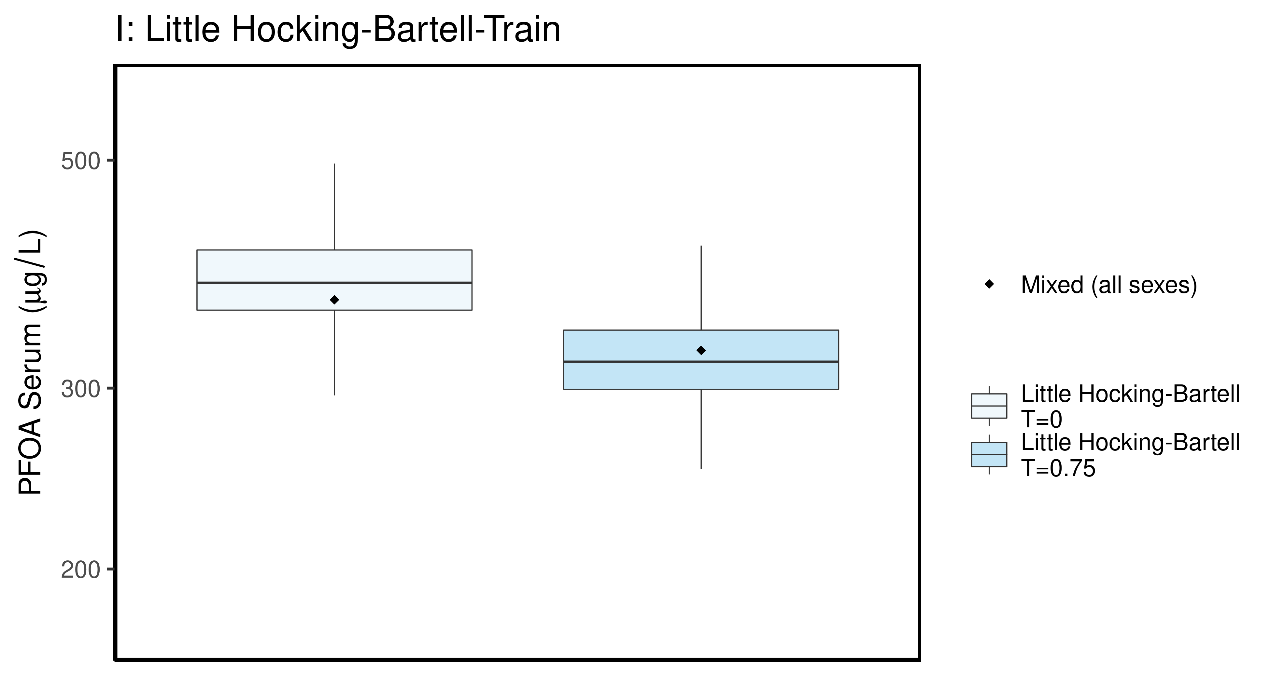

## Saving 6.5 x 3.5 in image

## Saving 6.5 x 3.5 in image

## Joining, by = c("legend_label", "City", "Train_Test", "datatype", "Time.desc")

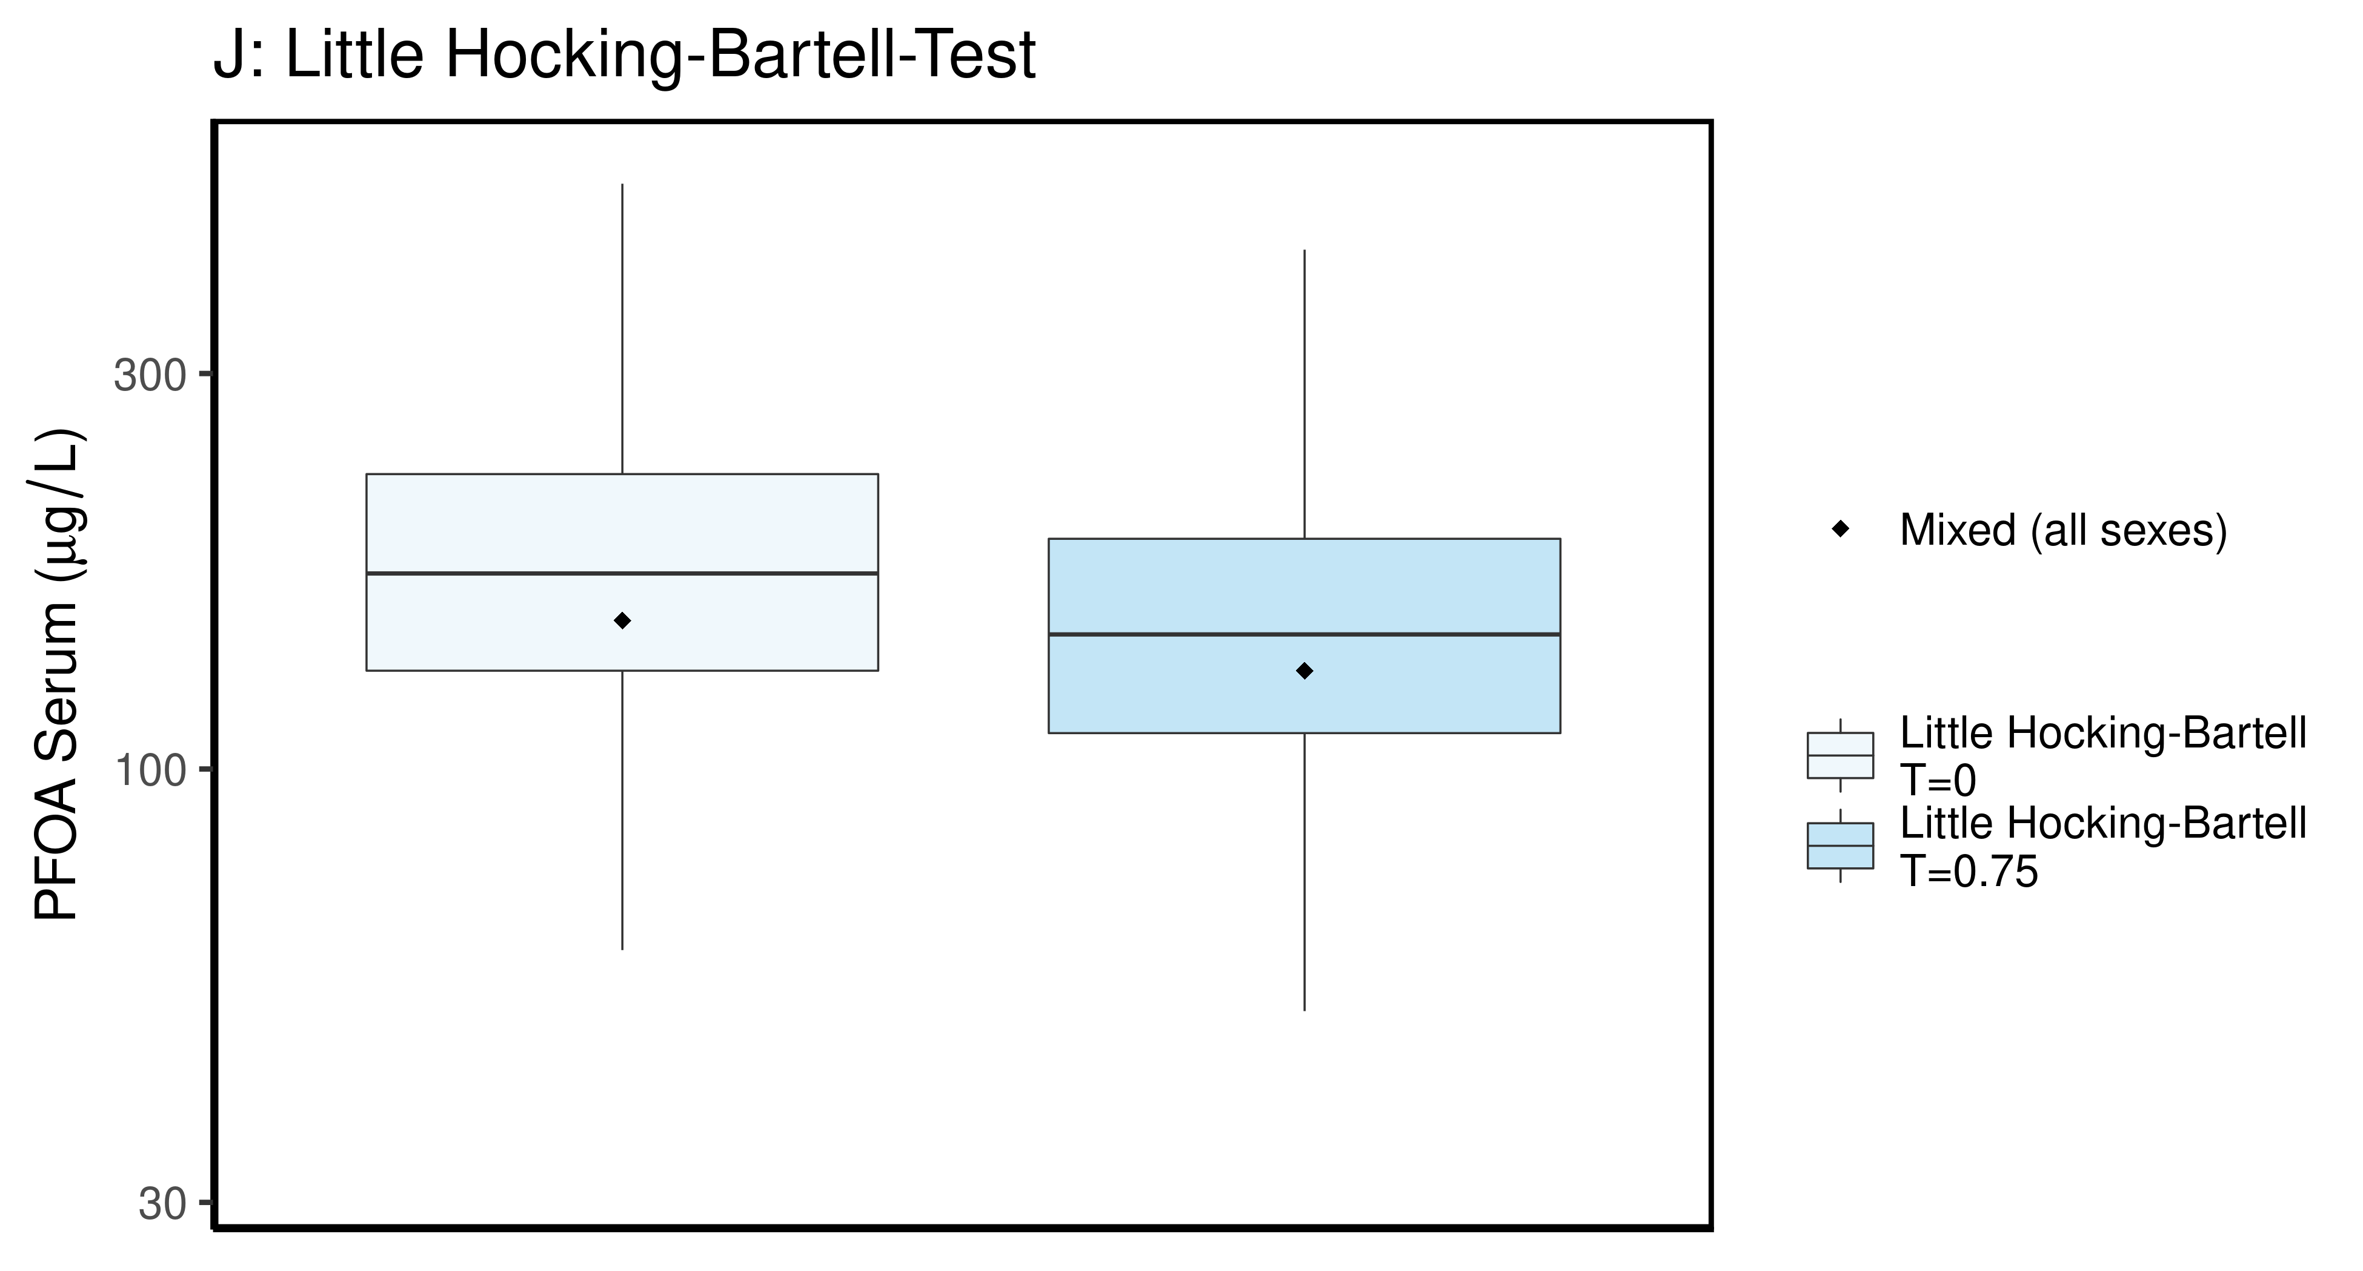

## Saving 6.5 x 3.5 in image

## Saving 6.5 x 3.5 in image

## Joining, by = c("legend_label", "City", "Train_Test", "datatype", "Time.desc")

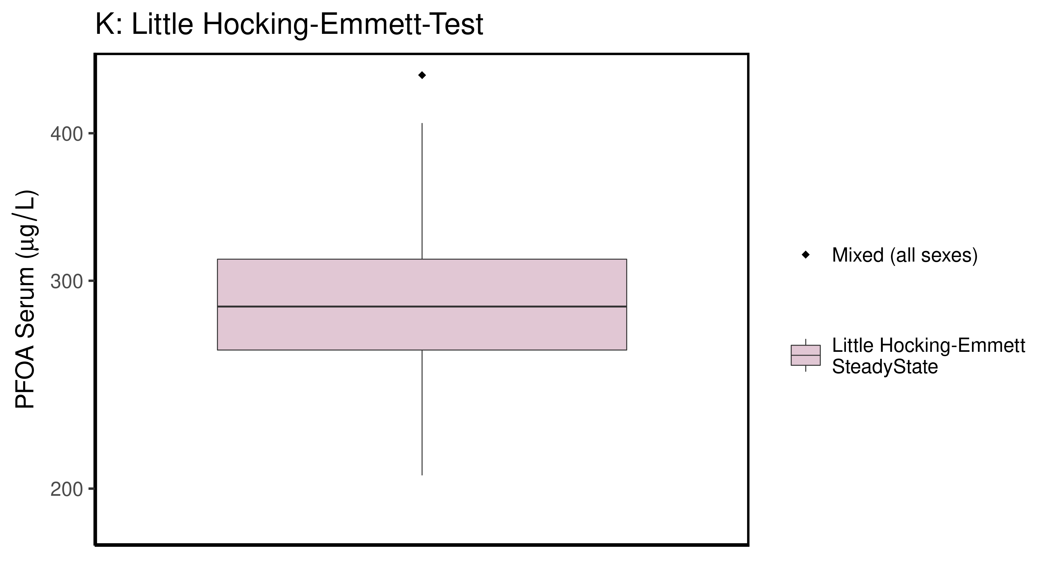

## Saving 6.5 x 3.5 in image

## Saving 6.5 x 3.5 in image

## Joining, by = c("legend_label", "City", "Train_Test", "datatype", "Time.desc")

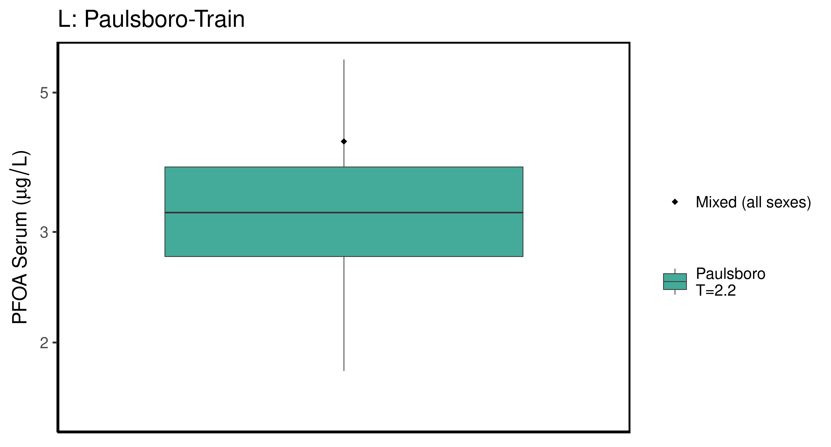

## Saving 6.5 x 3.5 in image

## Saving 6.5 x 3.5 in image

## Joining, by = c("legend_label", "City", "Train_Test", "datatype", "Time.desc")

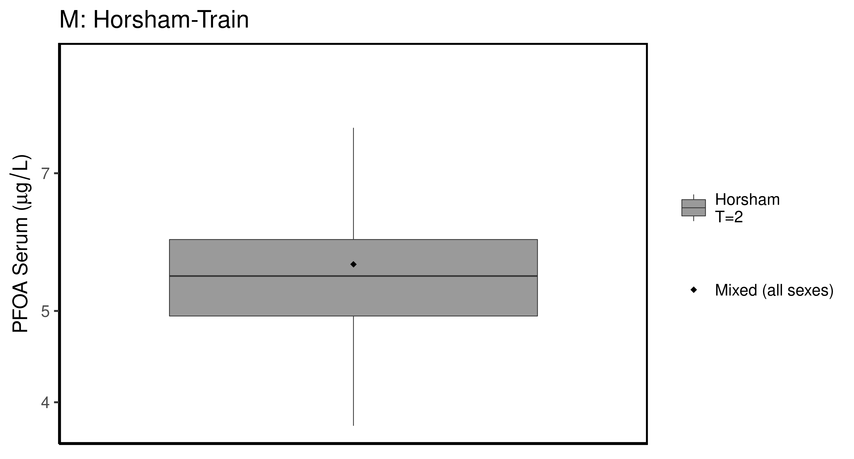

## Saving 6.5 x 3.5 in image

## Saving 6.5 x 3.5 in image

## Joining, by = c("legend_label", "City", "Train_Test", "datatype", "Time.desc")

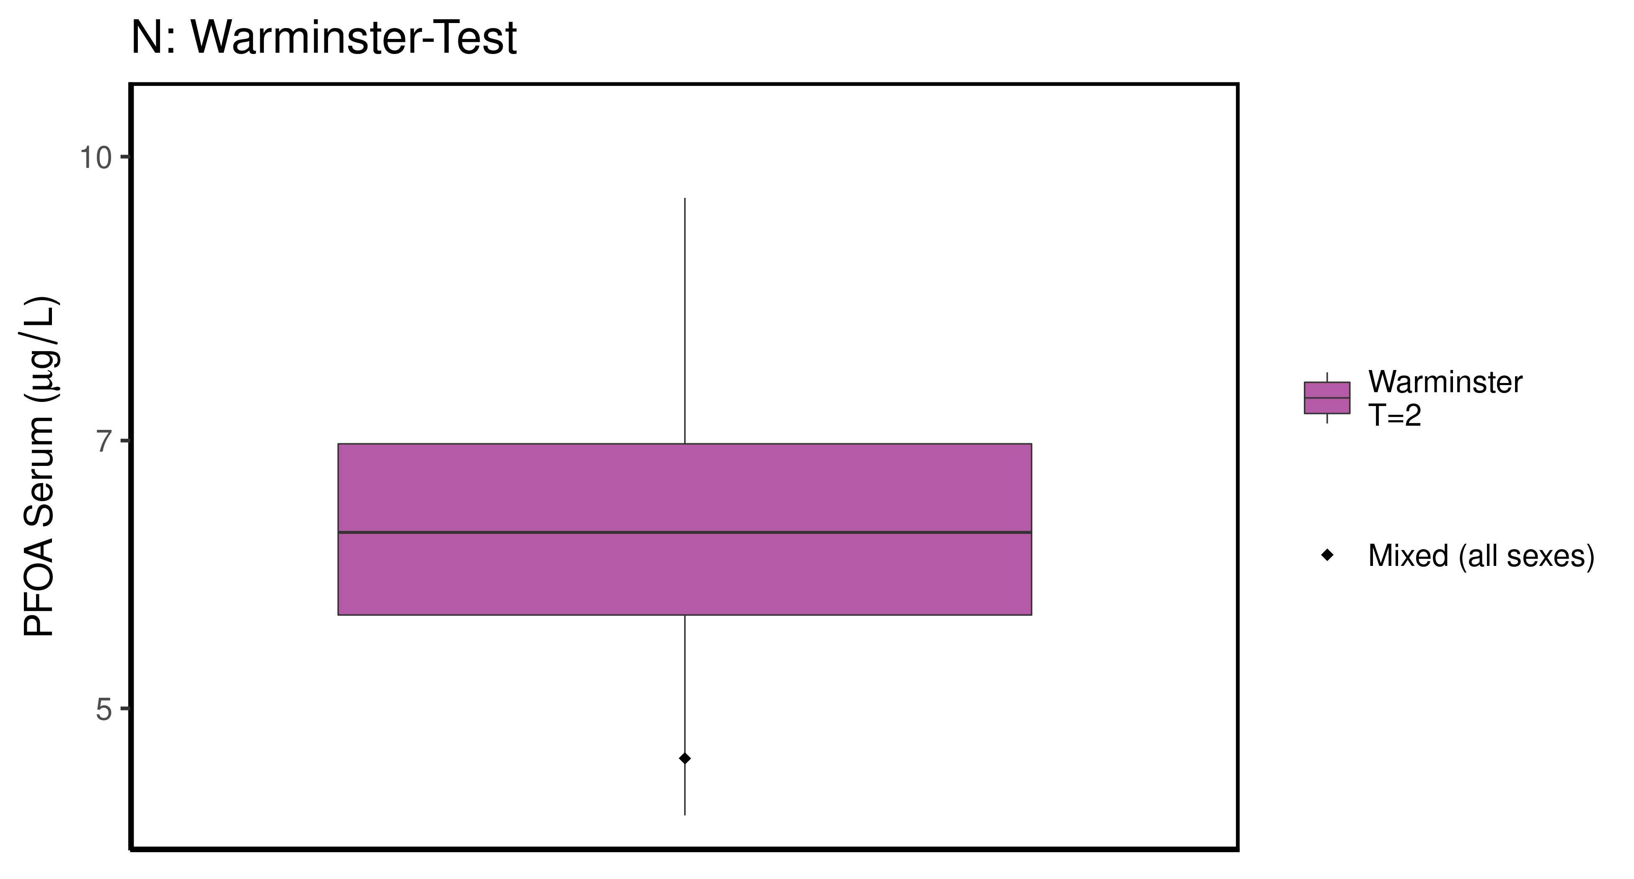

## Saving 6.5 x 3.5 in image

## Saving 6.5 x 3.5 in image

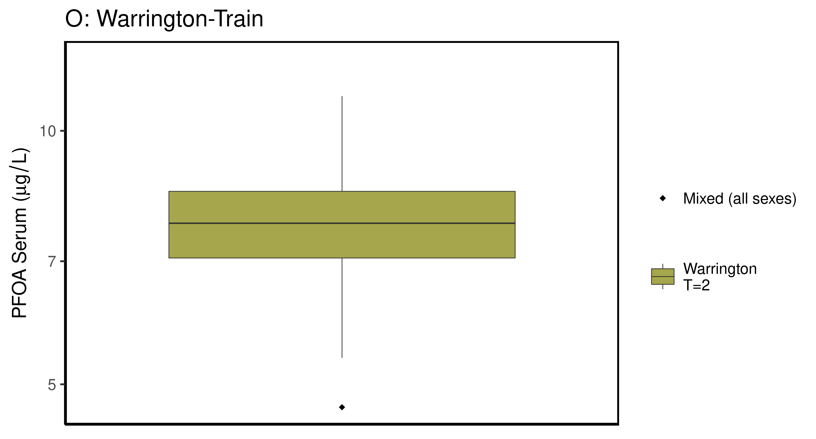

### make Training plot   
  
df_d_trt <- df_check %>%   
 filter( (Train_Test == "Train") & ((Output_Var == "M_Cbgd_Css") | (Output_Var == "M_Cserum"))) %>%  
 mutate_if(is.factor, as.character) %>% # drop factor levels unused  
 mutate(Dataset.Time = factor(Dataset.Time))   
   
  
 aes_lut_df_d_trt <- df_d_trt %>% select(City, datatype,Time, Time.desc, legend_label) %>%   
 inner_join(aes_lut ) %>%   
 select(-Train_Test) %>% ungroup () %>% unique ()

## Joining, by = c("City", "datatype", "Time", "Time.desc", "legend_label")

plt_train <- plot_sum_boxplot(dframe = df_d_trt, aes_lut= aes_lut_df_d_trt,   
 gtitle="G: Summary Data - Train" , facets = FALSE,   
 pfas_nom = pfas_name )  
 print(plt_train)

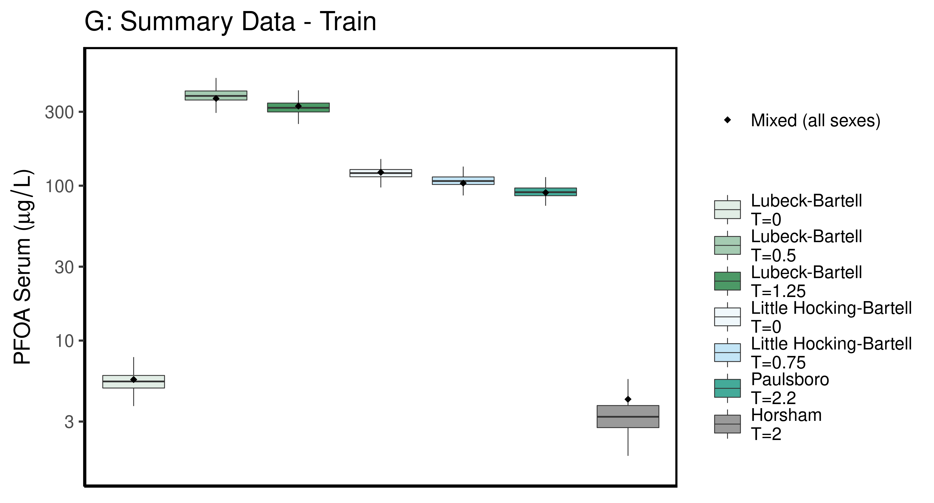

ggsave(here ("output-plots", paste0( sa, "SummaryTrainDataboxplot",pfas_name,".pdf")), plt_train,dpi=600)

## Saving 6.5 x 3.5 in image

ggsave(here ("output-plots", paste0( sa, "SummaryTrainDataboxplot",pfas_name,".png")), plt_train,dpi=600)

## Saving 6.5 x 3.5 in image

### make Test plot  
df_d_test <- df_check %>%   
 filter((Train_Test == "Test") &   
 ((Output_Var == "M_Cbgd_Css") | (Output_Var == "M_Cserum"))) %>%  
 mutate_if(is.factor, as.character) %>% # drop factor levels unused  
 mutate(Dataset.Time = factor(Dataset.Time))   
  
aes_lut_df_d_test <- df_d_test %>% select(City, datatype,Time, Time.desc, legend_label) %>%   
 inner_join(aes_lut ) %>%   
 select(-Train_Test) %>% ungroup () %>% unique ()

## Joining, by = c("City", "datatype", "Time", "Time.desc", "legend_label")

plt_test <- plot_sum_boxplot(dframe = df_d_test, aes_lut= aes_lut_df_d_test,   
 gtitle="H: Summary Data - Test", facets = FALSE,   
 pfas_nom = pfas_name)  
 print(plt_test)

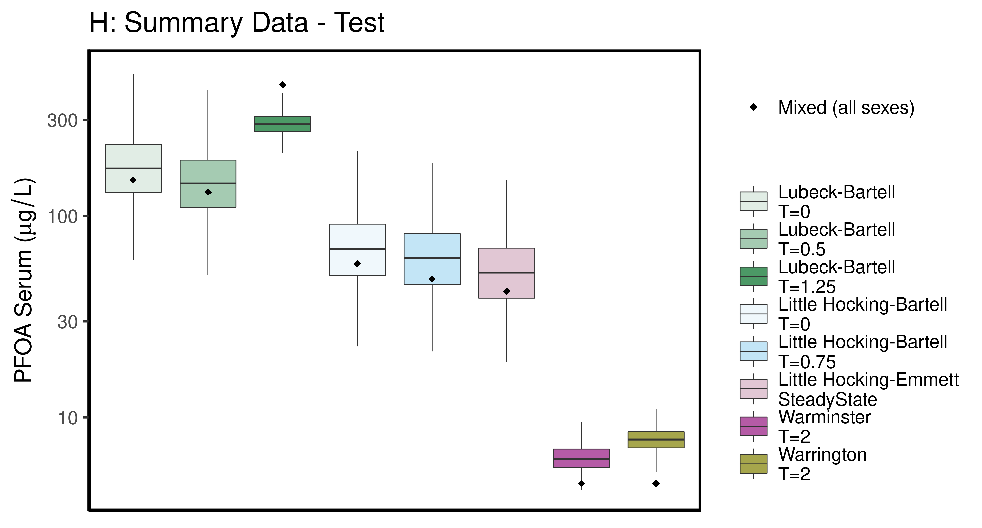

ggsave(here ("output-plots",paste0( sa, "SummaryTestDataboxplot",pfas_name,".pdf")), plt_test,dpi=600)

## Saving 6.5 x 3.5 in image

ggsave(here ("output-plots",paste0( sa, "SummaryTestDataboxplot",pfas_name,".png")), plt_test,dpi=600)

## Saving 6.5 x 3.5 in image

## PFOA

### Background posteriors

Shows shift in background estimate.

gmscale<-0.8  
  
dat <- multicheck$parms.samp[,grep("M_ln_Cbgd",names(multicheck$parms.samp))]  
datasetnames <- as.character(unique(calibdata$dataset))  
datasetnames <- gsub(" M","",datasetnames)  
datasetnames <- gsub(" F","",datasetnames)  
datasetnames<-datasetnames[!duplicated(datasetnames)]  
names(dat) <- datasetnames  
dat <- dat[,grep("Train",names(dat))]  
dat.df <- pivot_longer(dat,1:ncol(dat))  
dat.df <- rbind(dat.df,  
 data.frame(name="Prior",value=rnorm(5000,m=log(gmscale),sd=0.4055)))  
dat.df$name <- factor(dat.df$name,levels=rev(  
 c("Prior",datasetnames[grep("Train",datasetnames)])))  
dat.df$value <- exp(dat.df$value)  
  
p<-ggplot(dat.df)+  
 #geom_violin(aes(x=name,y=value,fill=name=="Prior"))+  
 geom_boxplot(aes(x=name,y=value,fill=name=="Prior"),outlier.shape=NA)+  
 scale_y_log10()+coord_flip()+  
 scale_fill_manual(name="Prior",   
 values=c("#009988", "#EE7733" )) +  
 theme_classic() +   
 geom_hline(yintercept = gmscale,color="grey")+  
 theme(legend.position="none",  
 panel.background = element_rect(color="black",size=1))+  
 ylab("Posterior shift in Background Concentration")  
  
print(p)

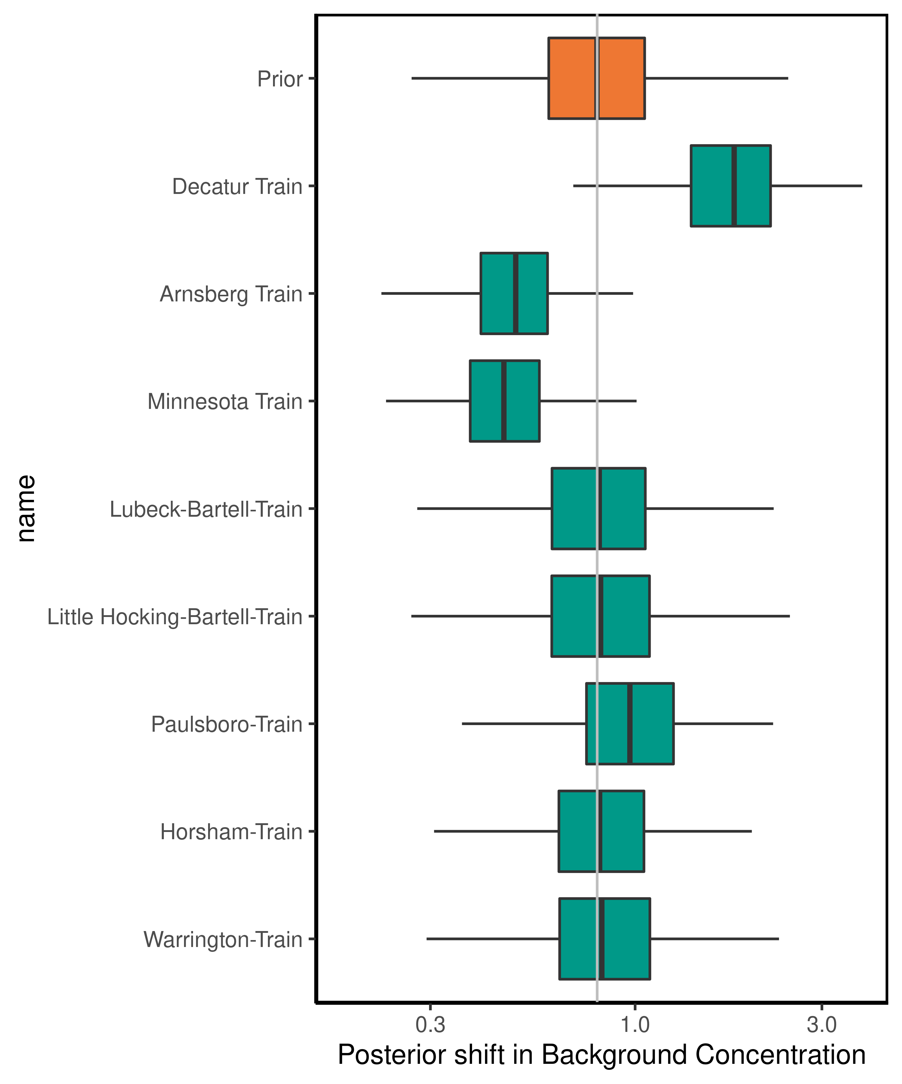

ggsave(here ("output-plots",paste0( sa, "PFOA_GM_Cbgd.pdf")), p,dpi=600)

## Saving 5 x 6 in image

ggsave(here ("output-plots",paste0( sa, "PFOA_GM_Cbgd.png")), p,dpi=600)

## Saving 5 x 6 in image

### Half-life

dat <- multicheck$parms.samp[,c("M_ln_k.1.","V_ln_k.1.", "M_ln_Vd.1.", "SD_ln_Vd.1.")]  
names(dat) <- c("M_ln_k(1)","V_ln_k(1)", "M_ln_Vd(1)", "SD_ln_Vd(1)")  
  
set.seed(3.14159)  
dat$z_ln_k <- rnorm(nrow(dat))  
dat$z_ln_Vd <- rnorm(nrow(dat))  
dat %>% rename_()

## Warning: `rename_()` was deprecated in dplyr 0.7.0.  
## Please use `rename()` instead.

## M_ln_k(1) V_ln_k(1) M_ln_Vd(1) SD_ln_Vd(1) z_ln_k z_ln_Vd  
## 12503 -1.47166 0.2259770 -1.027430 0.11872900 -0.961933416 -2.139841913  
## 15901 -1.57172 0.1917550 -0.981910 0.12890300 -0.292525723 -1.263479244  
## 17543 -1.44315 0.2218600 -0.846605 0.05661850 0.258788216 0.083307969  
## 18721 -1.63377 0.2671930 -0.803807 0.00251033 -1.152131886 0.188325130  
## 11662 -1.63952 0.2442100 -0.641437 0.19616300 0.195782826 0.189814193  
## 13403 -1.50146 0.1316760 -0.912848 0.04207130 0.030123945 0.217615352  
## 13192 -1.52804 0.2576120 -0.836255 0.00522934 0.085417732 -0.648814142  
## 15663 -1.62322 0.2206230 -0.833671 0.12510900 1.116610213 0.254774383  
## 1246 -1.46340 0.1607610 -0.864602 0.11869500 -1.218857416 -0.468830015  
## 16132 -1.35944 0.1421860 -1.046470 0.05301980 1.267368722 -1.192510054  
## 10602 -1.31808 0.1962300 -1.020060 0.07258270 -0.744781596 0.121228235  
## 10563 -1.57564 0.2097090 -0.575507 0.08585640 -1.131218571 -1.035932658  
## 15932 -1.63592 0.2893040 -0.441297 0.46389700 -0.716358490 -0.191888295  
## 1114 -1.50220 0.1654030 -0.812117 0.12570300 0.252652370 -0.970546336  
## 1699 -1.61622 0.1952380 -0.655576 0.06439360 0.152045707 0.057771938  
## 1141 -1.44708 0.0791159 -0.824623 0.03169700 -0.307656430 -2.110692675  
## 13383 -1.53241 0.1373040 -0.898336 0.06439640 -0.953017331 0.978176274  
## 12832 -1.58927 0.2061870 -0.757849 0.09033650 -0.648242811 0.371021737  
## 19552 -1.65200 0.1755320 -0.922508 0.35681400 1.224313624 0.720910931  
## 14423 -1.56912 0.2473010 -0.613524 0.27567500 0.199811608 1.879594880  
## 12372 -1.58129 0.2054630 -0.863814 0.01532240 -0.578483722 -0.396316112  
## 12042 -1.44236 0.2313180 -0.930943 0.08416760 -0.942300733 0.110322947  
## 10473 -1.56596 0.2387790 -0.504892 0.05603230 -0.203728180 -0.593140881  
## 1509 -1.63181 0.2301430 -0.703216 0.00560974 -1.666474840 0.419621770  
## 1552 -1.60037 0.2947500 -0.756522 0.00787158 -0.484455109 -0.545738743  
## 19513 -1.60375 0.2381920 -0.640758 0.10491500 -0.741072661 1.160921499  
## 17471 -1.43266 0.1720730 -0.896787 0.09401620 1.160615779 0.639817834  
## 18092 -1.51021 0.2343130 -0.663190 0.09107450 1.012067125 -0.122020443  
## 1613 -1.42880 0.1599680 -1.366620 0.17959100 -0.072078474 0.184645026  
## 14383 -1.50389 0.3123290 -0.591951 0.14044200 -1.136782298 -0.517806023  
## 14263 -1.48924 0.2104700 -0.621222 0.18017100 0.900624729 0.067988352  
## 18291 -1.63622 0.2309160 -0.890736 0.07126660 0.851770447 -0.184797156  
## 1945 -1.52990 0.3078630 -1.009580 0.08054770 0.727715174 -1.403691615  
## 19613 -1.43231 0.2006660 -0.824693 0.34993200 0.736502146 0.229740706  
## 1842 -1.57472 0.2309900 -0.884116 0.02773450 -0.352129617 -0.889081301  
## 1873 -1.52882 0.1832970 -0.846448 0.09996610 0.705515513 -0.160401177  
## 19423 -1.50740 0.1751370 -0.797601 0.07921920 1.300357989 -0.242136794  
## 19352 -1.51582 0.1875540 -1.128120 0.31836300 0.038252014 -0.028837196  
## 11812 -1.45436 0.1943910 -0.839713 0.17480700 -0.979283770 -0.316215474  
## 14982 -1.54901 0.1428640 -0.848721 0.30714300 0.793761231 -0.416160087  
## 11263 -1.56783 0.2199070 -0.710211 0.41491600 0.786506872 -1.023895957  
## 1028 -1.54302 0.2678610 -0.871150 0.19559700 -0.310463131 1.099495275  
## 1051 -1.46362 0.1975220 -0.995615 0.01698190 1.698884846 0.817712470  
## 17222 -1.62549 0.1728590 -0.610798 0.04805740 -0.794593709 0.168875510  
## 1747 -1.42129 0.1846450 -1.079430 0.10572600 0.348437716 0.038665440  
## 1284 -1.48424 0.2049750 -0.804076 0.04367570 -2.265401074 1.078174892  
## 1564 -1.58495 0.2873960 -0.915255 0.01014360 -0.162205279 0.379427297  
## 18632 -1.54907 0.1614390 -1.054610 0.00165336 1.130864991 -1.078174559  
## 19142 -1.46579 0.2090540 -0.941316 0.07023310 -0.455545976 0.188763468  
## 15793 -1.46362 0.1833740 -0.925623 0.22671500 -0.899166316 1.583133508  
## 1126 -1.47780 0.1995500 -0.867935 0.28911700 0.726838902 -0.250112295  
## 16502 -1.62102 0.1606710 -0.868282 0.25076100 -0.809440902 0.342994219  
## 15103 -1.57576 0.2397400 -0.900027 0.00821699 0.267085116 -0.124701883  
## 11251 -1.49379 0.2818330 -0.843613 0.16180800 -1.737263711 -0.993314763  
## 11732 -1.50231 0.2169980 -0.987321 0.05741900 -1.411425136 -1.021439085  
## 18382 -1.51482 0.2751650 -1.030920 0.25169800 -0.453551227 0.840642928  
## 13433 -1.42797 0.1483210 -0.919814 0.05892850 -1.035491275 0.849573118  
## 16403 -1.49892 0.1997390 -0.983599 0.13235400 1.362142893 0.469618942  
## 11871 -1.50834 0.2055990 -0.802875 0.08667930 0.917456737 -1.269655261  
## 1988 -1.48315 0.1924390 -0.785314 0.08054900 -0.785142161 -1.105120219  
## 1589 -1.51279 0.1841260 -0.923346 0.12130700 0.573518173 -1.897945965  
## 1449 -1.64977 0.2798170 -0.578292 0.16774900 0.918196208 0.491787265  
## 1232 -1.36807 0.3417130 -0.653308 0.19652100 0.256287273 -0.704722317  
## 10171 -1.47809 0.2403040 -0.793030 0.03993560 0.351966556 1.777576130  
## 1259 -1.49576 0.2375770 -0.649087 0.27527200 1.174337357 -0.245389029  
## 18503 -1.47120 0.2198610 -0.999776 0.34880200 -0.480846375 -2.111252318  
## 10801 -1.51003 0.2110390 -0.996705 0.15454600 -0.418829722 -0.585314536  
## 15263 -1.48332 0.1814320 -0.904369 0.40902900 0.955112803 -0.517903726  
## 1042 -1.49419 0.2424220 -0.828952 0.03377570 -1.289006611 0.513919145  
## 18363 -1.51216 0.2052980 -1.039480 0.11045500 0.186197433 -0.626426919  
## 19072 -1.35224 0.2485190 -0.922599 0.03118750 -0.031325502 0.192142595  
## 16632 -1.48603 0.2605770 -0.817629 0.01564830 0.467097310 -1.427277992  
## 1401 -1.54181 0.1358830 -1.034610 0.13711600 1.024197674 0.400991028  
## 14691 -1.43545 0.2440150 -0.910474 0.19227400 0.267358452 1.161564956  
## 17041 -1.48588 0.1928010 -0.966202 0.13837200 0.231826103 0.326346805  
## 19822 -1.61330 0.2439050 -0.588351 0.13230200 0.747592465 -1.014982273  
## 13613 -1.50885 0.2392160 -0.633701 0.24521900 1.217068511 0.101258362  
## 11013 -1.69096 0.2199700 -0.534025 0.01900890 0.383358345 0.991893279  
## 15791 -1.51648 0.1436290 -0.746068 0.09673090 -0.988052822 1.102650759  
## 16531 -1.56947 0.2702700 -0.662266 0.13761300 -0.156852910 0.280375017  
## 1970 -1.40317 0.2466890 -0.987173 0.17438100 1.735535216 -0.406177410  
## 16331 -1.35646 0.2602780 -1.288260 0.43768200 -0.352298306 1.286412690  
## 1242 -1.43832 0.1496560 -0.741701 0.03900760 0.688640044 -0.254030579  
## 15251 -1.52149 0.2075030 -0.881694 0.17508700 1.224406096 -1.144448704  
## 1653 -1.61168 0.1758520 -0.715660 0.08015940 0.794296303 0.266410910  
## 1140 -1.41430 0.1002270 -1.062620 0.17328800 -0.006402398 0.636855748  
## 17771 -1.55676 0.2255080 -0.744089 0.03847910 0.219150635 -1.402115093  
## 18012 -1.38234 0.2666460 -0.838148 0.01181150 -0.886463751 -1.511824827  
## 14062 -1.56862 0.2140640 -0.794915 0.04280680 0.439760291 -0.301192859  
## 1964 -1.30205 0.1852410 -1.111200 0.05588090 -0.886389751 0.491361149  
## 18413 -1.51758 0.1867480 -1.070000 0.14309100 -0.853818454 -0.898156496  
## 13791 -1.47473 0.1167100 -0.950589 0.34175100 -0.989994331 -1.575054814  
## 15832 -1.54427 0.2221950 -0.699935 0.41951700 -0.650877737 -0.503256667  
## 1060 -1.62196 0.2277440 -0.700480 0.14347000 1.053946660 -0.622908441  
## 12073 -1.52741 0.2097110 -0.940174 0.07511050 -0.390878033 -0.684829990  
## 15683 -1.55605 0.2399200 -0.884377 0.09924330 -0.070586394 -0.221516764  
## 1693 -1.44825 0.2611600 -0.998148 0.22416200 -0.462050809 0.388050833  
## 17531 -1.62703 0.1579760 -0.431300 0.02123260 0.540908267 -0.806316456  
## 10311 -1.40523 0.1564300 -1.137370 0.22822500 0.931634971 -0.547213054  
## 18041 -1.45637 0.1471540 -1.050410 0.18772200 -0.209274345 1.213494144  
## 19672 -1.47472 0.1184670 -0.918969 0.32436100 0.617350048 -0.417013230  
## 18351 -1.44541 0.1648200 -0.833319 0.12605100 -0.405077513 0.164593185  
## 13741 -1.49438 0.1397200 -0.858856 0.01891560 1.053103763 -1.569627007  
## 11892 -1.52589 0.1254210 -0.841719 0.26003500 0.602284246 1.466675890  
## 18762 -1.41077 0.1747840 -0.938952 0.05807670 1.017461177 -1.496085449  
## 1808 -1.56318 0.1873870 -0.606047 0.12204600 0.608167318 -1.150289019  
## 15861 -1.58406 0.2683330 -0.911643 0.13762500 0.206735995 -2.023009144  
## 12312 -1.45007 0.1416170 -0.871745 0.20459000 -1.897727292 -0.681652395  
## 13473 -1.36593 0.2800870 -1.076770 0.18433300 -0.682582832 0.507010414  
## 1040 -1.42147 0.2561510 -0.849688 0.01145310 0.481338415 0.747111894  
## 17573 -1.58928 0.1933030 -0.762938 0.00918553 -0.463031038 0.175989014  
## 19872 -1.58679 0.2888820 -0.631627 0.05272770 -0.279741696 -0.437523579  
## 1953 -1.51285 0.2003110 -0.880081 0.24434700 -0.413690145 0.942726154  
## 15883 -1.48029 0.2613290 -1.034740 0.06578180 1.618766521 0.891044960  
## 1663 -1.56782 0.2012710 -0.899684 0.13944800 -0.721055711 -1.691785958  
## 18913 -1.57129 0.2107510 -0.916803 0.16965800 -0.453093157 -0.712147393  
## 1005 -1.44127 0.2417650 -0.965525 0.08648320 0.014257161 -0.332268892  
## 1878 -1.58529 0.2219080 -0.774919 0.31081000 0.215764621 0.983033453  
## 15553 -1.56391 0.2264020 -0.863960 0.33118800 0.188870195 -0.988041784  
## 19433 -1.48263 0.1510180 -0.956022 0.04723680 -0.050148494 0.265546446  
## 15642 -1.68422 0.2677910 -0.668507 0.08586200 -1.495419632 -0.728186155  
## 13873 -1.46777 0.2112260 -1.015750 0.09210150 0.367837753 1.375405013  
## 17882 -1.59235 0.1623460 -0.471441 0.12496900 0.517144022 -0.599264333  
## 1857 -1.50125 0.1826960 -1.078360 0.04547980 -0.484335465 -0.272173202  
## 1103 -1.61380 0.1675800 -0.729922 0.21380000 0.674855616 0.405324773  
## 12581 -1.50950 0.2603350 -0.880965 0.09614510 -0.762448605 0.846734123  
## 1974 -1.36787 0.1572330 -1.005850 0.09913730 0.386073791 0.518125984  
## 13822 -1.50496 0.1704370 -0.853228 0.02475770 -0.664003345 1.579413771  
## 1101 -1.62594 0.2161180 -0.521347 0.03706260 -1.724344195 -0.112951698  
## 1198 -1.45837 0.1568960 -0.948387 0.27207500 1.156319079 -0.484652932  
## 19762 -1.44604 0.2104260 -0.869365 0.26606600 0.693506590 -2.377853826  
## 18271 -1.66192 0.2490240 -0.735196 0.26331900 0.143156356 -0.636048007  
## 18911 -1.51171 0.1493880 -0.912044 0.31328200 1.492813560 0.035663770  
## 19111 -1.50772 0.2341060 -1.005580 0.20565300 -1.632153479 -0.109166877  
## 1374 -1.59652 0.2487760 -0.855533 0.12625500 0.127846023 -1.871305162  
## 1920 -1.58874 0.1819160 -0.719057 0.23716200 -2.403663727 -0.079333090  
## 1504 -1.53211 0.2354720 -0.738271 0.16802500 1.443928256 -0.318596856  
## 16771 -1.53435 0.1623060 -0.837161 0.13471800 -0.878893050 0.118181119  
## 19693 -1.41520 0.1195790 -0.882301 0.03489690 -1.306438327 0.532403631  
## 13331 -1.61075 0.1856270 -0.686037 0.24688400 -0.877198993 -0.197683940  
## 18422 -1.58893 0.2807980 -0.794729 0.29577500 -1.164380459 1.664379027  
## 11663 -1.43399 0.1690300 -0.976866 0.38108400 -1.982347680 0.314495086  
## 13082 -1.61366 0.2640090 -0.827869 0.11757000 -0.989944235 0.601591759  
## 14941 -1.45710 0.1944660 -0.933029 0.02442340 -0.151684601 -1.429557536  
## 1073 -1.52209 0.2753300 -0.570507 0.09962210 0.912506791 -0.472999146  
## 1781 -1.28591 0.1158940 -1.060890 0.27705900 0.407669808 -0.487888829  
## 15091 -1.42076 0.1904500 -0.975126 0.05824720 -1.242184375 1.027388649  
## 13413 -1.50146 0.1286730 -0.908506 0.01943610 -0.642694412 -1.095763686  
## 12463 -1.44975 0.1559780 -1.000420 0.08914800 1.930243689 -0.916445608  
## 11261 -1.47394 0.2629680 -0.820186 0.17317600 0.410199364 1.054094779  
## 10231 -1.44967 0.2333160 -0.822707 0.02827360 -1.291349321 -1.439834035  
## 16911 -1.48570 0.2314710 -0.913189 0.10081700 2.635045375 0.532564109  
## 12011 -1.56731 0.2149610 -0.675284 0.04183570 0.487072288 -1.046928774  
## 14342 -1.55367 0.2719920 -0.759746 0.39567800 0.853892318 0.087385881  
## 1170 -1.27107 0.1558150 -1.177900 0.08436700 1.088442705 -0.174111691  
## 17372 -1.44077 0.2100670 -0.982287 0.11273100 0.226013957 -0.533826331  
## 1839 -1.57173 0.3002830 -0.796230 0.04772850 0.068198838 0.099317747  
## 11531 -1.46929 0.1755490 -0.838876 0.09596460 -0.984815533 -1.020107099  
## 16811 -1.52461 0.1270260 -0.756835 0.10230800 -1.310854422 0.430041832  
## 1825 -1.51603 0.2802960 -0.860012 0.24807500 2.464055335 1.502847759  
## 12443 -1.45651 0.1025680 -0.797462 0.07849340 -0.665428070 -0.270760795  
## 12893 -1.63062 0.1931120 -0.685089 0.13785500 0.912862648 0.871555415  
## 1694 -1.47276 0.2330490 -0.810850 0.13474500 0.964664226 -1.216293810  
## 11843 -1.53656 0.2382290 -0.810637 0.02641190 1.608002937 -1.892738669  
## 15731 -1.55126 0.1581580 -0.652906 0.03938930 1.835399525 -0.822382571  
## 15783 -1.46362 0.1739050 -0.935441 0.18111500 0.702462733 0.751782015  
## 11601 -1.37364 0.1647850 -0.874446 0.08462120 1.217854079 0.773574518  
## 17572 -1.57420 0.1314480 -0.776642 0.10168400 -1.123653829 -1.787532258  
## 1062 -1.58810 0.2365060 -0.560929 0.14094200 0.668330116 0.088817469  
## 12182 -1.44968 0.1895460 -0.837897 0.02789870 1.216411488 -0.180052904  
## 18073 -1.62703 0.1843660 -0.634706 0.22102500 0.234575354 -1.471714902  
## 1773 -1.50433 0.1150080 -1.054300 0.05083340 -0.418696588 0.490094947  
## 12412 -1.54795 0.1984830 -0.965646 0.02715030 0.238220090 -0.397833206  
## 14813 -1.49625 0.1979710 -0.957256 0.03075400 -0.550588192 -0.169679442  
## 19503 -1.48514 0.2438750 -0.776468 0.05408940 -0.500602769 -2.214982820  
## 1029 -1.58328 0.2665530 -1.053130 0.19608500 1.163897492 1.008145236  
## 1473 -1.55637 0.2113830 -0.620759 0.03013730 2.155536954 0.524260695  
## 1430 -1.47678 0.1234960 -1.003690 0.22617300 -1.709157009 0.264820635  
## 12303 -1.58434 0.2775070 -0.781534 0.00547987 -1.600822615 -0.388256354  
## 1738 -1.47054 0.2059140 -1.138330 0.08635400 -1.038553413 -0.399451920  
## 11051 -1.49242 0.1380070 -1.080310 0.30294700 0.323094221 0.227146190  
## 18882 -1.55474 0.1572610 -0.995736 0.09467410 -0.888847154 -0.611156980  
## 14953 -1.48089 0.1787230 -0.809274 0.05518180 0.393678982 0.540650478  
## 17223 -1.52081 0.2342470 -0.675548 0.08739450 0.236541468 0.909955002  
## 10543 -1.58910 0.1867230 -0.595261 0.12321700 -0.430496813 1.406622276  
## 19871 -1.39978 0.1587410 -0.806241 0.12190600 -0.547933126 -0.755587121  
## 15571 -1.48165 0.2059760 -0.795944 0.21346900 -1.322251659 -0.020592429  
## 19333 -1.62012 0.2800510 -0.743179 0.11353100 0.682126749 0.137858516  
## 1357 -1.55890 0.3594630 -0.866151 0.24142700 2.162789482 -0.921540392  
## 12813 -1.61187 0.2174620 -0.670458 0.19219500 -0.416669649 0.576523431  
## 1222 -1.51680 0.1382650 -0.952232 0.12351100 -1.357317897 0.298893720  
## 19032 -1.56889 0.1492250 -0.871424 0.04619300 -0.671226462 -0.862301037  
## 1190 -1.44839 0.2248310 -1.023400 0.14131800 0.649918243 -0.810138091  
## 17662 -1.47455 0.1881760 -0.767157 0.21055300 0.771291175 0.472555898  
## 1570 -1.63293 0.3135180 -1.038180 0.02633200 2.676631927 0.568499025  
## 12933 -1.68264 0.2280540 -0.578827 0.31038100 -1.370871421 1.413098269  
## 17162 -1.55273 0.2268330 -0.632349 0.03701740 0.057759145 0.058817380  
## 18321 -1.51920 0.1770830 -0.715982 0.02274700 -0.197067508 -0.583447921  
## 13532 -1.52071 0.1761820 -1.025710 0.00812839 -1.261517626 0.270123085  
## 14012 -1.60160 0.2043000 -0.564176 0.15641800 -0.662442562 1.078046441  
## 19571 -1.45727 0.2002960 -0.814684 0.19159300 -1.332352324 -0.146579622  
## 12991 -1.52876 0.2051540 -0.638119 0.06081950 0.277323621 -0.635253591  
## 17063 -1.48768 0.1674000 -0.838418 0.08106840 1.085533849 0.524084655  
## 19203 -1.57904 0.1686380 -1.003390 0.04666720 -1.642718489 1.105146081  
## 14513 -1.62902 0.2751270 -0.784087 0.13456600 -0.457180258 -0.501011903  
## 18052 -1.49711 0.3058780 -0.764733 0.15979200 1.461171845 0.424192601  
## 1957 -1.46159 0.1773090 -0.998855 0.12238600 -1.672532602 -1.077357662  
## 1965 -1.32044 0.1926720 -1.111200 0.05415650 1.561095996 -0.625837491  
## 13273 -1.49872 0.1836060 -0.937859 0.23021900 -1.493370648 0.840120571  
## 1789 -1.51714 0.1236580 -0.883284 0.19779000 -1.182449141 -0.059466609  
## 13492 -1.41573 0.1629760 -0.928449 0.17544300 -0.356586881 -0.077217546  
## 12513 -1.42899 0.1971010 -0.928000 0.00192778 -0.915640125 0.416709627  
## 14672 -1.45625 0.1545600 -0.741832 0.01116340 0.849485485 -1.379914328  
## 18373 -1.45855 0.1847810 -1.008510 0.24214700 -0.489607238 -1.482149933  
## 11793 -1.55149 0.2350570 -0.851831 0.06399110 0.727983210 0.122071411  
## 1361 -1.59264 0.3006300 -0.628721 0.35732600 -0.619313219 1.195887446  
## 15123 -1.62855 0.2970910 -0.572876 0.17084400 0.343735543 -0.254062405  
## 18791 -1.51166 0.2296060 -1.026080 0.06906510 1.813625401 -0.344407316  
## 10681 -1.44664 0.1670890 -0.911681 0.34748700 1.453226830 -1.809799151  
## 11143 -1.65897 0.1783280 -0.723412 0.19373000 0.412429443 -1.630895018  
## 1194 -1.51804 0.1869570 -0.993894 0.33836500 0.201975959 -0.271965872  
## 1330 -1.47303 0.1383530 -1.079770 0.15723000 1.684346898 -1.790901346  
## 18142 -1.61101 0.2973940 -0.682551 0.08291620 -0.964824478 -0.228499227  
## 1934 -1.55698 0.2360670 -0.673901 0.31838600 0.662155194 1.784240948  
## 1622 -1.37667 0.1467720 -0.962025 0.08310660 -0.553343994 -0.166313575  
## 14913 -1.49463 0.2457020 -0.729078 0.07277780 2.444205231 0.809087394  
## 14073 -1.55593 0.1912610 -0.672885 0.01815410 -0.304629836 -0.972329346  
## 19561 -1.57167 0.2138180 -0.873261 0.13776300 -0.117369869 -1.952502354  
## 1231 -1.38749 0.3290000 -0.952367 0.15375800 0.969428787 1.786422520  
## 1849 -1.46025 0.1835800 -1.133470 0.08447170 0.590939630 1.312987748  
## 15711 -1.51309 0.1529720 -0.744984 0.42657800 -1.208958402 1.108674735  
## 13711 -1.49286 0.2294590 -1.002580 0.05116460 -0.301928423 -0.993200725  
## 17031 -1.48617 0.1731730 -1.053090 0.25422400 0.401260475 0.526099803  
## 16543 -1.63116 0.2375610 -0.631440 0.17213600 -1.688368241 -0.768071012  
## 17671 -1.59076 0.1249640 -1.021390 0.37262500 -0.712992471 0.529000051  
## 19841 -1.45221 0.1263950 -0.845425 0.17743700 -0.254300337 0.142537992  
## 19063 -1.62009 0.2054040 -0.549231 0.04589220 -1.001566828 -1.540493313  
## 17851 -1.45132 0.1485200 -0.711420 0.19393300 -0.924100354 -0.776809099  
## 1478 -1.53036 0.2037910 -0.870497 0.10179300 0.440245569 -3.053299791  
## 18823 -1.62140 0.2185780 -0.773382 0.09813050 -0.326816611 0.871474290  
## 10932 -1.50150 0.1721280 -0.875252 0.43820900 -0.274475875 0.190962149  
## 12382 -1.57280 0.1790100 -0.796425 0.00190729 1.284142059 0.849572629  
## 11613 -1.45063 0.1960820 -1.023610 0.27384200 0.304211777 -0.563481733  
## 12701 -1.52907 0.2011730 -0.839790 0.09760780 1.273682656 1.204416928  
## 14801 -1.45297 0.2117900 -0.789956 0.04017980 1.033447932 1.704492687  
## 13023 -1.67134 0.2585600 -0.678247 0.19439000 0.665384156 -0.058008606  
## 12123 -1.59484 0.1905340 -0.854403 0.16322000 -0.313328109 0.770876717  
## 10272 -1.54918 0.1660880 -0.987095 0.07818230 0.464076685 -0.027690324  
## 18622 -1.55085 0.1614390 -1.054610 0.01783680 0.478605860 1.303131096  
## 15523 -1.52240 0.2046790 -0.831520 0.18697100 2.536235795 -0.711585886  
## 15201 -1.43087 0.1682790 -0.806788 0.11060400 -0.535063085 -0.771192049  
## 14391 -1.68229 0.2941630 -0.564536 0.01389470 1.368106222 -1.338907825  
## 1658 -1.73249 0.1785030 -0.707672 0.17158400 0.141844290 0.408160652  
## 17003 -1.53649 0.1253330 -0.796496 0.38154400 -0.782814969 0.206537589  
## 1316 -1.36099 0.2299940 -1.080690 0.17785300 1.881518733 -0.224476304  
## 15442 -1.74247 0.2691570 -0.490248 0.14354100 0.552922865 -1.504028164  
## 1008 -1.41926 0.1454490 -0.918740 0.01801490 -1.844856583 0.238798379  
## 18082 -1.47553 0.2442270 -0.575622 0.02794090 -0.550307914 -0.440094481  
## 1931 -1.48927 0.2269850 -0.610251 0.28893800 -0.026014759 1.085948334  
## 1192 -1.46432 0.1725400 -1.041090 0.29700000 -2.159250362 0.287937278  
## 16292 -1.46637 0.2876090 -0.795520 0.19957700 1.770600080 -0.592582238  
## 12013 -1.49997 0.1934430 -0.850260 0.13761100 0.760473482 -1.030482341  
## 1999 -1.49013 0.1985510 -0.805816 0.14815900 -0.484542846 0.722738858  
## 15621 -1.52221 0.2172880 -0.960737 0.12462600 -0.472763899 -0.814832560  
## 17171 -1.47128 0.1269160 -0.873157 0.10058800 0.331672075 0.414635154  
## 19781 -1.59443 0.1726600 -0.726153 0.26236200 -0.972300798 -0.192636529  
## 11202 -1.41715 0.2361960 -0.677463 0.01215970 -0.531244209 -0.410108658  
## 16253 -1.40409 0.1451160 -0.880630 0.06121620 0.062036740 0.206361537  
## 16722 -1.56685 0.2036900 -0.431193 0.00614806 0.103529988 0.284630186  
## 18962 -1.66723 0.2778420 -0.357716 0.16257400 1.169799329 -0.604884836  
## 1076 -1.54922 0.2850860 -0.732024 0.14108900 0.394189201 0.583220593  
## 1501 -1.53652 0.2181420 -1.023980 0.18250700 -0.134102361 0.280145010  
## 10951 -1.60862 0.1488190 -0.587854 0.08021530 -0.379875566 1.315610342  
## 15121 -1.42305 0.2205170 -0.943663 0.00166008 1.278666582 -1.452676821  
## 1006 -1.45835 0.1658760 -1.041610 0.02685650 -0.699332309 -1.158009146  
## 16093 -1.57911 0.2340450 -0.736613 0.13832500 0.564250526 -0.047178285  
## 18592 -1.60297 0.2448830 -0.996431 0.02716460 0.302941956 0.162912346  
## 16783 -1.50636 0.2155600 -0.669066 0.22861000 0.215441157 0.940933129  
## 17292 -1.47918 0.1296180 -0.812370 0.12715000 0.921002999 -0.392834083  
## 11801 -1.45800 0.1595060 -0.977365 0.03623260 -0.887551892 -0.562332042  
## 16312 -1.46575 0.2809990 -0.760710 0.07994250 -0.002893014 1.502073402  
## 1104 -1.61201 0.1675800 -0.729922 0.14592600 -0.195173624 -0.477261637  
## 13902 -1.54540 0.2138580 -0.940824 0.06445490 -2.234678901 -0.750163568  
## 1347 -1.48112 0.1602210 -0.850175 0.09190470 0.478322985 -1.018058650  
## 1769 -1.58797 0.1798590 -0.863449 0.08930080 1.622692015 -1.054689491  
## 11621 -1.44049 0.2040770 -0.821914 0.06171240 -1.196074086 -0.641345254  
## 18953 -1.50018 0.1867030 -0.800704 0.08020490 1.659509162 1.404537373  
## 10771 -1.49999 0.2058120 -0.901150 0.27686300 0.204545434 -0.065751336  
## 1117 -1.55935 0.1342070 -0.730113 0.24770300 1.385975853 -0.049392617  
## 10782 -1.59967 0.2237740 -0.727510 0.23085200 -0.857811795 0.510827457  
## 16763 -1.54000 0.1591860 -0.957888 0.01269450 0.685862076 0.285062593  
## 12292 -1.41802 0.1428340 -0.920909 0.33528400 -0.581662540 -0.044179742  
## 14191 -1.62425 0.1425280 -0.323139 0.23922300 -0.684552910 2.160619408  
## 15113 -1.57576 0.2397400 -0.892158 0.00932635 0.378472922 0.251437855  
## 19862 -1.55682 0.2789590 -0.656679 0.07768670 1.312957410 -0.757802743  
## 16053 -1.52975 0.1962480 -0.798433 0.17383800 0.314021521 2.029114324  
## 11031 -1.58578 0.1542590 -0.930519 0.20377700 -0.502185174 -0.759754169  
## 10963 -1.70848 0.1867380 -0.559722 0.03004730 1.252114604 0.540998808  
## 1755 -1.47470 0.2207560 -0.970891 0.16342000 -0.303155378 -2.266765003  
## 16961 -1.51445 0.1746730 -1.115340 0.11812500 0.811231864 -1.367218227  
## 1616 -1.46702 0.1878690 -0.835025 0.13227000 -1.259378794 1.046089176  
## 12221 -1.59772 0.1525030 -0.817333 0.04868550 0.762987289 0.345531150  
## 15873 -1.48029 0.1849780 -0.988465 0.14273000 -0.803453540 1.169703621  
## 1387 -1.60456 0.1596930 -0.544403 0.17973700 -0.379383917 1.622790746  
## 18883 -1.55698 0.2996970 -0.927342 0.03392070 -1.366494285 -0.277961194  
## 12152 -1.32541 0.1536200 -1.299060 0.06536500 3.519299065 -1.162967695  
## 1874 -1.54160 0.2382710 -0.808350 0.16713900 -1.213148497 0.875151132  
## 11321 -1.50159 0.1503970 -0.868966 0.07283840 0.194357317 0.244195278  
## 17601 -1.62028 0.2828880 -0.767772 0.02365270 0.094365637 -0.025469417  
## 16001 -1.33963 0.1936020 -1.130920 0.03943070 -0.878491419 -0.077051330  
## 15491 -1.52846 0.2742140 -0.799348 0.06709900 0.260435859 -2.050564466  
## 15013 -1.54953 0.2090640 -0.954543 0.00386793 0.657707063 0.061337130  
## 15821 -1.45996 0.1394660 -0.894239 0.05447210 0.765796530 -0.494998449  
## 15921 -1.38772 0.1129960 -1.159260 0.06455420 -2.235360626 0.479269669  
## 1852 -1.43362 0.1722580 -1.112890 0.10939400 -0.902826117 0.751390595  
## 10712 -1.47854 0.2143220 -1.064950 0.03251150 -0.166383835 0.172589245  
## 1394 -1.56434 0.1575540 -0.685158 0.01213650 -0.065499417 -0.060847194  
## 13771 -1.43173 0.1100630 -0.898113 0.13180300 -0.505638021 0.636966353  
## 11862 -1.44209 0.1440330 -0.954994 0.03337960 0.520286715 -1.463983320  
## 1966 -1.30730 0.2080360 -1.000460 0.04496450 0.035701483 -0.849069592  
## 11292 -1.49760 0.2064560 -0.806355 0.13790000 -0.910689564 0.508940075  
## 10831 -1.48399 0.2125920 -0.775372 0.05831600 0.914343124 0.632460951  
## 17903 -1.48591 0.2212290 -0.870024 0.03055080 -0.336709121 1.166244744  
## 1644 -1.67162 0.2526990 -0.853979 0.11915700 0.094762857 0.390579179  
## 1565 -1.50464 0.2385870 -0.825761 0.19595300 2.127220716 -0.136916556  
## 13241 -1.64265 0.1967160 -0.721639 0.30703700 0.196584478 -1.093804247  
## 16871 -1.49603 0.1235820 -0.792733 0.11359200 -0.967604740 -1.669799789  
## 1229 -1.45159 0.2661630 -0.967516 0.06786580 -0.284897245 1.131946555  
## 10372 -1.48385 0.2543650 -0.990624 0.05459720 0.164445997 0.569647807  
## 16003 -1.56084 0.2087230 -0.863092 0.06138920 -1.111870811 -0.629400068  
## 11721 -1.43958 0.2362340 -1.073470 0.04210570 -1.929364819 -0.917405418  
## 14731 -1.38979 0.2966200 -0.987106 0.09187860 -0.470260857 0.995658022  
## 14522 -1.55710 0.1710940 -0.565132 0.35936700 0.534387834 -0.889488176  
## 1525 -1.56751 0.2689480 -0.905883 0.19652400 -0.921049943 1.325976748  
## 16992 -1.49571 0.1460240 -0.865175 0.33402200 0.684374353 0.340950621  
## 16511 -1.59968 0.1821290 -0.577369 0.25657700 1.522078770 1.262076498  
## 14453 -1.60855 0.2017810 -0.660734 0.14535900 0.194613305 2.189657376  
## 11523 -1.59801 0.1552860 -0.684083 0.33082300 1.697224718 1.866736427  
## 13622 -1.66814 0.2689950 -0.908229 0.10545600 0.278068186 0.735091166  
## 15022 -1.45792 0.2054930 -0.770679 0.16933000 -0.571010463 -0.786304399  
## 1807 -1.58526 0.2245400 -0.686970 0.11733900 -0.157879440 -0.876974257  
## 13841 -1.49865 0.1578630 -0.730518 0.25572700 2.488339353 -1.220868128  
## 13602 -1.69939 0.2616670 -0.875576 0.35506500 1.071369094 1.616651857  
## 12461 -1.64280 0.2691720 -0.435398 0.06713870 0.342219077 0.498043756  
## 1135 -1.46821 0.1580720 -0.892317 0.01792630 0.221327427 1.602559271  
## 19683 -1.36848 0.1292280 -0.985185 0.01949360 0.068362742 0.635575578  
## 1320 -1.50616 0.1318970 -0.895245 0.34265900 0.307421602 -1.068431798  
## 12102 -1.38427 0.1996790 -0.681200 0.25090400 1.508633864 -1.707926964  
## 1567 -1.61215 0.2238680 -0.772034 0.11353100 0.615842239 -1.021218419  
## 19002 -1.49097 0.1894120 -0.721829 0.09799210 0.089812018 -0.227106122  
## 10362 -1.50830 0.2791370 -0.990624 0.03457450 -2.398452730 1.242464352  
## 15102 -1.54206 0.1651950 -0.880165 0.25209100 0.047807291 -0.578908578  
## 11942 -1.42589 0.2405160 -1.233740 0.06306870 0.336143355 1.032077158  
## 12732 -1.44115 0.1861940 -0.948983 0.27724600 0.434845736 -0.191477506  
## 1255 -1.44144 0.2791050 -1.034020 0.01721280 0.211023629 -0.424186098  
## 12453 -1.36340 0.1735970 -0.992776 0.07752970 0.110793489 -2.391613110  
## 13211 -1.67902 0.2857640 -0.657621 0.00574994 -1.993322911 1.646065343  
## 10972 -1.46777 0.1617620 -0.940791 0.40396900 1.505015705 -0.767060351  
## 16851 -1.51091 0.1470420 -0.802001 0.01899410 0.354157119 0.756270977  
## 1031 -1.49080 0.2101750 -0.859551 0.23755200 0.434837780 1.492709667  
## 10612 -1.34110 0.2220620 -0.908244 0.03836620 0.768243915 0.655936058  
## 16583 -1.62627 0.3169370 -0.535859 0.26887100 0.409688369 0.494717169  
## 14233 -1.48636 0.2239650 -0.720133 0.11231900 -1.976651601 -0.253101875  
## 10792 -1.58193 0.2287660 -0.727510 0.23085200 -1.087579363 -0.662941615  
## 1698 -1.66512 0.1917250 -0.681323 0.05640490 1.064863970 0.562125564  
## 1626 -1.53080 0.2484930 -0.870934 0.16008600 2.120202537 -0.779297892  
## 14002 -1.56688 0.1681660 -0.513453 0.31571300 -0.505837533 0.858962271  
## 1228 -1.54469 0.2348820 -0.831963 0.13339300 0.406987081 0.934961145  
## 1155 -1.46610 0.1747290 -1.160180 0.06328780 2.040025754 -0.791952504  
## 19331 -1.49767 0.3270680 -0.954200 0.24058200 -0.193935372 1.359486952  
## 1281 -1.50361 0.1570790 -0.891402 0.04977720 1.370222895 0.019649377  
## 17963 -1.52464 0.2377240 -0.892476 0.31192300 -0.515357348 -1.185940292  
## 17163 -1.56248 0.1647450 -0.447016 0.05040710 -0.718232806 0.343632123  
## 15473 -1.52872 0.2643100 -0.571078 0.33333000 -0.177242285 0.585487847  
## 16942 -1.50276 0.1602910 -0.749399 0.13892600 -0.401576463 -1.430200670  
## 13951 -1.49577 0.1391930 -0.978575 0.37831700 0.829883568 1.019029395  
## 17981 -1.49686 0.1400580 -0.740108 0.03130410 -0.785806614 0.320298932  
## 17043 -1.48828 0.1660760 -0.844094 0.16281500 -0.938501217 -0.501576176  
## 19892 -1.59347 0.2888390 -0.613089 0.07798820 0.417806768 -0.141376028  
## 16761 -1.47519 0.1555160 -0.844949 0.19839800 2.098097844 -1.430818217  
## 14713 -1.43092 0.2264300 -0.639910 0.37442800 -0.448862342 0.587857654  
## 12702 -1.43217 0.1576590 -0.916993 0.18215700 -1.095288092 0.868963574  
## 10551 -1.45105 0.1462760 -0.922492 0.11370700 -0.528972750 0.456654992  
## 10322 -1.49708 0.2984920 -1.033020 0.10165300 -0.484793938 -1.355959524  
## 18782 -1.40505 0.2223330 -0.737509 0.42116400 0.127757042 0.643807790  
## 10061 -1.59767 0.1269920 -0.757208 0.16436400 -0.074673107 0.070101188  
## 1083 -1.53817 0.2700500 -0.730248 0.12477900 -0.359162136 0.010391561  
## 14773 -1.36799 0.1743010 -0.924162 0.23427300 -2.048480559 0.721199978  
## 13932 -1.55261 0.2548150 -0.704767 0.11663500 -0.751180021 0.093814902  
## 14413 -1.55739 0.2600260 -0.736536 0.14709100 -1.581383000 -0.564257032  
## 15182 -1.56877 0.2220720 -0.869390 0.14961400 -0.289776058 0.007023682  
## 1371 -1.72882 0.2870550 -0.744408 0.09429150 -0.691954528 -0.561537486  
## 11582 -1.61957 0.1892780 -0.670785 0.17137500 -0.171987946 1.755959697  
## 11852 -1.44274 0.1636890 -0.870505 0.11226300 -0.222564010 0.170426604  
## 11001 -1.63609 0.1830960 -0.730948 0.02373350 0.919241279 1.065195204  
## 1943 -1.46580 0.1855460 -0.916135 0.19941600 -1.110065480 1.504156131  
## 15613 -1.61252 0.2010820 -0.929992 0.20503900 -0.660888997 0.659959697  
## 1793 -1.55676 0.1485310 -0.653115 0.01037830 -0.873774912 -0.838201076  
## 11502 -1.57305 0.3190160 -0.525297 0.09467700 -0.132809701 0.394689060  
## 16553 -1.63116 0.2097070 -0.702170 0.34536600 0.305489104 -0.379625994  
## 11162 -1.37099 0.1863210 -0.795357 0.09894210 2.163842485 2.066779896  
## 13412 -1.47622 0.2095640 -0.751334 0.39108800 0.880378505 -1.029749769  
## 14722 -1.55097 0.2625200 -0.822050 0.05474160 0.505116253 -0.123095504  
## 12323 -1.46704 0.2811320 -0.921961 0.10630700 0.110590205 0.173957707  
## 1722 -1.40051 0.1663530 -0.924951 0.05539080 -0.292858583 0.553190600  
## 1256 -1.45666 0.1526540 -0.954904 0.12622800 0.772319992 -0.759068678  
## 13092 -1.61047 0.2500110 -0.800462 0.09222460 2.128794229 0.035829594  
## 14762 -1.53787 0.2291770 -0.809759 0.12291900 0.547967970 -0.003495063  
## 18661 -1.68894 0.2228650 -0.677324 0.07436910 1.532129229 -0.220190416  
## 1032 -1.41771 0.2025880 -0.853602 0.39076500 1.666430854 -1.557680246  
## 12772 -1.46003 0.2705550 -0.975092 0.29239800 -0.478000049 -0.238045956  
## 1346 -1.52879 0.1768980 -0.938097 0.18542800 -0.368681625 0.424982482  
## 14222 -1.48069 0.1795730 -0.997278 0.21427200 -0.516166127 -0.446779715  
## 1432 -1.49428 0.1559050 -0.882634 0.22123800 0.396937689 -1.401854780  
## 1420 -1.40157 0.1683660 -1.107870 0.08892560 -0.314871760 -0.547414257  
## 15641 -1.57396 0.2303420 -0.750504 0.06893250 -0.684689801 0.247941769  
## 1591 -1.49958 0.2479540 -0.865271 0.26385200 1.632247789 -1.351702539  
## 10181 -1.48432 0.2506910 -0.776539 0.17389700 -0.684533761 1.285374670  
## 15213 -1.52670 0.1975190 -0.825591 0.39785300 -0.313076970 2.096632994  
## 18383 -1.50145 0.1803070 -0.926697 0.35996300 -0.640032652 -1.075716671  
## 17121 -1.52142 0.1405370 -0.834959 0.03218950 0.635304358 0.643818555  
## 11961 -1.69570 0.2928470 -0.603798 0.20059400 0.024848366 0.811107086  
## 1550 -1.72717 0.2859070 -0.679313 0.01462870 0.227622212 -0.373369162  
## 1021 -1.48354 0.2608950 -0.793619 0.07403470 -0.246068246 -0.117755702  
## 13783 -1.54611 0.2746990 -0.723687 0.11083200 0.024223829 0.939509301  
## 1472 -1.59210 0.2498340 -0.576934 0.15238300 -1.244582466 -0.223544486  
## 17673 -1.50497 0.1678060 -0.620597 0.03662980 -1.205974540 -1.188865752  
## 14023 -1.38964 0.1389070 -0.854477 0.02838590 0.273093950 0.599961163  
## 15453 -1.51991 0.2843590 -0.626933 0.10847800 1.729414034 -0.863306018  
## 16151 -1.52944 0.1968600 -0.847476 0.18731000 -1.064950869 -0.669136112  
## 14392 -1.68841 0.2432670 -0.902871 0.36563600 -0.113736688 0.758080913  
## 1606 -1.50807 0.2532860 -1.121310 0.25196000 -0.643751471 0.977212323  
## 14853 -1.49088 0.2196260 -0.875752 0.18648800 0.940648418 1.486960427  
## 16371 -1.42532 0.2203990 -1.061070 0.04566330 1.918810176 0.809182023  
## 14261 -1.57211 0.2171010 -0.880037 0.20193900 -1.006045550 1.049591298  
## 13171 -1.62818 0.3052030 -0.724928 0.21722200 0.547082630 -1.378317315  
## 10481 -1.68060 0.2202700 -0.581894 0.08894920 0.033847059 -1.166379732  
## 14142 -1.50302 0.2039430 -0.982989 0.10057500 -0.315828929 0.450531663  
## 15372 -1.56121 0.2715570 -0.939743 0.04127100 0.288544593 0.553986739  
## 13811 -1.51982 0.1707340 -0.921341 0.36133200 -0.344392202 0.171533785  
## 1300 -1.45299 0.2643750 -1.073200 0.15743700 0.116631435 -0.806881470  
## 1855 -1.45955 0.1588920 -1.149630 0.23371400 0.542965968 0.978852878  
## 18943 -1.48011 0.1918860 -0.800704 0.01223410 1.143947544 1.171035498  
## 18831 -1.45681 0.1715020 -0.823553 0.03793210 -1.284548845 -0.254750999  
## 1629 -1.60269 0.2000120 -0.880358 0.04233730 0.919811790 -0.261779474  
## 11953 -1.52795 0.1493190 -1.203140 0.05004570 -0.846090161 1.357008537  
## 13562 -1.57185 0.2204850 -0.941156 0.05787750 -1.419304273 1.048195428  
## 18421 -1.40577 0.1765290 -0.835779 0.07976180 -2.665697589 2.228898486  
## 20003 -1.35994 0.1678240 -1.022730 0.19834300 0.835106141 -1.470518812  
## 11401 -1.58505 0.1971660 -0.774160 0.24158100 2.377446549 -1.031250041  
## 1048 -1.48919 0.1993050 -0.821110 0.23316200 0.013969708 0.164813527  
## 12143 -1.54976 0.2504290 -0.779318 0.17970800 -1.633423995 -1.243838156  
## 1075 -1.55142 0.2850860 -0.728439 0.01539880 0.488932473 0.116308174  
## 18021 -1.43885 0.1650170 -0.676836 0.10744900 -1.019179409 1.197547370  
## 17623 -1.56458 0.2481620 -0.675031 0.06439390 1.090553483 -0.698130988  
## 1499 -1.47933 0.2354970 -0.842719 0.03511180 -1.139469805 0.293604948  
## 18673 -1.60311 0.1643570 -0.821628 0.09756690 -0.015725635 0.437297744  
## 1093 -1.49444 0.1846610 -0.717872 0.05115940 0.297491282 0.627762573  
## 13553 -1.42957 0.1519730 -0.786311 0.00982651 3.200590040 -1.160543514  
## 12592 -1.47815 0.1860290 -0.869114 0.01620470 0.089244244 -0.020788418  
## 12912 -1.54680 0.1815310 -0.892300 0.02948780 0.570972338 1.044724089  
## 1785 -1.42669 0.2171790 -0.991846 0.08288900 0.528685630 1.311594585  
## 14041 -1.56975 0.2135000 -0.883118 0.00203215 -0.440904798 -0.082439028  
## 1624 -1.46589 0.1993470 -0.957345 0.01713570 -0.672793368 0.919224762  
## 1841 -1.58289 0.2296940 -0.873117 0.07100870 2.154313365 -0.243269921  
## 19553 -1.54739 0.2263010 -0.391179 0.03320420 0.593852716 0.351094377  
## 12722 -1.43217 0.1634400 -0.994116 0.23131900 -0.384063768 -1.340384172  
## 15122 -1.41179 0.1467770 -0.927081 0.28481400 0.719783276 0.425846094  
## 1348 -1.42482 0.1731270 -0.832138 0.09016220 1.708173402 -0.814353733  
## 15183 -1.52820 0.2273670 -0.873265 0.10598700 1.075215667 0.693374081  
## 14432 -1.54149 0.1837410 -0.986642 0.33243600 0.777420367 0.705544556  
## 1468 -1.52714 0.2273480 -0.652243 0.11856900 0.052200047 0.278350539  
## 17953 -1.51122 0.1888740 -0.909895 0.12429800 -1.083698485 -1.202692142  
## 1557 -1.43841 0.1971180 -0.971405 0.00120255 -0.008856207 0.642761817  
## 19642 -1.43905 0.2482490 -0.986455 0.17539200 2.030643112 -0.605973945  
## 16191 -1.52013 0.2185760 -0.769066 0.11450600 -1.113328933 -1.377257613  
## 17011 -1.44545 0.1573750 -1.033650 0.13570000 1.138271925 -0.925992687  
## 1820 -1.52520 0.2170930 -0.880422 0.13424200 -0.614892642 0.567243857  
## 10851 -1.55563 0.2999810 -0.626022 0.00471981 -2.193536615 2.595481260  
## 13483 -1.38049 0.2561920 -1.084550 0.14871900 -1.215686372 -0.239984547  
## 13183 -1.59476 0.2636340 -0.807156 0.24493800 -0.045326362 0.687536401  
## 18462 -1.60507 0.2672580 -0.884388 0.02973600 1.598812624 -0.151788986  
## 15542 -1.61982 0.1783290 -0.602758 0.10187000 0.927542200 0.227544260  
## 18752 -1.41439 0.2021660 -1.021410 0.07233720 0.829284552 -0.668648038  
## 12081 -1.54116 0.1885010 -0.655092 0.03394090 1.024603876 0.030829067  
## 1014 -1.26405 0.1476700 -1.160320 0.03269000 -0.476238068 0.028429558  
## 15612 -1.76674 0.3375280 -0.667801 0.08488970 1.638868393 -0.365455074  
## 14833 -1.47812 0.2484540 -0.867909 0.13378900 -0.632050958 -2.208012195  
## 1639 -1.55076 0.1809390 -0.832294 0.02823040 -1.379618576 0.297039427  
## 10353 -1.46452 0.2528490 -0.771122 0.03499700 -0.257455748 2.129700659  
## 15011 -1.51556 0.1389780 -0.776806 0.02513700 1.679972711 1.325041143  
## 12253 -1.52683 0.1784320 -0.536272 0.36808800 -2.545858038 -0.116171447  
## 10793 -1.40285 0.1793950 -0.935126 0.17230300 0.012078784 -1.470146221  
## 10103 -1.45496 0.1923700 -1.018330 0.05143680 1.960925111 -0.379271835  
## 1903 -1.53717 0.1939060 -0.793830 0.00493727 -0.385905481 -1.465005931  
## 1679 -1.42264 0.1686210 -0.978543 0.10852200 0.910757548 1.075148263  
## 1795 -1.62570 0.1734150 -0.570858 0.04275820 -1.448130794 -1.226124877  
## 1489 -1.43750 0.2315680 -0.742989 0.27496200 -1.121614596 -3.056328234  
## 1881 -1.61298 0.2184480 -0.630581 0.13860100 -0.973617906 1.450657775  
## 15061 -1.32537 0.1226480 -0.867043 0.05831050 -0.067186922 0.717976859

dat$ln_k_i <- dat$`M_ln_k(1)` + sqrt(dat$`V_ln_k(1)`)*dat$z_ln_k  
dat$ln_Vd_i <- dat$`M_ln_Vd(1)`+ dat$`SD_ln_Vd(1)`*dat$z_ln_Vd  
linmod <- lm(ln_Vd_i ~ ln_k_i,data=dat)  
ggplot(dat) + geom_point(aes(ln_k_i,ln_Vd_i)) +   
 labs(subtitle=paste("Adj R2 =",signif(summary(linmod)$adj.r.squared,2)))

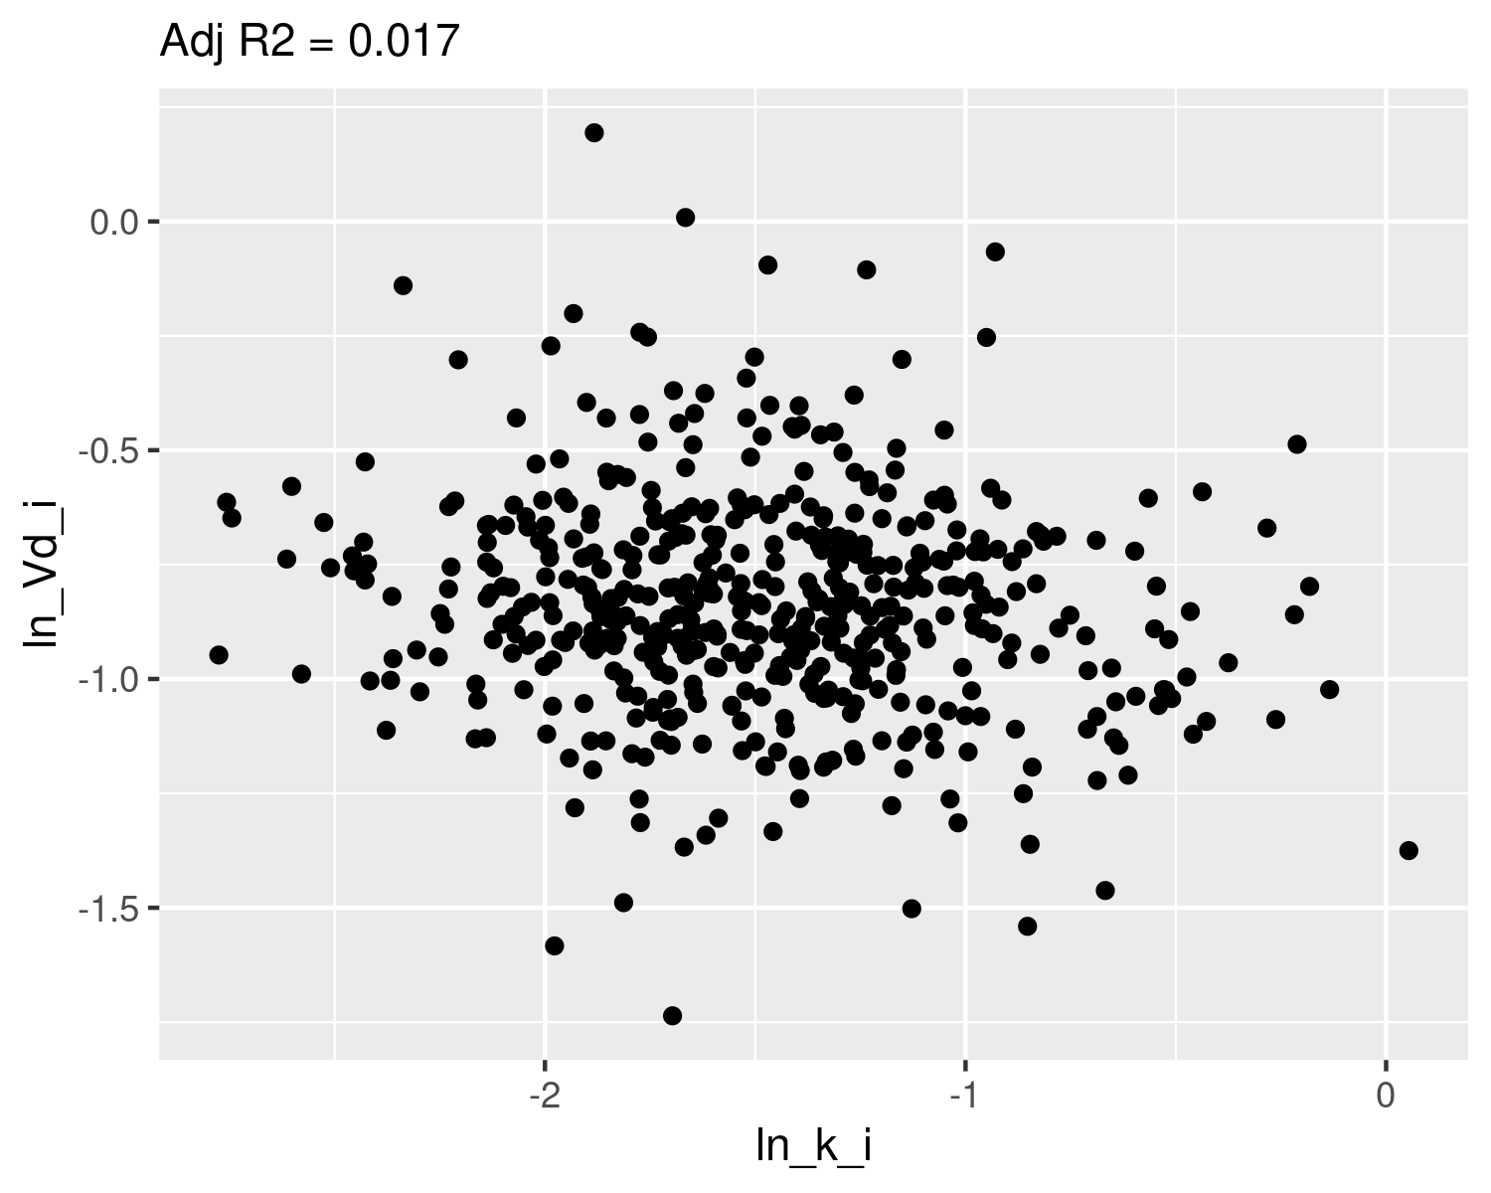

## Check normality

qqnorm(dat$ln_k_i,main="ln k Q-Q Normal")  
qqline(dat$ln_k_i,col="red")

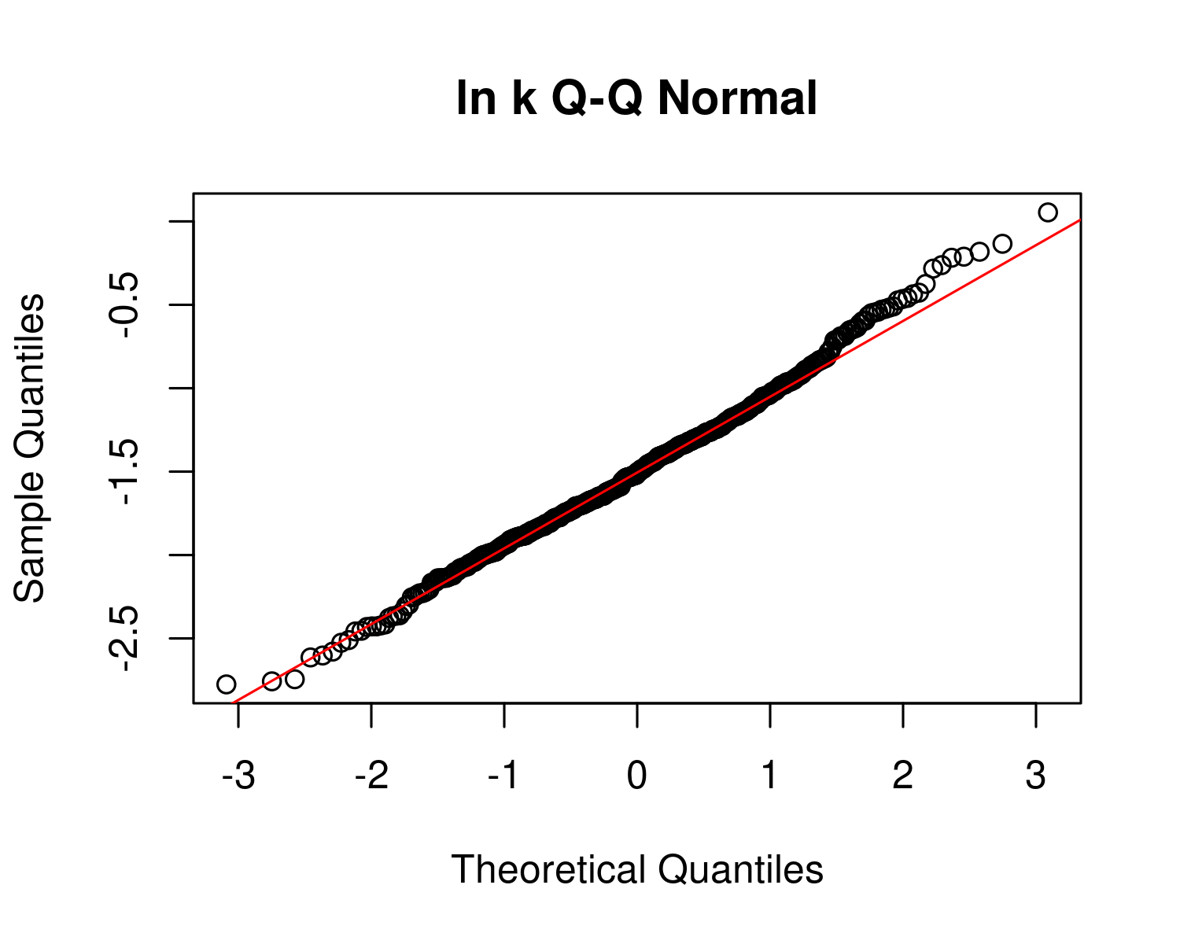

plot(ecdf(dat$ln_k_i))  
x <- seq(-3,1,0.01)  
m_ln_k_i <- mean(dat$ln_k_i)  
sd_ln_k_i <- sd(dat$ln_k_i)  
lines(x,pnorm(x,mean=m_ln_k_i,sd=sd_ln_k_i),col="red")  
text(m_ln_k_i-2*sd_ln_k_i,0.9,paste("m =",signif(m_ln_k_i,4),"\nsd =",signif(sd_ln_k_i,4)))

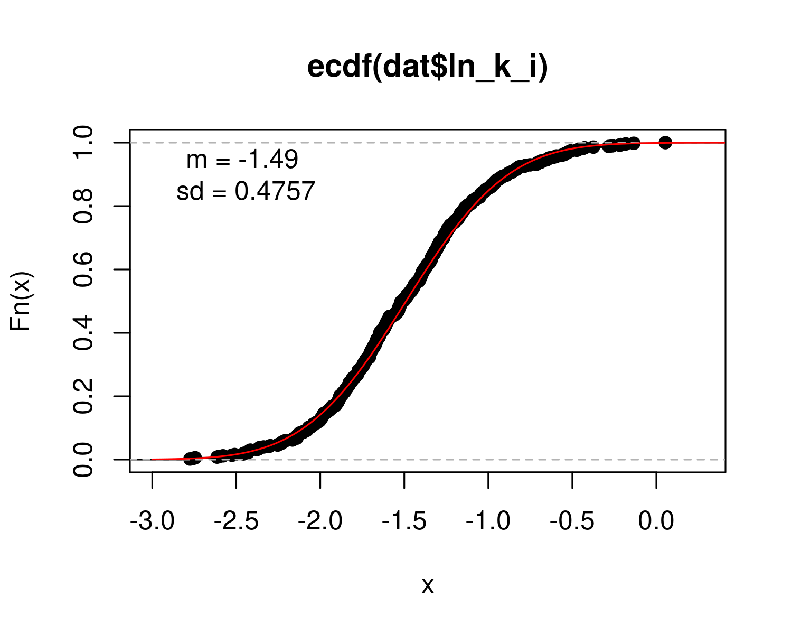

qqnorm(dat$ln_Vd_i,main="ln Vd Q-Q Normal")  
qqline(dat$ln_Vd_i,col="red")

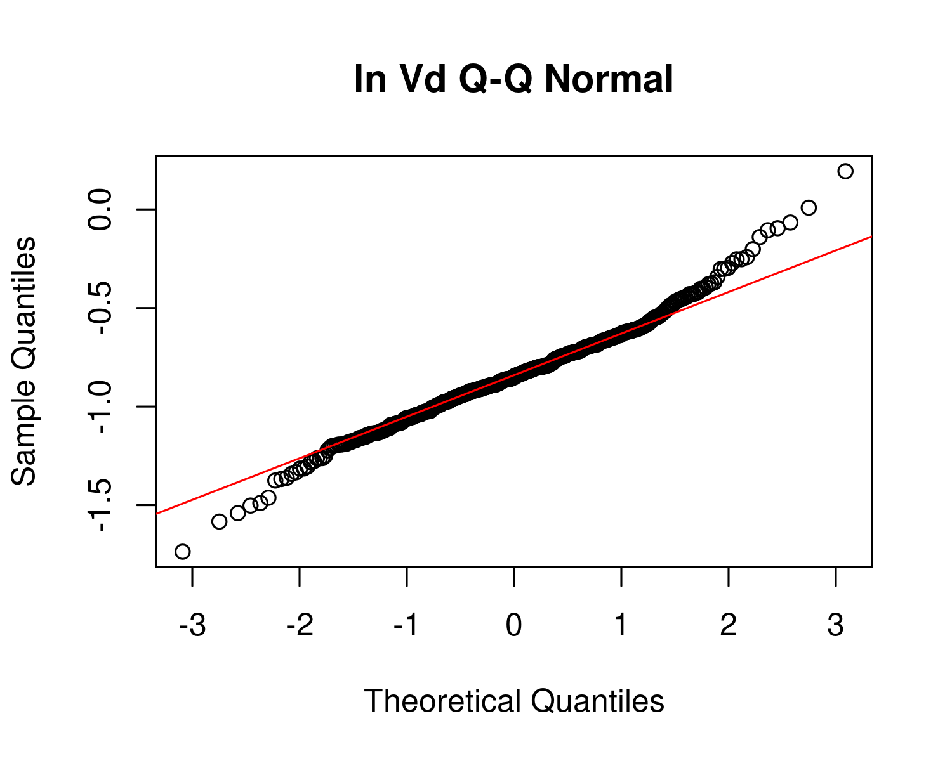

plot(ecdf(dat$ln_Vd_i))  
x <- seq(-3,1,0.01)  
m_ln_Vd_i <- mean(dat$ln_Vd_i)  
sd_ln_Vd_i <- sd(dat$ln_Vd_i)  
  
lines(x,pnorm(x,mean=m_ln_Vd_i,sd=sd_ln_Vd_i),col="red")  
text(m_ln_Vd_i-2*sd_ln_Vd_i,0.9,paste("m =",signif(m_ln_Vd_i,4),"\nsd =",signif(sd_ln_Vd_i,4)))

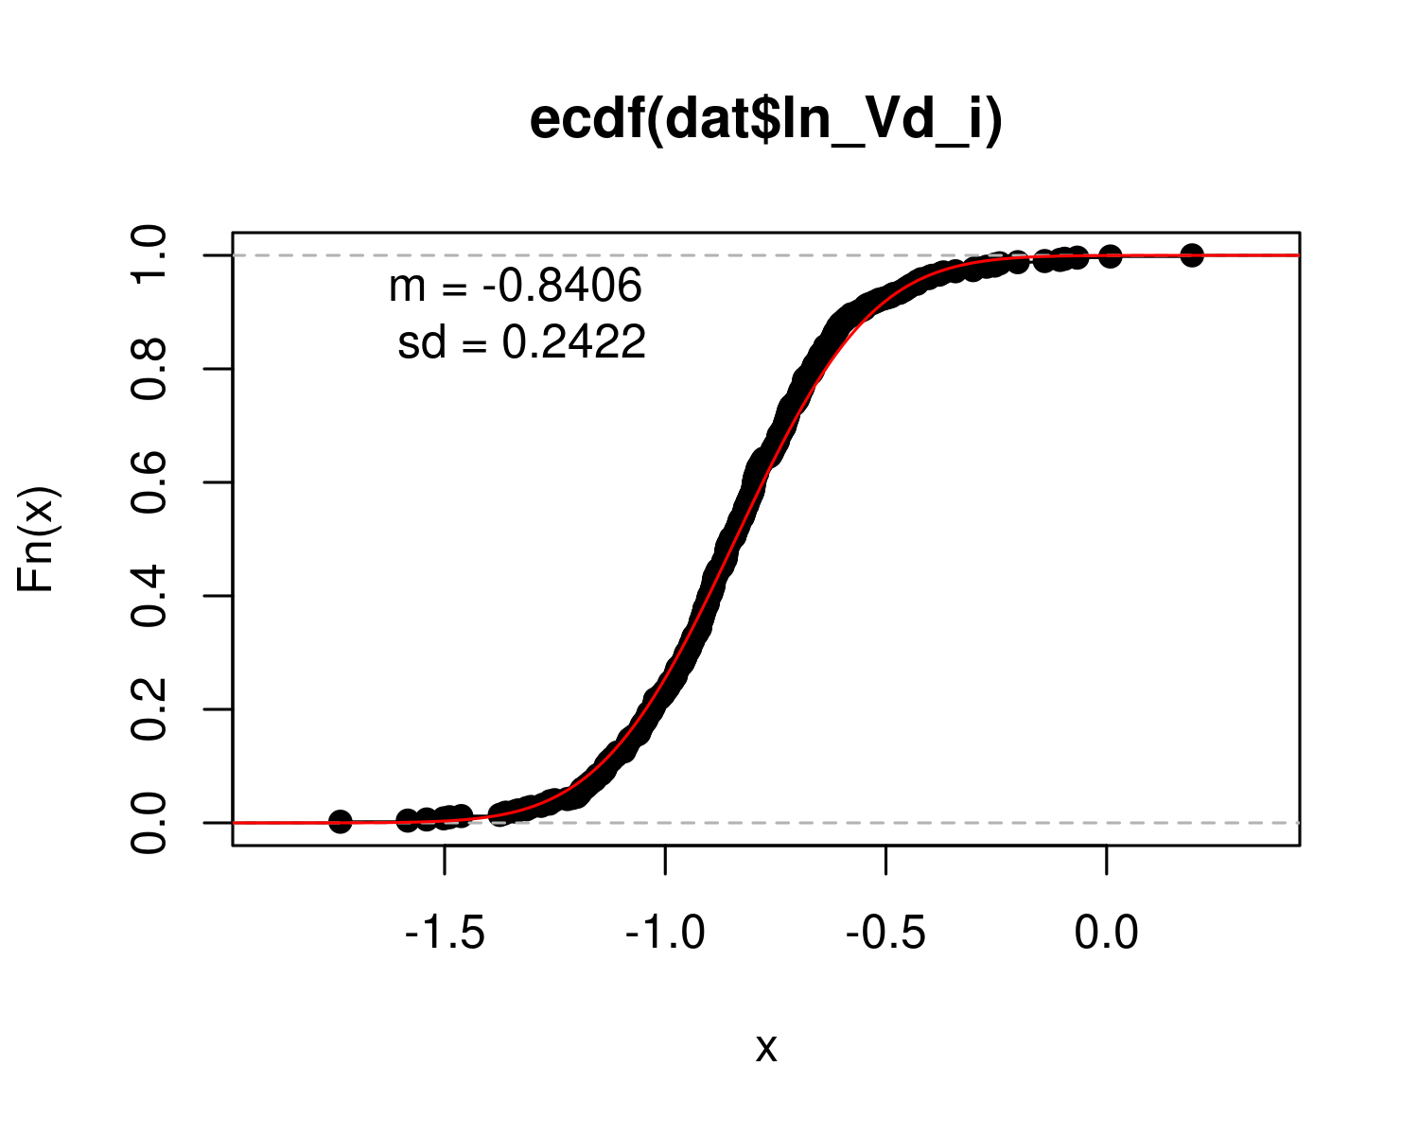 ## Fit to posterior for half-life population variability

ln_V_ln_k <- log(dat$`V_ln_k(1)`)  
qqnorm(ln_V_ln_k,main="ln V_ln_k Q-Q Normal")  
qqline(ln_V_ln_k,col="red")

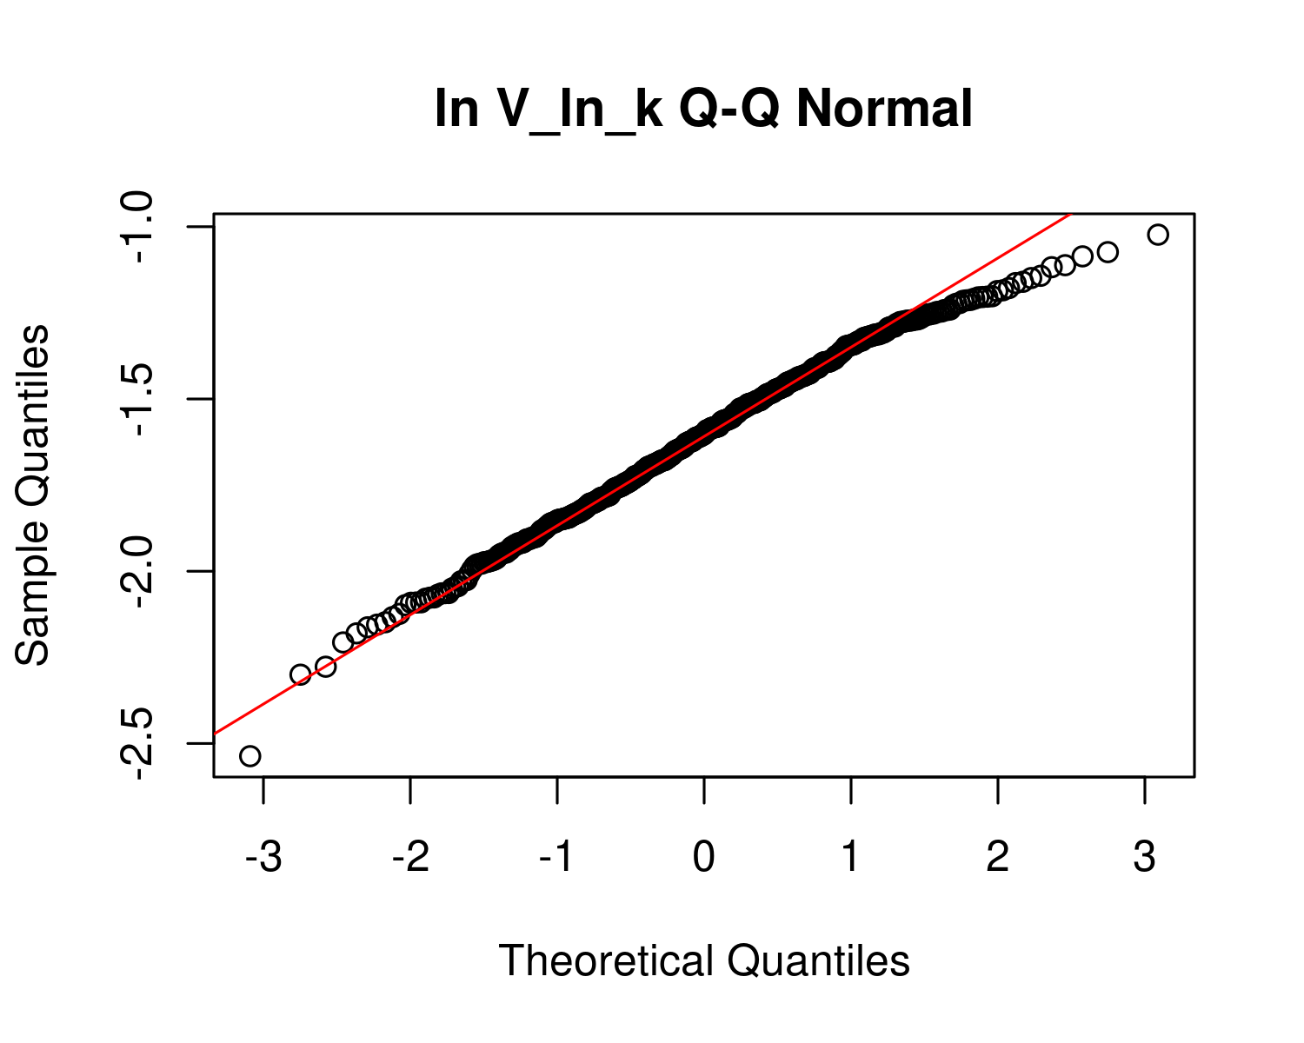

plot(ecdf(ln_V_ln_k))  
m_ln_V_ln_k <- mean(ln_V_ln_k)  
sd_ln_V_ln_k <- sd(ln_V_ln_k)  
x <- seq(-3,0,0.01)  
  
lines(x,pnorm(x,mean=m_ln_V_ln_k,sd=sd_ln_V_ln_k),col="red")  
text(m_ln_V_ln_k-2*sd_ln_V_ln_k,0.9,paste("m =",signif(m_ln_V_ln_k,4),"\nsd =",signif(sd_ln_V_ln_k,4)))  
text(m_ln_V_ln_k-2*sd_ln_V_ln_k,0.7,paste("GM =",signif(exp(m_ln_V_ln_k),4),"\nGSD =",signif(exp(sd_ln_V_ln_k),4)))

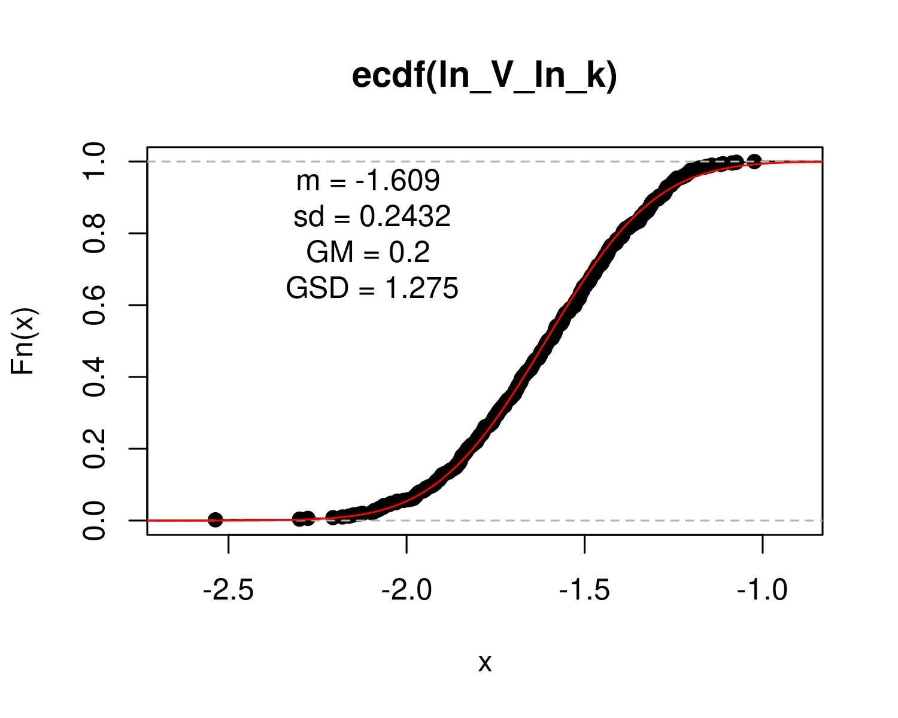

## Calculate table values for individual-level

hl_i <- log(2)/ exp(dat$ln_k_i) # individual half-life   
med_hl_i <- paste(signif (median (hl_i), 3)) # median of individual half-life  
ci_med_hl_i <- paste(signif (quantile(hl_i, prob=c(0.025,0.975)), 3),collapse="-") # 95ci med individual halflife  
gm_hl_i <- paste(signif (exp(mean(log(hl_i))), 3)) # gm (which should be really close)  
gsd_hl_i <- paste(signif (exp(sd(log(hl_i))), 3)) # gsd individual  
  
med_Vd_i <- paste(signif (median(exp(dat$ln_Vd_i)), 3)) # median individual Vd  
ci_med_Vd_i <-paste(signif (quantile(exp(dat$ln_Vd_i), prob=c(0.025,0.975)), 3),collapse="-") # 95ci med individual Vd  
gm_vd_i <- paste(signif (exp(mean(dat$ln_Vd_i)), 3)) # gm (which should be really close)  
gsd_vd_i<- paste(signif (exp(sd(dat$ln_Vd_i)), 3)) # gsd indiv  
  
med_CL_i <- paste(signif (median(exp(dat$ln_Vd_i+dat$ln_k_i)), 3)) # median individual CL  
ci_med_CL_i <-paste(signif (quantile(exp(dat$ln_Vd_i+dat$ln_k_i), prob=c(0.025,0.975)), 3),collapse="-") # 95ci med individual CL  
ci98_med_CL_i <-paste(signif (quantile(exp(dat$ln_Vd_i+dat$ln_k_i), prob=c(0.01,0.99)), 3),collapse="-") # 98ci med individual CL  
gm_CL_i <- paste(signif (exp(mean(dat$ln_Vd_i+dat$ln_k_i)), 3)) # gm (which should be really close)  
gsd_CL_i<- paste(signif (exp(sd(dat$ln_Vd_i+dat$ln_k_i)), 3)) # gsd indiv

PFOA_priors <- data.frame(  
 halflife_GM= log(2)/rlnorm(50000,  
 meanlog=-1.8971,sdlog=0.4055))  
  
M_k <- exp(as.numeric(dat$`M_ln_k(1)`))  
PFOA_halflife_GM <- log(2)/M_k  
  
pfoa_hlgm_pr_med <- signif(median(PFOA_priors$halflife_GM,3))  
pfoa_hlgm_pr_med_95ci <-paste(signif(quantile(PFOA_priors$halflife_GM,  
 prob=c(0.025,0.975)),  
 3),  
 collapse="-")  
  
pfoa_hl_median_gm <- signif(median(PFOA_halflife_GM),3)  
pfoa_hl_median_gm_95ci <- paste(signif(quantile(PFOA_halflife_GM,  
 prob=c(0.025,0.975)),3),collapse="-")  
  
p<-ggplot()+  
 stat_density(aes(halflife_GM, color = "Prior"),data=PFOA_priors,geom="line",size=2 )+  
 stat_density(aes(PFOA_halflife_GM,stat(density),color="Posterior"),geom="line",size=1.5 )+  
 xlim(0,15)+  
 labs(title = bquote("A: PFOA"~T[1/2]~"Population GM"),   
 subtitle=paste("Posterior Median (95% CI): ",  
 pfoa_hl_median_gm," (",  
 pfoa_hl_median_gm_95ci,  
 ")",sep=""))+  
 xlab(bquote("Population GM"~T[1/2]~"(yrs)")) +  
 scale_color_manual(name=NULL,#  
 values=c(Prior="#009988", Posterior="#EE7733" )) +   
 theme_classic() +   
 theme(legend.title = element_blank(),legend.position=c(0.8,0.7),  
 panel.background = element_rect(color="black",size=1),  
 legend.background = element_rect(fill="transparent", color=NA))  
print(p)

## Warning: Removed 80 rows containing non-finite values (stat_density).

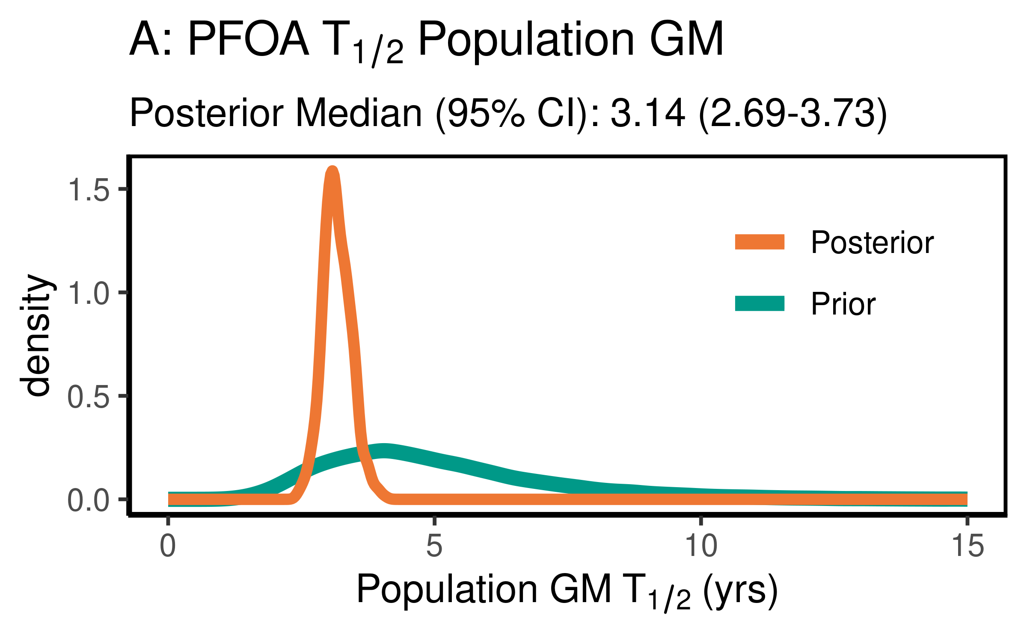

ggsave(here ("output-plots",paste0( sa, "PFOA_hl_gm.pdf")), p,dpi=600)

## Saving 4 x 2.5 in image

## Warning: Removed 80 rows containing non-finite values (stat_density).

ggsave(here ("output-plots",paste0( sa, "PFOA_hl_gm.png")), p,dpi=600)

## Saving 4 x 2.5 in image

## Warning: Removed 80 rows containing non-finite values (stat_density).

PFOA_priors$halflife_GSD = exp(sqrt(1/rgamma(50000,shape=9,rate=0.75))) #inverse gamma for the first trial  
PFOA_halflife_GSD <- exp(sqrt(dat$`V_ln_k(1)`))  
  
pfoa_hlgsd_pr_med <- signif(median(PFOA_priors$halflife_GSD,3))  
pfoa_hlgsd_pr_med_95ci <-paste(signif(quantile(PFOA_priors$halflife_GSD,  
 prob=c(0.025,0.975)),  
 3),  
 collapse="-")  
pfoa_hl_gsd_med <- signif(median(PFOA_halflife_GSD),3)  
pfoa_hl_gsd_med_95ci <- paste(signif(quantile(PFOA_halflife_GSD,  
 prob=c(0.025,0.975)),3),collapse="-")  
p<-ggplot()+  
 stat_density(aes(halflife_GSD, color = "Prior"),data=PFOA_priors,geom="line",size=2)+  
 stat_density(aes(PFOA_halflife_GSD,stat(density), color = "Posterior"),geom="line",size=1.5)+  
 xlim(1,3)+  
 labs(title = bquote( "B: PFOA"~T[1/2]~"Population GSD"),   
 subtitle=paste("Posterior Median (95% CI): ",  
 pfoa_hl_gsd_med," (",  
 pfoa_hl_gsd_med_95ci,  
 ")",sep=""))+  
 xlab(bquote("Population GSD"~T[1/2]))+  
 scale_color_manual(name=NULL,#  
 values=c(Prior="#009988", Posterior="#EE7733" ))+   
 theme_classic() +   
 theme(legend.title = element_blank(),legend.position=c(0.8,0.7),  
 panel.background = element_rect(color="black",size=1),  
 legend.background = element_rect(fill="transparent", color=NA))  
print(p)

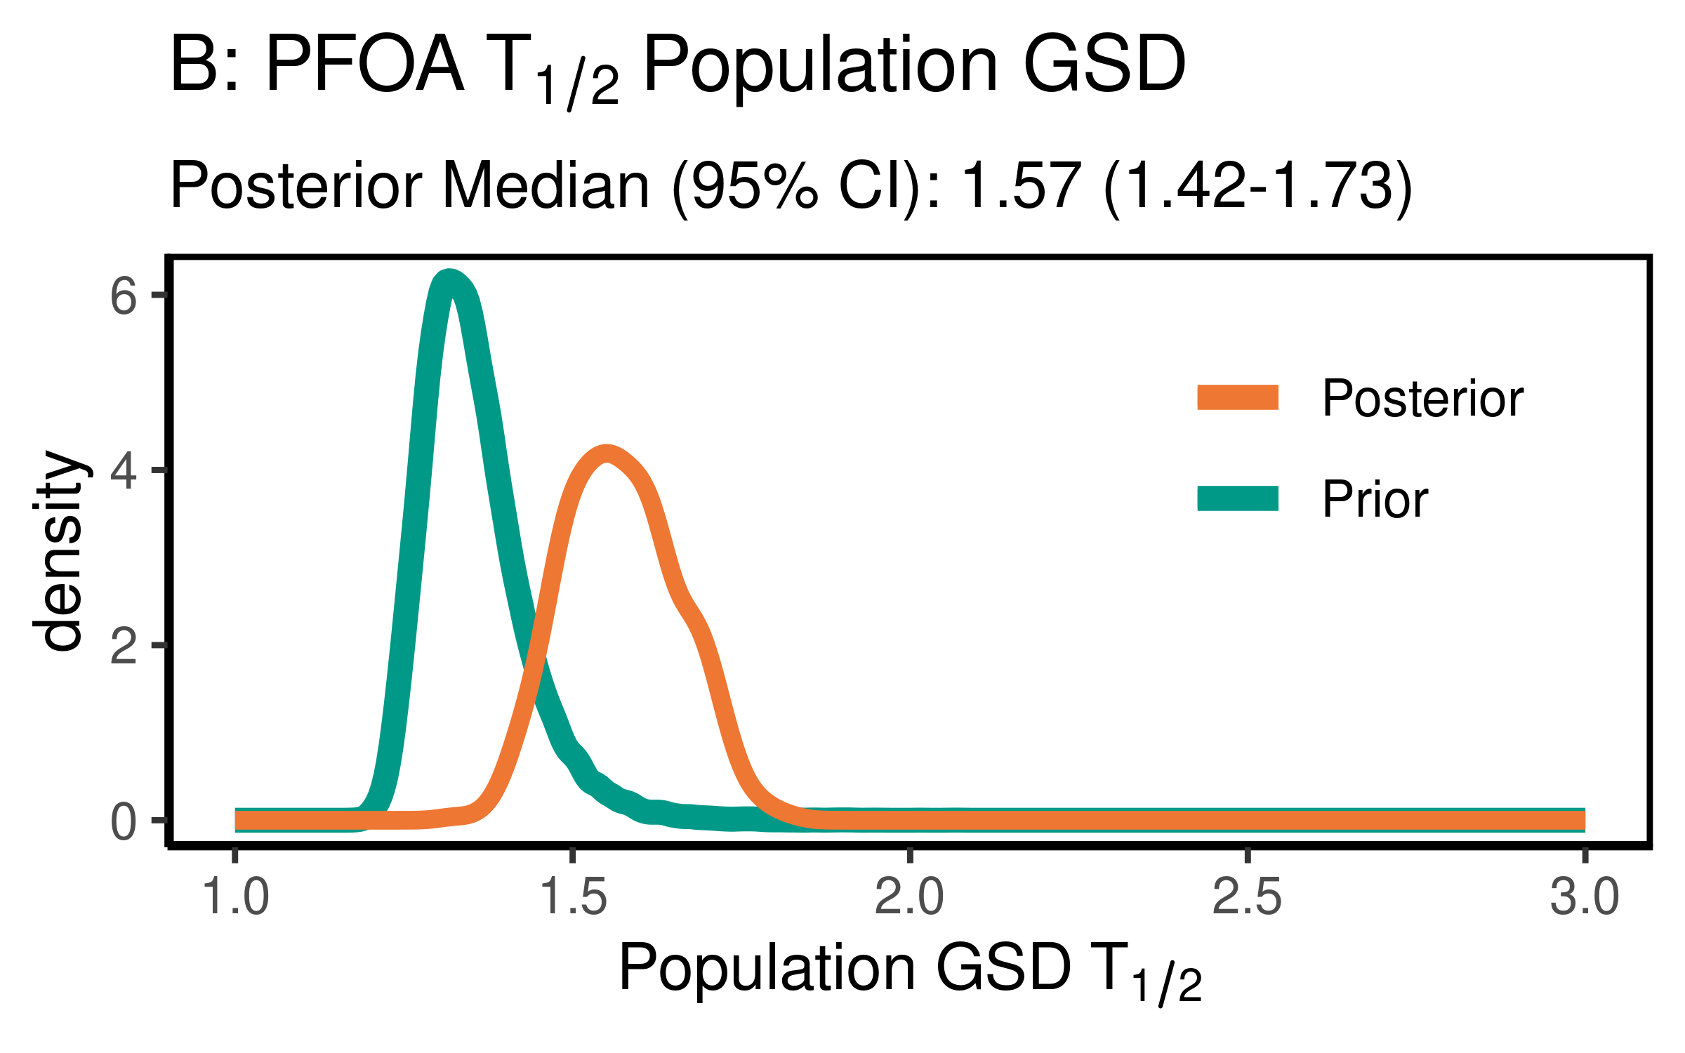

ggsave(here ("output-plots",paste0( sa, "PFOA_hl_gsd.pdf")) ,p,dpi=600)  
ggsave(here ("output-plots",paste0( sa, "PFOA_hl_gsd.png")) ,p,dpi=600)

### Distribution Volume

PFOA_priors$Vd_GM <- rlnorm(50000,  
 meanlog=-1.7720,  
 sdlog=0.2624)  
PFOA_Vd_GM <- exp(dat$`M_ln_Vd(1)`)  
  
   
  
pfoa_vd_gm_pr_med <- signif(median(PFOA_priors$Vd_GM,3))  
pfoa_vd_gm_pr_med_95ci <- paste(signif(quantile(PFOA_priors$Vd_GM,  
 prob=c(0.025,0.975)), 3), collapse="-")  
pfoa_vd_gm_med <- signif(median(PFOA_Vd_GM),3)  
pfoa_vd_gm_med_95ci <- paste(signif(quantile(PFOA_Vd_GM,  
 prob=c(0.025,0.975)),3),collapse="-")  
  
p<-ggplot()+  
 stat_density(aes(Vd_GM, color = "Prior"),data=PFOA_priors,geom="line",size=2)+  
 stat_density(aes(PFOA_Vd_GM,stat(density), color = "Posterior"),geom="line",size=1.5)+  
 xlim(0,1)+  
 labs(title = bquote( "A: PFOA"~V[d]~"Population GM"),  
 subtitle = paste0("Posterior Median (95% CI): ", pfoa_vd_gm_med," (", pfoa_vd_gm_med_95ci, ")" )  
 )+  
 xlab(bquote("Population GM"~V[d]~"(l/kg)"))+  
 scale_color_manual(name=NULL,#  
 values=c(Prior="#009988", Posterior="#EE7733" )) +   
 theme_classic() +   
 theme(legend.title = element_blank(),legend.position=c(0.8,0.7),  
 panel.background = element_rect(color="black",size=1),  
 legend.background = element_rect(fill="transparent", color=NA))  
print(p)

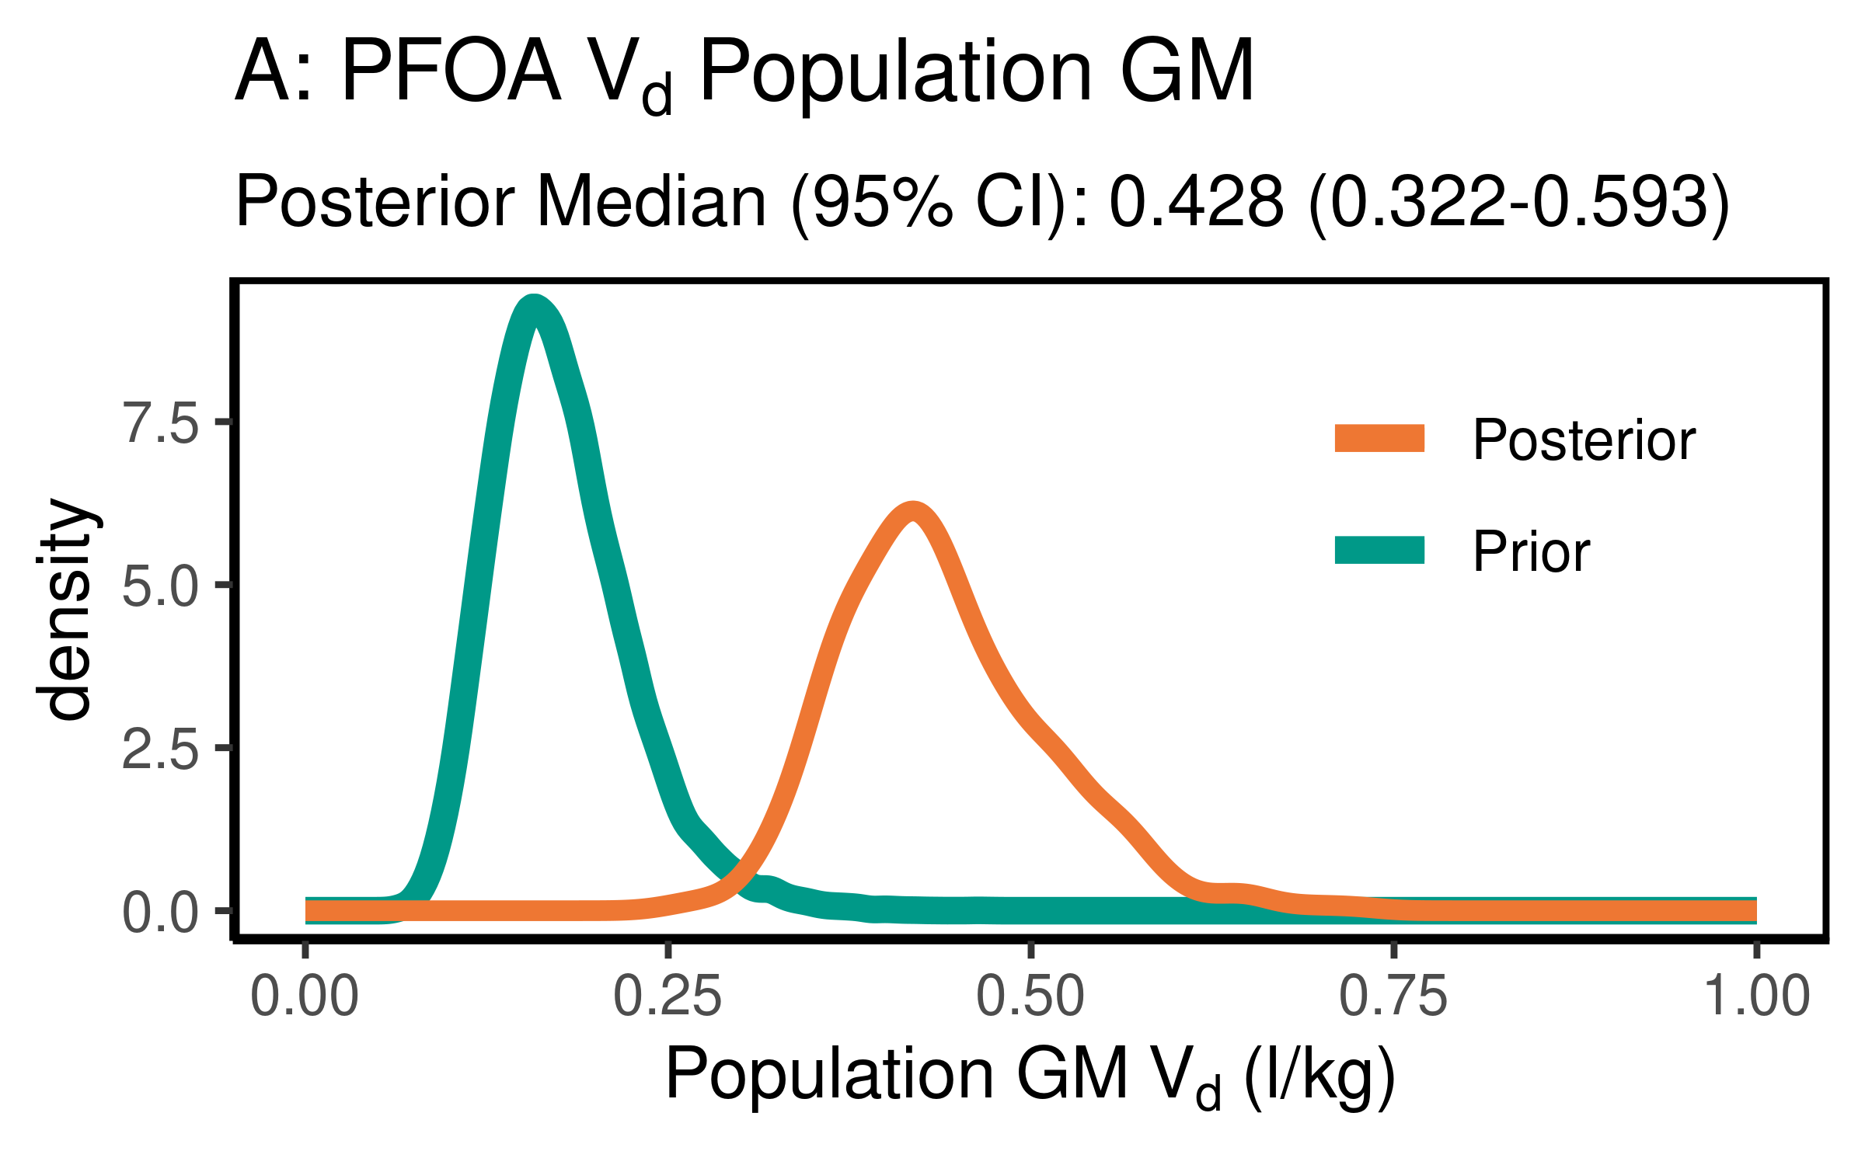

ggsave(here ("output-plots",paste0( sa, "PFOA_vd_gm.pdf")) ,p,dpi=600)  
ggsave(here ("output-plots",paste0( sa, "PFOA_vd_gm.png")) ,p,dpi=600)

PFOA_priors$Vd_GSD = exp(abs(rnorm(50000,sd=0.17)))  
PFOA_Vd_GSD <- exp(dat$`SD_ln_Vd(1)`)  
  
pfoa_vd_gsd_pr_med <- signif(median(PFOA_priors$Vd_GSD,3))  
pfoa_vd_gsd_pr_med_95ci <- paste(signif(quantile(PFOA_priors$Vd_GSD,  
 prob=c(0.025,0.975)), 3), collapse="-")  
  
pfoa_vd_gsd_med <- signif(median(PFOA_Vd_GSD),3)  
pfoa_vd_gsd_med_95ci <- paste(signif(quantile(PFOA_Vd_GSD,  
 prob=c(0.025,0.975)),3),collapse="-")  
  
p<-ggplot()+  
 stat_density(aes(Vd_GSD, color = "Prior"),data=PFOA_priors,geom="line",size=2)+  
 stat_density(aes(PFOA_Vd_GSD,stat(density), color = "Posterior"),geom="line",size=1.5)+  
 xlim(1,3)+  
 labs(title = bquote("B: PFOA"~V[d]~"Population GSD "),  
 subtitle=paste("Posterior Median (95% CI): ",  
 pfoa_vd_gsd_med," (",  
 pfoa_vd_gsd_med_95ci,  
 ")",sep=""))+  
 xlab(bquote("Population GSD"~V[d]))+  
 scale_color_manual(name=NULL,   
 values=c(Prior="#009988", Posterior="#EE7733" )) +   
 theme_classic() +   
 theme(legend.title = element_blank(),legend.position=c(0.8,0.7),  
 panel.background = element_rect(color="black",size=1),  
 legend.background = element_rect(fill="transparent", color=NA))  
print(p)

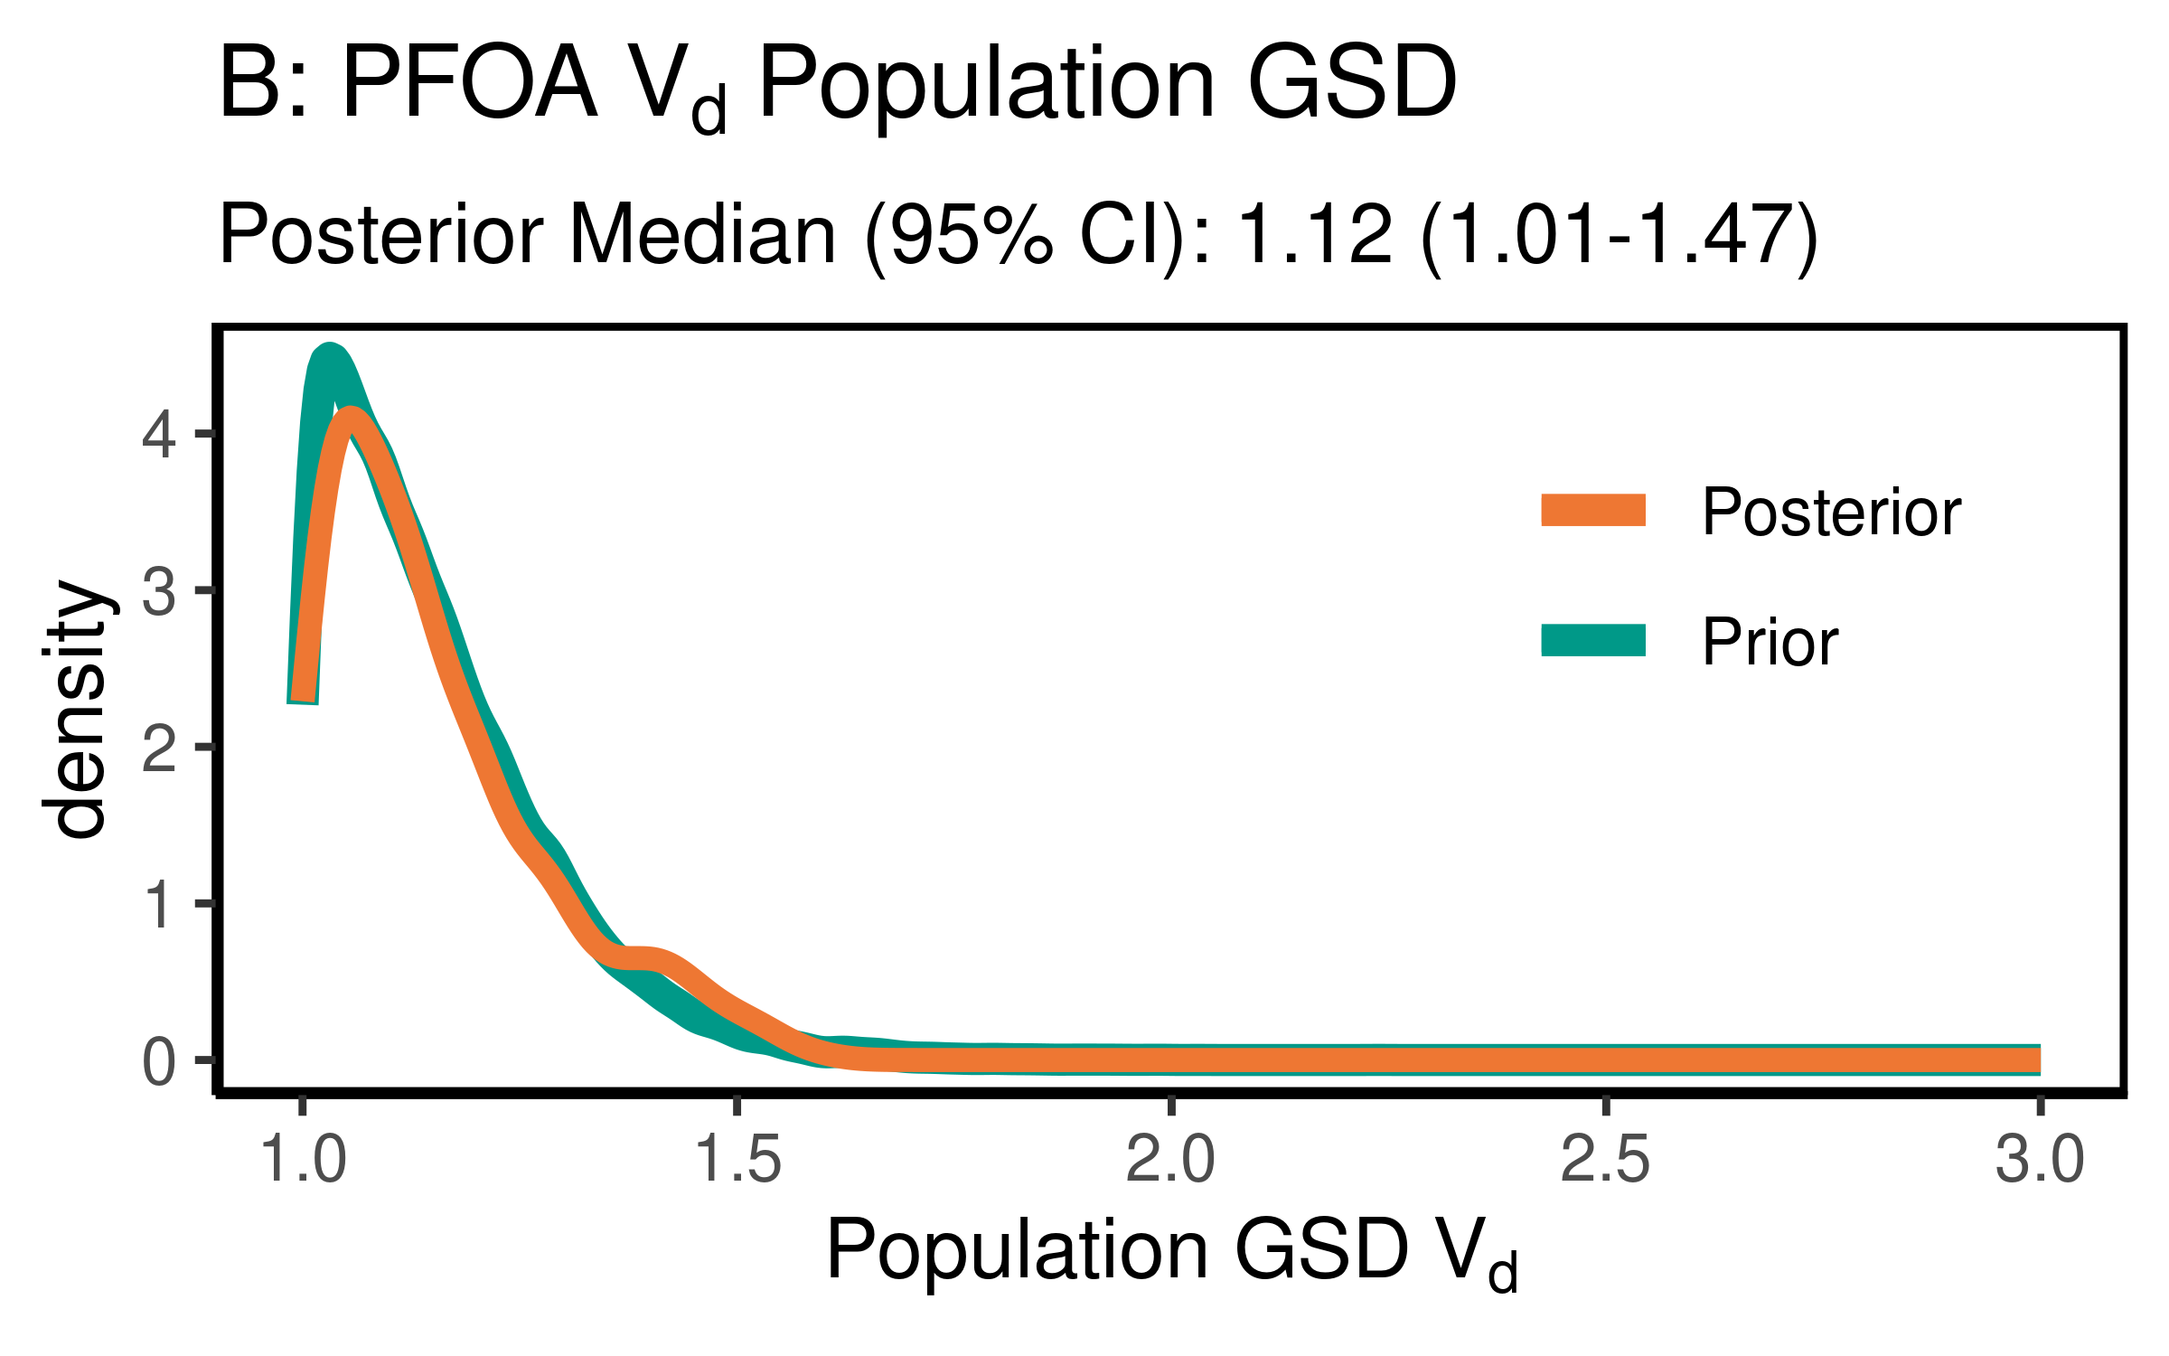

ggsave(here ("output-plots",paste0( sa, "PFOA_vd_gsd.pdf")) ,p,dpi=600)  
ggsave(here ("output-plots",paste0( sa, "PFOA_vd_gsd.png")) ,p,dpi=600)

### Clearance

Cl is k * Vd

PFOA_priors$CL_GM <- PFOA_priors$Vd_GM * (log(2)/PFOA_priors$halflife_GM)  
PFOA_CL_GM <- exp(dat$`M_ln_Vd(1)` + dat$`M_ln_k(1)`)  
  
pfoa_cl_gm_pr_med <- signif(median(PFOA_priors$CL_GM,3))  
pfoa_cl_gm_pr_med_95ci <- paste(signif(quantile(PFOA_priors$CL_GM,  
 prob=c(0.025,0.975)), 3), collapse="-")  
pfoa_cl_gm_med <- signif(median(PFOA_CL_GM),3)  
pfoa_cl_gm_med_95ci <- paste(signif(quantile(PFOA_CL_GM,  
 prob=c(0.025,0.975)),3),collapse="-")  
  
p<-ggplot()+  
 stat_density(aes(CL_GM, color = "Prior"),data=PFOA_priors,geom="line",size=2)+  
 stat_density(aes(PFOA_CL_GM,stat(density), color = "Posterior"),geom="line",size=1.5)+  
 xlim(0,0.25)+labs(title = "A: PFOA Clearance Pop. GM ",subtitle=paste("Posterior Median (95% CI): ",  
 pfoa_cl_gm_med," (",  
 pfoa_cl_gm_med_95ci,  
 ")",sep=""))+  
 xlab("Pop. GM CL (l/(kg-yr))")+  
 scale_color_manual(name=NULL,#  
 values=c(Prior="#009988", Posterior="#EE7733" )) +   
 theme_classic() +   
 theme(legend.title = element_blank(),legend.position=c(0.8,0.7),  
 panel.background = element_rect(color="black",size=1),  
 legend.background = element_rect(fill="transparent", color=NA))  
print(p)

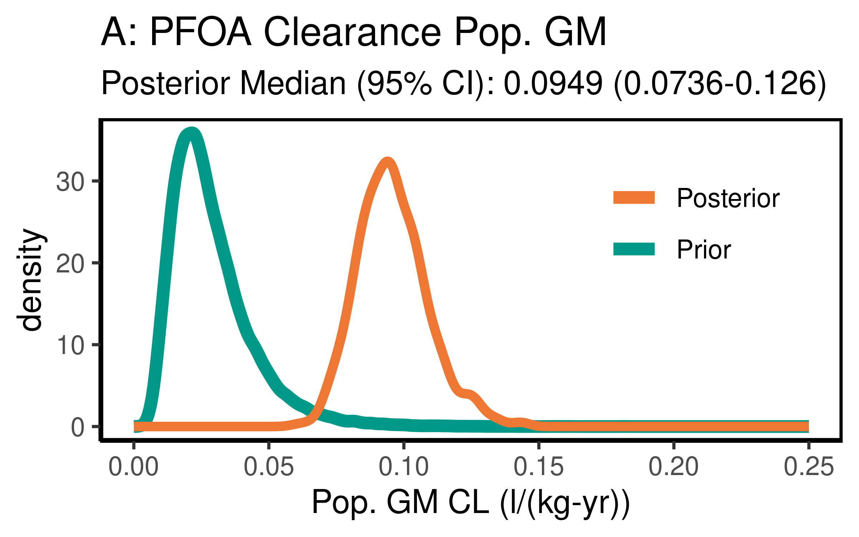

ggsave(here ("output-plots",paste0( sa, "PFOA_CL_gm.pdf")), p,dpi=600)  
ggsave(here ("output-plots",paste0( sa, "PFOA_CL_gm.png")), p,dpi=600)

PFOA_priors$CL_GSD = exp(sqrt(log(PFOA_priors$Vd_GSD)^2 +   
 log(PFOA_priors$halflife_GSD)^2))  
PFOA_CL_GSD <- exp(sqrt(log(PFOA_Vd_GSD)^2 +   
 log(PFOA_halflife_GSD)^2))  
  
PFOA_CL_gsd_pr_med <- signif(median(PFOA_priors$CL_GSD,3))  
PFOA_CL_gsd_pr_med_95ci <- paste(signif(quantile(PFOA_priors$CL_GSD,  
 prob=c(0.025,0.975)), 3), collapse="-")  
  
PFOA_CL_gsd_med <- signif(median(PFOA_CL_GSD),3)  
PFOA_CL_gsd_med_95ci <- paste(signif(quantile(PFOA_CL_GSD,  
 prob=c(0.025,0.975)),3),collapse="-")  
  
p<-ggplot()+  
 stat_density(aes(CL_GSD, color = "Prior"),data=PFOA_priors,geom="line",size=2)+  
 stat_density(aes(PFOA_CL_GSD,stat(density), color = "Posterior"),geom="line",size=1.5)+  
 xlim(1,3)+  
 labs(title = bquote("H: PFOA"~CL~"Population GSD "),  
 subtitle=paste("Posterior Median (95% CI): ",  
 PFOA_CL_gsd_med," (",  
 PFOA_CL_gsd_med_95ci,  
 ")",sep=""))+  
 xlab(bquote("Population GSD"~CL))+  
 scale_color_manual(name=NULL,   
 values=c(Prior="#009988", Posterior="#EE7733" )) +   
 theme_classic() +   
 theme(legend.title = element_blank(),legend.position=c(0.8,0.7),  
 panel.background = element_rect(color="black",size=1),  
 legend.background = element_rect(fill="transparent", color=NA))  
print(p)

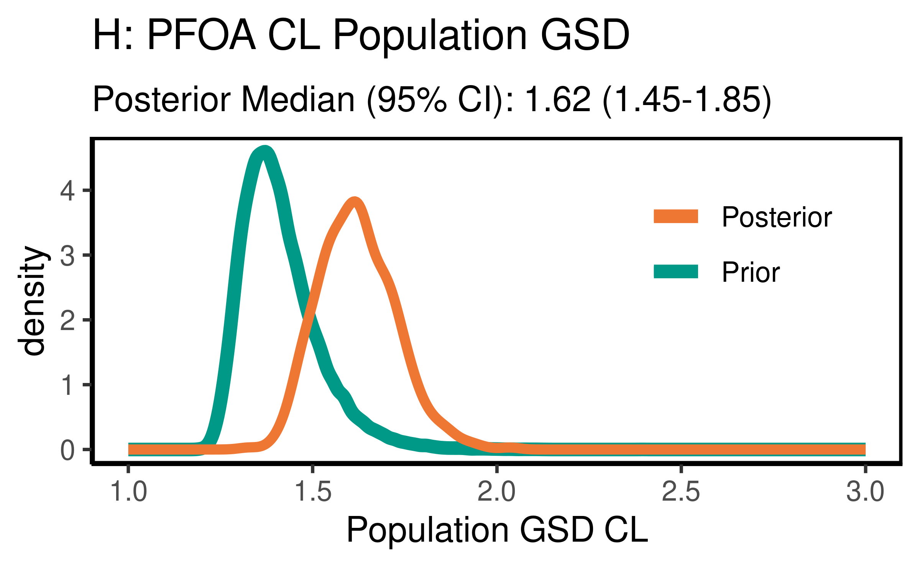

ggsave(here ("output-plots",paste0( sa,"PFOA_CL_gsd.pdf")) ,p,dpi=600)  
ggsave(here ("output-plots",paste0( sa,"PFOA_CL_gsd.png")) ,p,dpi=600)

## Table significant digit values

pfoa_hlgm_pr_med <- paste(signif(pfoa_hlgm_pr_med, 3))  
pfoa_hl_median_gm<- paste(signif(pfoa_hl_median_gm, 3))  
pfoa_hlgsd_pr_med<- paste(signif(pfoa_hlgsd_pr_med, 3))  
pfoa_hl_gsd_med<- paste(signif(pfoa_hl_gsd_med, 3))  
pfoa_vd_gm_pr_med<- paste(signif(pfoa_vd_gm_pr_med, 3))  
pfoa_vd_gm_med<- paste(signif(pfoa_vd_gm_med, 3))  
pfoa_vd_gsd_pr_med<- paste(signif(pfoa_vd_gsd_pr_med, 3))  
pfoa_vd_gsd_med<- paste(signif(pfoa_vd_gsd_med, 3))  
pfoa_cl_gm_pr_med<- paste(signif(pfoa_cl_gm_pr_med, 3))  
pfoa_cl_gm_med<- paste(signif(pfoa_cl_gm_med, 3))

### Population median estimates [95% CI]

|  |  |  |  |  |
| --- | --- | --- | --- | --- |
| Parameter | Prior GM | Posterior GM | Prior GSD | Posterior GSD |
| Half-life (years) | 4.62 | 3.14 | 1.34 | 1.57 |
| HL [95% CI] | [2.08-10.3] | [2.69-3.73] | [1.24-1.53] | [1.42-1.73] |
| Volume of distribution | 0.17 | 0.428 | 1.12 | 1.12 |
| [95% CI] | [0.102-0.286] | [0.322-0.593] | [1.01-1.46] | [1.01-1.47] |
| Clearance | 0.0255 | 0.0949 |  |  |
| [95% CI] | [0.00974-0.0664] | [0.0736-0.126] | [] | [] |

### Individual Posterior estimates

|  |  |  |  |
| --- | --- | --- | --- |
| Parameter | median GM [95% CI] | GM calculator input | GSD individual |
| Half-life (years) | 3.13 [ 1.13-7.83 ] | 3.07 | 1.61 |
| Volume of distribution | 0.427 [ 0.27-0.739 ] | 0.431 | 1.27 |
| Clearance (L/kg-yr) | 0.0957 [ 0.0369-0.262 ] [[ 0.0327-0.341 ]] | 0.0973 | 1.65 |

## ─ Session info ───────────────────────────────────────────────────────────────  
## setting value   
## version R version 3.6.3 (2020-02-29)   
## os Red Hat Enterprise Linux Server 7.9 (Maipo)  
## system x86_64, linux-gnu   
## ui X11   
## language (EN)   
## collate en_US.UTF-8   
## ctype en_US.UTF-8   
## tz America/New_York   
## date 2022-01-19   
##   
## ─ Packages ───────────────────────────────────────────────────────────────────  
## package * version date lib source   
## assertthat 0.2.1 2019-03-21 [2] CRAN (R 3.6.3)  
## backports 1.2.1 2020-12-09 [2] CRAN (R 3.6.3)  
## bayesplot * 1.8.0 2021-01-10 [2] CRAN (R 3.6.3)  
## broom 0.7.5 2021-02-19 [2] CRAN (R 3.6.3)  
## cachem 1.0.4 2021-02-13 [2] CRAN (R 3.6.3)  
## callr 3.5.1 2020-10-13 [2] CRAN (R 3.6.3)  
## cellranger 1.1.0 2016-07-27 [2] CRAN (R 3.6.3)  
## cli 2.3.1 2021-02-23 [2] CRAN (R 3.6.3)  
## coda * 0.19-4 2020-09-30 [2] CRAN (R 3.6.3)  
## codetools 0.2-18 2020-11-04 [2] CRAN (R 3.6.3)  
## colorspace 2.0-0 2020-11-11 [2] CRAN (R 3.6.3)  
## crayon 1.4.1 2021-02-08 [2] CRAN (R 3.6.3)  
## DBI 1.1.1 2021-01-15 [2] CRAN (R 3.6.3)  
## dbplyr 2.1.0 2021-02-03 [2] CRAN (R 3.6.3)  
## debugme 1.1.0 2017-10-22 [2] CRAN (R 3.6.3)  
## desc 1.3.0 2021-03-05 [2] CRAN (R 3.6.3)  
## devtools 2.3.2 2020-09-18 [2] CRAN (R 3.6.3)  
## digest 0.6.27 2020-10-24 [2] CRAN (R 3.6.3)  
## dplyr * 1.0.5 2021-03-05 [2] CRAN (R 3.6.3)  
## ellipsis 0.3.1 2020-05-15 [2] CRAN (R 3.6.3)  
## evaluate 0.14 2019-05-28 [2] CRAN (R 3.6.3)  
## fansi 0.4.2 2021-01-15 [2] CRAN (R 3.6.3)  
## farver 2.1.0 2021-02-28 [2] CRAN (R 3.6.3)  
## fastmap 1.1.0 2021-01-25 [2] CRAN (R 3.6.3)  
## forcats * 0.5.1 2021-01-27 [2] CRAN (R 3.6.3)  
## fs 1.5.0 2020-07-31 [2] CRAN (R 3.6.3)  
## generics 0.1.0 2020-10-31 [2] CRAN (R 3.6.3)  
## ggplot2 * 3.3.3 2020-12-30 [2] CRAN (R 3.6.3)  
## ggridges 0.5.3 2021-01-08 [2] CRAN (R 3.6.3)  
## ggsci * 2.9 2018-05-14 [2] CRAN (R 3.6.3)  
## glue 1.4.2 2020-08-27 [2] CRAN (R 3.6.3)  
## gtable 0.3.0 2019-03-25 [2] CRAN (R 3.6.3)  
## haven 2.3.1 2020-06-01 [2] CRAN (R 3.6.3)  
## here * 1.0.1 2020-12-13 [2] CRAN (R 3.6.3)  
## highr 0.8 2019-03-20 [2] CRAN (R 3.6.3)  
## hms 1.0.0 2021-01-13 [2] CRAN (R 3.6.3)  
## htmltools 0.5.1.1 2021-01-22 [2] CRAN (R 3.6.3)  
## httr 1.4.2 2020-07-20 [2] CRAN (R 3.6.3)  
## jsonlite 1.7.2 2020-12-09 [2] CRAN (R 3.6.3)  
## khroma * 1.7.0 2021-09-02 [1] CRAN (R 3.6.3)  
## knitr 1.31 2021-01-27 [2] CRAN (R 3.6.3)  
## labeling 0.4.2 2020-10-20 [2] CRAN (R 3.6.3)  
## lattice 0.20-41 2020-04-02 [2] CRAN (R 3.6.3)  
## lifecycle 1.0.0 2021-02-15 [2] CRAN (R 3.6.3)  
## lubridate 1.7.10 2021-02-26 [2] CRAN (R 3.6.3)  
## magrittr 2.0.1 2020-11-17 [2] CRAN (R 3.6.3)  
## memoise 2.0.0 2021-01-26 [2] CRAN (R 3.6.3)  
## modelr 0.1.8 2020-05-19 [2] CRAN (R 3.6.3)  
## munsell 0.5.0 2018-06-12 [2] CRAN (R 3.6.3)  
## pillar 1.5.1 2021-03-05 [2] CRAN (R 3.6.3)  
## pkgbuild 1.2.0 2020-12-15 [2] CRAN (R 3.6.3)  
## pkgconfig 2.0.3 2019-09-22 [2] CRAN (R 3.6.3)  
## pkgload 1.2.0 2021-02-23 [2] CRAN (R 3.6.3)  
## plyr 1.8.6 2020-03-03 [2] CRAN (R 3.6.3)  
## prettyunits 1.1.1 2020-01-24 [2] CRAN (R 3.6.3)  
## processx 3.4.5 2020-11-30 [2] CRAN (R 3.6.3)  
## ps 1.6.0 2021-02-28 [2] CRAN (R 3.6.3)  
## purrr * 0.3.4 2020-04-17 [2] CRAN (R 3.6.3)  
## R6 2.5.0 2020-10-28 [2] CRAN (R 3.6.3)  
## Rcpp 1.0.6 2021-01-15 [2] CRAN (R 3.6.3)  
## readr * 1.4.0 2020-10-05 [2] CRAN (R 3.6.3)  
## readxl 1.3.1 2019-03-13 [2] CRAN (R 3.6.3)  
## remotes 2.2.0 2020-07-21 [2] CRAN (R 3.6.3)  
## reprex 1.0.0 2021-01-27 [2] CRAN (R 3.6.3)  
## reshape2 * 1.4.4 2020-04-09 [2] CRAN (R 3.6.3)  
## rlang 0.4.10 2020-12-30 [2] CRAN (R 3.6.3)  
## rmarkdown 2.7 2021-02-19 [2] CRAN (R 3.6.3)  
## rprojroot 2.0.2 2020-11-15 [2] CRAN (R 3.6.3)  
## rstudioapi 0.13 2020-11-12 [2] CRAN (R 3.6.3)  
## rvest 1.0.0 2021-03-09 [2] CRAN (R 3.6.3)  
## scales 1.1.1 2020-05-11 [2] CRAN (R 3.6.3)  
## sessioninfo 1.1.1 2018-11-05 [2] CRAN (R 3.6.3)  
## stringi 1.5.3 2020-09-09 [2] CRAN (R 3.6.3)  
## stringr * 1.4.0 2019-02-10 [2] CRAN (R 3.6.3)  
## testthat 3.0.2 2021-02-14 [2] CRAN (R 3.6.3)  
## tibble * 3.1.0 2021-02-25 [2] CRAN (R 3.6.3)  
## tidyr * 1.1.3 2021-03-03 [2] CRAN (R 3.6.3)  
## tidyselect 1.1.0 2020-05-11 [2] CRAN (R 3.6.3)  
## tidyverse * 1.3.0 2019-11-21 [2] CRAN (R 3.6.3)  
## usethis 2.0.1 2021-02-10 [2] CRAN (R 3.6.3)  
## utf8 1.2.1 2021-03-12 [2] CRAN (R 3.6.3)  
## vctrs 0.3.6 2020-12-17 [2] CRAN (R 3.6.3)  
## withr 2.4.1 2021-01-26 [2] CRAN (R 3.6.3)  
## xfun 0.22 2021-03-11 [2] CRAN (R 3.6.3)  
## xml2 1.3.2 2020-04-23 [2] CRAN (R 3.6.3)  
## yaml 2.2.1 2020-02-01 [2] CRAN (R 3.6.3)  
##   
## [1] /home/ad.abt.local/layc/R/x86_64-pc-linux-gnu-library/3.6  
## [2] /opt/R/3.6.3/lib64/R/library